On Accountable Objects: Designing and Deploying Accountability Tools for Charities
Matt Marshall
Table of Contents

Abstract
Charities, Non-Profits, and other Third Sector Organisations are important elements of our civic society; operating in areas where the government (both Local and Central) have either under-served or are not trusted to operate. They are often funded through combinations of private or public grants and have legal protections excusing them from tax obligations. Due to their tendency to work with vulnerable and marginalised groups, and their financial status they are often required to be ‘Transparent and Accountable’ in both their work and spending.
This thesis presents a workplace study account of over three years’ embedded research within a charitable organisation in North East England, with details of additional engagements with other charity sector actors. In the thesis, I outline how ‘Transparency and Accountability’ are accomplished in everyday work practice and I chronicle a design process leading to the development of novel, inter-operable, accountability tools within this setting. These tools were trialled across two charities and then discussed with key financial stakeholders to critically evaluate their efficacy. I then present further implications for designing for ‘Transparency and Accountability’ in charities.
I provide the following contributions. Firstly; an understanding of ‘Accountability Work’ in workplace practice and design requirements for digital systems in these environments. Secondly, a model for the structured representation of everyday charity activities, first as the Qualitative Accounting Data Standard and then, through the implications of its deployment, in modelling commitments and actions. Thirdly; a set of design requirements for systems and interfaces to support the collection and curation of, and interactions with, this data in charities. Finally, I present Vanguard Design as an implementation and critique of participatory design principles in the environment of small front-line charities and contribute lessons for Digital Civics researchers in these contexts.

Dedication
This thesis is dedicated to Andi, Carl, Dean, Lynne, Mick, Owen, Sonia, Sydney, and the young people of the West End of Newcastle upon Tyne.
In loving memory of Mick, who did so much for so many and asked for so little in return.
Deyr fé deyja frændr deyr sjálfr it sama en orðstírr deyr aldregi hveim er sér góðan getr
Deyr fé deyja frændr deyr sjálfr it sama ek veit einn at aldri deyr dómr um dauðan hvern

Acknowledgements
It goes without saying that thesis-writing does not occur in a vacuum. Despite a few substantial bumps in the road, I am very glad to be in a position to submit this work and the only reason I am here now is because of the collective efforts of many in helping me. It is impossible to capture in words the deep well of gratitude I have for all mentioned and beyond.
First and foremost; special thanks to my collaborators and participants who took part in this work. Working within the context of The Patchwork Project made me a better researcher, and ultimately made me a better man. I started working there when I was 24 and thus the same age as many of the service users. I am not sure whether Patchwork intended to “do Youth Work” on me, but they did. They made me more collaborative, less anxious about how I appeared to others, and gave me more support than any other single institution involved in this thesis. This thesis is dedicated to them. If I named every young person who made me smile I’d never finish this work, but the 8 - 12 group at Patchy 2 formed some of the warmest and most treasured memories I own. Further thanks to Gateshead Older People’s Assembly and Edbert’s House for participating in the design and deployment. Especially to ‘Heather’, who furnished me with more tea and cake than I could handle during our visits. I cannot thank any of you enough, and I love you all dearly.
Next I wish to thank colleagues and collaborators within Open Lab. Dave Kirk’s herculean supervision efforts in getting this thesis even remotely close to submission cannot go understated. A true mentor and guide, thank you so much. My Digital Civics contemporaries, across the whole CDT, have provided immeasurable laughs and phenomenal guidance across the years. Special mention here must be given to Angelika Strohmayer, without whom I would not have made it through several key challenges. Thank you, Angelika, for being the best desk-mate in the world, helping me through it all, and for sharing my passion for tea. Rosanna Bellini must also not go unthanked. First in her capacity as colleague and Digital Civics researcher she has provided frankly stupendous inspiration and has set the bar very high, it’s truly been an honour to witness her work and share a lab with her. Her second capacity is as a confidante, flatmate, and surrogate sister. In this role she has provided a home for me in every sense of the word. This has involved unceasing support, patience, and familial care. Our kitchen table has been the site of many shared laughs, mutual care, and shared meals. If I had to thank a single person for helping me with this thesis, it’d be Rosanna Bellini.
My comrades in the Communist Party of Britain (Northern District) also need to be thanked; for embodying the importance of practice and disciplined militancy. This taught me much about sitting down and getting the work done. I especially wish to thank Martin Levy and Margaret Levy for the years of hard-learned lessons you manage to make enjoyable and accessible and for improving my reading of key texts and fundamentally making me a better Marxist. I must also thank Emma, alongside whom I’ve waved flags and clashed with fascists on many a rainy Saturday; and whose work as vanguard in the UCU stands as example to all.
My research ended in 2018 and the last two years, while writing, I have found a place and a home with my colleagues and co-operators at Open Data Services Co-operative, who’ve granted me the stability to finish this thesis and meaningful work alongside it. This small group of people have materially enriched the lives of so many, and given me the purpose, flexibility, and stability I needed to get well again and pick up this thesis to finish it. To mention one would be a disservice to all, but thank you all so, so, much.
I have also been lucky enough in the last few years to be surrounded by good friends, extended colleagues, and surrogate family, who have put up with me missing gatherings, and have fed both my body and soul in numerous ways to get me over the finish line. In no particular order thanks must be given to: Stacey McGeorge, Alice Adams, Karen Watson, and Jason Hussein at Goodspace Newcastle; Jack, Hannah, and Maia each of the family Arnstein; Kat da Silva Morgan and Feral Noir; Aga Czarny; Bernadine Fernz; and Alexandra Dent (who has been very patient with me and very supportive these last few months).
It would be wrong of me on many levels not to thank Bethany. You never stopped working to make me feel better, even when I couldn’t see it. I am eternally sorry and grateful, and you deserved so much better.
Finalmente, para Valentina gracias por la orientación, la paciencia eterna y por creer en mí. Te amo.

Lists of Tables and Figures

Lists of Tables by chapter

Tables in Chapter 5
- Table 5.1 - The Qualitative Accounting schema. Building blocks are described in other tables
- Table 5.2 - The FinancialData building block used for the schema
- Table 5.3 - The Quote building block used to capture written or verbal testimonials
- Table 5.4 - The Location building block was used to capture location context
- Table 5.5 - The API endpoints stipulated by the standard to receivers of QA data

Tables in Chapter 6
- Table 6.1 - Participants in deployments across Edbert’s House and GOPA
- Table 6.2 - Participants in the Interviews with Stakeholders portion of the evaluation

Lists of Figures by chapter

Figures in Chapter 3
- Figure 3.1 - Timeline of Research

Figures in Chapter 4
- Figure 4.1 - Mick at the Patchwork allotment with hired young people
- Figure 4.2 - A diagram of Patchwork’s organisational structure. Produced in 2017 and taken from their website in 2020
- Figure 4.3 - Map showing locations of Patchwork 1 (green) and Patchwork 2 (red) and walking route between them
- Figure 4.4 - A diagram of the sequential order of reconciling expenses to produce a canonical set of accounts

Figures in Chapter 5
- Figure 5.1 - Diagram of the system architecture showing systems in and out of scope for this thesis
- Figure 5.2 - Early sketch of Accounting Scrapbook collections interface using envelopes
- Figure 5.3 - The setting and presentation of colours within Accounting Scrapbook
- Figure 5.4 - top: The old interface for entering tags. Bottom-Left: New interface. Bottom-right: New interface demonstrating auto-suggest
- Figure 5.5 - Checklist allowing items to be added to multiple scrapbooks
- Figure 5.6 - Screens to add each different type of entry
- Figure 5.7 - Left: Adding an endpoint manually with a token. Right: Multiple endpoints shown on the Manage Sharing screen, one with a yellow key to indicate a token
- Figure 5.8 - The sharing screen showing share buttons for multiple services
- Figure 5.9 - Adding and displaying Customers and Funders in Rosemary Accounts
- Figure 5.10 - The form to add income to Rosemary Accounts
- Figure 5.11 - The form to add Budget Codes to Rosemary Accounts
- Figure 5.12 - Searching for Budget Codes and Tags
- Figure 5.13 - Adding a token to Rosemary Accounts
- Figure 5.14 - Turning a Rosemary Token into a QR code for easy scanning
- Figure 5.15 - Uploading an accounting spreadsheet to Rosemary
- Figure 5.16 - Checking that data has been interpreted correctly
- Figure 5.17 - A staff member can instruct the system on how to interpret their data by selecting which field maps to concepts in Rosemary
- Figure 5.18 - The Rosemary In-Tray with items to process
- Figure 5.19 - Notifications were used to highlight that items needed attention
- Figure 5.20 - The Costing screen in Rosemary Accounts allows a manager to see their funding pots and associate costs to them
- Figure 5.21 - Interfaces supporting adding data directly to Rosemary Accounts
- Figure 5.22 - Interface supporting editing of an individual item
- Figure 5.23 - Application logic to display an item. Highlighting decisions that the system makes about how to display various components
- Figure 5.24 - The Live Feed of an organisation’s profile page on Rosemary Accounts
- Figure 5.25 - The settings allowed an organisation to explicitly enable a “Live Timeline” of their activity
- Figure 5.26 - Form to generate a report in Rosemary Accounts
- Figure 5.27 - Expenses and Income Summaries
- Figure 5.28 - Images in a report. Images were collected as part of fieldwork and I have explicit permission to publish in this thesis
- Figure 5.29 - Events and Locations summary
- Figure 5.30 - Tags Summary and Quotes Gallery
- Figure 5.31 - Summaries of work and costs by grant
- Figure 5.32 - A report with most modules other than the Images module. Note this is a composite image due to the size of the report on the screen
- Figure 5.33 - Export option in Rosemary Accounts

Figures in Chapter 6
- Figure 6.1 - Timeline of deployments and evaluation
- Figure 6.2 - An example task to guide users through the system

Introduction

Background and Motivation to the Study
In August 2015 the charity Kids Company made headline news for coming under investigation for financial mismanagement (Grierson, 2015). Founded in 1996, it was one of the most recognised and celebrated charities in the UK at the time, and was set up to provide support to deprived children and its founder Camila Batmanghelidjh regularly featured in lists of influential people and her portrait hung in the national gallery (Renegade Inc, 2017). Its financial activities were widely publicised, and the organisation closed its doors soon afterwards (Elgot, 2015).
Kids Company was an incredibly wealthy charity, attracting ~£23m in 2013 (Charity Commission for England and Wales, n.d.; Bright, 2015), and the UK government had recently granted it a single grant worth £3m which it was now seeking to recover. The Guardian reported that Kids Company had burned through two financial directors in less than three years (Laville et al., 2015). The BBC reported that the organisation had received up to £46m of public funding, including 20% of the Department of Education’s grant programme in 2008 (BBC News, 2015). Camila Batmanghelidjh has since stated that the charity was actually audited 46 times since its inception, and that they were short of money because they’d built a solid reputation with the kids on the street that they helped which lead to surges in numbers (Renegade Inc, 2017). Kids Company itself was set up to address deprived inner-city children and the charity has claimed a high volume of direct beneficiaries within the region of 36,000 children per year, although that number was disputed (Ainsworth, 2015).
Kids Company serves as a very public example of contemporary opinions around charity and non-profit work and spending. Charities are asked to be “Transparent and Accountable” (Oliver, 2004; Dhanani, 2009) for both their actions and their spending. Charities find themselves playing an important role in society taking up the slack in areas where the private sector and government can either not be trusted or simply do not care to spend attention (Hansmann, 1980), and their actions are critical to generating and sustaining ‘Social Capital’ (King, 2004; Wang & Graddy, 2008); the shared skills, trust, and relationships within society which can determine its efficiency and character (Field, 2003). Operating in this space means that they are often trusted with grant money from both public bodies and philanthropic trusts, and often work with vulnerable people and groups in sensitive contexts. This can lead to things going wrong in ways that are potentially far worse than mis-spending project funds (Ratcliffe, 2019).
In the UK’s age of austerity the performance of this work is essential; Local Authority budgets have been continuously slashed and charities have stepped in to fill the gaps in service as the government withdraws its support. Any charity trusted with public funds has a hard job to do; making every penny count while trying to provide services on-the-cheap that have traditionally been the remit of Local Government. All of this places charities at an interesting, and precarious, intersection of being Accountable to large swathes of the population and a variety of stakeholders. Each of these stakeholders then demand their own forms of Transparency and Accountability (Koppell, 2005). Transparency and Accountability, however, are words that are often invoked but rarely defined (Hood, 2006) and these two seemingly simple terms each hide multifaceted, complex, shifting, and interrelated concepts that ultimately mean different things to different people. Charities, and similar Non-profit organisations across the world, thus find their daily work to consist of socially important (if not critical) tasks which they they then must work to account for in a variety of ways to a variety of people. They operate on limited resources as grant funding is increasingly difficult to come by and are increasingly forced to compete for shrinking funding pots (Radojev, 2018). This forces many to twist into new shapes and undergo transformations into ‘Social Enterprise’; a process which risks exposing them to market forces and losing their ability to generate Social Capital by cutting non-profitable services and transforming their beneficiaries into customers (Eikenberry & Kluver, 2004). It is thus the Sisyphean task of charities to perform crucial work on small budgets while wrestling with the hydra of being Transparent and Accountable for every action and every great-british-pound; one slip up could mean public outcry, defunding, and collapse which exacerbates the social conditions that gave rise to them in the first place.
It is during the collapse of Kids Company that I was part-way through the first year of my journey in the Digital Civics programme, and drawing up the plans for my Master’s dissertation study. I now turn to describe how this setting influenced my personal motivations for the study

Personal motivations for the study
My personal motivations for this research are the synthesis of the material conditions that were present during my year of MRes study immediately preceding my PhD. These were namely: the collapse of Kids Company and the questions it raised about the role of charities in civic society; and my growth from a Liberal idealist into a dedicated Socialist. I will discuss each of these in turn.
When I began on the Digital Civics programme as an MRes student in 2014/15 I went into the studies with an interest in HCI and Design processes, which were ignited from my undergraduate studies at Newcastle University. I also carried with me a personal dedication to concepts of “openness” which was born of my formative years engaging with the Free Software movement. Throughout the studies of the ‘MRes in Digital Civics’ these interests were refined through engagement with the course material and the contemporary literature. In one interaction my soon-to-be supervisor, David S. Kirk, recommended that I read The Open Source Everything Manifesto (Steele, 2012). I obliged and while I found it a bit new-age in places, I found it lent credence to the idea that open information and Open Source Intelligence (OSINT) could provide the foundation for a strong civic life. This seemed a natural fit for my passion for openness, participatory practices, and the arena of Digital Civics.
Stemming from this, my MRes dissertation originally focused on the consumption, analysis, and presentation of Local Authority data. This broadened my academic focus from the idea of “open” to that of Transparency and Accountability, as it pertained to government spending. By 2015 the citizens of the UK had experienced half a decade of Tory austerity politics which had slashed Local Authority budgets dramatically (Lowndes & Gardner, 2016), and I thought that developing systems to promote use of mandatory spending data to the otherwise-absent “armchair experts” (Cornford et al., 2013) would be a good way to flex my newly-acquired Digital Civics muscles. When Kids Company made the news its presence in the zeitgeist triggered conversations between myself and my supervisor around investigating people’s interactions with charity spending data. Charities are a prime example of a civic space, they do important work, and clearly people feel strongly about how they spend cash and perform work. We thus shifted the focus of the MRes dissertation and I sought participants from within the Charity sector in addition to those with a stake in Local Authorities.
The performance of that initial research made it clear that the local Charity sector were far more willing, and/or capable of engaging with me constructively than actors within the Local Authority. This presented me a much more interesting and fertile space for HCI and design research to effect real change in the lives of communities that had been so adversely affected by austerity. The paper stemming from that initial research (Marshall et al., 2016) showed a sector where various forms of Transparency and Accountability were at odds with each other; and there were opportunities to develop newer, more effective, interfaces and practices around communicating that I was keen to explore.
Throughout this year and study I was also developing my own citizenhood, and growing in my understanding of political economy and democracy. As I hope to have made apparent throughout this section; both the collapse of Kids Company as well as my induction into Digital Civics are events that were set against the backdrop of austerity. I either saw about me or continued to read about the continued effects of austerity in the UK: people not being able to eat (Dowler & Lambie-Mumford, 2015) and the subsequent rise of food-banks (Loopstra et al., 2015; Garthwaite, 2016; Garthwaite et al., 2015); devastatingly widening inequality in already neglected areas (Greer Murphy, 2017); and the worsening health of the UK population (Stuckler et al., 2017). At the same time the climate crisis rages on (Chakrabarty, 2014; Dawson, 2010; Frank, 2009; Guerrero, 2018), and the disproportionately wealthy increase their share of our wealth with each new crisis (Woods, 2020; Kentish, 2017; Davies et al., 2017; Zucman, 2019). Through engaging with the works and analyses of political economy by writers such as Marx (Marx et al., 1974) and Lenin (Lenin, 1917) I could make sense of these systems and saw them not as disconnected, chaotic, results of a system gone awry; but the natural effects of capitalism.
The conditions of austerity and my subsequent readings of political economy coupled comfortably with my newfound academic interest in the Transparency and Accountability of charities and other ‘Third Sector’ organisations. I saw further evidence of the appropriateness of a focus on the third sector, as Marxist analyses of the sector (Livingstone, 2013; Bhai, 2005) gelled with the academic literature that the entire existence of these organisations was a result of the systemic failures of a political an economic mode that neglected or could not be trusted with key activities (Hansmann, 1980; Salamon, 1994). This solidified in my mind the notion of front-line charities as sites of struggle, and the appropriateness of following the thread this of working within charities in my research in order to lend my resources and (hopefully) insight into how to improve their efficacy or make their lives easier.

Statement of Research purpose
With the above in mind the aim of my research in this thesis is to explore how digital technologies may be designed with, within, and for charities (and related Third Sector organisations) in order to assist them with becoming more Transparent and Accountable. In doing this I hope that I may help them find ways to not only address their critics’ concerns over their work and spending, but better account for their impact on civic life in attending to the matters ignored by the state or exploited by the private sector.
This will, necessarily, cover an exploration of what it means to be transparent and accountable as or within such an organisation. Or more accurately, what it takes to do Transparency and Accountability. From this I wish to explore what the system and interface requirements are for supporting this work and making it more straightforward for a charity to demonstrate the appropriateness of its work and spending to its stakeholders, as well as civil society at large.
Owing to this research’s performance as part of the Digital Civics programme, and the fact that the on-the-ground work of charities is labour performed by members of the working class; I will also be reflecting on design practices in this space. Charities and their related organisations are an inherently civic space, and one with particular characteristics. Any act of designing technologies in, with, or for the workers in this space will need to attend to ensuring that the members of that setting have an adequate stake in design. Therefore, it is also an aim of this research to explore the performance of design work in this space both as it relates to designing tools for Transparency and Accountability, as well as how design may operate in charities as a matter of concern for Digital Civics work. This aim also aligns with a history of workplace studies within HCI and CSCW (Anderson, 1994); which have by their nature of forefronting work practice made matters of ‘accountability’ within the workplace a matter of study (Button & Sharrock, 1998). This traditional notion of accountability of work (or account-ability, as it is sometimes conceived) within ethnomethodological studies of work practice should be leveraged to frame the design of technologies which in turn provide the foundation for new forms of Transparent and Accountable practices beyond the immediate workplace and thus underpin the relationships between charities, their workers, and their stakeholders.
I now turn to forefronting the nature and contributions of this thesis and make explicit the research questions that, in answering, achieve the aims of purpose of this research. I also explicitly state and label the individual contributions that this thesis makes in answering these questions.

Nature and Contributions of the thesis
This section delineates the areas of work which this thesis sits at the intersection of and makes explicit the research questions that I am seeking to answer in this research in each case. I also highlight and explicitly label the contributions of the thesis in resulting from answering each question.

Accountability Work
R1: How are the financial practices and Transparency obligations of a charity manifested in daily workplace practices?
As readers will discover in Chapter 2 there is a multitude of writing around the nature of Transparency and Accountability and how these interact in charities and the Third Sector. This does not account for how these obligations are present in the ground and experienced by the community surrounding organisations such as charities.
In order to begin designing for conceptual goals such as Transparency and Accountability there must be a study of how these concepts affect the daily work practices within organisations and settings where they’re important. Any systems designed to be used must consider the daily performance of workplace activity and how Accountability Work is organised as a result of this.
I address this question in Chapter 4 where I present my account of a field study of work practice inside a small charity. In this chapter I explicitly outline how Accountability Work is organised and performed, and put forward design recommendations based on this. In Chapter 6 I expand on this and illustrate how Accountability Work is underpinned by interactions with Accountable Objects.
Contributions
- C1a: an account of work practices (Accountability Work) in a small charity as they pertain to their Transparency and Accountability requirements, and how they are underpinned by the relationships between Accountable Objects.
- C1b: design recommendations for digital systems seeking to operate in organisations with Transparency and Accountability requirements.

Data and Interfaces for Transparency and Accountability in Charities
R2: How may data be structured to represent the work and financial life of a charity?
This thesis is concerned in part with the design and implementation of Open Data systems as a means to support Transparency and Accountability in charities. This requires attention on what is captured, how that is structured, and how well this represents the work of charities for achieving their aims in being Transparent and Accountable. In the realm of Open Data standards there has been work to model both government procurement (Open Contracting Partnership, 2021) and grants given to charitable organisations (360Giving, 2020a). My research seeks to add another piece to the puzzle around representing both work and financial practices on the ground in charities.
I address this question in two places. My first attempt at a model to capture and represent charity work and spending is documented in Chapter 5 where the first draft of the Qualitative Accounting data standard is designed with participants. The systems using the standard are then put to the test in Chapter 6 where I then further elaborate on these requirements based on lessons gathered from the field tests.
Contributions
- C2a: the Qualitative Accounting data standard. This is a prototype data standard and model for decentralised systems to share data around charity work and spending.
- C2b: the Commitment-Action Model for representing charity work and spending in relation to specific goals. This could be realised as a future update to Qualitative Accounting. This results from a thorough field test of Qualitative Accounting and represents an iteration overcoming its shortcomings when put to use.
R3: What are the interface requirements for systems that interact with data concerning the work and financial life of a charity, such that it is simple to capture, curate, and make use of this data?
Building from R2, R3 explores the requirements for interfaces that support interactions with data as they pertain to charity work and spending. This question is situated in existing research into Human-Data Interaction (HDI) which has explored the use of data as a boundary object (Mortier et al., 2014) as well as interesting ways of engaging with personal data (Elsden & Kirk, 2014). If a model for representing charity work and spending is produced then it will require interfaces that allow people to capture this data, curate it, and engage with it in some way. I therefore contribute to this work by explicitly addressing the requirements of interfaces that interact with data with notions of Accountability and Transparency
Similar to R2, I address this question in both Chapter 5 and Chapter-6. In the former I engage in a design process that results in several systems for collecting, curating, and presenting data whereas the latter chapter field tests these and I evaluate their effectiveness and forefront lessons learned from this.
Contributions
- C3a: a set of design requirements for producing systems and interfaces that support the collection and curation of data pertaining to work and spending within charities.
- C3b: a set of design requirements for producing systems and interfaces that support the presentation of and interactions with data pertaining to work and spending within charities.

Designing digital technologies in charities
R4: How should design work be performed in civic organisations such as charities so that they can participate in design while operating with limited resources?
Chapter 2 and Chapter 3 each discuss this thesis as being performed within the context of the Digital Civics programme of work within HCI. Within Digital Civics, HCI, and related fields such as CSCW there is often reflections and research on the subject of design’s application within given settings e.g (Strohmayer et al., 2019) and (Bellini, Strohmayer, et al., 2019). The research performed in this thesis took place within small, front-line, charities in the UK; of which there are many. Lessons from this experience are also applicable to settings which experience similar struggles and where the relationship between the researcher/designer and the members of the setting is not necessarily clear-cut.
I begin addressing this in Chapter 5 where I discuss the challenges of performing design work in charities and conceptualise Vanguard Design as a model for dealing with these challenges. Chapter 7 continues this reflection based off of experience performing the research as a whole and contributes lessons for HCI and Digital Civics researchers seeking to engage with charities and other Third Sector organisations.
Contributions
- C4a: Vanguard design as a model for design in civic spaces. This model attempts to address the contradictions of wanting to perform Participatory Design in settings where members are unable to contribute to traditional design activities due to institutional demands.
- C4b: lessons for Digital Civics researchers who seek to engage in charities and similar spaces in addressing specific challenges around motivation and participation.

Publications arising from this research
This research has directly resulted in two publications to date, of which I am the primary author of both. The first of these is was “Accountable: Exploring the Inadequacies of Transparent Financial Practice in the Non-Profit Sector” (Marshall et al., 2016), published at SIGCHI in 2016. This was an output from the first year of the Digital Civics programme as a result of my MRes research project, which I then transformed into a publication with additional guidance from the other named authors. I have included it here because it motivates the work encapsulated in this thesis and I draw upon it early on for directing my early investigations.
The second of these is “Accountability Work: Examining the Values, Technologies and Work Practices that Facilitate Transparency in Charities” (Marshall et al., 2018), which represents a publication directly related to Chapter 4 of this thesis and thus R1, C1a, and C1b. Thus my contributions to this paper are of the research material, the analysis, and discussion as well as the writing of the paper. David S. Kirk provided feedback and suggested edits to the paper, while he other named authors provided light feedback on earlier versions
I have not yet made attempts to publish any further papers from this research but it is my intent to do so after this thesis has been appropriately examined and amended.

The structure of this thesis
This thesis is structured to account for a research project that had the shape of a single long-term engagement or case study, which sought to design for and explore the implications of digital technologies in the realm of charity Transparency and Accountability. It starts with situating my research, outlining my methods and practices used to organise the research itself, provides empirical accounts of findings from fieldwork, design processes, and evaluations of technologies and presents a series of findings from each of these stages of the research. Finally I draw together these findings along with final reflections on the performance of the research in order to present contributions in the form of answers to the research questions outlined in section 1.3 of this thesis.
Chapter 2 provides the necessary background and academic literature necessary to engage with the remainder of the thesis. I first situate this research as being performed within the context of the Digital Civics programme of research (Olivier & Wright, 2015), particularly as it was conceived within Open Lab (Open Lab Newcastle University, 2021) at Newcastle University in the UK and elaborate on my place within that space. This chapter then introduces Third Sector Organisations (e.g. Charities, Non-Profits etc.) and explores their unique place within civic life, their importance to society as a whole, and their unique organisational challenges and pressures. Chapter 2 continues by exploring the challenge of Transparency and Accountability experienced by charities; and unpicks the dimensions of these terms so that this understanding may be applied to my research questions and analysis throughout the thesis. This chapter then explores existing research that explores the use of digital technologies in this space touching on notions of Open Data and Open Source technologies as a form of accountability, and interactions with data and finances that are supported through digital interfaces. Finally, I explicate the opportunities for research in this space at the intersection of digital technologies, the Third Sector, and Transparency and Accountability.
Chapter 3 outlines in detail the methodology and analytical heritage of the research that is presented in the thesis’ remaining chapters. I first outline this thesis as sitting within a tradition of Workplace studies and state how the setting and performance of the research fit within this tradition, as well as elaborate on how this framing is particularly appropriate for the research’s aims and objectives. Following this, I discuss the analytical orientations that were taken in this work: namely an approach inspired by Ethnomethodology to fieldwork and the study of work practice. I then present an overview and timeline of the research to situate it in the reader’s mind, and discuss the practical methods that were applied for the performance of fieldwork, design work, and the later evaluation of systems.
Chapter 4 presents the first empirical findings of the research as a study of work practice in a small charity. I first introduce the physical setting of The Patchwork Project (The Patchwork Project, 2021b) (Patchwork) as well as the staff who made up my collaborators during the bulk of this research. As part of my reporting on the setting and work practice I ensure readers of this thesis are aware of Patchwork’s broader aims, activities, and organisational structure in addition to their local setting within the West End Newcastle upon Tyne. The chapter then turns to reporting the work practices that make up Transparency and Accountability as it is manifested on-the-ground in the organisation. These are then used to derive early insights into the design requirements and characteristics of systems that operate in this space, describing the values that need to be embedded in their design as well as the architecture and characteristics they require to better enable Transparency and Accountability.
Chapter 5 provides a description the second empirical section of the research. This chapter covers the practice and output of the design work that immediately follows the fieldwork covered in the previous chapter. First I present an overview of the performance of the design work, going into detail about the activities that made up this phase of work such as the performance of design workshops, followed by a cycle of user-centred design. The chapter then goes into detail to convey the design and development of digital systems that were built to embody the lessons from Chapter 4 and address the challenges of the design space. I take care to present the design rationale for each major feature or design decision “in-situ” throughout this chapter so that it is clear where contributions of participants as well as insights from Chapter 4 were applied to the design. This chapter finishes with reflections on the performance of this design work; proffering lessons for the design of open data standards and infrastructure, as well as proposing a practical configuration of how to frame perform design work in a participatory and radical way in settings where participatory approaches may otherwise struggle to be applied.
Chapter 6 details an empirical study where evaluate the systems that were designed and built Chapter 5 are evaluated to determine their appropriateness and illuminate further design considerations. First I present an overview of how the evaluation was conducted across several stages in order to adapt to the material conditions of the participant organisations, as well as several new stakeholders that were approached for additional perspectives. I then present a series of grouped findings that illuminate the experiences and commentary of the participants who used the tools, and the stakeholders who reflected on the designs separately. Finally, I discuss future implications for system design in this space, demonstrating that data needs to strike a middle-ground between flexibility and openness and a need to tie actions to commitments as well as the implications for the interfaces that make use of this data, and how different forms of Transparency may benefit from this.
Chapter 7 accounts for all of the work collected in the previous chapters of this thesis. First I account for each of the research questions that were outlined in Chapter 1 and answer each of them using examples from the research. In doing so I demonstrate a contribution of knowledge in each case. Following this I then discuss the broader implications of the research in this thesis as situated within both the Digital Civics programme and within the context of Open Data, Transparency, and Charities. I draw on the issues faced by both myself and my contemporaries at Open Lab and provide a critique of Digital Civics’ initial framing and motivations. In doing so I highlight ways in which the performance of HCI research within civic spaces, especially the Third Sector, may contribute more impactfully to civic life.
Chapter 8 concludes the thesis. In this chapter I summarise research as well as and insights that have been contributed throughout the rest of the thesis. I use these contributions to frame the importance of doing additional work and suggest the immediate concerns that should be forefronted in successive research.

Background and Literature
This chapter discusses the background and literature of the various fields that inform this research. Given the interdisciplinary history of HCI research, and the socio-economic domain of non-profit enterprise, it should come of no surprise that this results in a rich and diverse nexus of perspectives which needs to be accounted for.
The chapter begins with grounding this focus within the space of Digital Civics before beginning an exploration of Charities and other forms of Third-Sector and Community Organisations in order to reach a workable definition of the term and ground the importance of these organisations to society as well as the challenges they face. Having reviewed these challenges the chapter then focuses on the Transparency and Accountability of these organisations and reviews the often ambiguous use of these terms and the challenges of producing Transparency and Accountability within an organisation. Next, the chapter explores the use of digital technologies as means to address these challenges through considering intersecting strands of research in interacting with data and finances through digital technologies.
Finally, the chapter ends by discussing the opportunities for research in this space that the thesis will explore in following chapters.

A work of Digital Civics
The research in this PhD thesis was performed alongside others and was framed as part of the Digital Civics program of work. As a term, Digital Civics is applied to a set of work addressing the roles, power, and potential of Human-Computer Interaction (HCI) to explore, learn from, and shape civic life through digital technologies. The term Digital Civics encompasses a varied set of research with themes of: trust; civic participation; localism; engagement with civil society organisations; and citizen commissioning (among others). I elaborate on these below, but it is not the remit of this thesis to provide a single canonical definition of Digital Civics. I do, however, wish to explore the term through reviewing work that was performed either explicitly under a Digital Civics banner or is otherwise held up as an example of the space.
It is my personal opinion that a definition of the term Digital Civics and its relationship to the work it represents is, complex and bi-directional. By this I mean that, by merely existing as a term, Digital Civics shapes and is in turn shaped by the work to which the term is applied. Therefore in lieu of a single, unchanging, definition with which I may boldly and confidently declare my work an example of, I instead wish to offer a short review of the space as I experienced it. First I consider broadly the use of the term Digital Civics before focusing on examples of research in the space that intersect or run parallel to my concerns – namely work that occurs at a local level and then specifically that which occurs within or is focused on charities and community organisations. Through this I hope both to establish this thesis as a work of Digital Civics, grounding its motivation and concerns, and open the space of Digital Civics itself to contributions from my research.

The Digital Civics Program
The term Digital Civics is not specific to a single stream of work coming out of Newcastle University but has been used internationally by researchers in the US, primarily in the Georgia Institute of Technology. Corbett and LeDantec explore the role of trust in technology, communities, and civic participation (Corbett & C. A. Le Dantec, 2018b, 2018a; Corbett & Le Dantec, 2019). Through collaborations with a municipal government in the US, Corbett and LeDantec explore how trust is operationalised in these settings through Trust Work and subsequently how trust may be designed for (Corbett & C. A. Le Dantec, 2018a). Further to this, they also discuss how technology may be used to design community engagement; asking the question whether Digital Civics interventions should be responding to user need or whether they should be designing for behaviour that is expected of the governance process (Corbett & C. A. Le Dantec, 2018b). Dickinson et al writes of the use of “civic technology” as a tool to support strengthen community assets, and how design may consider an asset-based approach to support building relationships between citizens and their governments; contrasting the “data-driven” agenda that conceptualises these interactions as purely transactional (Dickinson et al., 2019). In this vein Møller et al investigate citizen experiences of a social welfare system and highlight how the datafication of services shapes the experience of the system where data about a citizen is increasingly hard to access and contest by the very citizens it describes (Holten Møller et al., 2019). In the arena of public housing, Kozubaev et al demonstrate how smart home technology use in these spaces may be appropriated by residents as a form of self-organisation through tracking practices but demonstrates the blurring of the private and public that can arise as a result (Kozubaev et al., 2019), while Rumsey and LeDantec demonstrate that smart tracking technologies are now beginning to enter spaces such as the emergency services (Rumsey & Le Dantec, 2019).
The stream of work I am more familiar with is that coming out of Newcastle University where I was conducted my research as part of the centre for doctoral training in digital civics (Olivier & Wright, 2015). As noted by Olivier and Wright , the initial framing was to explore a more the ways digital technologies may support a more relational model of service delivery between local government and civil society. The early examples of these work (pre-dating the start of the doctoral training centre) are exemplified in projects such as PosterVote (Vlachokyriakos et al., 2014), Bootlegger (Schofield et al., 2015), Feed Finder (Balaam et al., 2015), and the subsequent App Movement platform (Garbett et al., 2016). All of these projects share as a concern the community production of value as well as acts of commissioning which are mediated or enabled through a digital platform.
The theme of platforms and commissioning influenced the “flavour” of some of the later work that was performed under the Digital Civics banner at Newcastle. Dow et al explore a platform for care organisations to commission feedback (Dow et al., 2016) while Johnson et al explored platforms for community decision making (Johnson et al., 2016). The value of this work both in its contributions to framing Digital Civics as well as their contributions to HCI and Design can not go under-stated, but Digital Civics expanded its reach to consider other forms of both local engagement and internationalist areas of work. The Parklearn project engaged in field studies to understand the role of technology in community-lead learning (Richardson et al., 2017, 2018) and WhatFutures considered the role of utilising existing platforms to design large-scale engagements rather than designing a new, bespoke, platform (Lambton-Howard et al., 2019). Prost et al consider technology’s role in Food Democracy (Prost et al., 2018, 2019) where Talk et al discuss the role of HCI and design in working within the contexts of a humanitarian crisis (Talhouk et al., 2018; Talhouk, Balaam, et al., 2019)
This is by far an exhaustive account of Digital Civics research but I hope serves simply to illustrate the breadth of concerns that fall under this umbrella. These researchers worked in a very diverse set of spaces in a diverse set of ways. Critically, they not only explored technology and design’s role in these spaces but drew insight from their engagements that helped to shape the way Digital Civics and HCI research at large is performed. Taking this into account, I feel that Digital Civics is less of a focus than a nexus of research and one that my work sits within. Where some work takes on a more explicitly internationalist set of concerns (e.g. (Talhouk et al., 2018; Lambton-Howard et al., 2019)), my work sits more closely in the sphere of local-scale engagements; particularly around charities and non-profit organisations. This review now turns to briefly highlight some work more closely aligned to mine in terms of both local engagements and charities.

Localism
A distinct theme within Digital Civics research as it was performed in Newcastle was that of localism – that is the local engagement of citizens, local politics, and other local civic matters. This took several forms within Digital Civics which I will briefly highlight examples of here.
The work of Johnson et al was mentioned briefly earlier in this section, where I cited it as an example of a technology that investigated community decision making (Johnson et al., 2016). Johnson et al’s work also contributes considerations into the role of the researcher as agent in civic technology deployments, and how the social capital of the researcher was important at a various points during the research (Johnson et al., 2016). Johnson et al expand their work around communities to explore and capture reflections on “deliberative talk” in consultative processes, and raise the implications of data systems’ supposed impartiality in supporting local deliberation (Johnson et al., 2017). Puussaar et al similarly examines how groups may make sense and share data (Puussaar et al., 2017), but also, working with Johnson, Johnson a critique of how Open Data may be made more useful for civic advocacy through deployment of a data platform that supports citizen interrogation, and (Puussaar et al., 2018). Additionally, Johnson et al further explore the role of data technologies in policy making and contribute considerations for building democratic and epistemic capacity through data as a participatory process (Johnson et al., 2018).
Richardson et al also consider local space and engagement in Digital Civics. They highlight how mobile technologies (through the Parklearn platform) may be used for civic M-learning, but also provide implications for harnessing existing social and civic infrastructures within design (Richardson et al., 2017). Richardson et al then expand on this with field studies of Parklearn to complement classroom activities and present discussion of how these deployments lead to participants having increased senses of ownership of their civic spaces (Richardson et al., 2018). Wilson et al have similarly feature community ownership discussion through their work with Change Explorer; a platform which leveraged smart watches to promote citizen engagement in planning processes which was shown to support participants in thinking critically about the areas they inhabit (Wilson et al., 2017).

Charities within Digital Civics
The civic and often local nature of charities and similar organisations lends them to alignment with the goals and areas of Digital Civics research. Many of my colleagues have been been engaged in collaborations with charities in their work, often as the spaces they operate in are also the concern of charities and charitable work.
Dow et al, explored the role of feedback technologies (ThoughtCloud, mentioned above) in care organisations that were charities (Dow et al., 2016). Throughout an extended engagement with these partners Dow not only had insights pertaining to the design of feedback technologies throughout the project (Dow et al., 2017), but also at later stages of the research drew important reflections on the material concerns of working within the space and the contradictions between grassroots desire for change and institutional rigidity (Dow et al., 2018). A similar set of extended engagements is that of Bellini et al, working within charities most notably in the arena of domestic violence perpetrator programmes. This extended collaboration has involved delivering such a programme alongside Bellini’s collaborators as part of her research, and therefore has incredibly important lessons to draw on ensuring design work does not undermine the trust of the service-providers-cum-collaborators (Bellini, Strohmayer, et al., 2019; Bellini, Rainey, et al., 2019)
Another good example of Digital Civics work within charities is the work of Strohmayer (Strohmayer, 2021); which also involves prolonged engagements utilising methods deriving from feminist and social justice methodologies. The first of these examples was through a partnership with the UK organisation National Ugly Mugs (NUM) (National Ugly Mugs, 2021), and draws attention to the potential of carefully considered technologies and design to feed into the critical work of sex work support services; even through the use of technologies most HCI researcher may consider mundane (Strohmayer et al., 2017). A later collaboration with a Canadian non-profit expands this work to an international space and highlights the pressing need for contextualisation in technology design and to cater to multiple formats (Strohmayer et al., 2019). In doing this, Strohmayer et al also bring to the fore the need to understand contexts not from the position of researchers and designers but from the position one is designing from. An important consideration for any piece of work calling itself Digital Civics and one that exemplifies the dialectical nature of the term.
Finally, it should be acknowledged that this practice, space, or context of working within, alongside, or through charities and community organisations has been explored more explicitly through a previous collaboration between myself and Strohmayer at Newcastle but also international colleagues Verma and Bopp, as well as McNaney who was operating out of Lancaster at the time (Strohmayer et al., 2018). Although reflections on the performance of HCI and Design research within the “Third Sector” is still emerging as a scope of study, this work should be acknowledged as one that is both born of and contributes to Digital Civics research.

Summary
This section has considered the positioning, concerns, and shape of Digital Civics research as a field as well as individual work within it. I hope both to have showcased the variety of approaches and foci of work that is performed under the banner of Digital Civics and to have demonstrated that there exists a convergence of engagements that primarily centre local engagements as well as engagements with civic organisations such as charities and other forms of non-profit.
With this established, it may be demonstrated that my work sits within this programme of research and thus exists as a work of Digital Civics. This review now turns to exploring some the background of my more direct concerns around Charities and their role in civic life to ground the focus of my research in this space.

Charities, what are they good for?
This section explores Charities and Non-Profit Organisations (NPOs); how they are defined, and what role they play in society. This is done for two reasons: firstly, to explore the ecosystems, landscapes, and settings within which these organisations operate so that the research is effective; and secondly, to ground the work’s relevance as playing a part in the everyday activities of the world.

What is a Charity?
Given that this thesis revolves around the design of digital technologies to support the work of charities, it is important to set forward a definition of a charity what its work may be. However, defining what constitutes a charity can be problematic because it is a specific form of organisation that belongs to an entire sector or family of organisations which have historically resisted definition (Salamon & Anheier, 1992b; Morris, 2000). This is largely due to the sheer diversity of both the organisations themselves as well as the legal and social frameworks in which they operate (Salamon & Anheier, 1992b). Even choosing which term to use is problematic not only because any given term can emphasise particular traits of organisations or exclude some organisations entirely, but choosing what term to use will give any discussion a particular national flavour. For example, the term ‘Charity Sector’ is often used in the UK whereas framing this discussion using the term of ‘Non-Profit Organisations’ (NPOs) makes it feel distinctly relevant to the USA (Frumkin, 2009). However, as noted, these organisations all share a genealogy, which means utilising literature that in turn uses a variety of terms to describe this group of organisations. A working definition of ‘a charity’ will be outlined at the end of this section.
Charities are a form of Non-Profit Organisation (NPO) which operate within what is often known as the “Third Sector” of the economy; emphasising their separation for public or state-owned operations as well as private for-profit enterprise (Salamon & Anheier, 1992b). The term ‘Third Sector’, however, is often used interchangeably with others such as “Voluntary Sector”, “Independent Sector”, “Charitable Sector”, or many others. Salamon and Anheier claim that this abundance of definitions often poses a problem, as each term emphasises a particular characteristic of these organisations whilst downplaying others – which can be misleading when attempting to describe them (Salamon & Anheier, 1992b). An example of this would be how the term “Voluntary Sector” emphasises the contributions of volunteers in the operation of the organisations, at the expense of organisations or activities that are performed by paid employees. Frumkin prefers the term “Non-Profit and Voluntary Sector” for this reason (Frumkin, 2009).
This diversity of organisations within the “Third Sector” means that a general definition is difficult to generate, however Salamon and Anheier go some way to provide one based off of the structural or operational characteristics of the organisations; which would therefore allow their definition to cater for the sector’s diversity of legal structures, funding mechanisms, and function. Their definition identifies five base characteristics common to the organisations (they use the term NPOs). These organisations are: “Formal”, having been constituted or institutionalised legally to some extent; “Private”, meaning they are institutionally separate from government; “Non-Profit distributing”, where any profits generated by activities are reinvested directly into the ‘basic mission of the agency’ instead of being distributed to owners or directors; “Self-governing”, with their own internal protocols or procedures as opposed to being controlled directly by external entities; and “Voluntary”, where the organisation’s activities or management involves a meaningful degree of voluntary participation (Salamon & Anheier, 1992b).
Frumkin gives three characteristics of these organisations which align with Salamon and Anheier’s framework. The organisations: do not coerce participation (ie they do not have a monopoly and interacting with them is optional); their profits are not given to stakeholders; and they lack clear lines of ownership and Accountability (Frumkin, 2009). These definitions are not without issue, as they notably exclude various quasi-commercial entities such as those found in the UK – ie Building Societies and Cooperatives.
It is the exclusion of such entities that presents an issue for achieving a working definition. Lohmann calls for a more expansive view of the “Nonprofit Organisation” since definitions often account only for those legally bound by particular legislation and that if academics work only within these confines then they are limited in their attention (Lohmann, 2007). Lohmann also takes issue with the term “Third Sector” as it often is not presented in context of what it is a sector of. Lohmann argues that the organisations generally included in definitions of the “Third Sector” are actually simply a part of a broader grouping termed the “Social Economy” which would include NPOs and Charities but also others such as cooperatives and member organisations (Lohmann, 2007). Moualert and Ailenei elaborate that the term “Social Economy” is tied with notions of economic redistribution and reciprocity, and argue that a “one-for-all” definition is not useful to produce, as the organisations within the Social Economy are driven by local contexts (Moulaert & Ailenei, 2005). They put forward that the Social Economy as a practice, as well as the institutions that make it up, are linked to periods of crisis – and that the Social Economy is a method to respond to the alienation and dissatisfaction of people’s needs by the For-Profit and State sectors at any given time (Moulaert & Ailenei, 2005). Monzon and Chaves go into detail about defining the characteristics of organisations that make up the Social Economy, largely echoing the definitions for the US-centric “NPOs” discussed earlier (Monzon & Chaves, 2008). In addition to this is their elaboration that “[the organisations] pursue an activity in its own right, to meet the needs of persons, households, or families … [They] are said to be organisations of people, not of capital … They work with capital and other non-monetary resources but not for capital.” This indicates that the unifying characteristic of these organisations is their concern for people, and begins to define them based on what they are rather than the via negativa of “Third Sector” (Monzon & Chaves, 2008).
In the UK, the term ‘Charity’ is protected and has a specific definition enshrined in law. According to the Charities Act 2011, a Charity is an organisation that is “established for charitable purposes only”, where the Act then later defines a list of charitable purposes to ensure that the organisation is acting for the public benefit (UK Government, 2011). These cover a wide variety of purposes and such as “the prevention or relief of poverty” and “the advancement of citizenship or community development”. Whilst this mirrors the Monzon and Chaves assertion that organisations pursue activity to “meet the needs of persons…”, it is the opinion of this thesis that enshrinement in law is not necessary treat an organisation as a charity for the purposes of research. This is so that any outcomes of the research can be applied to international contexts – where different legal definitions of the word “Charity” may exist. To that end, our definition of a charity going forward takes the common threads discussed in this section that Charities are: not-for-profit organisations that are legally distinct from government; are set up towards a charitable purpose (regardless of whether that purpose is enshrined in law); and that a citizen’s interactions with the organisation are voluntary. This definition will allow the remainder of this chapter (and subsequent research) to consider multiple types of legal entity within the UK and internationally to explore this space.

Why are Charities Important?
Charities are seemingly inherently valued by most individuals in civil society. The social motivations behind Charities and the wide variety of activities in which they involve themselves, as well as the manner of their involvement often means that the health of Charities, and the Social Economy more broadly, are often used as barometers for the health of civic society (Moulaert & Ailenei, 2005). I therefore wish to to explore the importance of Charities to society in order to understand better the world in which they operate.
Hannsman writes on the role of Charities that they often emerge from a “contract failure” of the market to police the producers of services, and that it is very rare to find Charities operating in industrial sectors (Hansmann, 1980). According to Hansmann, economic theory dictates that the failure is in accordance with consumers (as a group rather than individuals) to do one of the following: accurately compare providers; reach agreement as to the price and quality of services to be exchanged; and to assess the compliance of the organisation to their part of the deal, obtaining redress if the organisation is seen to have not complied. Charities emerge, therefore, when this process has failed to regulate For-Profit actors in any given economic activity: “The reason is simply that contributors [to a for-profit business] would have little or no assurance that their payments … were actually needed to pay for the service they received” (Hansmann, 1980, p.850). As noted, it is uncommon to find Charities operating in industrial sectors, and as such the services offered by these organisations can often be those that involve a separation between the purchaser of a service and the eventual recipient; e.g. the purchase and transport of food aid overseas. The inability of Charities to distribute profits to shareholders thus removes the incentive and power of organisations to reduce direct spend on the service; reassuring the purchaser that their money is not for the direct profit of shareholders (Hansmann, 1980).
Salamon writes that Charities “deliver human services, promote grass-roots economic development, prevent environmental degradation, protect civil rights, and pursue a thousand other objectives formerly unattended or left to the state” (Salamon, 1994, p.109). This insight reinforces Hansmann’s view that the activities of these organisations are concerned primarily with provision of services unattended to by For-Profit sectors. Salamon’s statement also implies the presence of State actors in a given activity and that State-provided services would mean that there is no requirement for a Charity actor if the needs of the people were being met. Frumkin argues that a core part of the Third Sector and Social Economy (which would include this thesis’ definition of ‘Charity’) is that it is responsive to demand; specifically the demands of a public who have unmet needs (Frumkin, 2009). Not only does Frumkin’s argument add weight to both Hannsman and Salamon’s admonition that the For-Profit sector is either unconcerned or untrusted with particular activities, but also that the State is either an absentee actor or that the service provided is unsatisfactory in meeting the needs of the public.
The nature and scope of activities in which Charities are involved are incredibly diverse. Salamon and Anheir outline a classification system, the International Classification of Nonprofit Organisations (ICNPO), that divides and classifies organisations into 12 groups based on economic activity, with an additional 24 sub-groups (Salamon & Anheier, 1992a). Whilst this classification system generally only provides high-level descriptors of organisations, lacking detail on the nature of how activities are performed pragmatically on-the-ground, they offer a starting point from which to begin to understand the far-reaching and diverse nature of the sector’s activities. Examples range from “Nursing Homes” and “Mental Health and Crisis intervention”, to “Housing” and “Culture and Arts”.
The activities undertaken by Charities are also important to society because they are generally understood to produce and sustain Social Capital (King, 2004; Wang & Graddy, 2008; Swanson, 2013). Generally, Social Capital is the term used to refer resources and access to those resources as permitted by one’s social network (Field, 2003). Putnam defined Social Capital as “features of social organisation, such as trust, norms, and networks, that can improve the efficiency of society by facilitating coordinated actions” (Putnam et al., 1994, p.167). The ‘resources’ in Social Capital may be physical resources (ie tools) or more intangible types of resource such as possessing a skill or qualities that are valuable to society.
The amount of Social Capital an individual (or group) possess can have substantial effects on their day-to-day lives in a variety of areas. Field discusses how an increased amount of Social Capital has effects on personal health and happiness, as well as the educational prospects of one’s children, and the amount of “anti-social” behaviour present in their communities (Field, 2003). Conversely, low amounts of Social Capital within communities can manifest as poor socio-economic conditions such as higher crime rates and low employment. Field writes about two flavours of Social Capital: ‘bonding capital’, which strengthens bonds between sociologically similar groups such as close friends and family; and ‘bridging capital’ which connects members to existing networks originally distinct to their own (Field, 2003). Bourdieu discusses how the bonding capital can be a means to denote or sustain privilege in society (ie the Old Boys’ Clubs) (Nash, 1990), and Putnam similarly states that whilst bonding capital can get one by, bridging capital is required to ‘get ahead’ (Putnam et al., 1994; Woolcock, 1998).
With this in mind, it becomes easier to understand how the activities undertaken by charities are linked to the health of society. As discussed, their activities are generally grassroots in nature and as such can involve producing bonding capital between actors who are their beneficiaries in addition to providing opportunities for developing bridging capital that people would otherwise not be presented with. It is also worth noting that Field discusses that there requires an investment in more than just network building in order for society to benefit from Social Capital – the individuals who form the network must also learn skills in order to benefit each other (Field, 2003). This is also an activity that is generally attended to by charities; organisations within this sector often concern themselves with benefiting others in the form of ‘skills development’ of either specialist forms or of a more generalised and transferable nature that were denied to them because of their existing sociological standing (Anheier et al., 1995).

What are the challenges of Charities today?
Like any organisation, charities experience a set of pressures dependent on their circumstances, with the heterogeneity of the sector meaning that each individual organisation will be subject to unique pressures. Generally, however, it is understood that there are a range of pressures that operate on Charities across the board.
As of writing, in the UK we have experienced nearly a decade of austerity politics which has resulted in significant reduction of funding to national services as well as Local Government Organisations (known as Councils) (Reeves et al., 2013; Lowndes & Gardner, 2016). The result of this is that Charities are having to supply people with the services that they require either independently providing services that were once provided by the Councils, or working as a contracted official supplier of a service once provided “in-house” . At the same time, the change in national leadership associated with the austerity agenda has lead to uncertainty in UK charities securing adequate funding to meet their needs as government grants are reduced or disappear entirely .
In response to this shifting environment, many Charities organisations are switching their operational model to that of a Social Enterprise (SE) or Social Entrepreneurship in general (Borzaga & Defourny, 2004). SEs are, yet again, a diverse set of organisations — but one that specifically combines business-like elements, activities and structures from the For-Profit sector and applies them to activities that are intended for social betterment and benefit to society; much like traditional charity organisations (Defourny & Nyssens, 2008; Doherty et al., 2006). Dart broadly describes Social Enterprise as “significantly influenced by business thinking and by a primary focus on results and outcomes for client groups and communities” (Dart, 2004, p.413), and Dees states that Social Enterprise combines the passion of a social mission with an image of business-like discipline (Dees & others, 1998). In practice, this often includes activities and practices that include revenue-source diversification, fee-for-service programs, and partnerships with the private sector . Defourny and Nyssens describe the rise of SEs across the world, and that the UK has used the SE ‘brand’ within policy documents for years, and give as part of the working definition that the organisations profits are “principally reinvested for [a social mission] in the business or community, rather than being driven by the need to maximise profit for shareholders and owners” (Defourny & Nyssens, 2008, p.6). This definition shares similarities to that for Charities discussed earlier in the review – however distinctly does not include the requirement that profits cannot be distributed to shareholders, only that they principally are used primarily towards an organisation’s social mission.
SEs are often cited as a solution to the issues being experienced by Charities, but they are not without criticism. Eikenberry writes that organisations adopting a social enterprise model actually poses a threat to civil society (Eikenberry & Kluver, 2004). She argues that change in model leads to a focus on the bottom line and overhead expenditures, and exposes them to market forces that they would otherwise be sheltered from. Aside from the effects on the organisation itself, this exposure means organisations can often adopt “market values” and “entrepreneurial attitudes” which means that the change in their operational model is detrimental to society (Eikenberry & Kluver, 2004). Dart elaborates that SEs differ from traditional NPOs as they generally blur boundaries between nonprofit and for-profit activities, and even enact “hybrid” activities (Dart, 2004). This could include activities such as engaging with marketing contracts as opposed to accepting donations, as well as behaviour such as cutting services that are not deemed to be cost-effective. Whilst there are large implications for organisations accepting funding from for-profit industries, a major implication of changing operational model is that the shift of effort from effective service delivery to financial strategy impacts negatively on the Social Capital that is generated (Eikenberry & Kluver, 2004). This is through less emphasis on building relationships with stakeholders (previously an essential survival strategy) as service users become framed as consumers, and through market pressures diverting resources towards skills such as project management and away from activities that build Social Capital. Doherty et al. echo this in their description of Social Enterprises, distinguishing them from traditional models of Charities by stating that the latter are “more likely to remain dependent on gifts and grants rather than developing true paying customers” (Doherty et al., 2006, p.362). Eikenberry’s concerns are manifested here, as the service user or “beneficiary” of an organisation becomes reframed as a “customer” due to the influence of market forces.
Social Capital plays a significant role in the success of a Charity organisation. As actors within social networks themselves, these organisations need to make use of Social Capital in addition to their pivotal role in producing and sustaining it for others. King writes that Charities were formed using Social Capital and part of their role is to “sustain and broaden” it in order to provide opportunities and make the mundane operation of an organisation smoother (King, 2004). She writes that those in leadership positions within an organisation draw upon techniques such as networking and skills development in order to allow the organisation to perform its work and meet its goals – calling Charities (she uses the term nonprofits) “the epitome of Social Capital in action” as the organisations can not only utilise but spread their Social Capital to others (King, 2004, p.483). Swanson shares these sentiments and explicates that strategic engagement of an organisation’s Social Capital should be a central tenant in its management and leadership, Fredette and Bradshaw echo this and discuss how bonding capital established between those in leadership roles allows them to collectively mobilise through the sharing of information and the building of trust (Swanson, 2013; Fredette & Bradshaw, 2012).
Trust is inextricably tied to Social Capital, as Field discusses that a network with high trust levels operates more efficiently than one with comparably lower levels of trust (Field, 2003). This means that in order for a Charity actor to achieve its goals more effectively, it must be trusted. Whilst it is important to note that there is some disagreement as to the exact nature of Trust within Social Capital ie whether Trust is a product or instigator of Social Capital; it remains that high levels of Trust allows an organisation to operate more effectively, and continue the cycle of production and sustenance of Social Capital for their stakeholders (Field, 2003). Schneier writes on Trust that it is essential for society at large to function (e.g. we trust in our currency, we trust in our qualifications etc.), although on-the-ground Trust plays a key role in accessing resources in the social network, since a transaction between two trusting actors is less expensive (both in terms of emotional labour and financial capital) to facilitate than a similar transaction between two actors lacking trust (Schneier, 2012). Trust, therefore, is an important factor for Charities in the performance of their work as lack of Trust will impede an organisation as much as high Trust will aid them.

Summary
It can be said, then, that since Charities perform work that is important to society and needs to be performed, and that since high levels of Trust allows them to operate more effectively; that it is important to society that we trust our Charities organisations to perform the work that they do. However, recent media coverage (at least in the UK) has often portrayed Charities organisations as being irresponsible with funding, ineffective in achieving the outcomes they purport to desire, and in some cases unaccountable for their actions (Benedictus, 2015; Beresford, 2015; Bright, 2015; Laville et al., 2015; Letters, 2016; Smedley, 2015). This review now turns to examining the concepts and mechanisms to which Charities can often be subject to related to their Transparency and Accountability.

Why is Transparency important to Charities?
This section explores Transparency and Accountability in the context of Charities. This is done so that we may understand the mechanisms by which these organisations may become more trustworthy to their stakeholders, facilitating not only their daily operation (as discussed above) but in doing so; continue producing value for society at large. In understanding the roles that organisational Transparency and Accountability may play in this, we situate the research as operating within these spaces in order to provide a foundational understanding from which to begin working.
Transparency and Accountability are seen increasingly desirable in governments and organisations (Hood, 2010; Oliver, 2004; Heald, 2003). Oliver states that Transparency has “moved over the last several hundred years from an intellectual ideal to centre stage in a drama being played out across the globe in many forms and functions” (Oliver, 2004, p.ix). Corrêa et al. say Transparency and Open Government is “synonymous with efficient and collaborative government” (Correa et al., 2014, p.806), and Steele goes as far to say “Transparency is the new `app’ that launches civilization 2.0” (Steele, 2012, p.70). Non-Profit Organisations (NPOs) in the UK are held to stringent Transparency standards by an organisation known as the Charity Commission, which is responsible for registering and regulating charities in England and Wales “to ensure that the public can support charities with confidence” (UK Government, n.d.b). The development of trust is foundational in the relationship between an organisation and those invested in its activities or performance, known as stakeholders, which is compounded by the notion that a stakeholder in an NPO might not be in direct receipt of its services (MacMillan et al., 2005; Krashinsky, 1997). Beyond this, Accountability is seen as a way of building legitimacy as an organisation (Anheier & Hawkes, 2009). Watchdog organisations such as the Charity Commission and others therefore play an important role in developing stakeholder relationships with NPOs through Transparency measures, making them accountable to those invested in them. Oliver writes that NPO expenditure is often the most “emotional”, and a person’s decision to invest in a charity will be down to how comfortable and confident they are in its operation (Oliver, 2004).
Hood writes that “Transparency is more often preached than practised [and] more often invoked than defined” (Hood, 2006, p.3). This section considers various definitions of Transparency in relation to the UK Charity Commission, NPOs, and the measures that are taken to make them accountable to stakeholders. It also inspects Transparency’s synonymity with Accountability.

What is Transparency?
As noted, the attributes of Transparency and Accountability are viewed as traits which are increasingly important and attractive traits in governments and organisations, and have moved over the last century from intellectual ideas in the wings to playing a central role across the globe (Oliver, 2004). Corrêa et al say of Transparency and Open Government that it is “synonymous with efficient and collaborative government” (Correa et al., 2014, p.806), and Steele writes that “Transparency is the new app that launches civilization 2.0” Steele (2012). However, the terms are still ambiguous. Hood writes that Transparency is “more often preached than practiced [and] more often invoked than defined” (Hood, 2006, p.3). This section therefore aims to explore various definitions of ‘Transparency’.
According to Meijer, Transparency was historically inherent in the actions and interactions of everyday society since, in “traditional societies” (sic), the density of social networks made one’s actions highly visible (Meijer, 2009). Meijer contrasts this with modern societies where “people do not know each other – many people in cities do not even know their neighbours” and argues that societies which operate at a larger scale suffer a decline in social control, which calls for new forms of Transparency that match the scale of the society (Meijer, 2009, p.261). The term Transparency has been a watch-word for governance since the late 20th century, yet its roots stretch back much further. Hood identifies three ‘strains’ of pre-20th-century thought that are at least partial predecessors to Transparency’s modern doctrine: rule-governed administration; candid and open social communication; and ways of making organisation and society ‘knowable’ (Hood, 2006).
The first of these “strains” of thought, Rule-governed administration, is the idea that government should operate in accordance to fixed and predictable rules and Hood calls it the “one of the oldest ideas in political thought” (Hood, 2006, p.5). This notion may be summarised effectively with the platitude of “a government of laws and not men”, where the laws are stable and governing is thus not subject to the discretionary attitudes of individuals. The second strain, Candid and Open social communication, had its early proponents liken Transparency to one’s “natural state”, and it saw an implementation in the ‘town meeting’ method of governance where members of the town would deliberate in the presence of one another – making all deals transparent and ensuring all parties were mutually accountable (Hood, 2006). The third of form of proto-Transparency doctrines, is the notion the social world can be made ‘knowable’ through methods or techniques that act as counterparts to studying natural or physical phenomena. Hood describes an 18th-century “police science” which exposed the public to view through the introduction of street lighting or open spaces, as well as the publication of information (all of which designed to help prevent crime) (Hood, 2006).
When viewed in this historical context, from these different perspectives, it can be said that Transparency is inherently concerned with information; access to it, and effective use of it. Oliver describes Transparency as having three key components: something (or someone) to be observed; someone to observe it; and the means supporting such an observation (Oliver, 2004). Heald discusses how these first two components can manifest in modern Transparencies with a property of directionality; a direction being an indicator of who is visible to whom (Heald, 2006). Heald conceptualises four directions of Transparency that exist across two axis: Upwards and Downwards; Inwards and Outwards (Heald, 2006).
The ‘vertical’ axis (Upwards and Downwards) refers to position in a given hierarchy, such as found within an organisation or a nation. An Upwards Transparency would indicate that those higher in a hierarchy can observe the conduct, behaviour or actions of those below them, whilst Downwards Transparency would mean that those higher on the ladder are made observable by those below them (Heald, 2006). The ‘horizontal’ axis (Inwards and Outwards) refers to relative position to an organisation and whether one can observe or be observed by it (Heald, 2006). An Inwards Transparency would mean that those external to an organisation may see into it, and conversely an Outwards Transparency would denote situations wherein an organisation may peer ‘out’ and monitor its habitat or other actors.
These forms of Transparency can (and often do) coexist simultaneously in a given situation, and any combination. Further to this, operation of a direction across one axis does not preclude the existence of its counterpart. For example, there may be a situation which can be described as possessing both Upwards and Downwards Transparencies. When this occurs Heald describes that axis as having “symmetry” (Heald, 2006). Real world examples can be analysed in this manner; a government’s surveillance of its citizens (or a private company’s surveillance of its workers) can be described as a combination of Downwards and Outwards Transparencies. The inverse of this situation, Upwards and Inwards, has also been encapsulated with the term ‘Sousveillance’ – a term coined by Mann meaning “to watch from below” (Mann, 2004). Mann gives two possible interpretations of the term Sousveillance. The first, as discussed, is an inversion of Surveillance formed by Upwards and Inwards Transparencies allowing citizens to capture abuses of power by those in positions of authority such e.g. by police officers at street level (Mann, 2004). The second interpretation of Sousveillance specifically refers to the relative positions of cameras in physical space such as the proliferation of cameras attached to modern smartphones. It can be argued that this has enabled the first form of Sousveillance, and that abuses of power that have always occurred and that they are only now being witnessed en masse . However, with the advent of digital monitoring endorsed by governments and corporate bodies, and the possibilities of these actors utilising citizenry’s smartphones – this means that Sousveillance can also have implications for the Downwards and Outwards forms Transparency discussed in the context of traditional surveillance. In addition to this, Ganascia also discusses how an increased desire for access to public information has lead to aspirations for “total Transparency” (sic), which in the US has resulted in government endorsement of data sharing (Sometimes called ‘Open Government’ or ‘Government 2.0’) (Ganascia, 2010). There have been similar moves in the UK (e.g. data.gov.uk) which are designed to improve the delivery and Transparency of public services (Shadbolt et al., 2012).

Transparency through sharing information
As noted, the increased desire for public access to information from and about their governments has often lead to the provision of this information, theoretically allowing a concerned citizen to look Upwards and Inwards into the machinery of their state.
The sharing of information, however, does not constitute the entirety of Transparency. As discussed, the historical context of Transparency appears concerned with two aspects of information; access to it is indeed one of these, however the effective use of such data is also an important factor. Schauer writes of Transparency that it cannot be simply equated with knowledge, and at best facilitates it: for information or processes to be Transparent he defines the criteria of being “open and available for scrutiny” (Schauer, 2011, p.1343). This definition notably lacks an explanation how groups or individuals may make use of information, and the cost for them to access it. Hood also acknowledges this as a tension between the historical “Town Hall” forms of Transparency, related to Candid and Open Social Communication, and its distant cousin concerned with accounting and book-keeping (Hood, 2006).
It is this concern with accounting and book-keeping that is most often associated with Transparency in common parlance. In this context there are also distinct flavours of Transparency that must be acknowledged. In government and business, Transparency can take the form of releasing information concerned with accounts and expenditure on a regular or semi-regular basis. Oliver discusses how this is an older form of Transparency and almost purely reactive – often in response to a scandal (Oliver, 2004). Further to this, Oliver writes that the Old Transparency is giving way to what he calls the ‘New Transparency’, which is more proactive and the taking on a stance of “active disclosure” (Oliver, 2004). Similar to Oliver, Schauer provides a discussion on the dualistic nature of Transparency divided across the same lines of passiveness vs activity – to the point where he names the twin forms of Transparency “Passive Transparency” and “Active Transparency” (Schauer, 2011). From this point, Oliver and Schauer’s discussions converge along similar lines. Old and Passive Transparency is concerned only with information being made available “for others to see if they so choose, or perhaps think to look, or have the time, means and skills to look” (Oliver, 2004, p.3); which resembles the discussion that definitions of Transparency often don’t consider how stakeholders may access or understand information about an actor. New and Active Transparency is not only demanding, but concerned with information’s interpretation and access and should be thought of as of communication concerned with the organisation’s responsibilities. Heald discusses a very similar division of Transparency which he calls “Nominal Transparency” vs “Effective Transparency” (Heald, 2006). The term “Nominal Transparency” describes something similar to the Old and Passive Transparencies outlined by both Oliver and Schauer, but more ominous. Heald says that whilst Transparency of any given organisation may increase on an index, there is a divergence with Effective Transparency to the point where it is Transparency only in name – creating an illusion of Transparency. For Transparency to be effective, Heald writes that there must be receptors capable of receiving, processing, and utilising the information (Heald, 2006).
Heald’s dichotomy between Nominal and Effective Transparency sits alongside two other similar dichotomies that he describes as being important factors to discussion of the term: Real-Time vs Retrospective Transparencies; and Event vs Process Transparencies (Heald, 2006). The first dichotomy deals with the variable of time in the availability of information as a Real-Time Transparency would take a form of continuous surveillance such as that enabled by modern technologies such as CCTV or (a little less odious) open data APIs which may be continuously polled to retrieve fresh, up-to-date, data. Retrospective Transparency describes a reporting cycle during which an organisation operates and then prepares an account of activity. The second pairing of Event and Process Transparencies concerns the subject of the Transparency. Event Transparencies describe objects or states that that are more easily measurable than their counterparts, Processes, which are more likely to be described in attempt to be Transparent rather than reported on. Events and Processes are inherently linked, as it requires a Process to turn one Event into another form of Event, such as an Input into an Output via a Transformation process. A concrete example of this would be financial input being transformed via action or spending into an output, and then later linked into an outcome for reporting. Of these Events, Inputs are the easiest to measure and can be measured directly. Outputs can also be measured although such measurements are effectively proxies related to activities undertaken, and linking these to outcomes can be a difficult or impossible task (Heald, 2006).

Transparency and Accountability
The imposition of Transparency measures is generally seen as tantamount to ensuring the Accountability of institutions, organisations, or individuals in power; and often the terms are used interchangeably (Fox, 2007; Hood, 2010). The two terms, however, are separate and have their own (if somewhat malleable) definitions (Fox, 2007). Fox discusses Accountability in terms of “the capacity or right to demand answers” or the “capacity to sanction”, whereas Transparency concerns itself with the public’s right and ability to access information; and whilst common wisdom dictates that Transparency generates Accountability, this assumption is challenged when held to scrutiny (Fox, 2007). Fox’s analysis of Transparency divides it into two categories – Clear Transparency and Opaque or Fuzzy Transparency – which closely resemble Schauer and Oliver’s definitions of the Active or New Transparency and the Passive or Old Transparency (Schauer, 2011; Oliver, 2004; Fox, 2007). Fox argues the importance of this distinction lies in the fact that as Transparency becomes an increasingly desirable term, opponents will express their dissent through provision of fuzzy Transparency. This is data which lacks information that can reveal organisational behaviour and thus cannot be used to generate Accountability (Fox, 2007). The Clear Transparency alluded to by Fox is defined as “information-access policies [and] programmes that reveal reliable information about institutional performance, specifying officials’ responsibilities [and] where public funds go” (Fox, 2007, p.667). Importantly, though Clear Transparency is concerned with organisational behaviour, it is not sufficient to generate Accountability – which requires the intervention of other actors (Fox, 2007). Accountability is also explained by Fox as either Soft Accountability (the ability to demand answers) and Hard Accountability (the ability to issue sanctions).
Fox stipulates that appropriate levels of Clear Transparency gives the public the ability to perceive problems, and to demand answers – which is a form of Soft Accountability known as answerability (Fox, 2007). Further forms of Accountability are founded on the ability to not only reveal existing data, but to investigate and produce information about organisational behaviour (Fox, 2007).
Anheir and Hawkes reflect Fox’s sentiment in their discussion of Accountability, where they describe Accountability as a “multi-dimensional concept that needs unpacking before becoming a useful policy concept and management tool”, and note that in the case of trans-national organisations; Accountability itself is a problem, and not simply a solution (Anheier & Hawkes, 2009, p.132). This discussion, whilst focusing on the difficulty of regulating Accountability across national borders, has insight into the ways that Transparency mechanisms may not be adequate for generating true Accountability in NPOs. They highlight how it is often media companies that reveal ‘unethical behaviour’ to the public, rather than formal auditing bodies – an example from the UK would be how the NPO Kid’s Company experienced negative media coverage over their closure relating to alleged misuse of funds (Elgot, 2015; Anheier & Hawkes, 2009). Anheir and Hawkes also draw on Koppel’s ‘Five Dimensions of Accountability’ framework – which imbues Accountability with a five-part typology: Transparency; liability; controllability; responsibility; and responsiveness (Anheier & Hawkes, 2009; Koppell, 2005).
Koppel avoids trying to produce a definitive definition of Accountability, stating “[to layer] every imagined meaning of Accountability into a single definition would render the concept meaningless”, and the five-dimensional typology is instead designed to facilitate discussion of the term (Koppell, 2005, p.95). Transparency features prominently in the typology, with Koppell referring to it as one of “foundations, supporting notions that underpin Accountability in all of its manifestations” alongside liability (Koppell, 2005, p.96). Liability, according to Koppell, is the attachment of consequences to performance and culpability to Transparency – punishing organisations or individuals for failure, and rewarding them for successes (Koppell, 2005). In this, the ‘foundational’ dimensions of Koppell’s typology are aligned with Fox’s definitions of Accountability which covers the capacity of demanding answers and to sanction, with Transparency as the ability to access the information in the first place (Koppell, 2005; Fox, 2007).
The remaining three dimensions of Koppell’s typology: controllability; responsibility; and responsiveness are all built upon the foundations of Transparency and Liability. Controllability is a form of Accountability where if "X can induce the behaviour of Y [then] X controls Y [and] Y is accountable to X (Koppell, 2005). Koppell notes that Controllability can be difficult in organisations that have multiple stakeholders to whom the organisation is supposed to be controlled by (Koppell, 2005), though is also unclear when describing the physical mechanisms by which an organisation may be controlled by other stakeholders. Romzek and Dubnick’s description of systems such as internal Bureaucratic and external Legal systems, as well as Political responsiveness, being utilised to control an organisation (Romzek & Dubnick, 1987) would indicate that mechanisms which produce Controllability are situated within the Responsibility and Responsiveness areas of the typology. Responsibility denotes the constraint of behaviour through laws, rules, or norms such as legal frameworks or professional standards of conduct (Romzek & Dubnick, 1987; Koppell, 2005).
Romzek and Dubnick use the term Political Accountability here, describing the relationship between those in a political office and their constituents, but the term could be applied to an organisation required to meet the needs of beneficiaries and thus falls into Koppell’s typology under Responsiveness. Responsiveness in the typology describes organisation’s attention to the needs of its clients, as opposed to the following of hierarchical orders (Koppell, 2005).
In the context of this typology, Koppell also puts forward a state resultant from an organisation’s engagement with the various forms of Accountability. Multiple Accountability Disorder (MAD) is framed as a condition afflicting organisations which attempt to engage in multiple, conflicting, forms of Accountability simultaneously; negatively affecting their ability to operate and perform their work as an organisation and dissatisfying the actors whom they are expected to be accountable to (Koppell, 2005). This is because the various forms of Accountability are rarely ever differentiated in practice, and “Organizations are often expected to be accountable – explicitly or implicitly – in every sense” (Koppell, 2005, p.99). An organisation may experience MAD as a conflict between adhering to expected professional standards and responding directly to the orders of a stakeholder and in some cases, multiple stakeholders may issue contradictory directives to an organisation that are expected to be obeyed (Koppell, 2005).

Summary
This section has considered the nature and implications of various forms of Transparency and Accountability to Charities. By grounding this as both a concern for these civic organisations as well as a complex space which must be navigated, I hope to have set the scene for the potential of digital technologies to explore and support Charities organisations in becoming more transparent and accountable.
This review therefore now turns to examining the ways in which digital technologies may be designed to support this important part of life as a Charity organisation and therefore aid them in performing their important civic role.

How can digital technologies support the Transparency and Accountability of Charities?
Transparency and Accountability can be said to be ultimately concerned with the sharing of information and the creation of pathways or mechanisms that allows stakeholders to act in accordance to it. Meijer argues that “Modern Transparency is computer-mediated Transparency” (Meijer, 2009, p.258), and Oliver goes as far to posit that digital technologies have sparked a self-sustaining Information - Transparency Cycle which is “unstoppable” and that information is now a commodity which is cheap to collect, organise, analyse, and distribute; the result of which is a reaction to missing information and a return to the collection phase (Oliver, 2004). Similarly, Steele, in his Open Source Everything Manifesto reflects on the ways in which the Internet has enabled the public to overcome previous restrictions on access to information and states, in no unclear terms, “This bodes well for humanity” (Steele, 2012, p.85).
Broadly, there are several strands of research into digital technologies that support interacting with information and data in this way; primarily these can be encapsulated within the areas of Open Data, and Human-Data Interaction (HDI) although the inter-disciplinary nature of HCI as a whole means that the subject matter naturally intersects or otherwise touches upon other research within the field. Also pertinent to the focus of this thesis is the broader “open” culture online (Open Source Software, Open Data, Open-Source Intelligence etc), as it often intersects with Transparency and Accountability in various ways.
This section thus explores the potential and implications for how data may be produced and appropriated by charities and their stakeholders through a discussion first around examples of Open Source and Open Licensing online, grounding these as historical precedent for digital forms of Accountability, and then discusses the design implications of interacting with data through Open Data, Open-Source Intelligence (OSINT) and Human-Data Interaction. It then turns to the pragmatic and investigates previous HCI research into previous examples pertaining to enabling interactions with finances.

Open Data, Open Licenses, and Open Source
Calls for greater Transparency from government often result in the production of information in the form of Open Data. Open Data is “data that anyone can access, use, or share” (Open Data Institute, 2017). It consists of organised data that is, generally, structured and placed online so that it may be consumed for use. Open Data can be produced, shared, and used by many people in many different contexts (e.g. scientific data sets, or government collection of environmental data). Often, it is parsed or processed in some way by digital technologies, and multiple datasets may also be combined in order to produce a desired insight for the stakeholder(s) consuming the data.
Of particular importance to Open Data is, almost ironically, licensing. Due to the presence of intellectual property laws in most legal jurisdictions; the reuse and redistribution of data is likely prohibited without explicit permission (Open Knowledge Foundation, n.d.). For this reason there exists a number of licenses online that guarantee these rights to stakeholders such as the Open Government License in the UK (UK Government, n.d.a) or the Creative Commons family of licenses (Creative Commons, n.d.). These licenses may trace their lineage back to the Free and Open Source software movements which have historically embedded values of openness and public access to information within their tools and distribution models.
Camp frames the access to source of a given piece of software as a form of Transparency and Accountability (Camp, 2006), a sentiment shared by various advocacy groups promoting end-user interaction with the software tools over proprietary alternatives (Pfaff & David, 1998; Balter, 2015). Camp outlines how that human-readable source code (specifically, source code that is not deliberately obfuscated) can be ‘audited’ similar to to an ‘open book’ form of Transparency. Camp then transposes these concepts into governance processes; where ‘open’ code could be compared to digitised versions of an organisation’s governance processes. With an open model, an organisation could be held to the same scrutiny as Open Source or Free Software source code (Camp, 2006).
Free Software in particular also demands a particular form of Accountability through specific use-cases, namely that of programmers deriving work from it. Free Software is often released under ‘restrictive’ or ‘copyleft’ licenses (e.g. the General Public License or GPL (Free Software Foundation, 2007)) which legally enforce that derivative software, or new software including Free-licensed code as a component, is also released holistically under the same license and thus under the same terms – enforcing access to the source. Stallman’s original GNU manifesto outlines the reasons why his GNU system employs a form of viral licensing: “Control over the use of one’s ideas’ really constitutes control over people’s lives; and it usually used to make their lives more difficult” (Stallman & others, 1985, p.9). In this, Stallman declares a unique form of Accountability that can almost be seen as paradoxical – one that explicitly controls the actions of a particular group (programmers) in order to dictate that they relinquish control over another group (end-users access to and subsequent use of software tools).

Interacting with Data
The rise of Open Data and digitally-mediated forms of Transparency brings about questions of how digital technologies may be designed to support people interacting with such data. Since the result of entities such as governments and charities trying to produce Transparency and Accountability is often information in the form of Open Data, interacting with data is ultimately how people will be interacting with these entities themselves. Therefore interactions with data, and how digital technologies may be designed to support these interactions must be considered.
Human Data Interaction (HDI) is a coalescing field that is concerned with the social world of how people interact with data about themselves and others. Whilst it considers technical infrastructure surrounding data (McAuley et al., 2011), HDI also brings data’s role as a ‘Boundary Object’ (Leigh Star & Griesemer, 1989) to the fore and considers its role as a pervasive aspect of everyday life in terms of how to enable citizens to interact with this data in a more explicit fashion (Mortier et al., 2014).
A ‘Boundary Object’ is anything which may be recognised across different social ‘worlds’, yet may be appropriated and adapted by the needs of individuals and groups in a manner that pertains to their specific needs and context. Star and Griesemer describe Boundary Objects as “both plastic enough to adapt to local needs … yet robust enough to maintain a common identity across sites” (Leigh Star & Griesemer, 1989, p.393) A good example of this is a receipt of purchase; it is unarguably a receipt, yet may be used by the bank to verify a purchase, by a store to prove that you own the items you’ve purchased, and proof that a transaction has occurred between your bank account and a store. Further to this, Crabtree and Mortier elaborate that Boundary Objects are “inherently social” and possess a “processual character” as part of the infrastructure of everyday life. To this end, they argue that Data is not so much an object in-and-of-itself but rather an object that is inherently embedded in human relationships (Crabtree & Mortier, 2015).
Data’s use as a Boundary Object is demonstrated effectively by the rise in personal informatics. In the Quantified Self movement, individuals collect and process various forms and sources of data about them as individuals, generally for the purposes of recording progress towards various goals (Swan, 2009, 2013). Contrasting the movement’s general use of data as a pragmatic, goal-oriented object, Elsden et al demonstrate that data can be experienced by people in many ways and can serve different purposes such as providing playful ways to engage with each other and one’s own data (Elsden & Kirk, 2014; Elsden, Nissen, et al., 2016). In particular, it is posited that data can offer an ‘alternative lens’ that other media does not, allowing people to view or represent an event in a different ways than originally envisioned and one that can be combined with other more traditional forms of documenting; and in doing so indicates that the record is always unfinalised and is continuously open to reinterpretation (Elsden et al., 2017).
Additionally, Data as a Boundary Object has place within an organisational context, offering opportunities to use and present data in an exploratory context in people’s shared worlds. In an academic context (most UK Universities possess charitable status and thus belong to the Third Sector), visualising research funding across the institution was found to act as a means of supporting members of staff in understanding the funding landscape of the organisation and in communicating narratives to the outside world around perceived successes. The system (and by extension, its data) was also found to support the review and contesting of data when multiple interpretations were available, and Elsden et al explicitly note its implications for organisational Transparency; with the caveat that a major design question raised by the research is whether contextualisation should occur merely through the data, or in conversation around it (Elsden, Mellor, et al., 2016).
As discussed, the presentation of information is not enough to engage in more modern forms of transparent practice; and the use of data (however nicely it may be visualised) is no exception to this and risks simply rehashing the older forms of Transparency with faster production of data. Cornford et al write that the UK Government’s agenda of producing Open Government Data (OGD) fails to address the questions of how information is to be interpreted for local contexts; mirroring the concerns of Elsden et al around how data should be contextualised (Cornford et al., 2013). Cornford et al argue that a wealth of open and structured data merely provides a ‘view from nowhere’ and that the true challenge lies in developing the interpretive communities that will utilise the information effectively (Cornford et al., 2013). Supporting this, Puussaar et al write that, in addition to barriers around access and limitations, there are barriers around “effective use” of data within communities, and their research elaborates on a co-design process and platform to tackle this challenge in the civic context (Puussaar et al., 2018).
Some successes have been seen in the uses of OGD for engagement; the London Datastore (Greater London Authority, 2021) collects, organises, and distributes a variety of Open Data pertaining to the City of London in the UK, and has seen great successes in terms of use-cases where developers and organisations have used data for service provision and governance purposes (Coleman et al., 2013). In the US, journalists have begun utilising data to fuel their practice (Ramos, 2013), and it has been argued that the proliferation of OGD has directly contributed to a ‘habit of engagement’ that in turn begins to develop a culture of civic participation through the use and responses to data about our civic world (Gordon & Baldwin-Philippi, 2013). Black and Burstein conceptualise a movement towards the ‘Twenty-First Century Town Hall’ (Black & Burstein, 2013) (possibly indicating a full circle movement to a more direct forms of Transparency discussed above) whereas Bloom postulates that OGD will form a new Commons resource (Bloom, 2013).
Sense making and engagement stemming from the use of Open Data draws upon the field known as ‘Open-Source Intelligence’ (OSINT). Generally, OSINT concerns itself with the gathering of intelligence for problem solving from various public information sources (Bradbury, 2011; Glassman & Kang, 2012). This places it in contrast to other forms of intelligence-gathering which are generally performed using specialist or secret sources of information. Traditionally, this would look like utilising sources such as newspapers and public records but in the modern era sources such as Open Data and Social Media profiles may be used as viable sources of information to begin making steps towards solving intelligence problems (Bizer, 2009).
The implications of an Open Data-fuelled OSINT for Transparency and Accountability are evident. As discussed, OSINT is concerned primarily with the application of information to solve issues or answer questions, so it stands to reason that an adequate data infrastructure would allow for (or even promote) engagement of stakeholders in OSINT for asking questions of charitable organisations (the ‘Habit of Engagement alluded to earlier (Gordon & Baldwin-Philippi, 2013)). At the very least, such an infrastructure would enable the organisations to produce effective and interactive responses to queries around the performance of their work and their spending.
Steele discusses the power of OSINT at length. Coming from a position that “the one unlimited resource in the world is the human brain” (Steele, 2012, p.146), Steele puts forward that the engendering of Transparency via the production of Open Data, and the resultant OSINT practices, would lead to a systematic practice of exchanging information openly (Steele, 2012). This would then allow societal actors and stakeholders to evaluate and respond to complex problems (Steele, 2012). Whilst Steele refers directly to engagement with Governmental processes, this could see use in the Third Sector as well; when a charity could present information about their work within the context of complexity. A pragmatic example that might be most interesting for charities is the example of a ‘True Cost’ calculation – wherein the True Cost of a white cotton T-Shirt is outlined in economic, societal, and environmental terms (Steele, 2012).
In the context of charities, Erete et al explore how NPOs use Open Data technologies to support their practice through practices resembling OSINT Erete et al. (2016). Data is largely used to create a narrative and engage in a story-telling practice around particular goals which differ in context – e.g. making grant applications, or internal management functions. Organisations are shown to combine multiple sources of data into a narrative, as well as being able to derive multiple narratives from a single data set Erete et al. (2016). Further to this, they discuss how NPOs operate with limited resources and as such may benefit from services such as Data Portals to enable them to acquire data easily to produce these valuable narratives, and put forward that additional value is created via such portals when they act to build or strengthen relationships between those seeking to use the data and those possessing skills or knowledge around its analysis. From the perspective of Transparency and Accountability, it stands to reason that systems can be developed that allows charities (NPOs) to engage actively in the data collection process, and allow them to construct multiple, and varied narratives from personal data sets that can be used in similar contexts to those described by Erete et al – ie supporting grant applications and internal management procedures, but also additional cases such as evidencing their work by retrieving and presenting information collected about it.
In summation, digital technologies surrounding Open Data and its use as a Boundary Object have strong implications for the support of Charities in terms of Transparency and Accountability. Use of data has in the past demonstrated a usefulness in civic and academic contexts, supporting processes that are integral to Transparency (review and contesting), as well as potentially acting as a vector to allowing stakeholders to explore the complexities orbiting particular topics such True Cost, and therefore spending. With this in mind the discussion now turns to previous HCI work in the area of interacting with finances.

How do digital technologies allow people to interact with finances?
HCI research has previously concerned itself with investigating the ways in which can facilitate people’s interactions around money. Work has largely been focused on small scale interactions such as those found at individual or family/small-group level. Examples include studies investigating how people manage personal finances in particular circumstances, as well as how people engaged with money on an experiential level (Vines et al., 2014, 2011). At larger scales, HCI has also taken into account the social world around financial transactions to theorise around the design of potential future payment systems (Ferreira et al., 2015); and alternative forms of capital such as cryptocurrencies and the surrounding Blockchain technologies have are said to have Accountability baked into the infrastructure of the systems themselves (Birch & Parulava, 2018). Previous HCI work demonstrates that people interact with money and their personal finances in a number of ways. Kaye et al discuss how interaction can play out at an emotional level; as individuals may make decisions that do not appear ‘rational’ from a purely financial perspective but are instead driven by other factors such as personal history or experience with debt (Kaye et al., 2014). A second facet is a form of management of ‘pots’ of money. In this context, money is not treated as a single entity but divided up along lines such as origin or intended use, and people use a variety of self-made or adaptable tools (both digital and analogue) in order to achieve this management; such as folders, notebooks, and spreadsheets (Kaye et al., 2014). This practice of dividing money semantically is notably also shown in the work of Vines et al when studying techniques people use to manage a low income (Vines et al., 2014). Finally, dealing with the unknown or ‘higher powers’ is an important facet of people’s relationships with money as they may lack important information held about them by other actors; such as their current Credit Scores (often used as a measure of financial health in the US), and they understand that their personal futures may contain events that they have not financially planned or accounted for (Kaye et al., 2014). Vines et al go on to describe how the systems people implement can give them a ‘confidence through awareness’ which may act as a ballast that partly allays their fears (Vines et al., 2014).
At the community Scale, Ferreira et al explored the social world surrounding money, specifically a community currency known as the Bristol Pound (Ferreira et al., 2015). Their work discusses how exchanges of money using the currency shared aspects of a conversation, as the transactors would engage in social interactions that were unbounded by the settings roles such as ‘shopkeeper’ and ‘customer’, prompted by the technology use required to pay with the currency. Further to this, the use of the shared currency (and the technological systems supporting it) gave the transactors an indication of shared values and interests (Ferreira et al., 2015).
Other instances of digital technologies supporting group use of money is the use of ‘Crowdfunding’ websites such as Kickstarter, or GoFundMe. In particular, the language and mechanisms of these sites share similarities with the process of donating to charities. These sites offer options wherein donors to a particular fund may have their donation returned if, for example, the total requested amount of donations has not been met. Beltran et al extend this concept further with their deployment of ‘Codo‘ which they describe as “Fundraising with Conditional Donations” (Beltran et al., 2015). In this deployment, Beltran et al describe how they developed a logical grammar which allows a donor on the system to more richly prescribe (or describe) the conditions of their donation, such as matching funds from other individuals or those within a defined group. Whilst this system does not proffer much in the way of exploring how organisations can report back on their expenditure, it presents the case that conditions may be put forward and codified as a means of providing a rudimentary Accountability; as an organisation may need to attract the support of more than disparate groups in order to receive their donations. This opens up the possibility that a system may be developed with an ’Accountability spin’, where conditions are put upon funds by Funding bodies that request reimbursement under the event that conditions that they set out are not adequately met.
It is also important to note that my previous work has explicitly explored how Transparency and Accountability are, as of writing, poorly supported by digital technologies (Marshall et al., 2016). This findings of this initial, exploratory, work highlights similarities between how individuals semantically divide money into ‘pots’ and how charities’ finances are often restricted to particular use-cases due to how charity funding operates. This study also indicated that it may be appropriate to shift focus from financial Transparency towards making organisations ‘visible’. This harks back to the historical roots of Transparency as a part-Science of making the social world knowable discussed earlier (Hood, 2006). The means to achieve this would be to produce a more qualitative form of accounting and supporting the interrogation of information collected by using standardised web technologies.

Opportunities
This review has introduced the research space of how digital technologies may be designed to support the Transparency and Accountability of Charities organisations, grounded these terms with explorations of both Transparency and Accountability as well as what the definitions and concerns of charitable organisations are. This has also been framed as a work of Digital Civics, where work within this sector sits within this particular research space and contributes to the continued development of Digital Civics research. This review now turns to the opportunities of pursuing research into these matters.
One of the key opportunities research in this space lay in the fact that despite there being a lot of work discussing what forms of Transparency and Accountability exist (Hood, 2010; Oliver, 2004; Heald, 2003), and what these may look like as modern digital initiatives around Open Data (Coleman et al., 2013; Gordon & Baldwin-Philippi, 2013; Bloom, 2013), and the shortcomings of these (Cornford et al., 2013; Puussaar et al., 2018; Marshall et al., 2016); there is as of yet no work discussing how these transparencies are produced on-the-ground. My previous work highlights how charities in the UK context are obligated to produce reports around work and spending (Marshall et al., 2016) yet this failed to produce the intended results in Kidz Company (Elgot, 2015; Bright, 2015) – therefore understanding and designing for front-line production of new forms of Transparency and Accountability in charities is not only an opportunity but also an imperative if Digital Civics is concerned with this space.
Related opportunities also include the design requirements for these interactions supporting Transparency and Accountability. Where there is existing work understanding people’s personal interactions with finances (Kaye et al., 2014; Vines et al., 2014; Beltran et al., 2015), and I call for more qualitative forms of accounting (Marshall et al., 2016) to make organisations visible; there has not been other work understanding what the requirements of such qualitative financial are or what interactions such data would support. Further to this we see how data and Open Data’s position as a boundary object lends itself to a multitude of possible human interactions (Elsden & Kirk, 2014; Elsden, Nissen, et al., 2016) however we have not specifically seen what the interfaces and interactions with data are that support Accountability and Transparency in this space. While I have produced an initial foray into the concerns of funders and stakeholders (Marshall et al., 2016) there is potential for understanding and designing for their needs further. Considering Digital Civics’ desire to reframe interactions into a relational context, there is also scope to explore newer and more relational forms of Transparency that may be enabled through the design of digital technologies.
In the context of Digital Civics, there are additional opportunities to explore the implications of working with and within Charities, in terms of how HCI and Design may affect civic life. Although I have cited a lot of recent Digital Civics work at the start of this review, a lot of it was performed concurrently to this research and has involved different methodologies, foci, and relationships with partners. Therefore research into this space is an important context for Digital Civics work more broadly to consider.

Summary
This chapter has discussed the background and literature of intersecting fields that inform this research. I began with grounding the topic of the research as one situated within the scope of Digital Civics research, one particularly focused on local engagements with charitable organisations. I then produced a workable definition of the types of organisation I was discussing as “Charities”, and explored their concerns focusing on the importance of Transparency and Accountability to these organisations and the challenges inherent in grappling with these.
I then turned to explore the use of digital technologies to begin addressing the challenges through intersecting strands of research into Open Data, interactions with data, and interactions with finances. Finally, I discussed the opportunities and imperatives for further research into this topic. This thesis therefore turns now to a review of the methodology that this research used to properly investigate the opportunities in this space.

Methodology

Introduction
This chapter discusses the investigative and analytical traditions of this thesis and how they were applied during the various stages of research that captures. As this research considers workplace settings its primary focus it is to be expected that the framing of the thesis, the analytical heritage, and practical application of methods all draw from established realms that centre the performance of work (and the implications thereof).
First the chapter considers the thesis’ place within the tradition of Workplace Studies. Setting out the characteristics of a workplace study; it outlines how these are useful and appropriate for the thesis’ focus and outlines how the subject matter and setting of the research within Digital Civics and HCI make it a natural fit for this framing. After establishing this I then turn to outline the thesis’ Orientations to Analysis wherein the analytical methods I described and justified. Alongside outlining my chosen analytical tools I spend some time along with some background to illustrate how the marriage of these frameworks is both appropriate and complementary given the subject of my investigations. After the investigation has been grounded in its traditions the chapter turns to the pragmatic and details how the research was actually enacted. I first present an Overview and Timeline of the research and delineate how each phase of the study was enacted and contributed to the investigation.
Finally, I end this chapter by recounting a Description of Methods used to perform fieldwork, design my interventions, and analyse data collected. These are situated within the traditions I outline in previous sections.

Digital Civics as a Workplace Study
This section situates the thesis within the tradition of a workplace study. Workplace Studies are a form of research that concern themselves with how workplace activities are organised and, in particular, the roles in which technologies play in assisting workers organising mundane activities and collaborative tasks (Heath et al., 2000).
Workplace studies came to be established within HCI and closely related fields such as Computer Supported Co-operative Work (CSCW) and Information Systems (IS) as a result of these areas of study moving beyond the scope of examining a single user utilising a single interface to consider group settings, as well as important revelations by Suchman that more consideration needed to be paid to the nature of interactions as situated in settings and context (Suchman, 1987, 1995). Kuutti and Bannon discuss a “turn to practice” within the scope of HCI and related fields, that encompasses this shift in focus from laboratory studies to studying and designing for real-world practices as they occur (Kuutti & Bannon, 2014). Schmidt writes of the critical role workplace studies have in dismantling supposedly common-sense notions of cooperative work by uncovering how it is routinely accomplished (Schmidt, 2000).
Within CSCW and HCI Workplace Studies have been used to inform systems design at various stages of design research. Plowman et al note three phases of design where workplace studies have been used: Initial Research and Implications; Design and Change Phase; and the Evaluation and Development Phase (Plowman et al., 1995). The research encapsulated in this thesis covers all three of these phases situating it firmly within the tradition of Workplace Studies through its methods and narrative.
Workplace Studies have close ties with ethnography, particularly the analytical framing and studies of work practice (Nilsson, 2005). The value of findings from studying work places is core to one of the goals of this thesis to understand how financial practices and Transparency obligations of a charity manifest in daily workplace practices so that they may inform design. Heath et al demonstrate how a workplace study may be used to derive implications for systems that support work practice with their analysis of dealers in a London securities house (Heath et al., 1994). Through analysis of the systematic way that dealers organise and co-produce their trading they elicit how systems may be better designed to support this work such as “Pen-based” systems to capture gestures that make the actions of others obvious and visible. In addition to providing the implications for specific workplaces Heath et al demonstrate the generalisability of their findings; highlighting the broader moves towards seamlessness between individual and collaborative activities through systems that enable cooperative editing. This thesis works within this tradition both practically and theoretically with the first phase of research embodying the Initial Research and Implications phase described by Plowman. In Chapter 3 I describe the performance of an ethnographic study of work practice which elicited initial findings and implications for the design of systems produced and evaluated later in the research. These “Implications for Design” (Dourish, 2006) address the research’s request for empirical data on what is done (and how) to produce Transparency in a setting.
The Design and Change phase of a workplace study is concerned with the production of prototypes or change in working practices (Plowman et al., 1995), and this is detailed further in Chapter 5.
Lastly, the Evaluation and Deployment phase of a workplace study is presented in Chapter 6 of the thesis. In this phase I take the prototype systems that were implemented in the previous phase (and the design of which was informed by the first phase) and evaluate them over an extended period. This sits comfortably in the tradition of previous cases such as Sanderson’s case study of the implementation of a video conferencing system (Sanderson, 1992), Bowers’ work within the UK Central Government (Bowers, 1994), and Rogers’ evaluation of a multi-user system in a London workplace through field visits (Rogers, 1994).

Orientations to Data
This section describes how I went about collecting data for this thesis and describes my analytical orientations to the field site(s) and the data that I collected.
The goal of this research was to understand the ways in which Transparency and Accountability are “done” in charitable organisations with specific regard to the role which digital technologies may play in facilitating this, and to provide these understandings as insights that may be used for design workers and researchers in this space. Following the tradition of a Workplace Study, I needed to understand the setting, then design for it or intervene some way, and then evaluate my designs (Plowman et al., 1995). In order to understand the setting I employed fieldwork techniques that were oriented towards producing materials for design (Randall et al., 2007; Crabtree et al., 2012).
Fieldwork for Design (Randall et al., 2007) situates fieldwork and ethnographic materials as being valuable to design. It can be used to establish a corpus of data from which, through analysis, one can derive materials that are used to inform design (Randall et al., 2007, p.147). This has bearing not only on the immediate research presented in this thesis, but adds to a broader corpus of data about particular settings to support researchers and designers understanding the similarities and differences in them. This material can then be used to inform requirements when designing through the analytical process of structuring the data collected through fieldwork (Randall et al., 2007, p.148).
There are many different ways one can orient the performance of fieldwork when collecting data and performing analysis (Randall et al., 2007; Crabtree et al., 2012, 2009). My particular orientations to the analysis of a field setting were heavily inspired by Crabtree et al.’s Doing Design Ethnography (Crabtree et al., 2012) which provided a practical set of instructions for orienting oneself to the fieldsite and collecting fieldwork data. This manifested chiefly as an orientation to the ‘work practices’ of the settings so that they may be described and used as material for design (Crabtree et al., 2012). Here the term ‘work practices’ is used to refer to the methodical ways that tasks and work are accomplished at the fieldsite [(Button, 2012; Randall et al., 2007; Crabtree et al., 2012). This type of study has a history within HCI and CSCW venues, with notable examples being Suchman’s seminal Plans and Situated Actions (Suchman, 1987) and Harper’s Inside the IMF (Harper, 2009).
One of the key ways that I attuned myself to the work practices of the setting was to develop a Vulgar Competence in these matters (Crabtree et al., 2012). Crabtree et al. write that developing a Vulgar Competence involves attending to the practical actions and reasoning that members of a setting are employing and identifying the methodical ways that they accomplished their work practice so that it is seen by the researcher in the same way as the other members of the setting (Crabtree et al., 2012). As described in Section 3.5 and later in Chapter 4 this was accomplished by myself through participation and immersion in the everyday activities of my main research participants during the fieldwork stage of the research.
Developing a Vulgar Competence of a particular setting’s work was beneficial to the research in several ways. First, by developing Vulgar Competence in a setting I as a researcher-cum-designer developed an intimate understanding of its work which may be used to develop accounts and inform design (Crabtree et al., 2012); since the goal of this research was to actually design in this space as well as provide long-term design requirements to inform future work this is not only appropriate but imperative. Secondly, my fieldwork was oriented to is predicated on members’ engagement in work practices that makes their actions account-able to others in a setting by making them observable and understandable to all who care to look (Crabtree et al., 2012; Button et al., 2015). In summary, developing a Vulgar Comptence in the setting was beneficial to the research because it allowed me to understand the mundane acts of producing Transparency and Accountability in a charity; since the topic of this research concerns Transparency and Accountability, albeit in the grander sense of the terms, this makes it appropriate as an orientation to analysis as this orientation mirrors the subject of my attention as a designer and a researcher.

A Note on Reflexivity
It is important as a researcher conducting this kind of qualitative, fieldwork-driven, research to acknowledge myself and my own positioning as to my orientations towards the data and the analysis (Anderson, 1991; Sultana, 2007; Delamont, 2009).
Academically and professionally I sit within a technological tradition. My undergraduate degree was in Computing Science and I entered the Digital Civics programme immediately following its completion. HCI is a multi/inter/trans-disciplinary space, and while I have attempted to shed my techno-solutionist tendancies; it must be acknowledged that HCI and CSCW as spaces are geared towards producing materials for designing — and it is largely for designing new interactive computing systems. One need only look at the tradition of ‘Implications for Design’ prominent at our targeted venues to see the pervasiveness of this (Dourish, 2006). My reflexivity here then presents itself as entering the fieldsite and being oriented towards collecting materials that were useful for design. This should, hopefully, be self-evident in the nature of this thesis. I did not enter to perform a sociological or anthropological study and make no claims to this; however it may be that the materials presented in this thesis have value beyond that which is useful for design and that, in my HCI/design tradition, I’ve not understood the full dimension of. Working in charities is an inherently political space (Hansmann, 1980; Feis-Bryce, 2015), especially during the era of UK austerity. Due to my choice of research partners I was often confronted daily with the realities of the economic imbalance between: myself as an academic whose lab could pay for taxis to fieldsites, webservers, and design materials; and the charities who were often struggling for grant income.
This economic imbalace affected how I thought about the work of designing. This is most evident in Chapter 5 and Chapter 7 in reflections on how design may be conducted in these settings. It also oriented me somewhat to pay attention to particular realities of work practices in charities, as it lined up with the way which I view the world socially and politically. Although it does not bear relevance to the analytical claims I make in this thesis, it must be said that my reality a dedicated Marxist-Leninist and literal card-carrying member of the Communist Party of Britain sensitised me in particular ways to the plight of workers in the charities and the economic relationships they held with others who operate within the charity ecosystem. Again it must be stressed that this thesis only presents data that was collected directly at fieldsites and through interviews, and makes no claim of particular theoretical frameworks. The data was analysed according to the steps of organising the ethnogaphic records into a narrative as described by Crabtree et al (Crabtree et al., 2012), however I was sensitised to the political economy of work and how it is alternatively seen as being ‘productive’ or ‘unproductive’ depending on the lens it is viewed through.

Overview and Timeline
This research began in late February 2016 when I reached out to the Patchwork Project (Patchwork) as potential participants (the reasoning for approaching this group in particular is given in Chapter 4). Following a brief meeting with them at a restaurant in Newcastle I began fieldwork the following week. The research then ended in late August 2018, culminating full-circle in a meal at the same restaurant (and on the same table) as it began. The work in-between these two dates consisted of several “phases” of research within the context of the workplace study that addressed the material needs of the project: an initial in-depth phase of fieldwork to understand how the interactional work of Transparency and Accountability was organised within a charity; a phase of iterative user-centred design to produce responses to the initial findings; early and expanded deployments which involved multiple organisations to test initial assumptions in my design response and to potentially bring further insight into the design space from organisations which operated differently to Patchwork; and finally some additional evaluation designed to bring in perspectives of other workers within the ecosystem such as accountants and funders as well as gather field data on some final iterative improvements made to the systems. It should also be acknowledged here that while the definition of ‘Charities’ I gave in Section 2.2.1 remains important to encompass the variety of Third Sector Organisations in the world, that this research was therefore performed with small front-line organisations and participants in the UK Charity Sector.
In practice, the “phases” of research followed on naturally from each other and are not as cleanly delineated as Figure 3.1 implies. As the research progressed partners were added and my understanding of each facet of the research grew, the research and I needed to accommodate this growth despite perhaps having ostensibly “passed that phase of the research” previously. This was most prominent in the relationship between the “design phase” of the research and the “evaluation phase”. For example sometimes the addition of raw exposure through more time spent at Patchwork during deployments meant I partook in a conversation or observed something that lead to a new understanding of their work practice. Or a conversation with another partner organisation (e.g. Older People’s Charity) lent an important critique of the work so far. This is perfectly normal for evaluation, but notably lead to further iteration on tools and systems to incorporate the new knowledge. To do otherwise seemed unnatural and, frankly, unethical given the collaborative nature of the setting and the nature of each partner’s work. By this I mean that my presence in these organisations meant that my actions had an effect on them and their ability to delivery front-line work; and I viewed the purpose of this research (and Digital Civics more generally) as having the ultimate purpose of benefiting their ability to operate. I felt that not iterating on designs to respond to new insight would thus constitute a breach of my integrity both as a collaborator who was taking up the time of the organisations and as a researcher who was in genuine attempt to progress knowledge and practice.
As such the discussion of each phase of research in turn here denotes the dominant focus of the research as it progressed; but it should be acknowledged that in any given phase the activities of a previous phase continued. Field notes were always taken with a focus on work practice and the manifestation of Transparency work, and small bouts of user-centred design were performed to fix bugs or add features when needed.
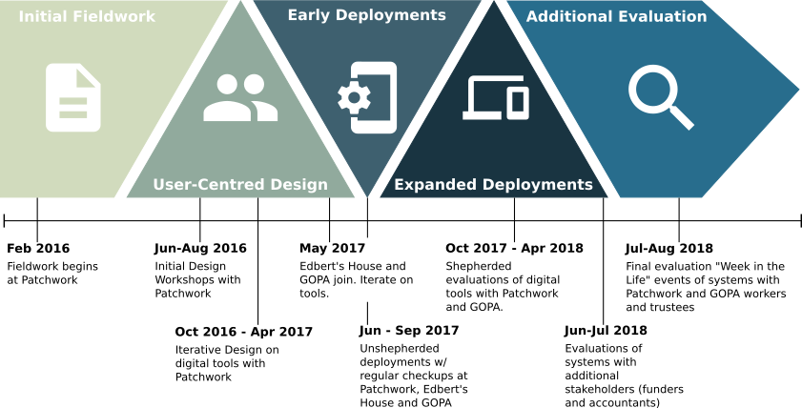
Figure 3.1: Timeline of Research
Phase 1: Initial Fieldwork ran from February 2016 to late summer of the same year at Patchwork. The purpose of this dedicated block of fieldwork was to orient myself to the work practices of the field-site. This initially involved looking explicitly at the different ways Transparency and Accountability manifested themselves as everyday practices through: characterising the performance of work related to Youth Work and management; and creating extra work from perceived or legal obligations for more formal forms of Transparency and Accountability. This phase of work started with weekly field visits to Patchwork, which overtime became either more frequent or less frequent as my schedule was intertwined with that of the organisation and different fieldwork methods were employed. Often I would visit several times a week in order to work on the accounts with the workers, volunteer, and take part in a team meeting. Sometimes, such as during the summer, I may not have visited during a given week. As noted, a variety of standard fieldwork methods were employed during this phase to develop praxeological accounts through techniques such as field notes, interviews, and participating in the work of the organisation itself. As the research progressed I became integrated into the daily life of the charity (and they became integrated into my daily life as a PhD student). The nature of my field notes thus shifted from “all-encompassing” to focused on specific phenomena, as I relied less on them to describe broadly how the workers at Patchwork organised their social world.
Phase 2: User-Centred Design (UCD) was the main characteristic of the next phase of research as focus evolved to investigating, designing, and implementing potential interventions. Fieldwork began to shift into UCD in late August 2016 with the completion of a design workshop focused around future technologies. In September the field visits took a short pause mandated by both Patchwork’s need to deliver the final part of their summer programme, and Open Lab’s need to deliver CHI papers. This afforded me the space to reflect on the findings of the fieldwork to date which resulted in the analysis presented in Chapter 3 of this thesis. The work’s rhythm resumed in October with design work consisting of early prototyping and regular design crits (Goldschmidt et al., 2010) worked into field visits and discussions and captured through field notes and requirements documents where appropriate. Design discussions maintained a vision of the larger system, but focused on different components in turn. October to December mostly focused on producing designs and implementations for a mobile application which became Accounting Scrapbook. After the winter break, development on what became Rosemary Accounts began and design was directed towards this away from Accounting Scrapbook. Throughout the whole process, discussions around the needs of the data and tools fed into the development of the Qualitative Accounting data standard, although it should be noted that Patchwork were much more interested in how the tools could produce and process information rather than standards development required for the design. This phase of research did not have a tangible drive by either myself or Patchwork to put our designs to use, simply develop them, whereas later stages of the research contained small pockets of iterative design and development while the tools were (supposedly) in use. In late April Patchwork and I were getting ready to begin phasing in use of the tools as additional partners were added to the research in the form of Community Project Gateshead and Older People’s Charity (GOPA) (both organisations have been pseudonymised for reporting, as they did not request de-anonymisation). Early discussions with these partners revealed new needs which were acted upon through some further design and implementation work and extended this phase of research until the end of May to account for their needs, improve the overall quality of the tools, and encourage their participation during deployments
Phase 3: Early Deployments lasted a total of four months from the beginning of June until the end of September. The deployments themselves were mostly unshepherded, in that I did not instruct the participants to use the tools in a particular manner other than providing technical support on their use when requested. At the outset of the early deployments all participants expressed their enthusiasm at using the tools they’d seen develop, so my intention was to try and understand how these tools could be appropriated by workers to support their existing work as it pertained to collecting and presenting information. I did “check in” on each of the participant organisations throughout the deployment, although the nature of these was different depending on my relationship to each one. “Checking in” on Patchwork was integrated into my visits there, where I could observe the use and non-use of the tools and casually chat or interview the workers as the deployment went on. As my relationship with GOPA and Community Project Gateshead was not as strongly developed; my regular visits had a distinctly more formal feeling. These were performed either bi-weekly or monthly depending on the schedules of myself and the workers there. Occasionally some lightweight design work was performed to fix a bug or tweak a feature to encourage or facilitate use. Despite this and for a variety of reasons this phase of the research did not see a lot of engagement from any participants regarding the deployed tools (even at Patchwork). This is analysed and reflected on in detail in the discussion in Chapter 06.
Phase 4: Expanded Deployments became necessary due to the poor uptake of the systems that had characterised the previous phase of the research. A year on from the original phase of design and development I renewed focus on making Accounting Scrapbook and Rosemary Accounts better integrate into the daily practices of my partners. Community Project Gateshead unfortunately withdrew from the research as the worker who had been my primary contact left the charity and, in lieu of the limited engagement so far, the organisation felt they couldn’t commit to maintaining our relationship. Patchwork and GOPA, however, agreed to commit to a more structured effort to use the technologies with a view of iteratively improving them as we continued the deployment. The deployments were characterised by being slow and requiring several different attempts to encourage engagement such as “weekly tasks” designed for participants to walk themselves through different features of the system which eventually became walkthrough sessions lead by myself. As such these structured deployments lasted a long time; from October 2017 until April 2018. It should be noted that the timescales for this phase of the research were extended due to the rise of mental health issues affecting my work during 2018. When both Patchwork and GOPA had completed the initial set of structured tasks I sought engagement from other actors within the sector such as funders and accountants. Several individuals were happy to give me their time and they assisted the evaluation of the tools by participating in interviews during the summer.
Phase 5: Additional Evaluation was performed in the final months of the research. This was, in my eyes, designed to compensate for what I perceived as a lack of proper engagement with the tools and to discuss with participants findings that had arisen during my conversations with funders and accountants. Through lessons learned from both earlier deployments, a short “challenge” was issued to participants to try and capture a “week in the life” of their organisation using the features of Accounting Scrapbook and Rosemary Accounts as much as possible. The engagement with this led, somewhat ironically, to the discovery of several technical issues in the systems which meant that the “week” turned into several weeks as progress was halted and began again several times. Following this dedicated use of the tools and reflection thereof through discussion, an exit interview was performed with each organisation to discuss the purpose and implementation of the research itself and the final state of our designs.

Description of Methods
This section outlines the practical methods which I utilised to undertake this research and describes their appropriateness both within the context of the Workplace Study tradition that my research continues and the analytical approaches that it takes.

Fieldwork Methods
As described earlier I desired to develop a Vulgar Competence of the setting in order to understand how its members account for and produce the social order (Garfinkel, 1967; Crabtree et al., 2012). To accomplish this I performed extensive fieldwork within Patchwork, the rough shape and duration of which I outlined in the previous section. I wish to describe now the specific tools and techniques I used during the performance of this fieldwork.
The foundation of my fieldwork was extensive site visits at Patchwork, initially performed weekly but then changing frequency as I grew more involved with the organisation and our work rhythm became intertwined. Similarly, the types of activities I participated in developed in scope. In ethnographic terminology my participation in these activities may be characterised as Active Participation (Schwartz & Schwartz, 1955). During site visits I would: visit and work on the allotment alongside staff and the beneficiaries of the project (ie young people); assist staff in producing the budget and accounts; producing an annual report; help plan and deliver activities for group sessions unless inappropriate; report to trustees; and many others too numerous to list specifically. As outlined by Crabtree et al in Doing Design Ethnography these activities served to develop my vulgar competence in the work of Patchwork but they also allowed me to gain acceptance in the setting (Crabtree et al., 2012). As I provided in input of labour through volunteering and assisting with preparatory work, and I demonstrated my commitment to seeing their work through their eyes, the workers at Patchwork began to see me as a member of the setting as well and this allowed me to have more frank and genuine discussions with them.
The extent of my participation at Patchwork allowed me to collect a variety of data and assemble a clear ethnographic record throughout. The tools and techniques I used here are standard to ethnographic enquiry, and should not need too much outlining. A lot of data was collected through the use of field notes and a fieldwork diary – which I populated with questions, observations, and diagrams to support my analysis (Crabtree et al., 2012, p.79) . An example of this is diagram of the Sequential Order of Work (ibid, p. 105) that I drafted in my notebook and then reproduced digitally for inclusion in Chapter 4. I was also able to perform individual or group interviews (ibid, p.80), which were useful to get an overview or to drill down into the work of something. In some cases these interviews were recorded whereas some of them were what I describe as “in-situ” ie they manifested as an in-the-moment questioning of a concept or some practical action being performed by someone there. Where not recorded these interviews were incorporated into my data corpus via my fieldwork diary. The fieldnotes and fieldwork diary, as well as interview transcripts, were used to create praxeological accounts of action and vignettes for presentation in this thesis and derived publications. These allowed for the conveyance of the local Accountability and situated action that were important both to the overall research and the design process that followed the initial fieldwork (ibid, pp. 122-130).
As the fieldwork process continued into the summer of 2016 discussions at Patchwork began to slowly and naturally turn to what design interventions may manifest as a result of the initial fieldwork I had performed. To support these conversations and create explicit room for them I also performed three “workshop” activities inspired by the concept of Futures Workshops (Jungk & Müllert, 1996). A Futures Workshop consists of three phases: critiquing the current state of the way things are done; a fantasy phase wherein participants come up with grand ideas to respond to problems; and finally an implementation phase where these fantasies are brought back towards the pragmatic in terms of what may be accomplished (ibid). As part of the research, these activities mark a transition from the purely investigative phase of fieldwork to one that was directly working with members of the setting to inform design, and therefore they may be conceptualised as an investigation into the social order of the setting and how technologies may support this work.
While Jungk describes a Futures workshop as a single workshop (ibid) the pragmatics of doing work with Patchwork necessitated that the three phases of the workshop were split across three months from June to September 2016. The reason for this is that Patchwork were delivering their Summer program during this time, which left no time for full day workshop. This change in pace allowed me to reflect on the conversation that was had during each workshop, as well as design materials and activities to be used as conversation pieces during the next one.
During the first workshop, the participants in Patchwork were guided in producing an artefact which mapped the flows of information and interactions with technologies. My questions and their answers served to check my understanding of their situated work that I had gathered from fieldwork to that point and also also to question things that were not clear to me yet. Hearing the workers at Patchwork reason out loud together about their work practice as a whole, rather than discrete portions of it, also helped illuminate the inter-connectivity of the setting’s interactional work.
In the second workshop, I produced a series of short Design Fictions (Hales, 2013) that were tailored to deliberately contrast or caricature the perceived values, behaviours, and norms of the setting and members. My intent here was to cause a reaction and make explicit the normal social order, and as such they may be considered as derived from Garfinkle’s “breaching experiments” – where the researcher disrupts the routine production of daily life in order to make this reasoning visible (Garfinkel, 1967). Crabtree writes of breaching experiments in technology design that they may be used to “provoke” (literally call forth) practice and that while they may be disruptive this is not necessarily the case (Crabtree, 2004). My Design Fictions were intended to be a little disruptive as I wished Patchwork to subsequently rally against the dystopian futures I detailed and instead proffer alternative designs that would be more closely aligned with their practice. In this sense they also touch on the notion of Provotypes; where a prototype is designed to provoke discussions around contemporary and desired future practice (Boer & Donovan, 2012). Provotypes also draw on Dialectics (outlined above) where the contradictions that give rise to practice are highlighted and then new practice may be considered; bridging investigation and design (ibid). While my samples of short Design Fiction may not be a true provotype (nothing was designed and deployed at this stage), they embodied this dialectical goal of assisting me in unpicking the contradictions in work practice and how this is made Transparent and Accountable; and ultimately lead to insights for design work. In the second half of this workshop Patchwork were asked to write their own design fiction and elaborate on what a theoretical pie-in-the-sky technology may look like although this didn’t occur on the day as planned (discussed further in Chapter 05).
The third and final workshop involved grounding the design insights from the first two workshops into what may achieved pragmatically. Because a month had passed since the previous workshop, a short design challenge was issued to the group to create Magic Machines (Andersen, 2013) that supported their organisation’s work in becoming Transparent and Accountable, and what the work practice was surrounding this. The results from these were then discussed as a group to unpick what desired work practice may be and how we may get closer to this given contemporary technologies and the scope of the research.

Design methods
One of the goals of this research was to actually design and subsequently deploy technologies for use within the setting to later evaluate them and another was to understand how technologies may be designed in Third Sector Organisations. As noted in the earlier overview this phase is characterised by User-Centred Design (UCD) methods.
My use of UCD methods emerged in response to the pragmatics of designing in the research space. Daily life at Patchwork was (and remains to this day) very busy and they have a pressing need to deliver their services to beneficiaries and respond to their needs. Therefore, despite the best will in the world, Patchwork has limited capacity to sit down with me and co-design systems in the name of participation. Indeed it became clear when the design phase of my research was starting that they had little interest in designing systems together as they felt that it was my role to do the design and implementation work. I discuss this in greater detail in Chapter 5.
My response to this challenge was to involve Patchwork as much as I could during the design process. Following the completion of the three workshops outlined above the data from these fed into the larger corpus garnered during fieldwork and analysed to produce high-level implications for design, as well as indications for specific design elements to incorporate for a deployment here. Attention was paid specifically to the interactional work of the design ie the workflow of systems designed were derived from Patchwork’s model of work, and then these assumptions were tested during this design and later evaluation phases both inside and outside of Patchwork. Inside of Patchwork my weekly field visits continued ahead of my volunteering sessions and deeper integration into the workplace such as attending extra-curricular activities with the workers (e.g. Fell walking, allotments, etc) meant that I was served plenty of opportunities to check my designs and assumptions with the workers there. The most used technique here was the use of the Design Crit (Goldschmidt et al., 2010); weekly I would present Patchwork with ideas, sketches, wireframes, prototypes etc and we would discuss the design. Key notes from these were recorded into my notebook or, occasionally, a requirements document. I would make changes or otherwise progress the design before returning the next week for more of the same.
It is that design rhythm and workflow that leads me to call this phase of work User-Centred Design as opposed to Participatory Design or Co-Design. The Scandinavian co-operative design movement arose out of the concern of workers having technologies negatively influence their working practices (Schuler & Namioka, 1993) which was certainly an initial concern shared by myself and Patchwork. It could be argued that there are elements of Participatory Design present in the research. The way that I participated and integrated myself into Patchwork, as well as my fieldwork’s analytical focus on work practice and my genuine concern for the workers and organisation meant that gradually their concerns became my concerns. Therefore it could be said I was facilitating worker’s design of technologies or that participation was somehow “configured” (Vines et al., 2013) in the research as I part of my work there was to design technologies for which which I systematically and enthusiastically sought feedback and approval on. I reflect on this more critically in Chapter 05
Nevertheless, I do question how truly participatory the act of design may be in this context, or indeed needs to be given the nature of the organisation. My feelings on this are expanded on later in the thesis, but the core value embedded in this research is to support the Third Sector through my research and technical skills. Patchwork didn’t expect me to become involved in everything in the business and in fact explicitly noted areas where it would be inappropriate and similarly felt that it was inappropriate to apply themselves to an area that was clearly my wheelhouse. As an (initially) external technical expert I fit the bill as someone who was suited to the design and implementation of digital technologies and for them the act of participation was that I was there and contributing at all.
Late in the UCD phase of research I expanded the scope to include involvement with two other organisations – Community Project Gateshead and Older People’s Charity (GOPA). I was introduced to Community Project Gateshead as they were visiting Open Lab due to a collaboration they had with another researcher there, and they seemed interested in my work. Since I desired to deploy the designs that Patchwork and I had worked on I followed up with a meeting to which they invited the manager of GOPA. Initially this meeting was to introduce them to the technologies and garner their interest in participating in evaluating them, however the discussion raised new needs that required addressing. I followed up with several design crits with Community Project Gateshead and GOPA to account for this and improve the overall quality of the tools. These iterations were fed back to and checked with Patchwork as well, although the organisations never showed interest in meeting together.

Evaluation Methods
After the design phase was complete the tools were deployed for evaluation in order to understand their appropriateness and to further illuminate the design space for future work. As described in an earlier section, the design phase involved instances of evaluation through the use of crit sessions with participants. After this, evaluation took place across three distinct phases where each had particular methods attached.
The first phase of evaluation began with early deployments that were, as noted, totally unshepherded and used observation and some small interviews to understand the worker’s interactions with the technology. After a short instructional session at each of the three participating organisations (Patchwork, Community Project Gateshead, and GOPA), the technologies were effectively “left” with my partners in that apps were installed on their phones and they knew of the existence of Rosemary accounts and had outlined to me a rough plan for their use. At Patchwork my regular visits across the week provided opportunities to witness use (and non-use) of the technology, and in addition to this I did small interviews in place of the design crits that we’d normally have. These lasted no longer than five minutes each and were not audio recorded – instead making their way to my fieldwork diary. I did not have similar levels of access to GOPA and Community Project Gateshead since I had not integrated myself in the same way as I did with Patchwork. In these cases I performed regular site visits at each organisation which varied from bi-weekly to monthly depending on our schedules. Here I did not get the chance to observe the technologies “in the wild”, as it were, but casually interviewed participants about how they were finding the technology. This also presented an opportunity for them to ask questions of me about the pragmatics of using the technology. Again these were not recorded in order to put participants at ease (they were often embarrassed about their non-use of the technology) but similarly integrated these findings through my fieldnotes.
The second phase of evaluation, which I’ve termed “Expanded Deployments”, was instigated after four months when it became apparent that there was poor uptake of the technology at all organisations – which I could only account for at Patchwork initially. After some wrangling of the remaining participants (Community Project Gateshead dropped out), I redesigned some elements of the technologies to make it a little smoother to integrate into daily life and we renewed a commitment to evaluate the technologies with a more structured evaluation. There was an understanding across the participants that the research here would be slower as I considered the daily pressures at the charities. The structure took the form of “weekly tasks” designed to walk participants through the use of various features of the system, with the intention of interviewing participants at monthly intervals after they’d completed three-to-four such tasks. After a few of these interviews revealed that, similar to previous attempts, there was similar lack of engagement I turned to the use of think-aloud co-operative evaluation methods (P. C. Wright & A. F. Monk, 1991a, 1991b) with audio-recorded in-situ interviews. These allowed me to sit with the participants and engage them while they used the system, as well as create explicit space for engaging with the systems within each Patchwork and GOPA.
During this phase of expanded deployments I also approached other participant groups that orbited around the sector as I desired their input on how useful the systems could be for their work. I interviewed several accountants and funders to gain first-impressions of the technologies and discuss future possibilities. These additional perspectives began to reveal what the “other side” of the interactions with the systems may look like given further consideration and development.
To tie off the evaluation a last “week in the life” deployment was performed. This used a similar unshepherded deployment method as used in the first phase, with the understanding that since workers were now familiar with the system and only had to commit to a week’s use that uptake would be more natural. There were a few technical issues which ended up restarting the deployment multiple times, however this was largely a success. During this week in the life of I didn’t perform any observations but instead interviewed individual participants about the system at the end of the evaluation. Finally, I performed two group interviews; one with each Patchwork and GOPA after the culmination of the research. We discussed the original aims of the research and reflected on its performance and challenges, as well as what future work in the space may look like. This was audio-recorded and transcribed.

Research Ethics
The research presented in this thesis involved the study of human activity through the methods outlined above. This requires some reflection on research ethics within the context of this project. In this section I first present the formal ethical approval process I underwent at Newcastle University, and then explicate on issues such as measures taken at field sites to ensure the safety of my participants and informants as well my own safety.

The ethics approval process
This research was concerned with how organisations made themselves transparent and accountable to their stakeholders and as such the ethical approval process for this research was relatively straightforward, owing to the nature of the questions I was asking and who my desired informants were to be i.e. the workers and administrative staff within charities, and some of their stakeholders.
The ethical approval for this research was completed in three stages, at the beginning of each calendar year and intended to cover the research activities for that year. This roughly correllated to getting permission for: fieldwork activity and use of questionnaires with partner organisations; design workshops and design activity with partner organisations; and the evaluation of deployed designs with partner organisations. Since I was not studying children or animals in any way, or people who would be vulnerable, this did not require a particularly strenuous ethics approval process. Newcastle University provides an online form (Newcastle University, 2021) which I used for the ethicals approval and to flag high risk areas during the initial application.
The only high risk area that I was required to highlight was that the research involved the use of Human Participants in a Non-Clinical Setting through use of some of the research methods I was to employ (observations, focus groups, etc). This section expanded to provide a checklist of areas that Newcastle University considered high risk activities. None of these areas were applicable to myself, as I didn’t require access to vulnerable groups and would be working and studying the staff within the organisations I partnered with.
When I later began volunteering at Patchwork, a frontline youth-work charity which is discussed in detail within Chapter 4, they requested that I begin volunteering with them. This was for two reasons: first, it would give me first-hand experience of the daily work of the setting and increase the face-time I spent with the staff; and secondly, volunteering would ensure that I was contributing back to the organisation and not simply “using” Patchwork as an interesting case study for resarch. I readily agreed to this but was concerned that this would invalidate my original ethics approval since the volunteering put me in direct contact with young people aged 8 and above.
I discussed this with my supervisor the next day who assured me that as long as Patchwork had some safety procedures in place, and that I didn’t generate any research material from the young people I was involved with, that the original framing of my ethics approval wouldn’t change. This was because the staff at Patchwork (and Patchwork itself) remained my focus of study, and I wasn’t going to be interviewing any of the young people (neither were Patchwork acting as a gatekeeper). This decision was sense-checked with other PhD supervisors at the time who agreed that as long as Patchwork had safety measures in place, that it was fine to rely on these as efficient safeguards. I discuss these safeguards in greather depths in the next section.

Keeping everyone safe in action
This section explicates the ways in which the everyday performance of the research maintained the safety of both participants and researchers, and ensured the consent of all participants at each stage of the research. I first discuss broad practices that apply to all participants, research partners, and settings. Then, given the extended and deep nature of my involvement with Patchwork in the research (and given the nature of their work with young people), I focus on the safety measures taken within this context.
Throughout the entire research process there were several key measures that were undertaken in order to ensure the safety and informed consent of all participants. Participants were presented with consent forms and information sheets for each activity of the research. This included getting explicit consent for: fieldwork; design activity; group interviews (where members of the group hadn’t already signed a consent form); individual interviews for partners involved at later stages of the research; and evaluation of the designs produced. All participants were anonymised (via pseudonyms) for reporting in the research, although several members of The Patchwork Project requested to be de-anonymised for reporting in this thesis and subsequent research materials.
As noted in the previous section; one of my key research partners, The Patchwork Project (Patchwork), requested that I begin volunteering with them in order to ensure that I was contributing back to the organisation as I studied them. This placed me in direct contact with young people and as such I was concerned about the ethics of this. As noted, it was discussed with my supervisory team and other academics with Open Lab at the time and found to be no ethical issue as long as I did not study the young people and conducted myself appropriately and under the assumption that Patchwork would put safety measures in place. Patchwork made me undertake a “DBS Check” via the Disclosure and Barring Service in the UK, which involves checking my criminal record to ensure that I was suitable for working with children (UK Government, 2021). This is something that Patchwork require of all staff, volunteers, and trustees as part of working within Patchwork. It is expected that these are refreshed regularly, with Patchwork requiring a minimum of 4 years between checks. As well as the DBS check I was required to undertake an accredited child safeguarding course and attain a certificate in Awareness of Child Abuse and Neglect (Virtual College, 2021). Again, this is something that Patchwork require of all staff, volunteers, and trustees and is generally renewed at the same time as the DBS check. Further to this, both myself and Patchwork undertook mundane good practice measures to ensure the safety of myself and the young people. I was always one of multiple staff or volunteers present when engaging with young people, and Patchwork took measures to ensure I did not participate in groups with particular demographics that may be perceived to be inappropriate for me. For example, as a large male researcher in my 20s it was simply understood as part of best practice that I would not be engaging in group activities with teenage women and girls.
In terms of risks to myself, there were no considerable risks that arose through the direct performance of my research activities. The majority of my field sites were within the organisational offices or buildings. On paper there were tangenital risks associated with the geographic location of my main research partners (The Patchwork Project) due to the socio-economic status of their local area and their service users. There were no incidents during my research there that made me concerned for my safety or the safety of others. Unfortunately, I did need to log one safety incident during the later stages of my PhD work. One day I was returning from a fieldwork site via taxi / hire car and was subject to unwanted sexual advances by the driver at the conclusion of my ride. I reported the incident around two weeks after it occurred and it was dealt with swiftly by the Open Lab staff and I took further measures to ensure that it did not repeat and that I was safe.

Personal reflections on ethics in this research
This section contains my personal reflections on the ethics of performing this research. Further critical reflections are given in Chapter 7 regarding responsibilities of ‘Ethical Responsiveness’ (Durrant & Kirk, 2018) when discussing the contributions of this thesis. Some of these themes are also discussed in more detail in Chapter 5 when discussing the performance of the design work, particularly around the role of the fieldworker in the setting and group (Fuller, 1999).
It is safe to say that my involvement with Patchwork, my primary research partners has grown beyond that of a formal research arrangement. My relationship with the team there and the organisation itself continues to this day in both formal and social capacities, well beyond the conclusion of the research contained in this thesis. Since 2018, I have continued in my capacity as a Trustee of the organisation and regularly see the staff for social events. During my research, though, I increasingly conceived of myself as holding a dual-role as both a member of Patchwork and being that of a research student. This presented itself as dilemmas between feeling that I was “Going Native” (Fuller, 1999; Kanuha, 2000) at times when I was engaged in social activities that felt distinctly “extra-curricular” in nature.
Joseph and Donnelly report on engaging in drinking activities as part of engaging in the group, contrasting the notion that the academics in the field should only be conceived of as “sober data collectors” (Joseph & Donnelly, 2012), and note that when participation in these activities diminish their informants are often less happy to speak with them. Their conclusions are that researchers should feel open to discussing activities such as drinking “on the job” (Joseph & Donnelly, 2012) as a normal part of the research setting and provide practical advice for verifying findings that were initially made during social drinking sessions. I do not drink alcohol so I didn’t get drunk with my participants; however I fully immersed myself, to the degree that I could, in the social calendar of Patchwork. This often involved evenings, weekends, and even holidays with the staff as if I was one of their own. This resulted in many “adventures” arising from fieldwork which Liebling and Stanko note are the type of fare that traditionally remains private or exchanged behind closed doors rather than published in an ethnographic account (Liebling & Stanko, 2001). For my part; the focused nature of my inquiry meant that there was often a clear delineation between “research activity” and “social activity”, and so these sessions mostly served me with opportunities to ingratiate myself into the group and get to know my research partners so that I could better understand them later. There were, however, cases where this line was blurred such as when I was climbing mountains with Patchwork in southern Spain. This was ostensibly staff training and socialising for Patchwork staff; however, when walking across a ridge there, conversation naturally turned to the progression of my research and the design of the applications we were building. This echoes Goodwin’s realisation that they were “capitalizing on [their] insider status” (Goodwin et al., 2003, p.571) and I was worried that I was exploiting the trust of my partners in this relaxed setting. As my engagement with Patchwork continued, however, this worry was alleviated as they made it clear to me that they were keenly aware of my original purpose in the organisation but had participated to the point where I was conceived as one of them; and that research and design was part of my role there. This is elaborated on in Chapter 5.
There were several times, however, during my research that Patchwork reported to me that academics (particularly my research institution within Newcastle University) held a poor reputation in the charity sector in Newcastle. This was, reportedly, because they were perceived to: swoop in; promise resources and technologies that the organisation badly needed; not bother to engage the workers or service users properly enough to understand their issues; and leave once their papers or research had concluded. This meant that there were several times where I felt the need to “defend” or otherwise gatekeep my research partners from other researchers and academics to prevent these practices occurring, and to ensure Patchwork did not think I would “open the door” to more researchers looking to exploit the setting. There were also other times when the economic divide between my research institution and my charity partners became all too apparent: such as when Patchwork asked about what financial resources I had available to me at the University, and whether it was conceivable that a grant be made to them for their participation in the research. These issues were raised and discussed in a workshop that myself and some colleagues ran at CHI 2018 entitled “Untold Stories” (Strohmayer et al., 2018) wherein we reflected critically on the academy’s relationship with charity partners. It was conversations such as these, as well as reflections on design practice, which lead me down the path of conceiving of ‘Vanguard Design’ as discussed in Chapter 5 and Chapter 7, to address the fact that researchers can often have the ability to capitalise on their insider status (Goodwin et al., 2003) and to try and tilt the balance back in favour of more equal participation and being answerable to my participants (Durrant & Kirk, 2018).

Summary
This chapter has discussed the framing, analytical inheritance, and methods used to perform the research in this thesis. I began with establishing the thesis as situated in the tradition of a Workplace Study in HCI and design, before illuminating the analytical traditions that result from this tradition as well as the research space.
With this instituted I then mark out the practical performance of the research. First I outline the timeline of research and set out phases inquiry that gave rise to the use of particular methods. Next I discuss in detail the methods used for fieldwork, design, and analysis of data before finally providing a summary of the research ethics involved in this research including critical reflections on some issues I encountered.
As I have now provided a scrutiny of the investigative traditions and practical applications of these in the research this thesis will now provide a detailed account of the first phase of this; a fieldwork case study of work practice.

Understanding Accountability Work

Introduction
This chapter concerns the first phase of the research, which consisted primarily of a long period of ethnographic fieldwork with an orientation to work practice (Crabtree et al., 2012) and the labour required to produce Accountability as part of everyday work in a small charity.
This first phase of research benefited the overall process in a number of ways. First, the ethnographic method and orientation to work practice allowed me as the researcher to develop a degree of Vulgar Competence in the processes and on-the-ground work that any technological intervention would need to be based around, and support. As such, the design requirements discussed at the end of this chapter are the result of analysing actual work practices of the organisation. Additionally, the length of the initial fieldwork period discussed in this chapter illustrated to me a wider, much more complete, picture of the charity ecosystem; who the various actors are, and the various forms of accountable practice that a charity and its workers must employ to navigate this. Finally, I believe the initial period of fieldwork with my frequent visits and the work I performed as part of it lead to buy-in from the charity when it came to discussing, designing, and implementing technologies together at later stages of the research.
As such this chapter discusses the work practices of a small charity as they intersect with producing Transparency and Accountability. Attention is paid to the different forms of work that the charity undertook and in what forms these were accounted for to others. These are then analysed to produce high-level design requirements which influenced the later design of technologies which were deployed into this space.

Participants and Setting: The Patchwork Project
This research began in earnest with my reaching out to a Youth Work charity known as The Patchwork Project (hereafter Patchwork or sometimes referred to as “Patchy” by locals and workers). I had briefly met two of the workers during some previous research that was performed during my MRes (Marshall et al., 2016) and their contribution left a substantial impression on me due to their interest in my research and what I perceived of as a very reflective discussion of their work. I was keen to work with them again and, thankfully, after a meeting with them over lunch they agreed to let me engage with them through fieldwork.
Patchwork are a small, hyper-local, charity and their work is inherently tailored to the needs of their immediate community. Since these needs shape the work and thus everyday work practice I feel that discussing work practice without providing a brief overview of the organisation and setting would provide an incomplete picture. Therefore I wish to briefly discuss the history of Patchwork and the community of Benwell.
In 1994, The Independent included Benwell, Scotswood, and Elswick together in its list entitled “No-Go Britain: Where, what, why”. The reasons they cited were “Crime, arson used to intimidate witnesses, feuds between rival families involved in drug dealing” as well as citing unemployment statistics of 24%, 28%, and 26% for the three areas respectively (The Independant, 1994). Colloquially, the area is seen as abandoned by the city council, and owes its reputation to the conditions that arise from lack of adequate services and funding.
Interviews with the staff revealed that The Patchwork Project began life as one of several projects originally operating under the banner of the Benwell Young Person’s Development Group (BYPDG). The group formed in 2001 (Find that Charity, n.d.a; The Patchwork Project, 2016) as an informal umbrella group to support the young people of the Benwell and Scotswood area of Newcastle, which was experiencing a withdrawal of local authority funding and feeling the effects of the resultant lack of service provision. Initially the group was very disparate and the various arms operated independently from each other, with residents providing community transport, toddler and infant care, Scouting troupes, and a football club as well as the youth work. The Patchwork Project began life with residents taking groups of children out for activities such as site visits and days at the local pool. The project manager described the efforts as “Very amateurish. It was great.”. According to the informant, the group was later formally constituted as a charity in order to “access funding and structure” although “only Patchwork was its responsibility. The rest of the activities were mostly just doing their own thing. The charity was started to support Patchwork”
The project manager describes how the success of the project lead to the entirety of the BYPDG becoming known by that name, and eventually the other activities either split off into their own local charities (e.g. the football club) or wound down due to the community members who drove the efforts retiring. Some elements of other activities were taken up by Patchwork such as the toddler group, but lack of available volunteers lead to this winding down as well. Michael stated that Patchwork continued to operate by itself within the structure of the BYPDG as a project but registered as its own charity in 2014 and taking over from where the previous organisational structure left off (Find that Charity, n.d.b) and also registered as a Company Limited by Guarantee in order to “protect the trustees in the era of risk assessments and individual responsibility”.
Patchwork’s stated aims of the charity on both their website (The Patchwork Project, 2021a) and the Charity Commission (Charity Commission for England and Wales, 2021) are as follows:
To help and educate young people between the ages of 5 and 25 years resident in the West End of Newcastle Upon Tyne and the surrounding area, including those who are involved in the Criminal Justice System or at risk of becoming involved in the Criminal Justice System, without distinction of sex, sexual orientation, race or political, religious or other opinion, through their leisure time activities so to develop their physical, mental and spiritual capacities that they might grow to full maturity as Individuals and members of society and so that their conditions of life may be improved. (The Patchwork Project, 2021a)
The organisation also specify a discrete set of needs that they seek to address with their daily activity on their website:
- The need of access to social and informal education so that social inclusion, citizenship and opportunities to contribute to the community are improved. In order to increase individual and social well-being.
- The need of support in relation to confidence and personal belief in order to access mainstream services; employment, training, health and dental services, social and policing services etc.
- The need to access leisure time play and positive activities that improve understanding of boundaries, rights and responsibilities,
- The need to have these things accessible locally
- These needs are exasperated by those participating living in areas of high deprivation and attending limitations on family and individual opportunity. (The Patchwork Project, n.d.)
In-keeping with this I saw that the primary service users of Patchwork were constituted of people aged around 8 to 25 although it must be acknowledged that Patchwork will also offer support to individuals outside of this range if they feel it will support a young person. A consistent example of this that I witnessed often was a member of staff supporting a parent or family member of a service user with activities such as applying for unemployment benefits or identifying documents (ie driving license, birth certificate, passport). Patchwork’s service users typically come from the immediate surrounding areas of Benwell, Scotswood, and Elswick although families often move around and occasionally a young person will move to other areas of the city but still travel to Patchwork for sessions. A large number of the service users and their families are from Eastern European ethnic and racial background since the local area houses a number of immigrant families; primarily Czech, Slovak, and Roma although I often witnessed arguments amongst the young people I worked with as to where these cultural distinctions were drawn. The other large group that makes up the bulk of the service users is White British and there are also a few families from the Bangladeshi and African diasporas in the area. Michael, the manager at Patchwork, affectionately introduced their core demographic to me as “Slovak, Bangladeshi, and White Scum – as perceived by the government anyway!”.
The way Patchwork engage with their service users is often very bespoke to a given circumstance and they will tailor support to a person or family as required. However they build the relationships with people through three core modalities: drop-in sessions; working with discrete groups; and “detached” work which involves operating without the use of a building. This set of approaches ensures that they may reach new people and build longitudinal relationships with young people across time. Drop-in sessions are generally held from the morning to afternoon as the project opens and group work will begin in the late afternoon and early evening as the schools empty and young people return home (or gather in the street). Groups are given a particular time slot (e.g. Wednesday evenings) and sessions are generally expected to last until around 19:00 or 19:30 in the evening. Detached work does not occur every night but often takes place around once or twice a week depending on priorities of the workers on a given week and generally lasts a lot longer, often going until around 21:30 at night. During the school holidays the regular schedule is suspended and Patchwork will engage with the groups to construct a schedule of full-day or half-day activities across the break which limits detached and drop-in time.
There are a number of activities through which Patchwork will work with groups and individuals. Groups will often go out for bike rides, climbing walls, visits to locations, cook outside in the park, do crafts, or go swimming (among a whole host of other things). Further to a regular cadence of activities a group or individual might be encouraged onto and supported through a Duke of Edinburgh award (The Duke of Edinburgh Award, 2021), or another programme through Patchwork. This will often involve workers taking weekends to take young people hiking or camping, and teaching orienteering sessions in Patchwork 1 on a group’s scheduled session. Patchwork will pay extra attention to young people who are either in more explicit need or more engaged. An example of this I witnessed was Patchwork hiring some young people to work as gardeners at their allotment (Figure 4.1) in order to spend more time with them and to teach them the value of applying themselves. Another important aspect of Patchwork’s work is to support individuals and families who are currently within the criminal justice system. This involves prison visits, transporting people for court dates, providing formal wear, and other forms of bespoke support.
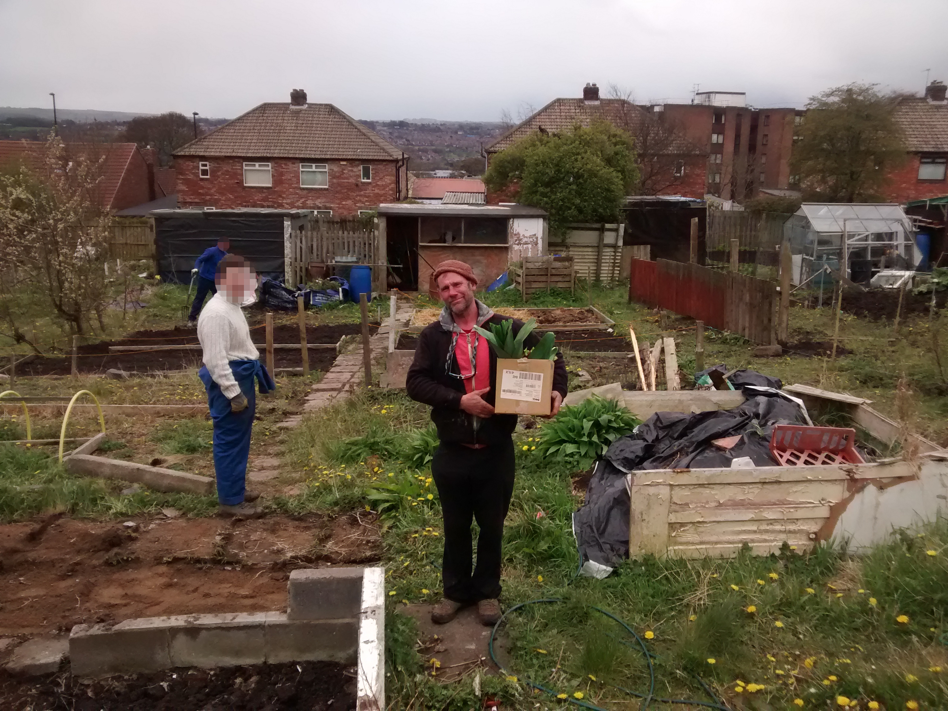
Figure 4.1: The project manager (Michael / Mick) at the Patchwork allotment with hired young people
The service users of Patchwork are generally very consistent in their presence within the context of Youth Work. I am sure any Youth Worker will have the scars of trying to wrangle disaffected young people into a form of schedule and I saw that Patchwork was no different in this. I worked with the 8–12 year old mixed group for several years and there was always a combination of: people who turned up every week; those who only popped through when they could; and those who would disappear for months and reappear later. Young people often attracted their friends to the group and when cliques formed sometimes this would prevent some people from attending regularly. This is exemplary of other Patchwork engagements that I saw. Older service users would sometimes visit every day during drop-ins; sometimes for direct support, to use the computers, or just to be around Patchwork for a chat (and sometimes just to get a free hot drink!). This also translates to the various groups that Patchwork work with; sometimes a group starts off very strong and then stops coming to Patchwork seemingly randomly which causes irritation on the part of the workers. Often the groups reappear for a variety of reasons, but most commonly because they want to take part in the summer programme.
This is to say that the work of Patchwork is exactly what one would expect of a hyper-local charity working directly with young people in a community that is generally seen as alienated. It is myriad, ever-evolving, and bespoke to circumstance. Having illustrated this I will now to elaborate on the people at Patchwork and the organisation structure.

People and Organisation Structure
This chapter discusses the initial fieldwork that was performed from February 2016 to around June or August that same year; wherein it transitioned into a phase of design work as noted in Chapter 3. This is important because the findings in this chapter use quotes from, and observations of, people who no longer work at Patchwork. My research with Patchwork continued until late 2018 and during this time period there were several changes in staff at Patchwork as some workers left and others joined. Further to this my involvement with Patchwork did not end with the completion of this research and they have remained an important part of my life. This involvement has meant that I have witnessed further updates to the roster which I will note at appropriate times.
During this period of initial fieldwork Patchwork consisted of three full-time and four part-time staff. With the exception of “Ludek” and “Charlene” who I have pseudonymised for reporting; all of the names reported are de-anonymised. This was done on request of the workers who wished their story be told as accurately as possible in the name of Transparency. Ludek and Charlene had left the project by the time this request was given and so I’ve not revealed their names.
Andi is the full-time Senior Youth Worker at the project. Her duties at the project involve designing front-end service delivery but also searching for funding via grant applications. She is one of two people whose money is used for purchasing and thus may claim expenses, alongside Michael.
Charlene performed administration duties when I first arrived at Patchwork, although she was never explicitly referred to as an “Administrator”. Her duties included producing the budget and working on the spreadsheets alongside Michael, as well as ensuring all members of staff were paid and expenses claimed properly. She left Patchwork shortly after my fieldwork began in May 2016 to take up a full time position at another organisation.
Dean was a full-time Youth Worker at the project. Hailing from Benwell himself Dean first attended Patchwork as a service user before being hired by the project as a worker. As all workers are involved in planning and delivering activities to young people, Dean performed these duties alongside Andi and Mick; but took a special interest in organising trips for young people. Throughout my fieldwork, Dean also took part in submitting funding applications. In 2019 Dean submitted a resignation to Patchwork due to personal circumstances.
Ludek was a part-time Youth Worker at the project. He was originally involved in the project as a service user; being a member of the Slovak and Romani community that live in the West End of Newcastle. Ludek’s participation in Patchwork appeared to be sporadic and he often did not show up for work, leading to the organisation dismissing him during this initial fieldwork period.
Lynne is the project’s current administrator and took over from Charlene around May 2016. During the period this chapter reports on she worked two days a week at Patchwork (Monday and Tuesday), and worked the rest of the week at another project in the same area (West End Women and Girls). When she came aboard Mick mentioned to the group in a meeting that “It’s quite exciting because the Project hasn’t had a proper Administrator before”. Lynne has since increased her hours at Patchwork and works the majority of the week there.
Michael (Mike / Mick) is the full-time Manager at Patchwork. Hailing from Sunderland he has been involved in delivering Youth Work for many years, and came to Patchwork as a manager in 2005. As a manager and a youth worker himself Mick is involved in front-end service delivery as well as administration and management duties. He writes the majority of the funding applications, and is one of two people who work on the budgeting and accounting (alongside Charlene/Lynne), and also is one of two people who may claim expenses alongside Andi.
Sonia was a part-time Youth Worker at the project. She originally interacted with the project as a service user and, similar to Dean, became involved in delivery. She was the volunteer co-coordinator for the project during my time there and in 2018 moved to a full-time position. A focus of her work was supporting young women and girls and she also headed activities at the play centre. At he end of 2019, Sonia also resigned from Patchwork to seek opportunities elsewhere.
Sydney (Syd) is Andi’s dog but is often conceptualised as a worker in conversation, and is frequently positioned in the front of The Project and as such often interacts with service users and community members.
Throughout the extent of my research at Patchwork across 2016 - 2018 I also worked with a number of volunteers from the community who are too numerous to recount in full. However in 2019 Karl and Owen, two consistent volunteers and service users, began full and part time positions respectively as trainee Youth Workers on a trajectory similar to that of Dean’s.
Structurally the charity is, like all in the UK, governed by a board of trustees. There have been a number of trustees over the years and during this initial period of research my contact with them was limited. Later stages of the research involved the trustees more directly (for evaluation) and these participants will be noted then. A current list of trustees (including myself) is available at Patchwork’s website (The Patchwork Project, 2016). I also provide in Figure 4.2 a diagram of the organisation structure as conceived of by the workers, taken from a drawing hosted on their website (The Patchwork Project, 2017) (note: hyperlink goes to a .doc file).
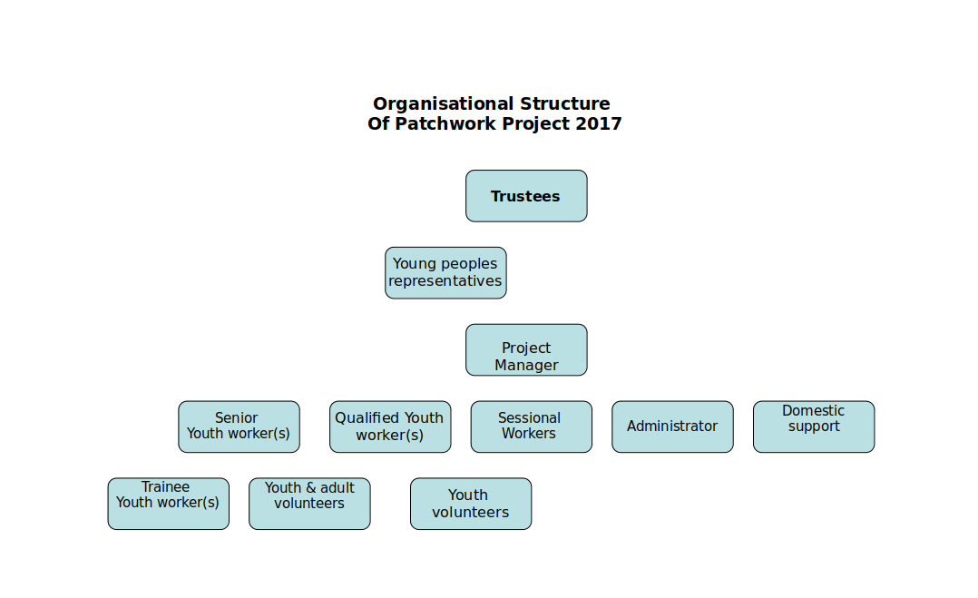
Figure 4.2 A diagram of Patchwork’s organisational structure. Produced in 2017 and taken from their website in 2020
When this work began Patchwork operated on an annual financial turnover of approximately £130k and out of a single site situated on the main Benwell high street. The site serves as a community hub and central offices and is often referred to by several names including “Patchy”, “The Project”, and more recently “Patchy 1” by both staff and community members.
Soon after I began fieldwork with Patchwork they received a large grant (discussed in greater detail later in the chapter) and opened a second site nearby. This site was once the old community play centre which Patchwork received from Newcastle Council by way of Community Asset Transfer (My Community, 2020) in early 2016 and is designed for young people’s play. Patchwork use this as a mutifunctional space for activities such as: young people’s play (primarily for groups aged 8–12 years); public events such as activity days; rented use such as by local religious groups (providing a stream of income for the charity); and storage for equipment that Patchwork use for other activities such as camping and cycling. The play centre is referred to as either “The Play Centre”, “Patchwork 2”, or “Patchy 2” in conversation. During the time of this fieldwork Patchwork also maintained an allotment at the Benwell allotments site although this has since been given up and turned over to others as the Play Centre has a patch which is suitable for growing vegetables.
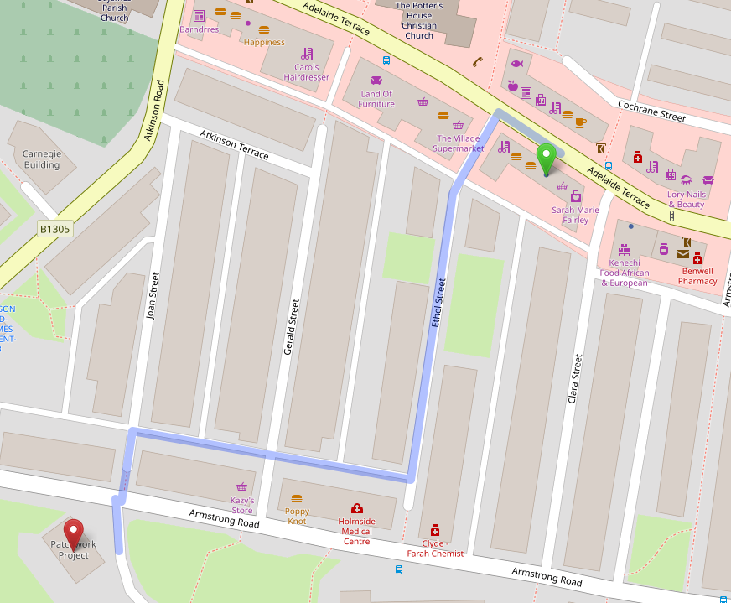
Figure 4.3 Map showing locations of Patchwork 1 (green) and Patchwork 2 (red) and walking route between them

Gaining Access, Integrating, and Research Activities
The fieldwork reported on here was conducted over seven months with Patchwork, beginning in February 2016. As noted in Chapter 02 this fieldwork and data collection were ethnographic in nature (Crabtree et al., 2012) and formed of participatory-observation activities at the charity. I involved myself in a very wide variety of activities at the organisation, including shadowing workers during their day-to-day duties, assisting with accounts preparation, and performing volunteering duties on a weekly basis.
Initially, fieldwork consisted of weekly meetings timed to coincide with Charlene’s shifts (on a Thursday) so that I could assist in administration and budgeting work. After three weeks I expanded this fieldwork to include participation in Patchwork’s work as a volunteer youth worker on Monday nights, and in addition to this would involve myself during the week – travelling to Patchwork and taking part in their activities during the day. These activities could be quite varied across the week and could consist of; planning and organising activities (including purchasing and budgeting); creating monitoring materials such as questionnaires; being involved in strategy meetings with partners; visiting the allotment and digging up food for preparation; responding to needs of service users as they wander in; visiting or hosting academics to discuss broader implications of their work; or writing funding applications.
I also partook in a lot of activities with the organisation outside of their immediate work duties; such as Fell Walking or climbing cliffs in Spain (and hosting Syd on a number of occasions while Andy was on holiday). Participation in these activities integrated me into the organisation not only by increasing my face-time with the workers, but demonstrating that I saw myself as becoming part of their community rather than an outside researcher. This in part has to do with how these activities straddle the workers’ personal and professional lives; this will be discussed in full later in this chapter.
Initially I relied on taking comprehensive field notes during visits, where possible. There were several instances where I was mocked (albeit lovingly) for having my notebook out, and others where the activity (such as digging) had to be reflected upon after the fact when I returned home. Later, when I become more confident, I began to ask workers for clarification on their tasks and purpose in the moment. I conceive of these moments as ‘in-situ’ interviews; and although they were not audio-recorded, they were integrated into my data through inclusion in field notes. As noted in Chapter 03 all of these activities produced my vulgar competence of Patchwork’s work and supported my integration into the organisation.
Following this period my integration with Patchwork increased and I eventually became a trustee of the organisation. However this chapter reports on work performed prior to that.

How do Patchwork account for their work and spending?
These accounts focus on how members of the setting achieve their goals through interactional work and are grouped based on the activities they relate to: Accounts of Spending; Accounts of Activities; and Accounts of Hidden Work.

Accounting for Spending
I describe here how the charity spends money, and what is involved in producing the accounts required by legal processes. Spending occurs in two ways: core organisational costs (salaries, building rental, etc.); and spending which is based in the activities of a given working day. These each have distinct mechanisms through which money is spent, and accounted for.

Everyday Spending
Everyday spending is made accountable internally by funnelling spend through two senior staff members. Charlene, the charity’s part-time administrator, described this:
Charlene: “The staff get paid back through expenses, and only Mick and Andi are allowed to make expenses claims which they’ll make generally when they notice their bank accounts are getting low”.
Charlene’s comment says two things. The first is that two senior workers, Mick and Andi, are the only ones allowed to make expenses claims for purchases. This allows them to ensure that all claims are deemed appropriate since they may monitor purchases and remove the possibility of abuse by other staff members. Their personal practices are also indicated by Charlene – they only make claims when they “notice their bank accounts are getting low”. That this is possible to do also indicates the practice of storing transaction records for compilation and reimbursement. While this may initially seem restrictive, I observed practices involving the devolution of purchasing work to other staff members, allowing multiple workers to make necessary purchases. I saw that this devolution of responsibility could occur in two ways. Below is a vignette describing each of these, which details events that occurred across two days of fieldwork:
Whilst helping prepare for a ‘Community Activity Day’, Sonia and I were tasked with producing a grocery list for the BBQ. While walking to the store we were approached on the side of the road by Mick in the minibus. He asks us if we’re “off to buy food?”. Sonia affirms and Mick replies “Here, take this” handing her his bank card, “Do you know the PIN?”. Sonia nods and Mick chuckles, saying “Aye. Half of Benwell know that PIN now” and driving off. When shopping, we explicitly choose the cheapest possible store-brand products. I ask about this and she tells me “We can’t be seen to be buying brands really”. We use Mick’s card to pay and later, Mick returns around an hour later and retrieves his card and the receipt of purchase from Sonia, checking over it briefly before putting it in his wallet. The next day, I was walking to the Play Centre when Mick pulled up in the minibus heading in the opposite direction at speed. He stops only to hand me 20 and tells me “We need toilet roll for the Play Centre. Go get some from Specials’ [convenience store] across the road, the cheap pack at the back of the shop”. After making the purchase I head to the Play Centre which is already full of activity. I find Andi and hand her the money, which she takes and asks me for a receipt. She stores the receipt together with Mick’s cash in her back pocket.
This illustrates how spending is funnelled through the senior staff whilst still allowing the organisation to distribute the labour of purchasing by devolving responsibility. Sonia is handed Mick’s debit card so that it is his money that is spent, and this acts as a buffer between the member of staff and the organisation’s finances. This buffer is also present when Mick hands cash to me so that they can participate in spending. There is also both evidence of an immediate internal checking process and an awareness of wider notions of being responsible with spending. Mick checks the receipt that Sonia presents to ensure appropriateness, and Sonia does not wish to be “seen to be buying brands”. Sonia may have to justify purchases if called upon by Mick, and in context of the charity’s overall budget – this is due to the perceived appropriateness of a spend. This is also seen when Mick explicitly provides me with instructions to purchase the “the big cheap pack” of toilet roll. This accounting to me also provides them a way of making sense of the organisational values at Patchwork. The activity of going and purchasing some toilet roll is the kind of work a new member of staff would perform when getting used to the organisation; Mick informing me of the purchasing requirements without prompting may be understood as an act of training where the end result is a member of staff (or the community) who implicitly understands that “the big cheap pack” of toilet roll is the best choice (and why). Overall, these internal measures show that the organisation may attest to being responsible with money when able to present context but this is unaccounted for via formal means.

Staff Salaries
In meetings with Charlene during fieldwork, I discussed with her how staff are salaried at Patchwork:
Charlene: “Dean and Andi get paid full time, I get paid part-time. Mick works full-time but he’s only paid part-time.”
Charlene lists several of the staff and their pay-schemes, but noticeably says here that Mick is working full time but only paid for part of his work, indicating that his salary is variable even though his role is central to the organisation. During a subsequent fieldwork session, Mick elaborated on this:
“It’s what’s best for …I don’t care how much I get paid, and it’s money that I have to end up looking for. I put salaries down for the last few years, and it took a while to put Dean up to £20K when he started because of money. With the Big Lottery Fund coming in now we can start thinking about putting the salaries back to normal.”
Mick’s discussion of the staff accepting lower pay provides insight into the values of the organisation. The staff are dedicated to the organisation’s work, and are aware of their impact on its finances; accepting lower pay in order to “keep things going”. Where Mick discusses having to look for the money to pay staff, he also touches upon how raising pay creates an increase in labour as he is required to expend effort sourcing funds to make up the difference. Further into fieldwork, Mick provides additional insight into this during discussion about staff salaries and standard pay increases amid the adjustment:
Mick: “We’re putting salaries up which is a big relief for everyone. I’ll be on £30K, but not really because that means more tax so you have to judge it carefully. Because of the tax brackets, past a certain point it makes no sense to give me a pay increase because of how much it’ll cost. An extra hundred to me per week will be several thousand a year to the charity which I have to find and justify finding. This way everyone still sees their pay increase, including me, but I’m not too worried about finding the extra cash. It’s still the least you’ll ever see another project manager get paid round here though. Some larger organisations have six or seven heads on about £100K; nearly a million you need before you even get anything done.”
This emphasises Mick’s awareness of how staff salaries impact the organisation; he is willing to keep his salary lower than that of comparable positions in the area (“round here”) and demonstrates that he would need to justify to others a pay increase that required searching for a disproportionate amount of further funding. Mick also mentions how the staff will be relieved that the salaries are being brought in line with standard pay rises; illustrating that the salary cuts have tangible effects on staff and further defining their position as a value-driven cohort. When Mick discusses the salaries of larger organisations he also reveals his views on what money and people are supposed to do in an organisation; they are supposed to be put towards the organisation’s work and paying head staff large salaries creates pressure from extra work and financial requirements “before you even get anything done”.

Compiling Accounts
All income and spending must be accounted for formally through compilation of ‘the accounts’; records of financial transactions that must be produced, audited and presented to bodies such as the charity’s Board of Trustees (like a corporate executive board who act in a supervisory capacity for a charity) or the Charity Commission (UK governing body). Compiling accounts was an activity I was involved in during fieldwork, generally performed alongside the administrator (Charlene, and later Lynne). When initially instructed in the task by Mick, I was given insight into the role of financial accounts in the organisation and what is involved in the task:
Mick: “We have this budgeting tool. It’s an Excel spreadsheet really […] this lad who used to work for us set it up, we can add funders and add spending and stuff and we can use it to see how much we have left in each budget. At the end of each financial year this gets sent to the accountant so they can sign it off for us.”
This encapsulates two things about how this work is performed. First, it may be performed by several people, and that this role may be more transitory than others in the organisation. During the course of our involvement, the role of Administrator changes from Charlene to Lynne, and was previously occupied by another prior to research beginning (the “lad”). This brings into question how well imposed administration tasks fit with the value driven nature of the organisation’s other activities. It also reveals how the organisation views using the spreadsheet when doing budgeting; Mick refers to it as a tool, with which he can present an account of the budget to himself, and can be used to generate another account to others (one which is legally or contractually stipulated).
Figure 4.4 outlines the process of how an expense occurs from the Acquisition stage through being filed and recorded, up until how the expenses repayment is then made and the records are adjusted before finally being reconciled.
A major component of producing a canonical set of records to produce this account to others is the act of Reconciling expenditure. Reconciling is the process of mapping transactions in the bank statements to transactions in the budgeting spreadsheet. The process is required as a component of having the financial accounts ‘signed off’ by an independent accountant. I outline the process of reconciling accounts below with an extract from my fieldwork diary and in Figure 4.4:
Lynne taught me how to reconcile accounts today. She first took a large wallet labelled receipts from behind her and inside there were two separate folders for Mick and Andi; being the only two workers who may claim for expenses. She also fetched a small box of printed bank statements. She handed me the wallet and we started going through them one by one starting with Mick’s. As I read the value and items from each, Lynne would note them in the spreadsheet along with the worker and adding a budget code. Occasionally when she knew which project an expense was for she would “cost” this to a fund in a dropdown menu in a column in the spreadsheet. She would then search through her stack of printed bank statement and find the transaction that matched the expenses claim for the worker. Where an expenses claim was comprised of several receipts, she would group these together in the spreadsheet and adjust the value column for the total, rather than the individual expenses. She would then physically tick the transaction in the statement, tick the receipt that I handed to her, and list an “r” in the spreadsheet which stood for “reconciled”
I note from this extract that three components are required for reconciliation: an entry in the logbook (ie the spreadsheet); the transaction in the bank statement; and the receipt of purchase. The first point of note is that the actual reconciliation work is performed by the charity workers themselves, and that the role of the accountant is to act as a checker. It is interesting to note that while the “accounts” are the result of the workers’ labour; the means of producing Accountability using these records is not under worker control but is mediated by a paid third party. Patchwork may not present these accounts to the public and get them “signed off” by them but are required to contract out.
Figure 4.4 presents a diagram of the sequential order of how an expense claim occurs and how it is eventually recorded in the accounts and reconciled to produce a canonical set of accounts. The diagram presents “horizontal and vertical slicing” of the process (Crabtree et al., 2012), where the work order is atop the diagram horizontally, and then elaborated on in sequences which are shown vertically underneath headings. This diagram was produced first on paper in my field notes, verified with Patchwork staff, and then reproduced digitally and in a stylised manner for the thesis.
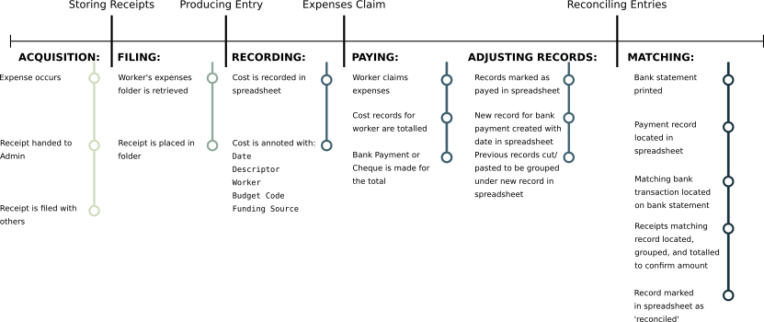
Figure 4.4 A diagram of the sequential order of reconciling expenses to produce a canonical set of accounts
It is also of note that Lynne (and previously Charlene) developed their own internal processes to producing a record that maps onto an external standard. The standard in question is that of having a canonical record of their income and spending; whereas the process of adding ticks and the reconciliation marks (the ‘r’ in the spreadsheet) are their own way of expressing this critical matching stage of producing a canonical set of accounts.
I did, however, witness that there is an inherent tension when presenting accounts for auditing to a chosen third party. The final stage of making your accounts canonical is the auditing processes.These require accounts to be ‘ratified’ (checked and signed) by an accountant, and often experience conflict when engaging with commercial accountants. I describe this below:
During a meeting, Mick asks to speak to me about the accounts. “I’m not happy with the accountants at the moment, they’re being problematic”. I ask why and he responds “They just want us to use Sage do you know Sage? The accountants don’t like that we don’t use Sage, and I think that’s because they can just import it and have it do their job for them.” At a later meeting with trustees Mick speaks again on the issue, “We’re thinking of scrapping Ellison’s. They’ve upped the price to £1300 …, and they’re trying to force us to use Sage so we do their job for them. We’ve spoken to a woman we found on the Chronicle who says she’ll do it for £20 an hour and she’s happy to do them in whatever format we want. She’s been in and looked already and she’s told us that we’ve already done the job, and all she’ll need to do is double-check a few things and sign it off. We have to make sure she’s got the right, y’know, qualifications, to do that but aye it looks much better.”.
Here Mick shows that there is an explicit point of contention that arises when commercial accounting models are misapplied to charities. The accountants use expensive commercial software and apply it as a de facto standard, presenting a barrier to the charity engaging with the auditing processes required of them. These attempts to influence Patchwork’s toolkit and thus their accounting practices demonstrates a conflict that, in order to become transparent in a particular way, they must use methods imposed upon them that do not support their own practices of accounting for money and alienating them from their current accounting processes which match their work practice. That Sage Accounts (Sage UK, 2021) is expensive commercial software is also of note. Patchwork own their spreadsheet; it is tool that they developed and use to produce their records. They do not own Sage, and in addition to the money it would further remove them from the ability to produce their own records in a form that becomes canonical and leads to the production of their Accountability to others.
Other features of the tool and accounting process are brought to light when Mick details the process of ‘Costing’ to me:
Mick: “This lets us see how much money we have in each fund, and then in the other screen here I can assign it to a funding pot and then this updates.”
At a later point in fieldwork, Mick elaborates on this practice, and how the organisation benefits from it:
Mick: “I do this when someone tells me that a report [to a funder] is due. I’ll see what the fund says I can spend it on, and then I’ll cost things to it and move things around so that each fund is happy. Sometimes I do it when we need to spend money from a fund that’s due and I can go back and move things so it’s used up, then there’s loads to put in the report. Or sometimes if we need money for something, I’ll go and free something up from a fund by moving things to other funds.”
Costing work is as such related to the reports that funders stipulate as part of their funding arrangement with the charity. Mick shows that the organisation has some flexibility in the way that it costs things, and uses this to justify spending that may have been outside of the original proposed use for the funding.

Accounting for Activity
As well as having to account for financial spending, Patchwork are also required to account for their work activity. Accountability here is notably experienced through both formal procedures and more interpersonal interactions with the community. I outline below how the organisation navigates this, in order to explicate the work practices that support communicating the organisation’s activities to others.

Curating qualitative records
I observed the workers engaging in the production and curation of qualitative records that assisted them in presenting an account of their work. Some forms of record were stipulated as legal requirements, whereas others were produced at the prerogative of workers as this extract from my fieldwork diary shows:
During a session, I observed Andi taking photographs using her phone. She would often approach participants to take a photograph of them. Whenever possible, Andi would call to another youth worker and ask them to get into the photograph as well. The next morning, I have been tagged in photographs by ’s Facebook account alongside the other workers and young people in the photographs.
Andi’s behaviour shows her producing a qualitative record of the event and activity that occurred. She can be seen collecting photographic evidence of their attendance in-situ, and using this to elaborate on the context of their work. The practice of uploading these to a social media profile produces an account of their activity for others, and tagging people in photographs on the platform encourages those tagged to look at them and potentially allows others (such as parents) to glimpse the activity as well. As well as on social media, print out a selection of photographs in a poster format, which are displayed around their main community hub. The workers reflected on this practice in a group discussion:
Andi: “Part of it’s capturing that moment in time because it’s gonna be gone. Y’know, and it would be very easy for them to forget […] So you’re capturing it for them, you’re capturing it for their parents to see what they’ve achieved, or for the Duke of Edinburgh so they can prove whatever it is they’ve done. You’re putting on the wall as a celebration, you’re putting it in the annual report for funders to see and also for young’uns to see […] Like loads of kids will be like ‘will this be going on the wall?’.”
Mick: “We just take lots of pictures because it becomes a resource for us as well. The ones on the wall are of the D of E because they’re positive images. Sitting down two people and talking one to one and that — it’s not very entertaining.”
It can be seen here how Patchwork use a resource bank of records built up by photographs for different types of accounts, to different people. This illustrates the elasticity a record may possess; Andi relates how photographs may be used as evidence for participant’s involvement in an award, whereas Mick conceptualises them as “positive images” and a resource for the organisation’s future needs. Andi also explicates how the photographs are shown to parents in order to provide an account of their child’s activity with . This also demonstrates how the photographs are repurposed to provide an account of value in the annual report, and to provide a personal record for the young people when it’s placed on the wall in “celebration”. The ability for these records to form a resource from which different accounts can be derived also sits in contrast to other forms of work that perform that, as Mick indicates here, are more difficult to account for (“Sitting down two people and talking one to one and that — it’s not very entertaining”). I observed this first-hand during fieldwork when Mick expressed frustration at the records that are required to keep of their meetings with service users, and how it is difficult to present these to others:
I followed Mick to a filing cabinet that was unlabelled. He took out a folder to show me an example, “Here. This is a monitoring form we have to fill out every time we have a chat with someone. You say who it was, what you chatted about and what the outcomes were. Standard ticky-box stuff. We’re meant to keep this, and we do by the way, but nobody ever asks to see it. I’ve got files here from ten year ago which haven’t seen the light of day. People complain at us that we’re not doing our job and ticking boxes but we are, but nobody ever comes in. Nobody ever asks.”
Mick’s frustration indicates that while he is fulfilling legal and stipulated obligations designed to make Patchwork accountable for their work, they are not given the opportunity to demonstrate this properly. When Mick describes how photographs of these chats would be “not very entertaining” it becomes obvious that while Patchwork could theoretically generate records of these the effort required to do so would not result in a substantial gain for the charity when trying to demonstrate their value.

Accountability of activity in the community
In contrast to the perceived indifference of regulatory bodies, I found that the workers at Patchwork saw themselves as being highly visible and thus accountable to their local community both in their roles as youth workers, but also as individuals within it due to an inherent visibility of their presence. This is characterised by Dean’s conception of Accountability during a group discussion:
Dean: “There’s the visibility in and out of work. It’s not a one-way thing, I’m not Dean the youth worker during the day and I’m not Darts-Dean at night I’m both and I’ve got to be very aware that young people and the families that I work with, […], I live in the same area as them and they are watching me constantly. In and out. I’ve got to be visible. It’s… an awareness of your role within the community. And I think another one for me, being accountable is remaining humble and just thinking that I’m very much where I’ve come from and I’m very like the young people I work with and they know my family.”
With this, Dean shows us how he sees his role in the community by living and working in the same area. Dean provides a view that Accountability for his actions as a youth worker is lived in each moment. He is constantly watched by those around him, even when outside of work during his recreation activities and can therefore be seen as a whole, rather than only through a lens of his output at Patchwork. I saw this value in practice through the way that Patchwork configures their Social Media presence:
Andi: “We didn’t like having a Facebook ’Page’ because it treats you like a business and wants you to pay so everyone sees your posts. We want to be seen in the community. So we made the account a person instead and everyone is our friend and the kids message us at stupid hours …When Facebook changed it so that you couldn’t have a company name as a person, we changed our name to ‘Mick’ as Mick doesn’t use Facebook himself. [The community] know it’s all of us though, not just him.”
Andi emphasises the value-driven nature of the organisation’s work through how they’ve chosen to configure their Social Media presence. She notes that whilst there is a pragmatic benefit in how personal accounts are seen on the Facebook platform, this embodies their desire to be seen as part of the community. Later, the organisation took steps to maintain this dynamic by capitalising the identity of a worker, Mick, for use as a profile name. When Andi elaborates on her belief that the community understands they are interacting with all workers through the Facebook account, she belies her belief in the dynamic that the workers are visible and present as part of the community and are not abstracted by their involvement in the organisation – being visible and accountable.
Another way in which Patchwork curate Accountability to their community is how the workers engage in extra-curricular activities involving both themselves and members of the community. These are ostensibly the workers engaging in recreational activities but in some capacity they almost always involved an element of staff training or engaging with wider members of the community. An example of this would be the activity of Fell Walking. Patchwork staff will often go out as a team to walk up the Fells, putting to use and further developing their skills in the activity directly, but in doing so effectively “scouting” the location as a potential activity to include young people in. That community members such as trustees or Benwell residents are often present also demonstrates Patchwork’s commitment to the area, and further facilitates their ties to their service users.

Accounting for Hidden Work
I have just shown how accounting and reporting for charitable activity is a key part of everyday life at Patchwork however I also witnessed that there is an understanding that a lot of the everyday work of Patchwork is hidden from regular reporting streams. I have termed this Hidden Work which refers to the effort required by the workers to make their work productive, and has been called Unproductive Labour in Political Economy (Marx et al., 1974), and Articulation Work in CSCW texts (Schmidt & Bannon, 1992). I concern myself not only with how this is performed but how it is accounted for and communicated to others. In this context it refers to effort expended by workers at the charity in addition to what the task demands in-the-moment. An example would be the planning required to execute community sessions ahead of time. I found that accounting for this hidden work occurs only in conjunction with its performance, during meetings, or discussions about activities and planning – it is rare for those outside of the organisation and immediate community to be made aware of this work. Accounting for hidden work is thus more informal, and often complicated by the nature of Patchwork’s activity. I elaborate on these points below.

Responding Work
A lot of hidden work arises from Patchwork’s open-door policy, which requires an immediate response to community members coming through the door for their services or informal discussions – disrupting the processes by which workers are performing (and accounting for) hidden work. This came to the fore in one discussion during fieldwork:
We were discussing another youth project operating in the city, as have recently acquired a Play Centre and are finding ways to use it most effectively so have visited other charities to learn from them. It’s mentioned that the other project execute elaborately planned evenings of activities for their attendees and Dean exclaims “They’ve got the time they don’t start until half four! As soon as that shutter goes up we have work to do!” He gestures at street-facing window towards the front of the room. The group nod in agreement
Dean is discussing how Patchwork’s activity cannot be judged against that of another organisation with different working patterns. He also makes reference to the open door policy and its effect on their working day regarding planning and makes clear that these informal meetings are conceived of as ‘work’; there is effort expended when conversing that prevents them from performing other tasks. These conversations must be engaged in because they also form an important part of how Patchwork organise their work. This was elaborated on during a group discussion with me:
Andi: “So aye, [anon] is a good example. […] I know he was doing football, I knew he was doing work experience so he’d have the time and you just think well it would be really good for him to do it for his future. Y’know, so having a conversation with him to say look are you interested in this?”
Engaging in conversations that arise from the open-door policy can thus translate to outcomes, in this case a beneficiary getting a work experience placement based around a hobby. This qualifies Dean’s earlier utterance that the organisation has “work to do” as soon as they start: these conversations are work that must occur for to achieve its goals effectively, but it is difficult to provide an account of this to others.

Understanding Hidden Work through Context
Hidden work is rarely accounted for outside of the organisation and immediate community. During fieldwork, however, Mick related how outsiders may be introduced to the context of the organisation to understand the labour required to perform everyday tasks and achieve outcomes:
“It’s like when this guy from [a funder] came in to check. Most funders don’t and they don’t understand us. He came in and he loved it. He said that he was amazed we could keep the place running, we had so much going on around here that we deal with on a daily basis.”
From this it is established that Mick understands the difficulty of accounting for this labour to others — most funders do not visit and thus do not understand how the project achieves its aims. The work involved in delivering results for Patchwork is responsive, complex, supportive of others, and facilitative of them accomplishing things in a way that makes it difficult to tie these to discrete acts to the project’s stated aims. That the funder is amazed at the scale of everyday work and effort being expended shows that this is not captured or represented elsewhere; and can be accounted for only by being present and producing one’s own account from the context of the activity. I later saw that this problem is compounded and is encapsulated with a vignette of activity leading up to a scheduled evening event in the organisation:
I was due to attend a session with a group referred to as the ‘Slovak Lasses’ group, comprised of young Slovak women aged between 15 and 24. The sessions run from 1600 approx until about 1830, and the plan is to run a BBQ event for the attendees. From 1545, two participants had turned up alongside a part-time worker and sat at computers browsing Facebook. Dean is also on Facebook using the account and has several chat windows open. When prompted, Dean responded that he is “chasing up” the rest of the group to make sure that they were coming. Whilst passing, Andi convinces the attendees to accept her taking a photograph of them. Dean signs off the computer at 1630 and at 1655, there is no sign of other attendees. Dean is visibly concerned, pacing back and forward. He mutters that “we should sack this group”. Sonia nods then says “this is ridiculous. We have two young people and four staff”. I am dismissed by Dean who says “You can go if you want. It’s a bit weird if we outnumber the girls and we have loads of staff in”.
This example shows two things. First, it reinforces the issue of hidden work only being able to be accounted for in-the-moment. Dean performs the additional task of ‘chasing up’ participants; work which emerges as the evening progresses and is only visible to those in the room. Secondly, it raises the issue of how the staff’s efforts would appear if mapped to outcomes in an accounting process. Sonia indicates that such a mapping would not appear favourable (“We have two young people and four staff”), and Dean hints that this is not an uncommon occurrence (“we should sack this group”). Patchwork has to balance the goal of maintaining a relationship with the beneficiaries – which can lead to important outcomes – with the need to make and be seen making effective use of their time and labour resources. The slower and seemingly less productive execution of the event also directly contrasts with what Mick describes as the funder’s surprise at the high levels of activity during a visit. This likely results from an intersection of elements such as the specific beneficiaries, the time of day, etc. but when isolated from context these two incidents each paint seemingly irreconcilable views of the organisation’s daily life.

Inferring Hidden Work
I did see that hidden work may sometimes be inferred by other members of the organisation, in addition to those present as it occurs. This is often achieved through the records that are produced as a by-product of activity in conjunction with the worker’s implicit knowledge of each others’ work practices:
I was participating in a planning session for the evening’s activities; initiated when Dean and Andi each took out large workbooks. Andi asks “Where’s Mick?”, to which Dean responds that he is “down the allotment”. Andi looks puzzled at this and Dean elaborates, “He’s seeing how [the gardener]’s getting on” and turns the notebook to show Andi. There is a task list which shows ‘allotment’. Andi looks at this, and nods.
This shows that workers may use records to infer the activity and thus the work of others in the charity. Dean shows Andi a workbook entry which contains only a single word that allows both Dean and Andi to construct a context around Mick’s current whereabouts. It can be seen how Andi and Dean understand that work is being performed at the allotment, and that Mick’s absence indicates that it is him performing it. Furthermore; the workers are able to infer the nature of this work, as Dean is able to ascertain that Mick is checking up on someone whilst there. Similarly, I also saw that financial records such as receipts could be re-appropriated and used for this inferral:
Mick was having lunch and moving items on the table out of his way, to place his laptop there and write a report. Moving a pile of paper, he turns to inspect it and finds a receipt, saying aloud “What’s this? Ohh. It’s the pancake stuff for tonight; Sonia’s been shopping.”
The receipt makes Sonia’s work accountable internally, as Mick recognises that the items are a list of ingredients to make pancakes, an activity commonly run by the charity. He infers that there has been effort expended in acquiring these materials when he says “Sonia’s been shopping”, and can attribute this to Sonia through knowledge that shopping was a task to be completed and that Sonia was assigned to it. The receipt also pertains to the charity’s activity – running a session involving cooking. This shows how accounting for this hidden work hints at the organisation’s work towards goals. Notably, this testifies that record may exist within several contexts: evidencing expenditure, the inferral of activity, and the by-product of work related to activity (a cooking session) that may be accounted for.

Summary of Accounting practices
This section has provided a detailed description of the work practices involved in making Patchwork transparent and accountable to its stakeholders. This accounting work has been presented as grouped based on the area of activity that this interactional work relates to: Accounting for Spending; Accounting for Activity; and Accounting for Hidden Work.
Each of these areas of this Accountability work is achieved through a variety of ways which are organised to make sure that the organisation meets its legal and contractual obligations to report spending and activity as well as its immediate concerns of being transparent to the community.

How should systems be designed to support Accountability Work?
My field observations demonstrate that those working in a charity may experience Accountability in multiple ways, with reference to their values, work, and responsibilities both as an organisation and individuals. This fieldwork shows how legal and financial frameworks surrounding the organisation has a pronounced effect in the work required for a charity to account for the use of resources – both financial and labour – and also that members of the setting can experience this Accountability as part of their everyday work in the organisation. I also presented evidence that the organisation and its workers view themselves as inseparable from their local community, thus accountable to it; this relationship requires a maintenance effort similar to the legal demands of government and funders.
These findings show how conflicts may emerge from the ways in which the charity views itself as accountable to various stakeholders such as its community, its funders, and governmental bodies. In one key instance, Patchwork must be accountable to funders by reporting their use of grant money whilst simultaneously tailoring activities and spending with regard to the emergent needs of their beneficiaries. This conflict is rooted in the Accountability pathways that they must engage in: charities are controlled by their funders to ensure that their spending falls within a specific remit, and this conflicts with a need to be responsive as an organisation and act in accordance with the needs of beneficiaries. This is discussed by Koppel as Multiple Accountability Disorder (MAD) (Koppell, 2005) and compounding this is the various ways in which the organisation is required to make itself transparent. As discussed, Transparency is often seen as a foundational element of Accountability but the relationship between the two is nuanced – where various forms of being transparent may generate different forms of Accountability (Koppell, 2005; Fox, 2007; Hood, 2010).
This raises questions around the role of technologies in charities and how they allow workers to navigate conflicts inherent in their Accountability requirements. In the following sections I discuss design considerations for future systems that seek to assist charities in managing the tensions associated with becoming transparent and accountable.

Support the Accountability of Work Practice
Our research began by examining Accountability from the perspective of public and voluntary sector administration, where organisations may be accountable to others through a number of different pathways such as producing answers when questioned (Fox, 2007; Koppell, 2005). This is demonstrated in our findings as much of the work involved in ‘doing Accountability’ involves workers producing answers for stakeholders in the form of reports on spending and how activities were delivered in relation to this expenditure. I posit this offers HCI an opportunity to affect change through a form of Accountability with which it is intimately familiar: the accountable nature of work (Garfinkel, 1967).
While ‘work’ in Garfinkel’s terms refers explicitly to interactional work in the accomplishment of ordering social settings, these interactions are what form the basis of an organisation’s accomplishment of its goals. For example, my findings show that a receipt of purchase obviously means someone has been shopping, and is also incorporated as evidence in the financial accounting process. Prior work has been done by Strauss on “Articulation Work” (Strauss, 1985, 1988), referring to how constituent elements of tasks are fit together and articulated by members of the settings to support coordinating work and keeping it flowing. In this chapter, I show how an organisation such as Patchwork engages not only in Articulation Work in order to progress the work and its various project; but that some of this work is performed explicitly to articulate their work to others who are not involved in the daily production of work in the setting so that they are meeting their obligations of being “Transparent and Accountable”. This ‘Accountability Work’ can account for the work it does towards it goals for others and to key stakeholders not necessarily involved in the work — but the emergent nature of outcomes means that this only provides a partial view. I show that visitors to Patchwork comment upon activity there as the work and the context of that work is made obvious; yet the accountable nature of that interaction is not supported through systematic processes for reporting.
Making Accountability accountable here, then, involves producing systems that allow the communication of organisation’s accomplishment of their work practice in relation to their goals. This should be in such a way that the work of an organisation is made obvious at a glance. My findings demonstrate that the charity appropriates social media as an ‘organisational accounting device’ (Dourish, 2001), making their activities observable and reportable to those who care to look. As such, I propose that technologies be developed to support the communication of work practices in context with organisational goals. For instance, accounting software that appropriates social media features such as timelines, tagging, and events to contextualise financial records or work toward outcomes. This would provide a resource for both workers and stakeholders and in doing so may begin to address the current chasm between reporting processes and the emergent nature of outcomes; making it clearer to all parties how the work of a charity sits in its local context.
In speaking of providing resources for workers I feel that an otherwise obvious point must explicitly be made in that any systems designed for their use must be provided as a non-proprietary system. Patchwork express a clear desire to avoid costly software (“The accountants don’t like that we don’t use Sage”) and prefer to rely instead on their home-grown toolkit that they’ve designed and assembled to meet their needs. If Patchwork are to benefit long-term from any system deployed, then it must be developed explicitly as a non-proprietary system would be one that is released as Free Software under an open license so that they may use it without cost.
Since any new system will need to be both Free Software and purpose built to address the needs of Patchwork it must also address the issue of interoperability. Speaking again of their obligations with accountants Patchwork note of the accountants system that “they can just import it and have it do their job for them”. This fieldwork has focused on a single organisation’s work practice and design requirements but in order to leave the door adequately open to future developments this interoperability should be designed into the system as a core value.
It is also imperative to ensure that these systems cannot be used to control or monitor the actions of workers, effectively ‘managing’ productive labour to make this accountable to funders (Harper, 1992). Systems should instead provide workers with means to produce accounts of their work flexibly, and express these accounts in a diverse manner. This enables the different forms of Transparency that predicate various accountabilities (Koppell, 2005; Fox, 2007; Hood, 2010). Such systems will thus need to enable the configuration of Transparency to support making work accountable for those who care to look. I discuss how this may be achieved below.

Enable configuration of Transparency
Charities such as are shown to engage simultaneously in multiple forms of Transparency to satisfy their Accountability requirements. While regulatory bodies and funders are concerned with spending money and monitoring output this is widely accepted to be divorced from the true impact of an organisation’s work (Heald, 2006). Simultaneously, Patchwork take efforts to make themselves transparent and accountable to their community through practices such as using social media and having open-door policies.
These efforts are in line with calls to partake in more active forms of Transparency which are seen as more communicative (Oliver, 2004; Schauer, 2011). It can be seen here, however, that this often requires extra work on behalf of the workers to articulate their results and efforts to the community on top of compiling reports for other government entities and funders. Important here is the narrative form this Transparency takes, and HCI has previously seen how charities can construct narratives surrounding their work through the use of Open Data (Erete et al., 2016). Patchwork engage in a process which involves them collecting data which they fashion into narratives. Digital tools also play a role in ‘Costing Work’ to satisfy requirements that spending appears to have been in accordance with funding conditions, but is actually spent as the charity responds more directly to beneficiaries. This is an example of how charities may feel compelled to frame their work by tailoring reports to meet expectations (Lowe & Wilson, 2015), and demonstrates how the values embedded in the design have negative impacts on how the organisation may achieve its goals (Pine & Mazmanian, 2014).
While my previous work calls for qualitative forms of accounting (Marshall et al., 2016), I put forward that new systems must do more than simply incorporate additional data into the accounting process; they must be designed with embedded values that better reflect the needs of an organisation and its beneficiaries. As these may differ between organisations, systems should seek to support workers in easily matching their records to the required format per request without much additional labour. Providing interfaces to retrieve, combine, and present data in a multitude of ways would go some way in supporting charities experiencing multiple Accountability requirements. Doing so acknowledges not only the conflict of multiple accountabilities and transparencies; but the problem that is the effort required to manage these conflicts separately. This would allow organisations a material means to configure Transparency based on context. It also presents new opportunities for stakeholders to engage charities; if systems allowed the controlled retrieval of information (McAuley et al., 2011), then stakeholders may actually assist in configuration work and create new ways to interpret the data that is more meaningful for them.
This may be achieved practically through providing lightweight, inter-operable, data collection tools and interfaces (e.g. mobile and web applications) that allow workers to easily collect, combine, and process information based on evolving needs but operate independently without commitment to one platform. Thus the design embodies values of organisational control and flexibility to support workers collaborating in curating an organisational account. This account would then take the form of an interrogable dataset that can be configured to meet the mode of Transparency and Accountability required for a given purpose. That these systems and interfaces must be simple to use should also be forefronted. Patchwork are a charitable organisation which means that any time (and money) spent on training may be equated to resources directed away from service delivery. Simple and purposeful tools accommodate Patchwork’s economic nature as well as the social character of staff turnover; systems should able to be learned easily from people with a variety of skillsets and backgrounds.
Providing this configurable form of Transparency requires that systems consider the means by which the dataset is created, curated, and queried. I address this below.

Create Contexts through Linked Accounting
I have portrayed the challenges of accounting for Hidden Work; the activity behind what is being accounted for. This challenge also manifests in terms of the increasing demand for charities to not just account for their activity, but for their outcomes - the effect of their activity on the lives of those with whom they work (Lowe & Wilson, 2015). Holding organisations accountable for delivering outcomes (e.g. improving the health of a community) has been critiqued as they are often the result of overwhelmingly complex systems, which any given organisation cannot control, and therefore cannot be held accountable for (Lowe, 2013). Our findings demonstrate that a disconnect exists in how organisations may perform work and how it is reported upon; such as being concerned about numbers attending a group.
Historically, the ‘Linking Processes’ between input of work and money to work output and eventual outcomes has been problematic and poorly understood (Heald, 2006). People often seek to create ‘program logic models’ which connect activity to outcomes as a linear model of cause-and-effect (Schalock & Bonham, 2003) but as discussed; outcomes are generally emergent and such models are not representative of how they come about.
Since outcomes emerge from complex systems interacting (Lowe, 2013; Lowe & Wilson, 2015), I have proposed that digital technologies support configuration of Transparency. The role of Linked Data (Bizer, 2009) is central in this for two reasons. First, data is a boundary object (Crabtree & Mortier, 2015; Leigh Star & Griesemer, 1989) that may be appropriated and adapted as a means of providing ‘alternative lenses’ (Elsden et al., 2017) on work and spending; as such, Linked Data supports the configuration of Transparency by providing the material means to combine and show information in context based on need. This allows organisations to rapidly produce lenses on their work to satisfy reporting requirements while predicating only that an initial link be developed between income, work, and outcome to support traversal and presentation of the data. Second, Linked Data implies interoperability with other datasets which speaks to the complex nature of outcomes discussed above. These linking processes could support charities, or other actors, linking multiple datasets to better understand the complex nature of how outcomes are emergent; and from this produce a context that better situates the role of the charity in producing that outcome.
Such a system also has grounds in the legal procedures necessary to audit a charity’s financial accounts. I note that these are somewhat federated in nature; there exists a standard and agreed upon mechanism for having one’s accounts verified and signed, yet multiple actors may perform the ratification. This ecosystem resembles that postulated by the Dataware Manifesto (McAuley et al., 2011), and creating a Linked Data set within a charity would support this process through the controlled sharing of data. This federation may be achieved through making digital tools independent and interoperable, as described above. Furthermore, linking data could see this form of federated system used to produce other forms of Transparency; processes acting on Linked Data could be used to create new interfaces around work and spending that support the more active forms of Transparency discussed at the start of this paper (Schauer, 2014).
In doing this, systems would support the creation of ‘Linked Accounting’. That is to say these systems may engender accounting and reporting process built upon the premise that organisations are being asked to account for outcomes that have no control over, but their work (and spending) is accountable and may be linked to outcomes as having taken place. This shifts the focus of ‘accounting’ in charities towards the accountable performance of work, and contributes Linked Data for the wider community to use in mapping and understanding the complex systems contributing to outcomes.

Summary
This chapter has provided an ethnographic account of work practice within a small charity as it pertains to the everyday work of becoming transparent and accountable for their work and spending. The organisation was introduced before accounts of their work practice were provided and then these were discussed as a design space which indicates that Accountability work may be supported by systems that: support the Accountability of work practice; enable the configuration of Transparency; and create contexts through linked accounting practices.
These design implications may be realised through the provision of a system that:
- Is provided at no charge to organisations
- Is simple to use for workers
- Provides a way of exchanging its data in a way which is interoperable with other systems that other actors may be using
- Provides a way of joining financial spend data to activity information
- Provides mechanisms for the workers of the organisation to curate the records that are in the system and the links between them
- Provides multiple ways of presenting or retrieving information from the system
The next chapter of this thesis illustrates the designing of systems that seek to meet these requirements.

Designing Accountability Tools

Introduction
This chapter presents an empirical account of the design process that was undertaken in order to produce systems that were later deployed.
This phase of research was important because it transitioned the research from the fieldwork accounts of the previous chapter into a phase where design work was being performed and tools were being produced. This allowed for sense-checking of the findings from the previous phase of research as well as a field-test for trying to embed these sensibilities into designs. It also allowed me to reflect on the performance of the design work and the implications for designing Transparency tools in charities and other civic spaces in the future.
As such this chapter begins with accounts of the performance of design workshops and how these transitioned into an iterative design cycle. It then gives an account of the systems themselves which I present as a design rationale for their core features. Finally, I reflect on lessons learned from this design process including early insights into the nature of these tools; where the responsibility for doing the design work lies; and considerations for performing design work in spaces such as these.

Beginning Design Work with Futures Workshops
As noted in Chapter 03 design activities began in late August 2016 with the performance of design activities building on my fieldwork at Patchwork. This section elaborates on the design activities encapsulated in a Futures Workshop and the resulting discussions and space it created to take forward into development.
I originally intended to perform a single workshop using the Futures Workshop (Jungk & Müllert, 1996) framework, however due to scheduling restrictions was instead performed as three separate workshops spaced roughly three to four weeks apart in each instance. Each workshop was performed with Patchwork in the main room at their central hub (Patchy 1) and the workshops lasted approximately 60 - 90 minutes in each case.
Chapter 03 discusses these workshops under the heading of Fieldwork Methods, but I must reiterate that these research activities marked a transitional phase from the strictly investigative fieldwork activities and towards the design phase of this research. They served as a bridge where I was situated at the field site but beginning to bring design activities into the work there. The workshops allowed me to first check assumptions by presenting them back to Patchwork in a particular way and then use these discussions to fuel a reflective process about work practice and digital systems that could in turn be used to organise design work. Full details of the workshops can be found in the appendices of this thesis (Details of Design Workshops).
With this in mind the performance and “output” of the workshops was captured and conceptualised as part of the ethnographic corpus with which to begin the iterative design process that lead to the implementation of a system. Each of these workshops were audio recorded and some photographs were taken at each but the data was later damaged. This left only an audio recording and partial transcript for the first workshop, as well as some photographs for the third amidst my field notes. The remainder of the iterative design process was started quickly after the performance of these workshops so these additional materials were used as prompts for memory during the early stages of sketching and prototyping.

Continuing Design with Crits and Iterative Development
Following the three sessions that began the iterative design process I launched into a User-Centred Design (UCD) cycle which resulted in the design and implementation of lightweight, inter-operable, systems which were later evaluated (evaluation detailed in Chapter 06). The details of these systems will be given in the next section but consisted of: a mobile application to capture data; a data standard to standardise and facilitate transmission of data; and a web application to consume, manage, and present data in the system.
This portion of the iterative design cycle was performed across six months from October 2016 to April 2017 with Patchwork and was incorporated into my field visits to the charity. Output from the initial workshops, as well as the analysis of initial fieldwork presented in Chapter 04 fed into these designs. At early stages I followed a straightforward process of sketching out system architecture diagrams, interfaces / wireframes, and sequences of interactions in pencil and then checking these with the team at Patchwork each week in a process derived from the Design Crit (Goldschmidt et al., 2010). At later stages this process remained the same excepting that I demonstrated early stages of implemented interfaces on phones and web browsers. Feedback from these sessions was captured in my field notes and then acted upon in the next week’s worth of design iterations.
It became clear early in this process that although Patchwork valued the principles of Participatory Design as I presented them; they trusted me to design them a system or application to address their needs based on my time spent there. As such their interest and engagement varied across the weeks based on a number of factors, and in some cases my sketches were only glanced over with a cursory “yeah this looks fine! Excited to see it” (Andi) from one of the team. The result of this is that I had a large degree of flexibility in designing the systems based on the requirements and design implications discussed in the previous chapter; although these were presented back to Patchwork early on as a way of sense-checking my interpretations of their work practice. These requirements were accounted for by embedding these principles into the system architecture and while I tried to make it clear what principles were guiding the design of the systems; Patchwork remained focused on how the interfaces and processing of data supported the pragmatic accomplishment of their work practice.
This skewed the priorities in the design process towards data capture early on; meaning that the early focus was on the production of what later became the Accounting Scrapbook mobile application. While Patchwork did indeed care about the types of information that they could capture in the system and how to link it up there was less enthusiasm about the concept of a Data Standard as this was out of the immediate scope of their concern. Because a goal of this thesis was to understand how to capture data about charity work and spending in a standardised way, I felt like it was too important to “drop” as part of the system. I instead made it clear to Patchwork that our discussions about capturing information in an application were also feeding into the design of what became the Qualitative Accounting data standard. Although, oddly, Mick was very keen on influencing the name of the standard for no discernible reason and my attempts to move away from the term “Qualitative Accounting” were met with lighthearted but firm protests.
By the Christmas break in December 2016 “Accounting Scrapbook” was in a condition where no substantial or controversial changes were being introduced at each crit session. In the January I shifted focus onto designing a web service to consume and present back the information that was captured using the mobile application. This followed a familiar route progressing from sketches to early prototypes across the months of January 2017 to April 2017. Notably it was difficult to get sessions and design input with Lynne during this time because of her role as part-time. Our sessions at Patchwork rarely coincided and Lynne’s limited hours per week meant that the taking up of her time was felt very keenly. This made sense-checking these designs with her difficult and presented a challenge since I was envisioning that she may be the primary user of what became Rosemary Accounts when it came to deployment and evaluation. I believe Patchwork as a whole were slightly fatigued by the design process when it came to designing this portion of the system, as I noted less enthusiasm at this stage. This may have been partly due to the timing of this process as Patchwork had to accommodate their regular activities as well as planning for several school holidays (where their programme resembles the intensive summer-programme).
In May 2017 I was preparing for deployment and evaluation and sought other charitable organisations to participate in this. A chance meeting with the CEO of Community Project Gateshead (a pseudonym), a charity based in nearby Gateshead, in the offices at Open Lab (they were participating in other projects) was met with enthusiasm on their part and they expressed keen interest in joining the research. I followed this up with an initial meeting with them onsite at their project to find that they had also invited workers at Older People’s Charity (OPC), another Gateshead charity, who also appeared enthusiastic at testing out the systems and who both agreed to be part of the research. This initial meeting was followed up by separate follow-up sessions at each of these organisations to introduce myself and the research to the workers and communities there. As I was introducing the Rosemary Accounts software the staff of Community Project Gateshead raised several concerns about some design features which resulted in a discussion on how best to address the balance of data protection, privacy of service users, and the display of media. I ratified these concerns with OPC and suggested improvements before informing Patchwork of the changes and sense-checking with them before implementing them in the system. These adjustments were made to accommodate these new enthusiastic partners and hopefully see a successful and involved evaluation stage, but resulted in the development work stretching across May 2017 and into June 2017. I will discuss the specific adjustments made in the next section.

System Details and Design Rationale
This section outlines the systems and design rationale of the software that was developed for deployment. Attention is first spent on an overview of the systems including their decentralised architecture and how this addresses design requirements that were raised in the Chapter 04. I then take each “component” of the system in turn and walk through its features and elaborate on the design process that lead to them.

System Overview and Embedded Values
The previous chapter makes clear that a design requirement was to support a configurable Transparency which did not impose a specific presentation or collection process for the data, and was flexible to the needs of workers. I also stipulated that, since it is established that values may be embedded in the design of a digital system (Pine & Mazmanian, 2014), any design seeking to be useful in this space embeds the values of Flexibility and Worker Control. I also suggested that data in the form of linked data is required to create contexts required to understand a charity’s work.
This data also needed to be produced in a way that it would be inter-operable with other systems that other actors may be using (e.g. software for signing off accounts) however this potentially would have provided a contradiction with the requirement that any systems be provided as community software with no charge for the organisations. This is made clear by Mick’s utterance in the previous chapter where he expresses distaste at being asked to use Sage’s expensive accounting software, yet the accountants require this tool to do their job.
To address these design challenges the system architecture took the production, exchange, and consumption of the data as the fulcrum upon which other interactions should be built and to decentralise the systems that exchanged this data. Heeding lessons from my previous work which called for standardisation (Marshall et al., 2016) a data standard was produced to describe what data should be captured and how it should be structured. The decentralisation of the systems, as opposed to producing a monolithic ‘platform’, addressed two key requirements: that Transparency may be configurable as new systems and interactions may be designed to make us of the data in new and interesting ways as needs emerge; and that an organisation can not be forced to use a proprietary system as different pieces of software would be inter-operable by using the data standard for communication.
Evidence of this approach being technologically and interactionally feasible came from a review of existing decentralised social media technologies on the Web; namely those found on The Fediverse (Gehl, 2015; Holloway, 2018; Liu et al., 2020) and The Indieweb (Werdmüller, 2013; Indieweb.org, n.d.a). This was useful because these technologies were attempting something similar to this project in that they were developing interfaces and rules for the production, exchange, and viewing of data that were not bound to a specific platform. In this case; status, likes, and other activity commonly found across social media. The Fediverse and Indieweb are themselves separate but inter-operable spheres of decentralisation of social networking on the web. The former focuses on producing explicitly federated platforms for large groups of users but which share a common language and protocol known as ActivityPub (Webber et al., 2018) which describes how data should be structured and shared. On the other hand the Indieweb’s attention is around achieving networking and compatibility of individual sites and blogs (Werdmüller, 2013).
During the design phase of this project the Fediverse was yet to reach its current level of maturity but I followed its development closely in order to learn from it. It provided a useful case study as to how a rich variety of different interactions may be had when heterogeneous systems shared the same language (the ActivityPub standard) and how different needs may be addressed. From the same vocabulary the fediverse produced: Mastodon (Mastodon gGmbH, 2021), a Twitter-like interaction around microblogging ‘toots’; Peertube (Framasoft, 2021), a decentralised alternative to YouTube with comment and subscription provision; Friendica (Friendica, 2021) providing a Facebook-like experience; and more recently Pixelfed (Dansup, 2021), a decentralised image sharing service like Instagram. There are many others such as Diaspora* (The Diaspora Foundation, 2021) and GNU Social (Free Software Foundation, 2021) which provide new or other combinations of interactions around ActivityPub data which are not intended to be direct or close-to-direct analogues of proprietary, closed, systems. Through the ActivityPub standard each of these pieces of software are able to communicate not only between instances of themselves but between instances of each other as well (e.g. subscribing to a Peertube channel via Mastodon (Derek Caelin, 2020)). This was valuable as a living and field-tested proof-of-concept for attempting to enable new interactions around charity spending and activity data.
Taking a decentralised approach early on in the design process also had the benefit of allowing for the potential to add new applications, services, interfaces and interactions for evaluation very simply and without needing to modify existing systems. Although only a few systems were evaluated in this thesis (see Chapter 06) if the potential to work with new stakeholder groups arose then systems evaluating or addressing these needs may be developed and deployed very easily and contribute to the ecosystem without affecting the work practices of those already using existing tools.
It is in this way that decentralisation also begins to address value-driven concerns in its design that were surfaced in Chapter 4 Platform Capitalism is the term used by Srnicek to describe the economic model where a private, for-profit, entity owns the software platform (apps and associated web tooling) by which economic exchange is done and work is organised (Srnicek, 2017a, 2017b). It is closely linked with the rise of the so-called Sharing Economy (Martin, 2016) and classic examples of this model are: “ride-sharing” platform Uber; rental platform AirBnB; and food-delivery service Deliveroo. In this sphere it has raised concerns on the future of worker’s rights (Vallas, 2019), but in addition to those companies associated with the Sharing Economy the definition of Platform Capitalism includes popular work and social platforms such as Facebook, Twitter, Google and the increasing amount of software that is run on web technologies as a service (Srnicek, 2017a, 2017b). Kleiner, adding an explicitly Marxist analysis, writes that this is expected of the web overall since it is capital’s attempt to reduce peer-to-peer exchange on the Internet by reconfiguring the shape of the network to a more centralised Client-Server model so that resources may be accumulated, commodified, and controlled more easily (Kleiner, 2010). Again Mick’s criticism of being forced to use expensive proprietary accounting software that he does not control embodies this concern as experienced by a worker in this setting. With this in mind, producing a decentralised system architecture was essential in order to achieve the goals of embedding the values of Flexibility and Worker Control which have been established as design goals.
The result of embedding these principles and technical concerns to address the design requirements was the outline of a system architecture that had at its centre a prototype data standard which was termed, as noted in an earlier section, the Qualitative Accounting data standard. In order to support collecting information I produced a lightweight mobile application called Accounting Scrapbook and in order to support the curation, presentation, and sharing of the data Rosemary Accounts was produced.
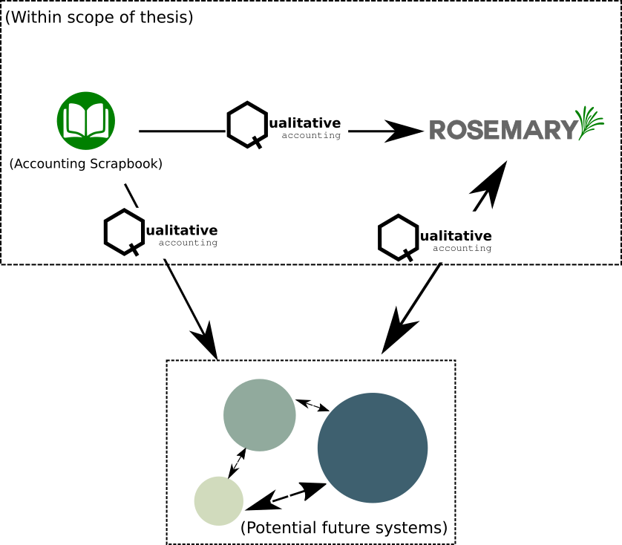
Figure 5.1 Diagram of the system architecture showing systems in and out of scope for this thesis
Taking design cues from existing data standards such as Open Contracting (Open Contracting Partnership, 2021) and 360Giving (360Giving, 2020a) it was also important to make each component of the overall design available under Open Source licensing. During the reseach period, both Accounting Scrapbook and Rosemary Accounts were developed “in the open” via an open-source repository on Github, a popular open-source code repository (Github.com, 2021). When Microsoft acquired Github in 2018 (Microsoft News, 2018) I transferred the repositories to an open and public repository on Gitlab, a popular alternative (Hethey, 2013) which many users migrated to after Microsoft’s acquisition of Github (Reuters, 2018).
I continue by providing an overview of the features and development of each of these component parts.

The Qualitative Accounting Data Standard
In order to achieve interoperability and move towards a decentralised ecosystem, applications and services need a common language with which to communicate; allowing them to share and process data amongst themselves. A standard is a way of defining vocabulary and rules that dictate how data is described and structured (Field & Sansone, 2006). As data becomes increasingly available online there have been multiple calls for standardisation across various sectors of industry and academia (Mucina et al., 2000; Quackenbush, 2004; Hammond, 2005; Marshall et al., 2016). As such a prototype, lightweight, standard was designed with Patchwork to inform later system design. This also provided the design benefit of being able to synthesise findings around what elements of practice were crucial to capture and communicate as well as an opportunity to check this with the workers.
This standard was tentatively named “Qualitative Accounting” (hereafter QA) in reference to the findings from earlier work (Marshall et al., 2016) although during the design process I raised concerns about how this may be a misnomer. This was because the inclusion of latitude and longitude coordinates for locations, financial data, etc could not necessarily be said to constitute “qualitative” data by themselves. After I raised this as a concern Mick protested saying he thought the term was “catchy” and that “Qualitative is in the eye of the beholder. Eh I like that, write that down!”. Because of this the name remained in place as focus soon shifted towards developing the individual tools that implemented the schema.
Since our technical challenge involved both the structuring and transmission of data I took inspiration from ActivityPub (Webber et al., 2018) and as a result our prototype standard contained two main components: a data schema for collecting and annotating data representing money and work which was design more collectively; and a Web URI schema which defined expected URI endpoints and behaviour so that systems implementing the standard could communicate with arbitrary domains using Web technologies. This latter component was mostly tended to by myself as Patchwork saw it as a purely technical concern although they did express mild curiosity as to how the component systems were communicating.

Defining what to capture
Given the above the key challenge became unpicking what was essential to capture and transmit. This was achieved in the design process by drawing upon the field notes and my ethnographic work at Patchwork, looking at existing practices, and then sense-checking these with the workers. During this process it became clear that to ensure engagement that the fields and structure of the data be kept as simple and minimal as possible to make it simple to collect and organise. The end result is the schema outlined in Table 5.1, and this section outlines the design rationale behind each field described in the schema.
Table 5.1 The Qualitative Accounting schema. Building blocks are described in other tables
Field | Type | Description
id | string | Unique identifier for the transaction created by your system
date_created | date-time | Date the record was created on the system (ISO 8601)
date_given | date-time | Date given for the record, to allow for retroactive creation of accounts (ISO 8601)
tags | array[string] | Qualitative tag descriptors for the item. No hashtags (see below)
quote | Quote (see below) | Snippet of text to capture sentiment. E.g. “It was a good day - Anon”
financial_data | FinancialData (see below) | Financial data associated with the item, such as spend or income.
media | array[string] | Array of Uris to media items, such as images, documents, or videos. See below for details.
location | Location (see below) | Geographic location of item, such as an address or lat/long
description | string | Any additional information or notes that the producer would like associated with the item
The base metaphor for the schema was an individual action or item to which information could be appended to account for various dimensions. The schema was designed to be as simple and flexible as possible so that the workers could appropriate it for their own ends and not having separate schema for different activities meant that we avoided arbitrary delineations for different types of activity that may not make sense to other organisations. Something that the focus of this research was to try and avoid.
In order to link the performance of work with the charity’s income and expenditure it was necessary to record this financial data. I presented Patchwork with the MonetaryAmount schema (Schema.org, 2021b) as defined by Schema.org (Schema.org, 2021a), a community and collaborative project intended to create and maintain common schemas for components such as these (Schema.org, n.d.). This was met with raised eyebrows from the Patchwork staff, and Mick went as far to say “This is a bunch of useless rubbish. We just need to say how much we spent”. Taking this as a design cue I wrote down each of the fields inside of MonetaryAmount and we began crossing them out as we decided we didn’t need them. The end result was a much more simple FinancialData building block (Table 5.2) which contained only two fields; the value of the transaction and its currency to make it internationally accessible.
Table 5.2 The FinancialData building block used for the schema
Field | Type | Description
currency | string | Three letter currency code as designated by ISO 4217 (e.g. ‘GBP’ for Pound Sterling)
value | Number | Financial value associated with the item. Positive for income, and Negative for expenditure
During this conversation we also noted the requirement to model income as well as expenditure although Patchwork left it to me to decide how to implement this. Initially I had thought to add an additional field within the FinancialData block which described how the value should be interpreted. However I decided that since the same field would be used to describe the flow of money that it should be interpreted based on the value of the transaction where a positive number is associated with income and a negative number is associated with spend. This gave the technical benefit of reducing the amount of information to be recorded but added a semantic rule that needed to be explained if others were to develop tooling around the standard.
I next turned attention to unpicking what other information Patchwork communicated to others. The description field was included in the schema as a foundational element which would add context to the other dimensions of data included in the item. For example a description could detail the purpose of a spend, give a description of an event that was run when combined with location data, or describe the story behind images. My field notes on Patchwork’s activities as well as the annual report (The Patchwork Project, 2015) placed a high prominence on photographs as well as quotations and testimonials from their beneficiaries. A discussion from fieldwork also noted in the previous chapter denotes this:
Andi: “Part of it’s capturing that moment in time because it’s gonna be gone. Y’know, and it would be very easy for them to forget […] So you’re capturing it for them, you’re capturing it for their parents to see what they’ve achieved, or for the Duke of Edinburgh so they can prove whatever it is they’ve done. You’re putting on the wall as a celebration, you’re putting it in the annual report for funders to see and also for young’uns to see […] Like loads of kids will be like ‘will this be going on the wall?’.”
Mick: “We just take lots of pictures because it becomes a resource for us as well. The ones on the wall are of the D of E because they’re positive images. Sitting down two people and talking one to one and that — it’s not very entertaining.”
To address this, as well as leave the option open to attach other forms of media such as videos etc, I added the media field to the schema which was to take an array of URIs which pointed to images, videos, reports etc. Originally this was a single URI as I had envisioned Patchwork would want to create separate items for each photo (such as on Facebook or Instagram) but feedback from Andi during some evaluation of Accounting Scrapbook prompted the change to an array: “It’d just be easier if I didn’t have to go through and create a new photo every time”. The URIs meant that photographs and other media could be hosted elsewhere which decoupled the media storage from the data transmission. This would allow Patchwork and other organisations to continue using their existing services for photos (Facebook and Dropbox) and to append the URLs later if necessary. For images transmitted using Accounting Scrapbook this opened up a technical challenge of how to generate URIs for an arbitrary endpoint which I discuss later in this section.
{
"media": [
"https://rosemary-accounts.co.uk/qa-media/ebc6df075e0200c451757ba3d051f79b47b2c976",
"https://rosemary-accounts.co.uk/qa-media/28cf4ef03ac7023ce0dc816b4aab6558d7e6079f",
"https://rosemary-accounts.co.uk/qa-media/f659164d121f53c10af8b626ec110e2e48ff21bc"
]
}
Figure 5.2 Sample JSON data for media
Once photographs were modelled as it was also important we developed the Quote block (Table 5.3) to capture the testimonials that were prominent in the annual reports. Similarly to FinancialData I originally presented Patchwork with the Schema.org Quotation object (Schema.org, 2021d), but this had inherited a lot of complex fields around “Creative Work” and only added the SpokenByCharacter field. While Dean noted that “All of our lot are characters like”, after a brief discussion the Schema.org model gave way to a simpler model allowing Patchwork to capture the text of a quote as well as the attribution.
Table 5.3 The Quote building block used to capture written or verbal testimonials
Field | Type | Description
text | string | Content or body of the quote
attribution | string | The name of who or what the quote is attributed to
Geographic data was included to allow the schema to represent place in the records. This was added because of my field observations and participation in Patchwork’s activities that took place outside their main sites and allow them to start mapping these. For example when Patchwork take a group of young people out camping they will then reflect on their experiences at a location, and provide a narrative of “experiences” for groups or individuals. Similarly Patchwork often support members of the community in situ. On one site visit I visited a member of their beneficiary’s extended family’s home with Andi to diagnose why their washing machine was not working. Place and location were thus deemed important to support making visible the work Patchwork do and their effects in the community.
Table 5.4 The Location building block was used to capture location context
Field | Type | Description
name | string | Name of the location
address | string | Address of the location
latitude | string | Latitude point of the location
longitude | string | Longitude point of the location
The result was the addition of the Location building block (Table 5.4). Similar to previous blocks, I discussed the Schema.org Place (Schema.org, 2021c) object with Patchwork who thought that it was very difficult to understand all of the different fields. I then presented them with a trimmed down version which included a single address field, latitude and longitude coordinates, and a place name. The single address field was chosen so that workers did not have to spend a lot of time entering the address, and the latitude and longitude could provide detailed locations if desirable but also could be omitted for privacy and protection reasons. This would allow Patchwork to create details about events or work within a community and give either precise locations or street / area level details which could be mechanically resolved to a radius of impact or activity later.
Finally, two fields named date_created and date_given were added to the schema to date each entry. The dates are separate because this would allow for Patchwork to retroactively add data which could be dated appropriately (for example to produce a timeline of activity) using date_given. The former field, date_created could be used by systems and interfaces to group activity on the system itself ie to support providing logs of when data was added.

Linking items with tags
One of the key design challenges as raised in Chapter 04 was to provide a way of linking discrete items together in a flexible but consistent way in order to support Patchwork, similar organisations, and stakeholders in creating contexts around work and thus making their work practice accountable.
To build this into the data model I took initial inspiration from the phenomena of hashtags on the social web. Hashtags are a form of metadata tag used on social websites such as Twitter, Instagram, Youtube etc. which allow users to add dynamically generated and embedded metadata to a post (Panko, 2017; Zappavigna, 2015). This allows content to be thematically grouped and searchable without requiring direct or directional links between individual posts (Zappavigna, 2015) and Bruns and Burgess state that this supports the formation of ad-hoc publics around topics and events as information can be released and added to the narrative at great speed (Bruns & Burgess, 2011). Given Patchwork’s familiarity with social media and use of sites such as Facebook to communicate images with hashtags this seemed an appropriate way to support linking in the standard as it meant that data did not have to be so heavily curated by linking it manually after initial creation. The social media use of hashtags also provided a case study around how data users may potentially interact with the hashtags and search through items around a particular topic or theme of a charity’s work.
I sense-checked this idea with the staff at Patchwork during a site visit, Dean and Andi seemed enthusiastic about the idea (they were by far the most social media-savvy and understood hashtags) whereas Mick and Sonia did not have strong opinions.
In the background I decided to keep flexibility as much as possible and decoupled the “hash” element of the hashtag to allow for multi-word tags (not possible given pure hashtags (Doctor, 2012)), however discussions with Dean and Andi lead to Accounting Scrapbook retaining the hashtags as part of the interface as that made the most sense to them.

Data transmission - a technical challenge
With the flexibility built into the architecture it became necessary to describe a way in which both applications developed for this research and theoretical future applications could communicate with each other consistently. ActivityPub and Indieweb protocols each describe stepwise protocols for discovering Application Programming Interface (API) endpoints on heterogeneous systems (Webber et al., 2018; Indieweb.org, n.d.b) however to make future development easier and to test the proof-of-concept simply I instead imposed that my applications would follow rules about what API endpoints should be provided by systems, detailed in Table 5.5.
Table 5.5 The API endpoints stipulated by the standard to receivers of QA data
Endpoint | HTTP Method | Description
/qa-data | POST | Accepts a JSON payload to store a single QA data entry
/qa-media | POST | Accepts a form-encoded POST request with form label media to support uploading files
/qa-media/[sha-1FileHash] | GET | Using the [sha-1FileHash] as a key, retrieves the media associated with that key to the requester
The technical response was to require receivers of QA data to at least provide a /qa-data url on their system e.g. https://example.org/qa-data, https://rosemary-accounts.co.uk/qa-data to provide a common way for applications to send the data. This means that sending applications can construct a full URI to send the data to a receiver given only a domain name. Separate endpoints are also provided to decouple the sending of media items (/qa-media) and, later, to retrieve the item (/qa-media/[sha1FileHash]) in a standard way (since hosting services may provide their own URI schemas to retrieve images). This was done to support use-cases such as mobile applications so that they may send data entries and media asynchronously, and that upon failing to send a large image file the rest of the data is not lost and workers may recover the media another way.
This gave the following stepwise process for sending QA data from a standalone application to a hosted service:
- Determining the full URL to send data to, based off of the URI Schema and the domain name
- Translating its data entries into the QA standard based off of the JSON Schema outlines above, including URIs to any media.
- Sending the data entry with a HTTP POST request containing a single JSON-encoded entry.
- Repeating step 3 for all data entries.
- (conditional) If the data entry contains media that is stored locally (e.g. on a phone), send the media separately.
For entries with media URIs I noted earlier that this provided a challenge when sending from a mobile application with local images to a service where the URIs will not necessarily be known; especially since the sending of media was decoupled from the action of sending data. The lightweight technical solution I implemented to address this was to agree the way that media URIs were constructed if they were uploaded to the receiver rather than hosted on a third party prior to transmission. To accomplish this the application or service doing the sending makes a cryptographic hash of the file using SHA-1 (Burrows, 1995) which gives a unique identifier for the file. While SHA-1 is not perfect (Biham et al., 2005; De Canniere & Rechberger, 2006) it was deemed appropriate for the research as it was lightweight, many programming platforms support it as a hash function natively (e.g. android (DevProf, 2012) and PHP (The PHP Group, 2021), used in this research), and the use-case in the research would not be working with a large dataset where there were risks of collisions or exposing data to malicious attacks.
After the hash is generated, it acts as a unique key to form part of a URI slug. This slug is then appended to the path /qa-media/ on a given domain e.g.
https://rosemary-accounts.co.uk/qa-media/629095bf6f1d232fe9d21f05be7bea2cf8f8d10f
Of course, if the sending application also hosted the media in a manner that was available over the internet (e.g. two hosted web services communicating), it would mean that a URI already existed and the generation step could be skipped. For other cases, such as in local applications (desktop / mobile), means that a URI can be generated and sent as part of the associated data entry seamlessly.
For retrieval of the image the receiver may choose to store the image themselves or further decouple it and host it on a third party service. This approach is described below for Rosemary Accounts. As long as a receiving application provides the API endpoint of /qa-media/[sha-1FileHash] to later reference or redirect to the media hosted elsewhere then this meets the protocol set out in the standard.
The last challenge for the transmission of data was how to later identify each individual item that was being transmitted. For this reason the id field was added to the schema which was to be treat as a unique key for the item, and separate to an application’s internal database identifier. Since this thesis was concerned only with prototypes this aspect of the design was not as important in the design space as it may otherwise be. Therefore the QA standard only gave recommendations that item ids take the form of a string in the format of applicationName_deviceid_itemid where itemid is the unique internal identifier for the item in the internal database. This was an admittedly under-explored aspect of the design at this stage as lack of good identifiers would mean that analysis of the data would be difficult if large datasets from multiple organisations were accumulated. Given the limits of the scope of the thesis and the lack of interest from Patchwork in data standards, however, I felt it best to swiftly move on to designing components that felt more tangible to them.
Given this the focus of design shifted to how the staff at Patchwork and workers at other charitable organisations may collect the data as part of their everyday work.

Accounting Scrapbook
With the QA schema setting out the basis of what it was important to capture and communicate; our attention turned to designing a system that the Patchwork staff could use to collect and transmit the data in a flexible and lightweight manner. My initial ideas were to try and build upon collective work and activities that Patchwork were already performing e.g.:
- A Facebook application to transform items on their Facebook timeline into QA entries
- A Wordpress plugin for their website to transform their uploaded budget spreadsheets into QA entries
- A mobile application to track events or movements and log these as QA entries
After discussing each of these, and others, with Patchwork we decided to produce a single mobile application to support workers doing data collection. This was because when presented with all of the various options that did specialised or single things Patchwork didn’t like the idea of having to learn to use a plethora of tools (Andi - “Eh? I thought it was just going to be one or two things like a button on the website”). The Facebook and wordpress plugins were discarded after a technical review on the complexity of the Facebook platform (and privacy concerns from Patchwork), and upon confirming with Andi that uploading to the Patchwork website (a wordpress install) did not occur as part of regular activity. I then reviewed findings from field notes and the workshop sessions in order to target the key areas of technology use that could be built upon. Andi, Dean, and Sonia (to a lesser extent) each used their phone prominently in the collection of photographs which were tied to groups and events. Mick also used his phone for this purpose but during my field visits he was mostly working at Patchwork 1 while I was at a group session with the others, and during the earlier drop-in sessions he was often concerned with funding bids or one-on-one interactions with drop-ins.
Targeting a phone thus provided an opportunity to make an application that was carried with staff and could be used on-the-fly as they went about their day, or later as a curatory activity. This was deemed viable as Andi discussed during a site visit how she would spend some hours on the evening sorting and uploading photos to the Facebook album after the fact; I later confirmed she did this when checking if that’s how she envisioned using the app. She responded with “I guess, yeah”.
As noted in the earlier section the various screens and components that made up the application were sketched out in pencil either by myself ahead of a site visit or during a site visit itself. Later when the application was in active development I would instead present them the current version of the app on my phone and any feedback on the interface or features would be noted down via quick sketches or through fieldnotes.
The result of this process was Accounting Scrapbook; a lightweight mobile application designed to allow the charity workers to collaborate in collecting and curating information about their work and spending. This section continues by describing the design rationale behind core features of the application.

Building rich metadata using collections and tags
With the notion of ‘tagging’ items being central to achieving the desired outcome of a linked dataset it became a key task for the app to make it as easy as possible for a worker to simply and quickly add tags to items. The way we addressed this was to embed the notion of collections within the app to which many items could be added and semantically grouped together. Discussions with Patchwork the concept of “collections” initially did not make sense other than to Dean and Andi; who were more familiar with social media. To make the concept more accessible to other members of staff I decided to employ a real-world metaphor into the design first choosing “envelopes” as the metaphor and in fact most of the early design sketches used this to communicate the idea of collections (Figure 5.2). This was chosen because of the prevalence of envelopes in budgeting apps (e.g. Goodbudget (Dayspring Partners, 2021), Budget with envelopes (Notriddle, 2021)) and because I suspected that simply using the term “collections” would be too high level for some of the staff.
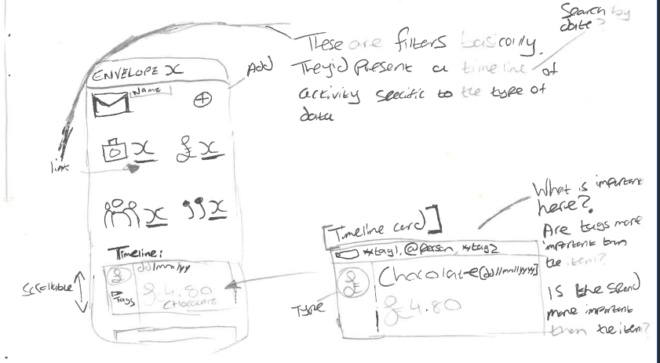
Figure 5.2 Early sketch of Accounting Scrapbook collections interface using envelopes
The notion of envelopes did communicate the idea of collections to Patchwork; who became relatively enthusiastic about it but did not like the term “envelopes” as it sounded very formal. Andi said that it was “weird” as envelopes were used “for letters and documents”. Brainstorming new terminology at Patchwork didn’t bear immediate fruit but after several site visits I was able to suggest framing the collections as Scrapbooks. The scrapbook metaphor was rooted in informality and flexibility as well as being an established practice of using otherwise disparate items to form a narrative (Christensen, 2011; Goodsell & Seiter, 2011). The team approved with Dean commenting that “Well scrapbooks always look a bit tatty, and that’s us like”. Following this the app was named Accountability Scrapbook and then later Accounting Scrapbook where the latter sounded “snappier” (Dean). The individual items in the app were also referred to as Scraps from then on.
Organising items into scrapbooks matched Patchwork’s organisation of their Transparency work into discrete activities such as “annual report” or “photos of lads group”. A key benefit of collections from the perspective of the staff (and the desired qualities of the dataset) was that they themselves could be given tags which rapidly could be applied en masse to all of the items stored within a collection – this made it possible to generate links between all of the items within a collection. The QA schema has no notion of collections so this was a way of ensuring that this semantic group was kept intact once the data had “left” the app to be sent elsewhere. From the point of view of the staff, this meant that they didn’t need to spend several minutes tagging each individual item (although tags could still be applied on an individual scrap to add even more context).
During my fieldwork and the design sessions described above I saw evidence of items being used for multiple contexts; a photo might be used in the annual report or put on the wall and a receipt may be used to provide evidence of a spend or evidence of work having been performed for a specific project. For this reason the ability to add a single item to multiple scrapbooks was added. Technically this provided the benefit of being able to add the tagsets of multiple collections onto a single item. I checked whether this made sense to Patchwork who agreed that it did although Sonia did query how it would work (“So I can move it to another one later?”) and I needed to explain that an item could be added to as many scrapbooks as one wanted at once.
To support staff differentiating between their scrapbooks I added the ability to choose a colour for the scrapbooks which would be rendered visually within the app (Figure 5.3). Not wanting to worry about which colour palette to choose I implemented a custom colour selector, although later when it came to evaluating the app there was feedback that the palette should have been more limited: “I found it hard to choose what colours to have, and it was hard to pick the same colour twice” (Andi).
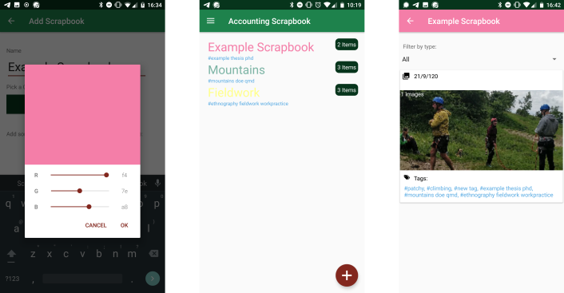
Figure 5.3 - The setting and presentation of colours within Accounting Scrapbook
The format for tags also required several iterations and design decisions. The initial sketches of the app gave the format of hashtags since I had checked this with the team beforehand and they were familiar with the concept. Initial design sketches also contained the provision for Twitter-like handles which could be used to reference individual people or workers where appropriate (e.g. @dean) which can be seen in Figure 5.2. Conceptually I envisioned these being treat the same way as regular tags except with separate semantics, but when I asked Dean and Andi about them they were confused as none of the team used Twitter or other sites where the “@-handle” syntax was used. Initial versions of the app also enforced the hashtag rules of “no spaces” (Doctor, 2012) in tags despite QA’s flexibility around tag syntax to try and leverage Patchwork’s familiarity with the concept. During later stages, however, Andi and Dean (by far the most engaged in the testing) expressed a frustration at this, and OPC has also fed back that they’d like to use multi-word tags. As a result the app was adjusted to allow this, alongside an interface change to make it easier to enter the tags.
The original interface for entering tags was a minimalist, proof-of-concept, field was used which allowed free-text entry and parsed tags as separated by commas. This remained in place until much later when I had asked each Patchwork and OPC to use the app across the space of a week. Feedback was that it was difficult to add tags easily as remembering to type a comma was difficult. Patchwork also noted that a small typo could result in using a different tag. I then implemented a slightly different interface with an auto-suggest box and list of tags which was populated one by one (Figure 5.4). Both charities reported that this was much easier to use following implementation.
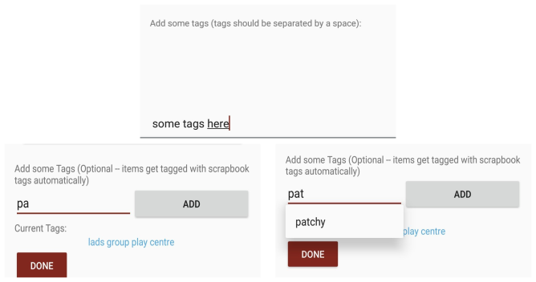
Figure 5.4 - top: The old interface for entering tags. Bottom-Left: New interface. Bottom-right: New interface demonstrating auto-suggest
Adding entries to a collection was done via the interface used for creating an entry and didn’t require any modifications after its initial development. When creating an entry a button labelled Choose Scrapbooks brought up a checklist of scrapbooks which the staff member could use to add the entry to multiple scrapbooks.
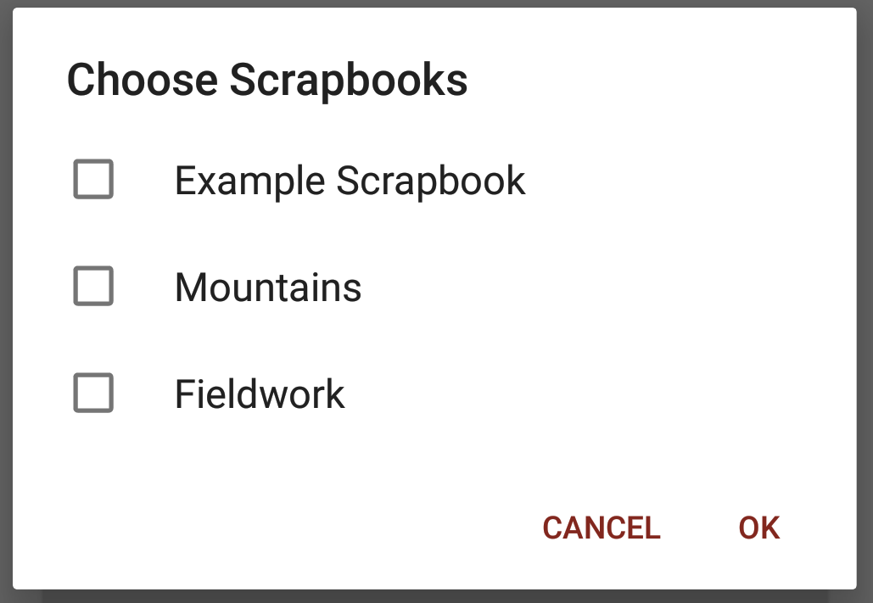
Figure 5.5 - Checklist allowing items to be added to multiple scrapbooks

Adding entries
Accounting Scrapbook provided the facility to capture several discrete types of entry which were called ‘Scraps’ colloquially and in-keeping with the scrapbooking metaphor:
- Images / Photographs
- Spending e.g. expenses
- Quotes
- Activities or Events (Location data with descriptors)
These types of entry were produced to mirror the components of the QA data standard (described above) as well as Patchwork’s work practice. Initial sketches of the interface did not differentiate between adding different types of entry and supported building it up iteratively but conversations with Patchwork indicated that would not be as intuitive as, to them, it seemed to contradict the goal of having a large number of items rather than a fewer, richer, entries. To address this I took post-its which each represented the different fields of the QA model that we had outlined several weeks before and sat down with Dean to start combining them in various ways to see if different combinations “made sense”. The exercise only lasted 20 minutes before Dean needed to make time for a drop-in but resulted in the four discrete types of entry that made it into the application. A rejected combination using fields for an Image and a Quote was nearly included as a fifth type but Dean changed his mind at the last minute saying that Patchwork collected quotes separately to images at times, and having too many types of entry would “confuse [Andi and Mick]”. Another key outcome of this exercise was that I managed to confirm my analysis that the staff did not want to manage income on the app as accounting for that was much less distributed and mundane. As such the application only has provision for spending. Internally, the application’s database does not differentiate between types of entry and instead stores all entries as a single class and displaying the different types of entry by checking a variable; this was to reduce overhead if the need for a new type of entry emerged from early deployments.
Adding entries is performed by selecting one of the options on the main menu of the application. Each of these takes a worker to a screen set up to gather this information (Figure 5.6), add tags to an entry, and add it to one or more scrapbooks.
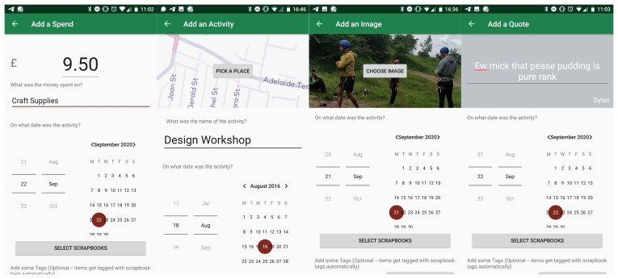
Figure 5.6 - Screens to add each different type of entry
While Add a Quote and Add a Spend screens were designed and implemented without any fanfare or excitement from the staff, the Add an Image section was one of the key areas Andi fed into the design of the app although this was after an initial deployment. My early sketches and the early versions of the application envisioned that staff members would take photographs using the app and tag them as they go. As noted during an earlier section; during an early evaluation of the application Andi contributed she found it would be easier if she could add multiple photographs at once. I agreed to change the interface to support this (which also involved a change to the QA model) while retaining the camera feature. Later that day I observed Andi taking many pictures at once during a play session and when she drove me home later in the evening she was reviewing them as I entered the car. I asked her whether she checked the pictures before sending them to Facebook and she replied that she did. Finally I asked whether it’d be easier for her if the app opened up her gallery to choose existing photos rather than take them to which Andi said that it “probably would”. These changes were implemented for the next iteration.
Similarly Add an Event required reviewing during an early evaluation stage. The interaction on this screen was actually fairly effective; staff could open a map which allowed them to choose the location for the activity using their phone’s native maps interface however staff were confused around term Events. This hadn’t come up during initial sketching and conversations to this point because critically they understood what the screen did and the interaction around it but what Patchwork called Events and what I had envisioned as Events were different things. I noticed this when, during an early evaluation, it was clear that none of the staff had collected any Event entries in the app and asked about it. Andi looked confused and said that “We haven’t had any events this week though” so I enquired about what they’d been up to and it became clear that they didn’t conceive of their group sessions, drop-ins, and mundane performance of work as “Events”. Feeling embarrassed, I asked what they thought of as events and Dean responded with “The AGM, the activity day down the play centre in the summer, stuff like that”. Searching for a term to bridge the gap I asked the group what they’d call their work activities to which Dean, taking the lead in this exercise, said “Just… activities!”. The rest of Patchwork nodded silently in agreement. As OPC were also involved at this stage (following design, and in initial evaluation) I checked this with them and they agreed that Activities was a better word.

Sharing data to decentralised services
As part of the system architecture required the transmission of data it was necessary to discern a way which would feel quick and simple for Patchwork to do this. Patchwork, as I expected, were less enthusiastic about this aspect of the app because it felt to them like it was my job to come up with something they could use.
My address of this was to include the ability to “share” scrapbooks with web services. Nicholas John writes that the act of “sharing” has become a key characteristic of participating in the social web (John, 2013). Sharing in this context is the act of contributing new resources (e.g. user-uploaded photos, statuses etc) or using one’s space on a channel to further distribute the content of others e.g. a re-tweet on Twitter (Yang et al., 2010; Starbird & Palen, 2010; Nations, 2021). It is often presented as a feature in social media apps, and phones can have a “share menu” where users may share content from one application to or via another. Sharing scrapbooks of information thus fit with contemporary web and mobile design languages and leveraged an understanding that Patchwork would already understand, especially Andi and Dean. This was checked with them early on.
I knew that there needed to be a way of adding and managing endpoints for an arbitrary number of services because Accounting Scrapbook was not designed to be tightly coupled with another service. Thus to share a scrapbook there needed to be a way of adding a place to “share it with”. A screen was added under the title “Manage Sharing Services” which would allow anyone using the app to connect it with the web service later. Originally this was done purely manually through typing out a URL as well as a “token” to facilitate identification (ie so that the receiving end could identify who was sending the data and assign it appropriately). The reason for this was expedience; Patchwork and myself had been designing the screens for the app for several weeks and it was harder to enthuse the team about this. At later stages when we were designing Rosemary Accounts I demonstrated connecting Accounting Scrapbook to the website. Andi and Sonia said it was confusing to type in the token and while Dean understood the process said it could be awkward to do it many times. A brief brainstorm resulted in a new feature to both Accounting Scrapbook and Rosemary Accounts which could be used to swiftly connect to services using a QR code and scanning using the Accounting Scrapbook application. Since some theoretical future web services may not require tokens to connect; I made this field optional and added a small icon to indicate that a token was present (Figure 5.7).
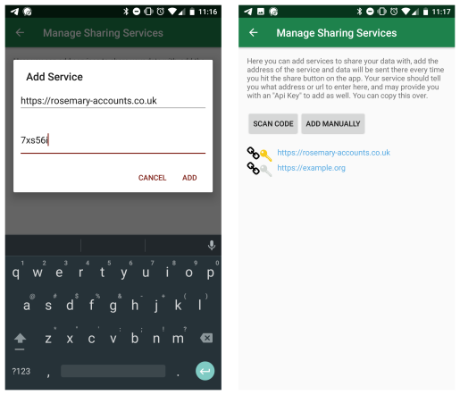
Figure 5.7 - Left: Adding an endpoint manually with a token. Right: Multiple endpoints shown on the Manage Sharing screen, one with a yellow key to indicate a token
Sharing is performed by then accessing the Share screen (Figure 5.8) on the main menu. Staff could select scrapbooks using a checkbox interface and then individual Share buttons were presented alongside a list of endpoints however in this research only a Rosemary Accounts endpoint was ever added. After pressing a Share button the application would begin the sharing process outlined in the QA transmission protocol and share media items (images in this case) and QA entries as JSON. A pop-up on the app indicated progress as well as notified of any errors.
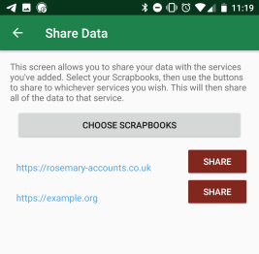
Figure 5.8 - The sharing screen showing share buttons for multiple services

Discarded feature: generating a spending report
To support the staff using the application and not duplicate their work early versions of Accounting Scrapbook also included the functionality to generate a short spending report in .csv format. This report consisted of a basic export of all of the Scraps with spending data with description, amount, date, and tags. The .csv file would be generated and saved to their phone. The reason for this is that if they committed to using the application in lieu of regular receipt practices it would provide a way to quickly “import” the spending data captured in the app directly into their existing spreadsheet. This was effectively a safety net so that if Patchwork had collected a large amount of data it would not be lost if deployments did not go well.
Initial evaluation and discussions following this indicated that, contrary to my estimation that it would provide reassurance, this feature actually introduced ambiguity into the use of the app. The workflow so far was established by analysing how receipts were collected and processed (Figure 4.3) and building on these. In effect Accounting Scrapbook was trying to provide ways to make the Acquisition phase easier by facilitating the transmission of spending data. The ability to generate a short budget report file broke this established work practice by introducing a new potential job of work that didn’t fit the organisation. For this reason it was removed as a feature.

Technical Implementation Details
This section briefly outlines the technical implemenation details of the Accounting Scrapbook application.
Accounting Scrapbook was designed and build as a mobile application targetting the Android platform (Google, 2021). It was build natively for Android using the Android SDK tools provided by Android. Android was targetted as a platform for practical reasons: most of Patchwork staff had Android phones, and those that did not could be provided with phones owned by Open Lab; I owned an Android phone myself for testing and debugging initial versions of the application; and I did not possess a Macintosh machine which was required to develop an iOS version of the software. At the time of development, the latest version of Android was Android 7.0, so the development tools were configured to target this version of the platform as well as several versions prior to account for older versions of the system that my participants used.
A key external library that was used in the development of Accounting Scrapbook Realm (Realm.io, 2021), a persistance library that promised greater efficiency and ease of development compared with the native Android database tools. This was used to model the classes for the Collections, Tags, and Items.
My own Android phone does not include key featues provided by Google such as Google Maps, and therefore I was aware that I needed to develop a method of allowing the user to select their location from a map even if Google Maps was not installed. This was to account for my own ability to debug the application, but also I felt increased the application’s attractiveness to the broader Open Source community and would permit the application to be distributed on app stores such as F-Droid (F-Droig.org, 2021) following the research. To effect this I built a lightweight location chooser using resources from OpenStreetMap (OpenStreetMap, 2021). In practice, Accounting Scrapbook checks whether the user’s phone has Google Maps installed and prefers it if present. This is because during this research I was more likely to encounter participants who were using Google Maps. If Google Maps is not found, then the app opens up the lightweight location chooser instead.
In a similar vein, a technical challenge that I was presented with during the development of the application was how to support the capturing of QR codes for users. This was because there was a potential that not every user’s camera would support parsing QR codes and returning the result. This was achieved by integrating a QR capture library (Owen, 2022) into the application which is called regardless of the user’s own device.
The source code for Accounting Scrapbook is available online.
I now turn to the design and implementation of the final component of the design used in this research, Rosemary Accounts.

Rosemary Accounts
Once Accounting Scrapbook was in a place where it looked like it may be an effective way of allowing workers to collect data my attention started to turn to designing a place for this data to go. From my fieldwork working with Patchwork’s spreadsheet and observing Andi selecting photographs to share I knew that there needed to be some process of curating the accounts before they’re presented to stakeholders. Like with Accounting Scrapbook, the initial stages of design were the result of brainstorming activities either by myself or with Patchwork staff where available. Unlike with Accounting Scrapbook the staff who were most engaged with this process (Andi and Dean) were not those who I envisioned would be directly using the system (Mick and Lynne) due to Lynne’s limited time at the office and requirement to focus on her work at hand. This meant that I had to rely more on both my own understanding of the setting from my fieldwork, as well as the other staff’s natural reflexivity as members. In short; because Andi and Dean had a broad understanding of Lynne’s work and how she performed it I could rely on their accounts for some degree of insight to inform design in matters where my fieldnotes were sparser.
The result of the exercise was a web application called Rosemary Accounts, which was designed overall to superficially imitate the trappings of a professional accounting system such as Sage accounts (Sage UK, 2021) to facilitate the curation of financial data (activities such as reconciling transactions and managing income). A web application was chosen as the implementation technology for this for several reasons: firstly, the scalability of a web application meant that I did not need to be concerned about installing the application across participant machines and that updates could be issued easily; secondly, it provided a central point to collect information during the study. This meant that during evaluation, it would be easy for other stakeholders to find and evaluate the information that my participants had collected.
An additional design concern for the system to address was the social elements of Transparency noted in Chapter 04 such as the creation of contexts to present to others. This meant that I needed a way to explore both: the interface requirements to support Patchwork (and other organisations) in curating the datasets; and interfaces for presenting these contexts to others. Therefore there were two main functions or “facets” to the application:
- a user-area using metaphors and screens similar to a web accounting application. This was to support organisations curating and organising their data.
- a front-facing “profile” page for each organisation which was accessible to the general public. This went through some key interactional changes which are detailed in the Public-facing data with profiles, reports, and timelines section.
When questioned about the purpose of this “website” by Patchwork I explained Rosemary’s as “Sage Accounts and Facebook mixed together. But hopefully not rubbish”. Dean raised his eyebrows and nodded, Andi seemed disinterested, and Mick replied “alright then.”. Core features central to the QA data standard were also carried over such as the presence of tags and support for the different fields outlined in the schema.
The name Rosemary Accounts was derived from an in-joke between myself and Mick at the beginning of designing this application. I said we should be looking to do “one better” than Sage Accounts (the de-facto standard that Mick was standing in defiance of) and he replied “What’s one better than Sage? Like Parsley, Sage, Rosemary, and Thyme?” in reference to the folk ballad Scarborough Fair (Wikipedia, 2021). We chose Rosemary as the item that came immediately after Sage thus accomplishing our goal of “doing one better”.
Design and development on Rosemary began near the end of January 2017 and progressed slowly, taking several months. Patchwork were the ones mostly involved in the design process early on but I noted a lack of interests compared to other engagements particularly Accounting Scrapbook. My interpretation of the reasons for this is that Andi and Dean, by far the most enthusiastic participants in giving me feedback, were not going to directly use this system so it was not central to their work practice. As noted, Lynne was harder to get hold of due to limited hours so my interactions with her were more limited although I did manage to use our sessions curating the spreadsheet to ask pointed questions and show her screens or sketches. She did proffer feedback but I often left the field site that my academically-informed grand visions of participatory design were not manifesting as planned. Thus I was left to rely on the requirements set out by my field notes and the brief reviews of sketches and interfaces that I could wrangle from Mick or Lynne.
In May 2017 I was building up to a trial deployment of Rosemary Accounts and I met the CEO of Community Project Gateshead who expressed interest in participating (noted in Section 5.3 of this chapter). Before deploying the system I had several meetings with them and OPC to demonstrate Rosemary and Accounting Scrapbook and solicit feedback. They raised important design issues that had not come about from my interactions with Patchwork that affected a key interaction on the public-facing portion of the site. This needed to be adjusted before deployment and I discuss the design rationale behind this in Section 5.9.4.5
I now turn my attention to describing the features and interactions that Rosemary Accounts supports.

Managing income
Managing income is a key part of financial data in charities that was still left unaddressed by Accounting Scrapbook. In Patchwork’s spreadsheet there is a tab for managing income streams from grants, and with the Play Centre (Patchy 2) being hired out to groups it made sense to try and accommodate potential income from this as well. To begin the design process for this I signed up to a free trial of the web based version of Sage accounts to understand the design features of the interfaces. Lynne and I spent half an hour together understanding which features would be useful and I later sketched some ideas out. After sense-checking these findings with Mick and Lynne where possible I began implementing them.
From these chats with Lynne and my previous fieldwork it became clear that the core requirements of the interface were to: keep track of where income is coming from and whether it constitutes a “funding pot”; or whether it is in “unrestricted funds” for a charity. Initially I thought to explicitly establish funding pots to make it easier to tie expenditure back to each. However Mick and Lynne reminded me that, generally, a single grant constitutes a pot and that most of their unrestricted funds would be coming from the Play centre so it might be unnecessary and would create an extra administration burden that Lynne needed to manage. My fieldnotes confirmed that a spend is retroactively applied to a grant by Patchwork rather than through creating a specific interaction around pots.
To address this I made it so that Rosemary Accounts supported the creation and management of Customers and Funders, and added screens to Add Income which would create QA data entries for incoming money. Importantly; the system distinguished Customers and Funders as any incoming money associated with a Funder would be classed as a grant whereas income from a Customer would have the income totalled as unrestricted funds. This was grounded in the fieldwork as Patchwork were noted to be hiring out the Play Centre building, and as such the design needed to accommodate this. This also had the benefit of the system being able to infer a particular level of unrestricted funds; as all income derived from “Customers” would be unrestricted.
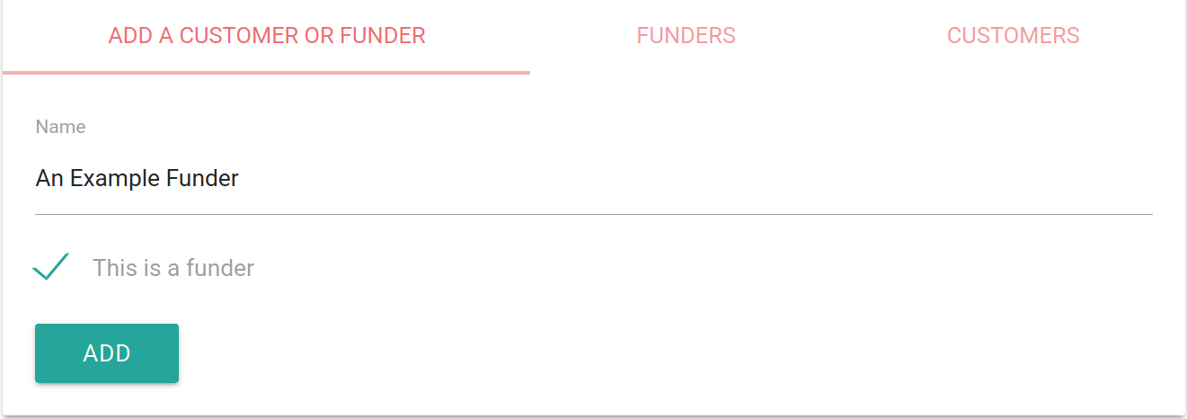
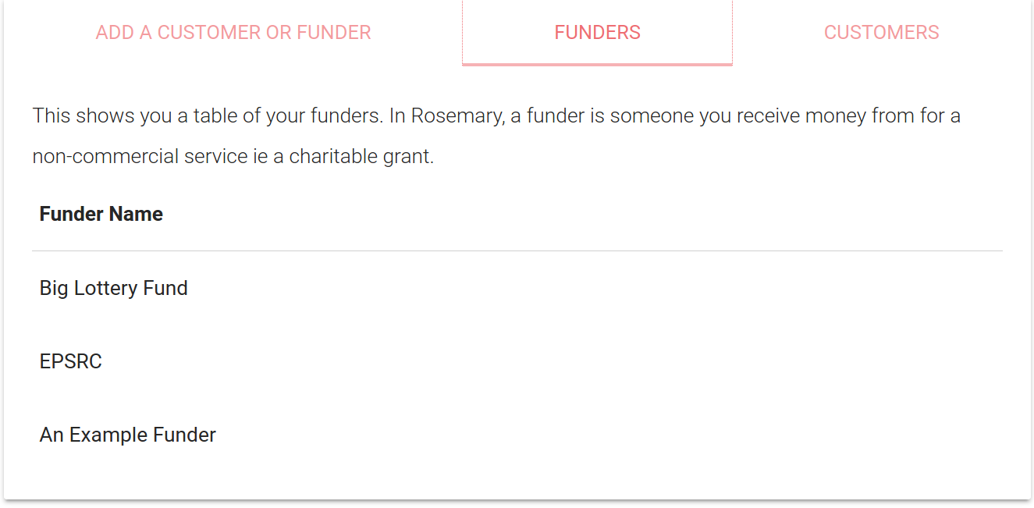
Figure 5.9 - Adding and displaying Customers and Funders in Rosemary Accounts
When adding income (Figure 5.10) Rosemary enforced that it should be associated with a Customer or Funder in order to minimise additional work later. The system retrieves a list of all Customers and Funders and requests that income is associated with one.
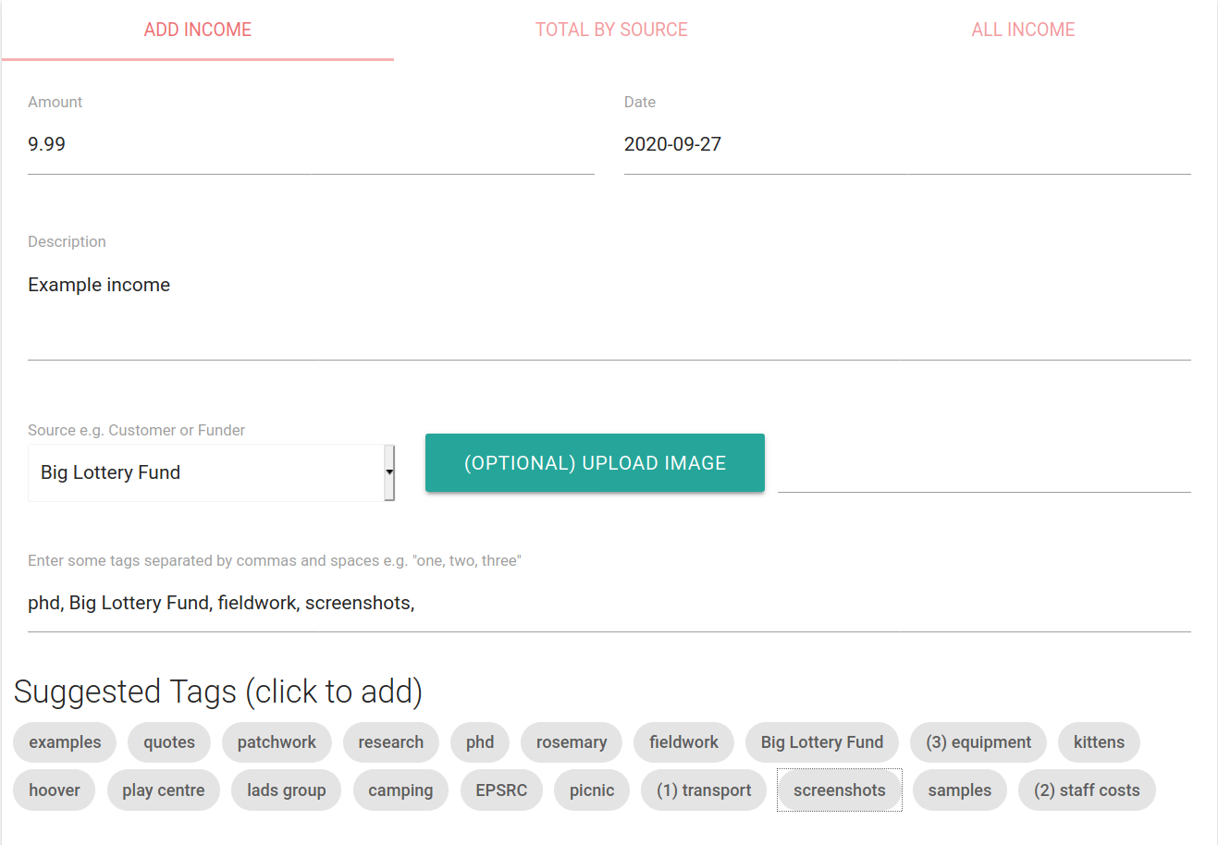
Figure 5.10 - The form to add income to Rosemary Accounts
During some initial evaluation sessions it became clear that manually typing Tags and Budget Codes for income was not natural to either Lynne or the administrator at OPC. I asked whether having a list of the most popular tags would help, to which “Sure you could try that” was the best answer I managed to elicit from Lynne. For this reason you can see in Figure 5.10 that the form suggests some of the most commonly used tags in the system. Click a tag will add it to the form field.
The next core requirement that emerged from interactions with Community Project Gateshead and OPC was the support of Budget Codes. While Patchwork do not use Budget Codes, many other organisations do use them to help label expenses. After chatting with Community Project Gateshead and OPC it was decided to implement Budget Codes to accommodate these participants. A short in-situ interview with each of these new participants revealed that budget Codes are used in many ways by organisations: some have only a few, some many; some organisations may give them a numeric code, and some choose not to; some allow multiple budget codes to be applied to an expense, whereas some are strict and allow only one. When considered like this Budget Codes effectively take the same form as Tags in that they are short qualitative descriptors that can be applied to mark up information. Because of this, Rosemary stores Budget Codes internally as Tag entities which were included for compliance with the QA standard, with additional optional properties to flag them as a budget code. I then provided an interface to add Budget Codes explicitly to the system without an associated item (Figure 5.11).
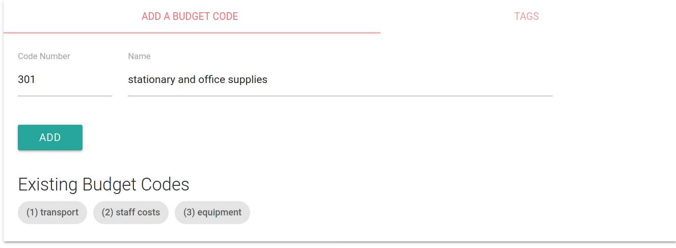
Figure 5.11 - The form to add Budget Codes to Rosemary Accounts
As Budget Codes and Tags were related I also provided a search feature on this screen (Figure 5.12) to allow Patchwork and the other organisations to search for individual items via their Budget Code or Tag and to see the tags they had in the system. This was initially added to the My Activity screen described later but feedback from Lynne and OPC indicated that the administrators would prefer it to be closer to where they add Budget Codes. The interface allowed an administrator to search for multiple tags and presented the results. Items which possessed all of the tags were forefronted, and then individual searches for each of the other tags in the system were presented alongside. This was to ensure that items could be found effectively without needing to know their exact combination of tags.
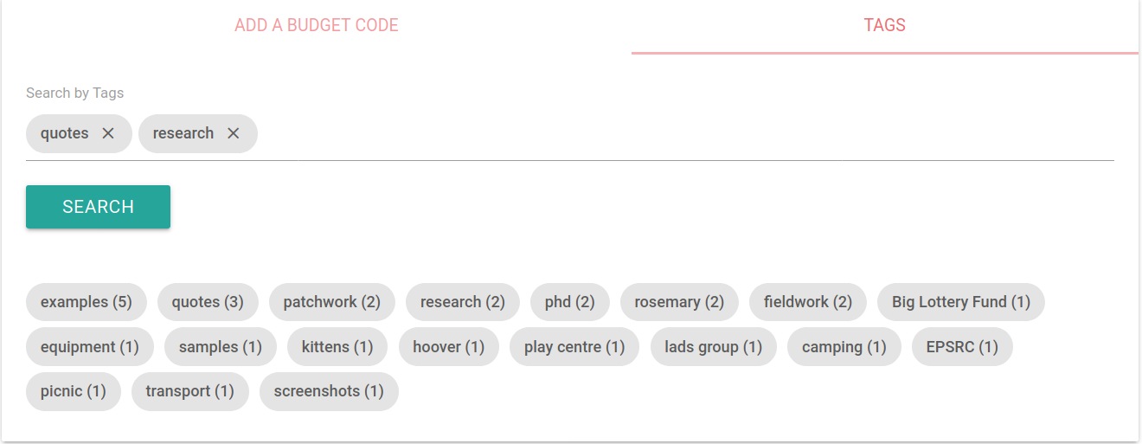
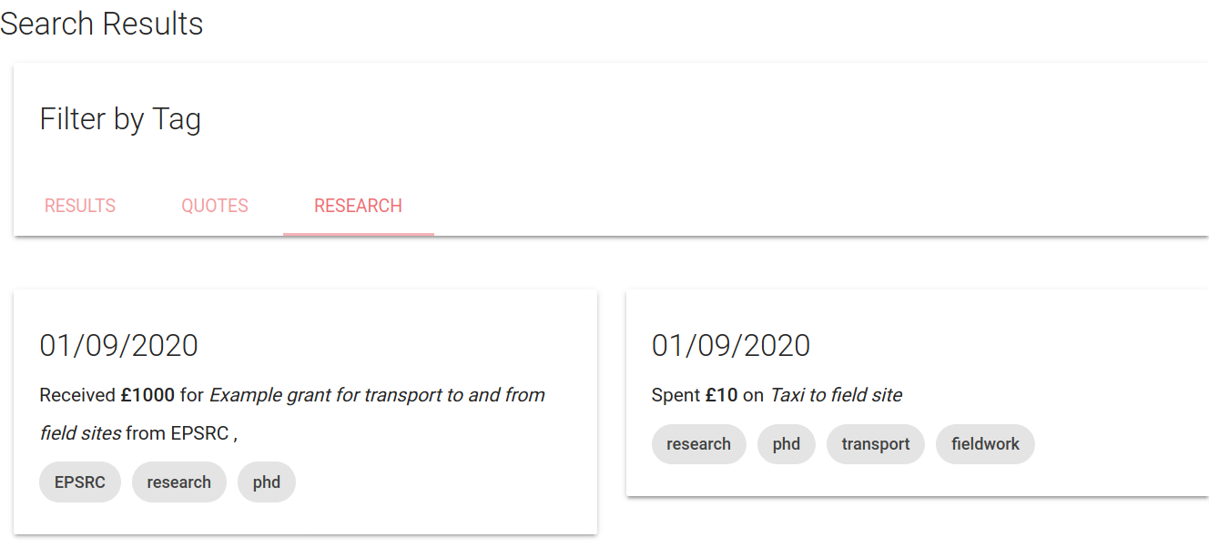
Figure 5.12 - Searching for Budget Codes and Tags
The only other requirement related to income that emerged from discussions with Mick and Lynne was the reconciling of income against bank statements. Since it was not feasible to automatically extract bank transactions in the given time-frame and scope for this research (a feature present in accounting systems such as Sage) we collectively decided that it was out of scope for Rosemary, and that Patchwork would rely on logging the income there and using their existing practice of reconciling via the accountant and spreadsheet.

Receiving and Sorting incoming data via the In-tray
As Rosemary was designed to exist as part of a theoretical ecosystem of tools, and be compatible with the QA data standard it needed to have a way to receive incoming items that were sent from either Accounting Scrapbook or another theoretical origin point.
The QA standard dictated that Rosemary provide facility to upload QA entries and media via api endpoints so this functionality was provided. In order to accommodate multiple organisations during the trial and identify data appropriately Rosemary allowed each organisation to add unlimited “tokens” to the system. These tokens would allow a sender of QA data to identify which account the data belonged to, and also prevented unauthorised items being added to the account. Rosemary provided an interface (Figure 5.14) to quickly add tokens which were designed to be inputted into applications such as Accounting Scrapbook.
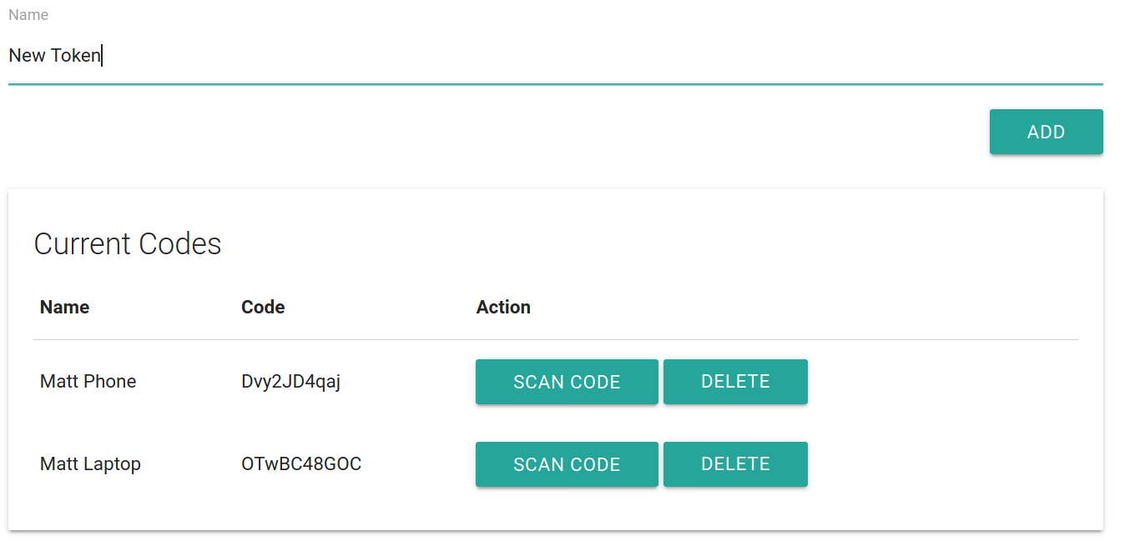
Figure 5.13 - Adding a token to Rosemary Accounts
As noted in an earlier section, it was highlighted by Patchwork that it was awkward to add in the tokens on the Accounting Scrapbook app. To facilitate the ease of this I implemented a QR code feature on Rosemary Accounts. This would generate a QR code for each token (Figure 5.14) which could later be read by Accounting Scrapbook to connect the app and transmit the token and URL easily.
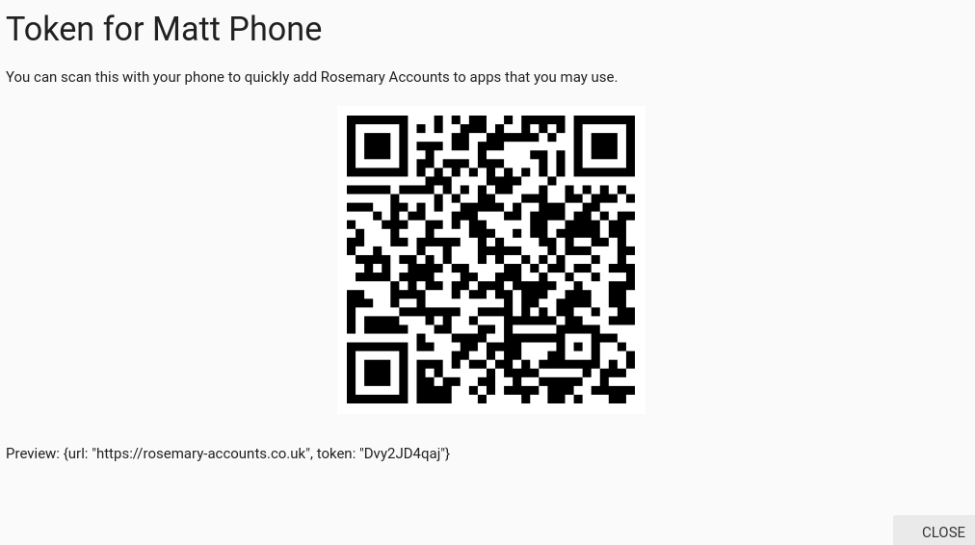
Figure 5.14 - Turning a Rosemary Token into a QR code for easy scanning
Another technical challenge was posed by Community Project Gateshead who requested that, if they were to participate in the research, they’d like to be able to upload their existing income and expenditure spreadsheets to the application so that they could make use of it straight away. I ratified this with OPC and Patchwork who agreed it was a good idea. One of the key challenges was that each of the organisations used different spreadsheet templates within their organisation which needed to be accommodated. This presented three options: ask that the organisations each go through an intermediate step of standardising their spreadsheets; write custom parsers for each organisation’s spreadsheet; or allow for variation and ask a user of the system to perform a simple configuration task.
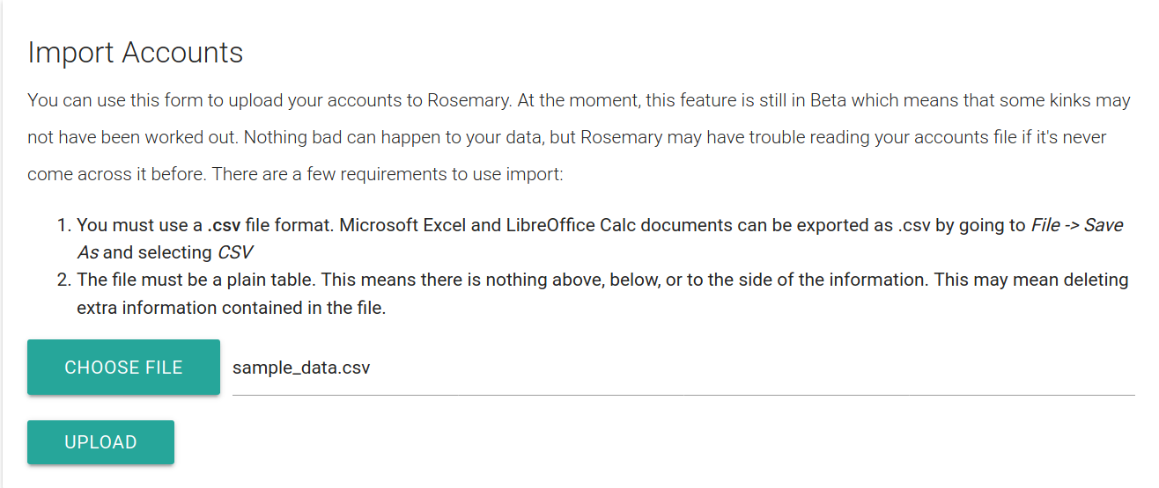
Figure 5.15 - Uploading an accounting spreadsheet to Rosemary
Investigating the options with each Community Project Gateshead and OPC (Patchwork staff were unavailable) immediately discounted the idea of standardising templates across the organisations as the staff were already busy. Eventually I decided to allow for variation and designed an interface to support “wiring” columns in a custom spreadsheet to the fields in Rosemary. First, a staff member uploads their file (Figure 5.15) after ensuring that it is a plain CSV file (ie no aesthetic formatting and empty cells). Next, they are presented with a sample of their data to check that it appears as expected (Figure 5.16).
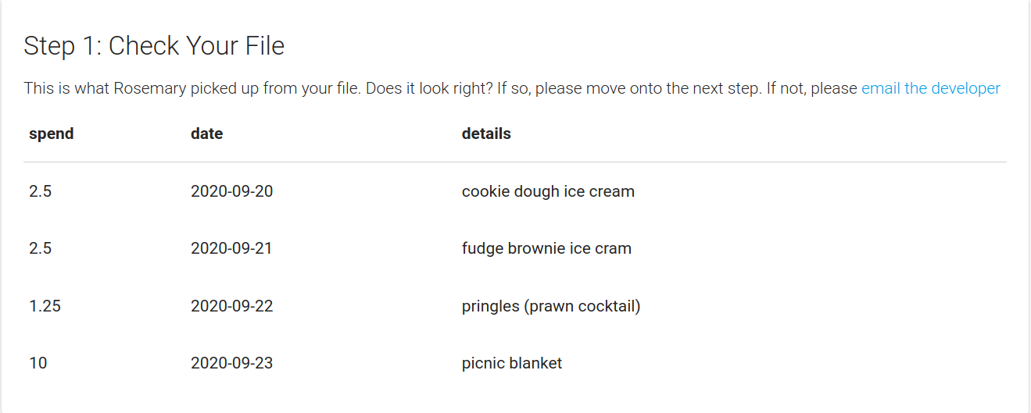
Figure 5.16 - Checking that data has been interpreted correctly
Finally they are presented with some simple questions about the “shape” of their data in order for Rosemary to build a mapping between their own columns and those used the application (Figure 5.17). After doing this the data is parsed and entered into Rosemary’s database for approval.
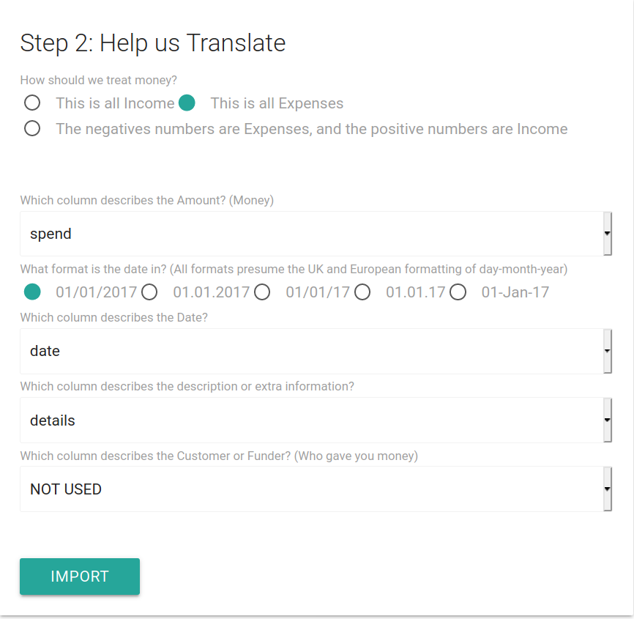
Figure 5.17 - A staff member can instruct the system on how to interpret their data by selecting which field maps to concepts in Rosemary
This meant that, as a system, Rosemary was more sustainable as it didn’t require custom parsers for each new organisation, and the configuration required by a member of staff was kept to a minimum.
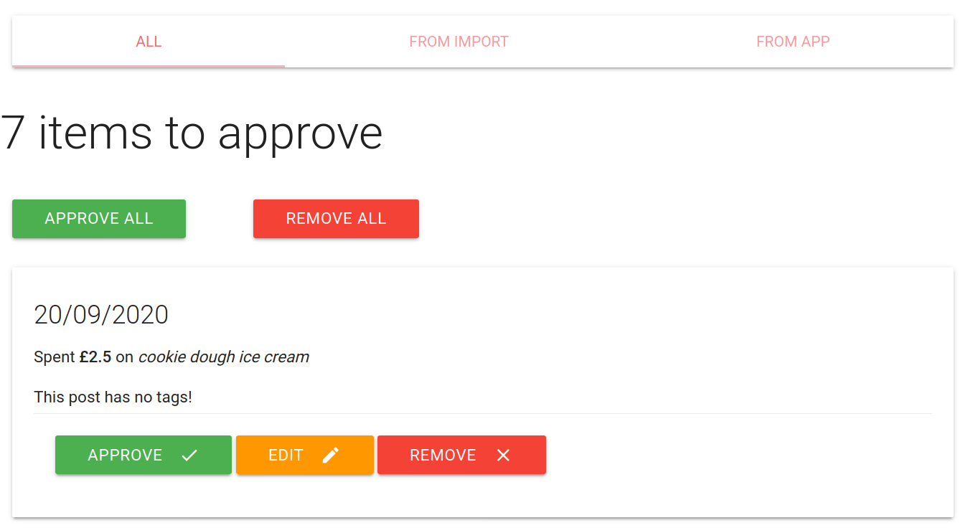
Figure 5.18 - The Rosemary In-Tray with items to process
Finally, with multiple ways to get items and data into the application from elsewhere (via either spreadsheet import or the QA-mandated API) there needed to be a way of identifying which new information was entering the system and that it was as-of-yet uncurated. The In-Tray screen (Figure 5.18) was developed by observing how staff at Patchwork dropped off expenses and receipts to Lynne for (Figure 4.3). Receipts are placed in a wallet or tray and are then retrieved for later processing. When items are imported to Rosemary via either an application like Accounting Scrapbook or via file upload they are flagged as “unapproved” and appear in the In-Tray. A small notification was added to support the staff member using the system that they had new items to process (Figure 5.19).
Figure 5.19 - Notifications were used to highlight that items needed attention
Feedback on the In-Tray resulted in a few iterations on its design. During an initial evaluation period the interface was originally labelled the Inbox but both Lynne at Patchwork and the administrator of OPC thought that it was confusing; that the term Inbox was synonymous with email. After changing to the In-Tray (in reference to Patchwork’s box of receipts) both staff members were satisfied that it was appropriately labelled. Additionally, staff using the spreadsheet upload feature noted that they’d like to find those items in the In-Tray straightaway and deal with the ones uploaded via Accounting Scrapbook later. To address this I added tabs to the screen differentiating items by how they were imported. Further to this it was requested by the OPC administrator that I add an “Accept all” button to the screen so she could process large numbers of items. I also added a “Reject all” button to complement this feature.

Supporting Costing to draw links
Costing work was observed to play a significant role in the production of reporting to charitable funders. During “costing”, an expense is set against a particular income stream; usually retrofitted and presented in a way that matches the funding restrictions. This can be done for several reasons: to use up money from a particular fund so that the charity does not have to give any back; or to free up money for an expense that otherwise cannot be costed elsewhere in the current funding environment. At Patchwork Mick was the one who performed the costing work as he was the the one who was most in tune with the funding requirements, although he would often consult with Andi and Dean for clarifications and reminders on various projects. I checked this with the CEO of Community Project Gateshead and the Manager at OPC; both of whom agreed that “everyone does it. Funders know.” (OPC manager).
From a data perspective, the “costing” of expenses to income allowed a direct line to be drawn between two items. Despite this not being necessary or accounted for in the QA standard, it was necessary and useful to allow this in Rosemary as part of the curation step to support managing a funding pot. An interface was implemented to support costing work (Figure 5.20); in this interface a worker may look over their funders and grants associated with each funder. They then may take any expense that is “uncosted” and associate it with the fund and maintain an overview of the amount left from each grant. Conversely, they may “Uncost” an item to remove it from the fund.
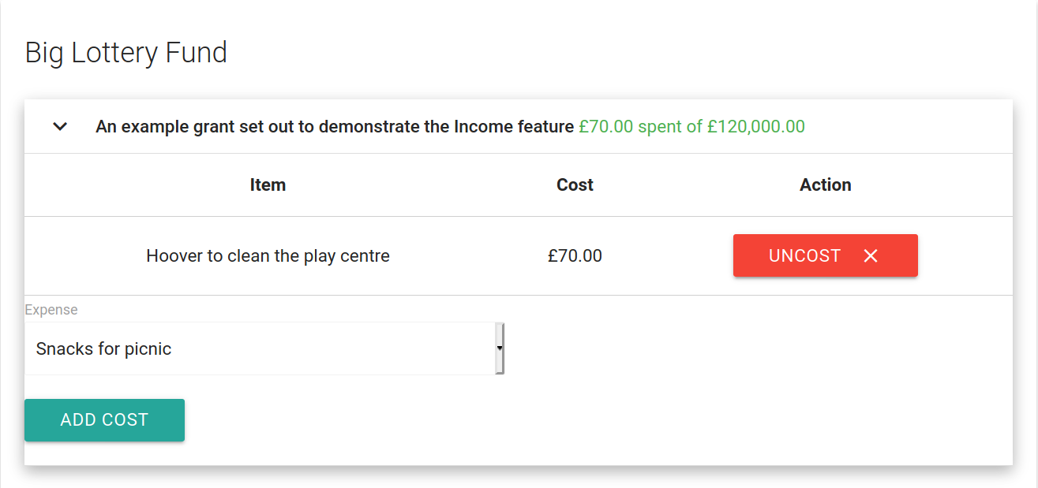
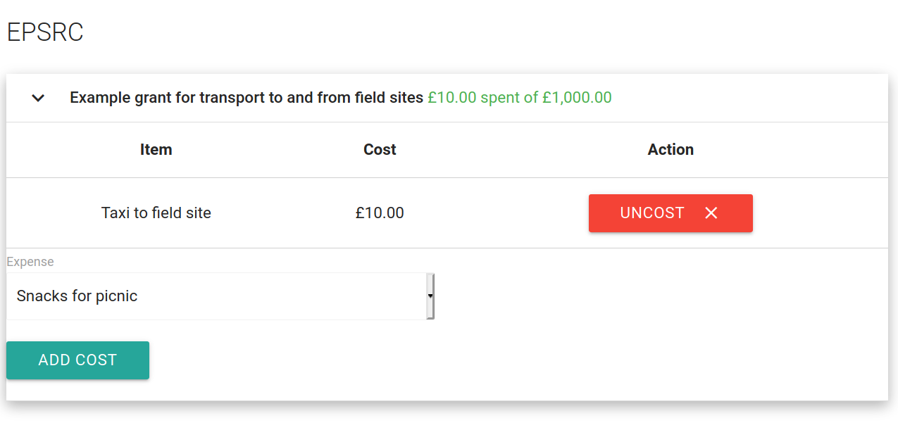
Figure 5.20 - The Costing screen in Rosemary Accounts allows a manager to see their funding pots and associate costs to them

Adding and viewing Non-Financial Data
I knew from my fieldwork that although it was likely Mick and Lynne wouldn’t be using the Accounting Scrapbook application, that they might want to edit some of items that came in in order to make them more ready for reports. It became necessary then for Rosemary to support adding various types of item similar to Accounting Scrapbook, and to display these.
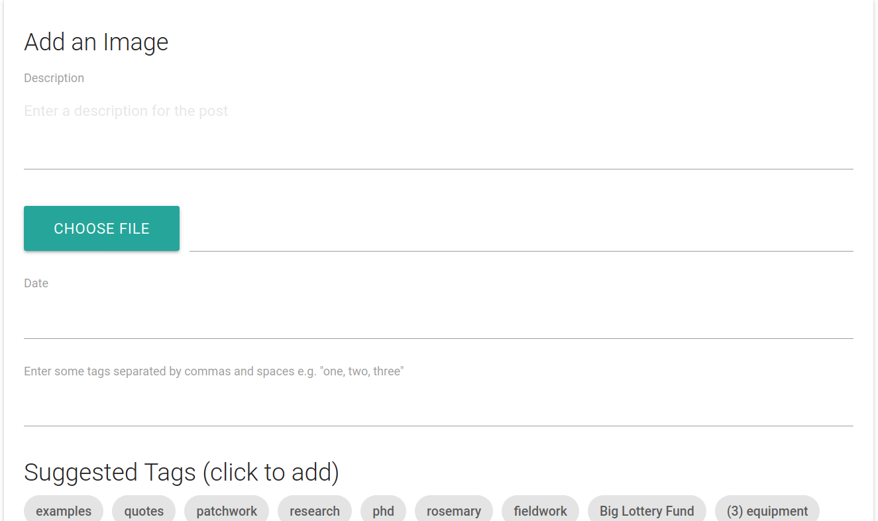
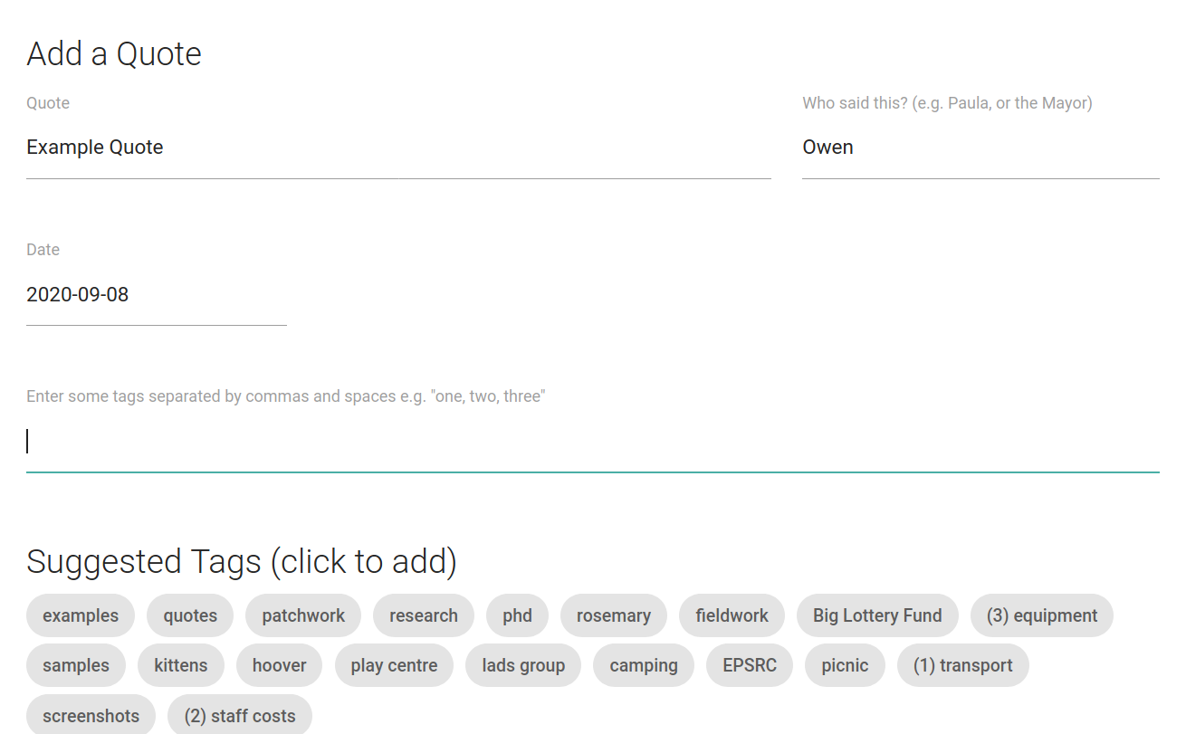
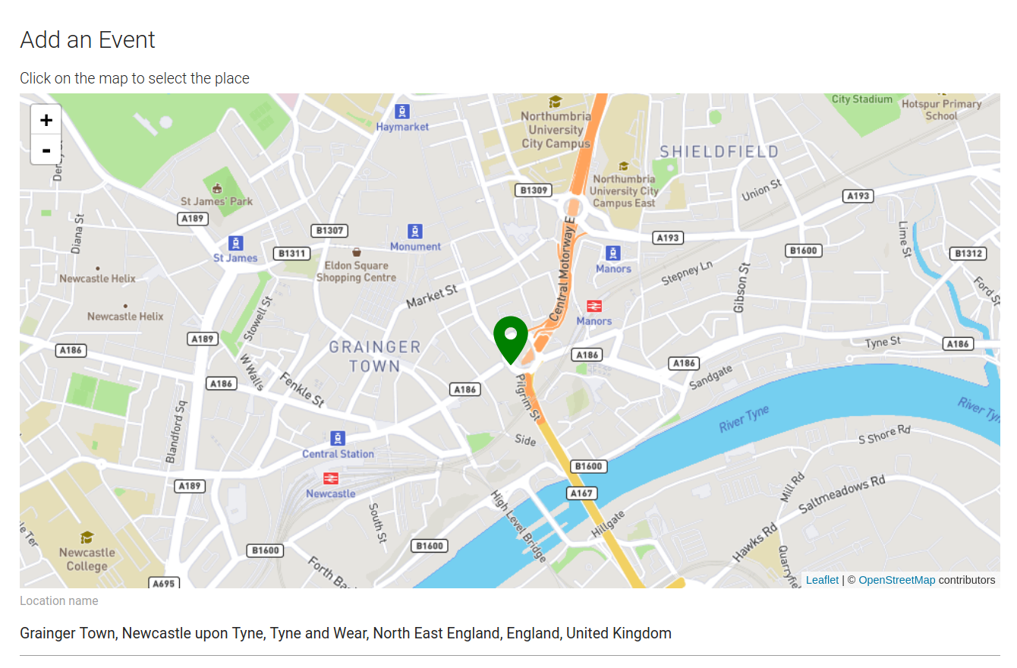
Figure 5.21 - Interfaces supporting adding data directly to Rosemary Accounts
Several interfaces were developed similar to Accounting Scrapbook in order to address this need; allowing a user of Rosemary Accounts to add information directly to the system (Figure 5.21) as well as edit items individually (Figure 5.22).
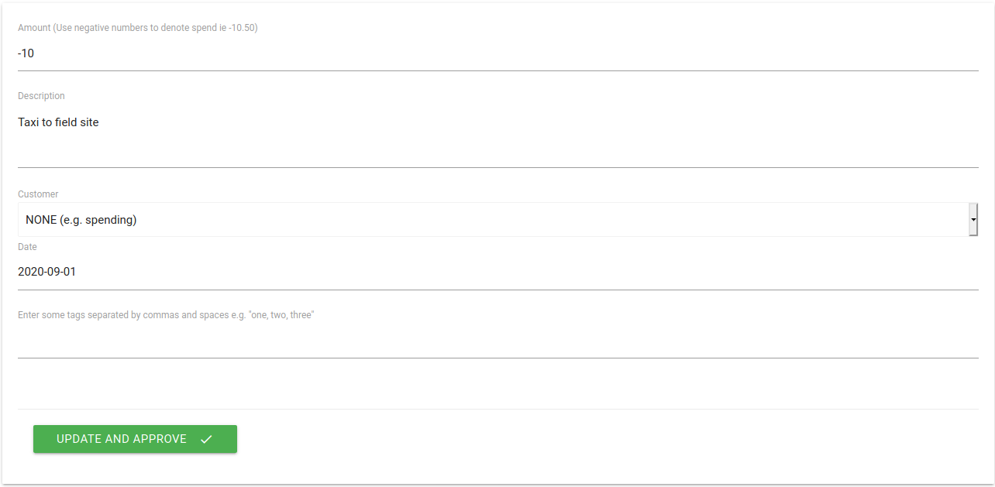
Figure 5.22 - Interface supporting editing of an individual item
Finally, it was required to display these items in the system. The QA schema we had developed did not delineate between different types of items so there was no programmatic way to discern whether an item was a spend, or an activity etc. Indeed this was the purpose of having such a flexible schema. To use this ambiguity as a resource, Rosemary didn’t impose arbitrary delineations of different types of item where it came to display and instead treat each item the same. It added different visual components based on the fields that were present in each item which allowed for receiving different types of combinations from theoretical future systems. This meant that despite neither Accounting Scrapbook nor Rosemary itself supporting the creation of an item with every field in QA populated, it was theoretically possible to display if the research had resulted in more systems being designed.
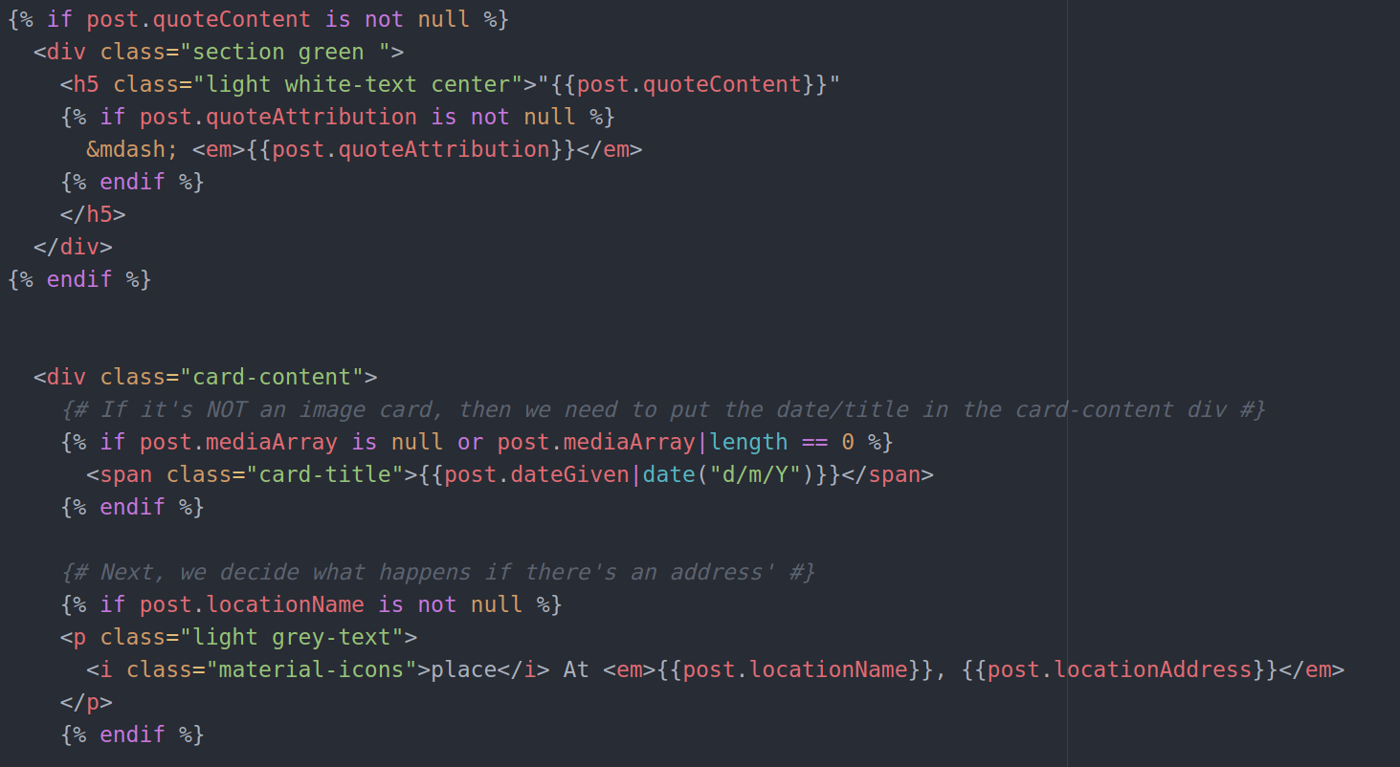
Figure 5.23 - Application logic to display an item. Highlighting decisions that the system makes about how to display various components

Public-facing data with profiles, reports, and timelines
As noted earlier a design goal of Rosemary accounts was to explore interfaces for the presentation of data about charity work and spending. For this reason a public-facing element of the application was designed to support this. Initially the heavy use of social media by Patchwork influenced the inclusion of a Facebook-style profile page which provided a live feed of items in the system (Figure 5.24). The purpose of this page was to act as an alternative form of summary page suitable for a variety of stakeholders, contrasting the reporting style present on the Charity Commission. There were also several pages branching off of the main profile page:
- /gallery; a portal collecting all items with image data.
- /where; a portal collecting all items with location data, displaying interactive maps.
- /tags or /what; a search interface for a visitor to search for items based on combinations of one or more tags.
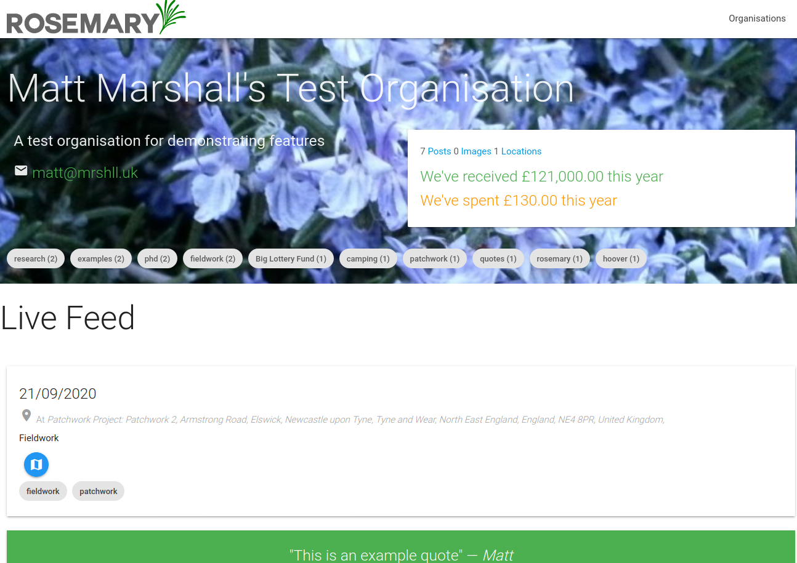
Figure 5.24 - The Live Feed of an organisation’s profile page on Rosemary Accounts
Patchwork were initially relatively enthusiastic about the social media timeline although Andi did ask why “Why [she] shouldn’t just use Facebook”. After a quick discussion about how items in Rosemary were (theoretically) linked to the accounts she was satisfied that it wasn’t just duplication of work. Later, discussions with both Patchwork and Community Project Gateshead lead to the adjustment of the profile page’s core interaction. Community Project Gateshead raised a concern that it was inappropriate to display a “Live” timeline by default due to pictures of their vulnerable beneficiaries potentially being in the system. I agreed this was an overlooked concern as Patchwork’s social media practices may differ, but when I checked this with Mick he also pointed out that an organisation’s live budget was an inaccurate reflection of their finances until finalised for the year (since spends are moved around). He also conceded that he’d feel uncomfortable not knowing who was viewing the images of the young people at Patchwork; as the Facebook account allowed Patchwork a degree of control and understanding as to who could access the images.
To address this concern I redesigned the profile page around the publication of “Reports” which were curated sets of items that presented a particular overview or context. This tied in to the original plan to implement Reports as a feature, but the concerns raised by Patchwork and Community Project Gateshead meant that this was centred as a more prominent public-facing interaction. As part of this redesign there remained the option to enable a “Live Timeline” through a settings page (Figure 5.25), and the profile page defaulted to showing published reports. Any items that were published via report were made visible by requirement so could be explored as individual items.
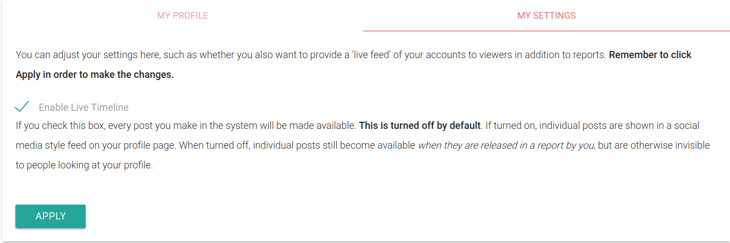
Figure 5.25 - The settings allowed an organisation to explicitly enable a “Live Timeline” of their activity
Reports in Rosemary were designed to be a flexible way to produce summaries of work and spending, mirroring the way information is recombined by the organisation for various audiences offline already. This was in effort to build in the Configurable Transparency that was introduced as a design requirement in the last chapter. Reports are modular and consist of various different components that may be omitted or included to present a particular view of the organisation’s work and spending. Each of these modules was included based on discussion with Patchwork and OPC and sense-checked for appropriateness.
To create a report (Figure 5.26), a worker gives the report a title e.g. “January Manager’s Report”, “Trustee Report”, or “Public Report 2018” and then sets a number of parameters for the report.
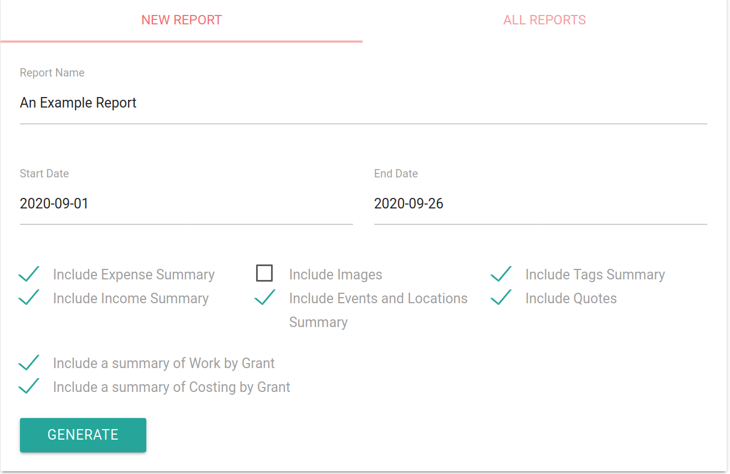
Figure 5.26 - Form to generate a report in Rosemary Accounts
First, they must bound the report by date to create a snapshot of time. This is achieved setting a Start Date and End Date. This allows information to be given context through tine, and was based on the observation of reporting on time-bounded activities such as at 6-weekly trustee meetings at Patchwork, or reporting to funders about activity in a particular time-frame.
To report on financial information, there were options to include an Expenses Summary and an Income Summary (Figure 5.27). These are things often included in management accounts reports and I saw similar reports being presented to trustees. The output of this was to give headline figures of total expenditure alongside the most commonly used tags for the items and highlighting the cost centres via Budget Codes. For Income this was simply listed and totalled. Originally I had thought to include a tag summary for income, but when asking Mick about this he responded that trustees mostly just wanted to know that “[Patchwork] is going to last another six months” and that it may confuse them having so many words on the screen.
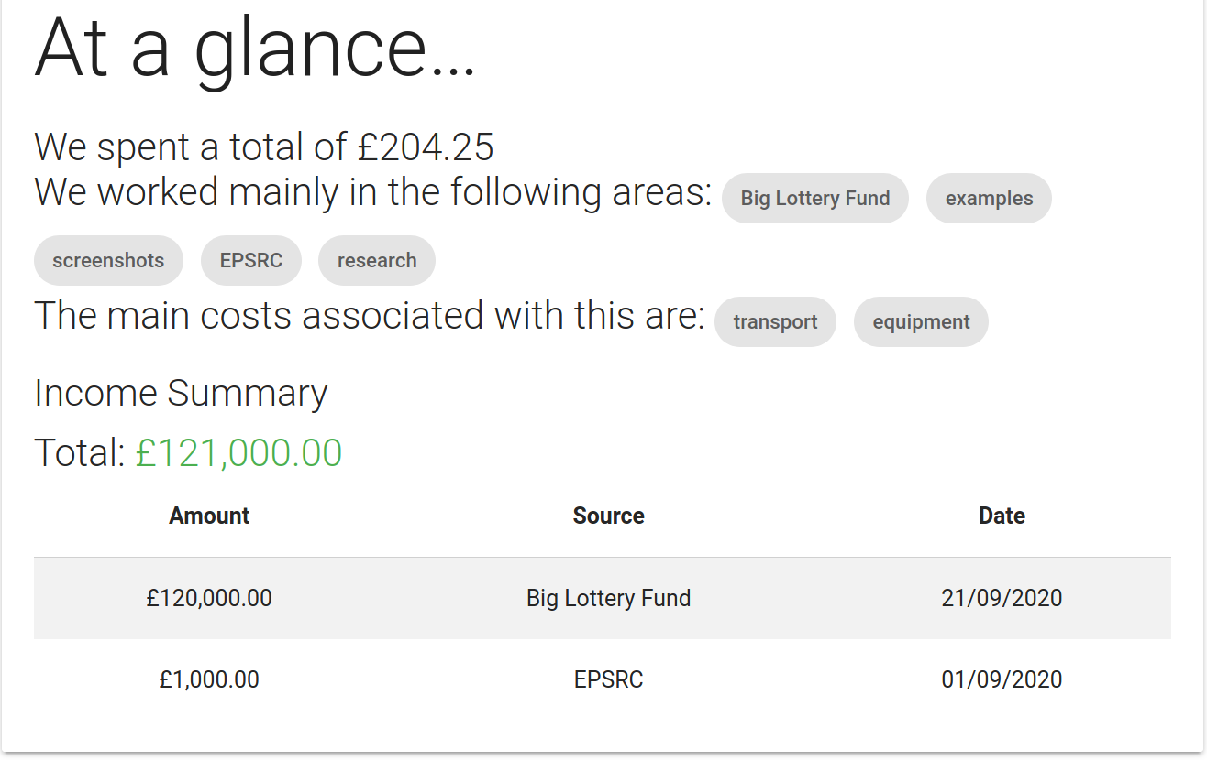
Figure 5.27 - Expenses and Income Summaries
Selecting Images for inclusion in the report displays a gallery of images collected during the time period without the tags or description. This was added to support organisations such as Patchwork who made heavy use of images as evidence; even if they could not use the report from Rosemary directly in their report to a funder then they could use it to collate which images were relevant.
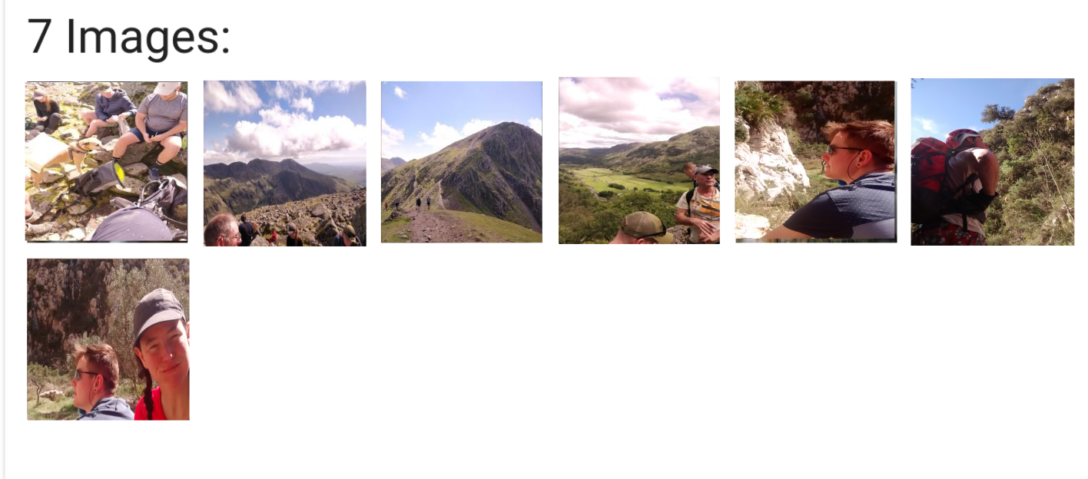
Figure 5.28 - Images in a report. Images were collected as part of fieldwork and I have explicit permission to publish in this thesis
Reports also features the ability to summarise Events and Locations which displayed a total for, and details of, items marked with location information during the time period. This was implemented to support Patchwork totalling the number of activities they’d performed across e.g. the summer programme. This was originally intended to include a map to visualise activity and get a sense of reach across the city, although technical errors delayed the implementation of this feature beyond the start of evaluation. The summary table (Figure 5.29) was to support Patchwork copying and pasting the information into reports for funders (something witnessed during prior fieldwork).
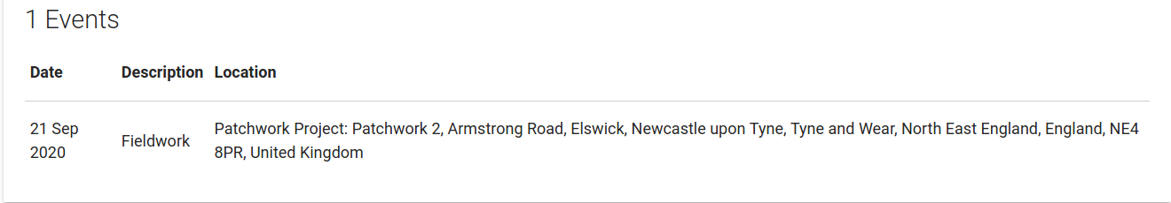
Figure 5.29 - Events and Locations summary
It is also possible to generate a Quotes gallery collected during this time period to support Patchwork curating a gallery of quotes for use in their annual reporting. Additionally a Tags Summary displayed the most used tags to support communicating areas of work. These tags link to searches of individual items so that a reader may explore them at leisure. Both a Quotes Gallery and a Tags Summary are shown in Figure 5.31
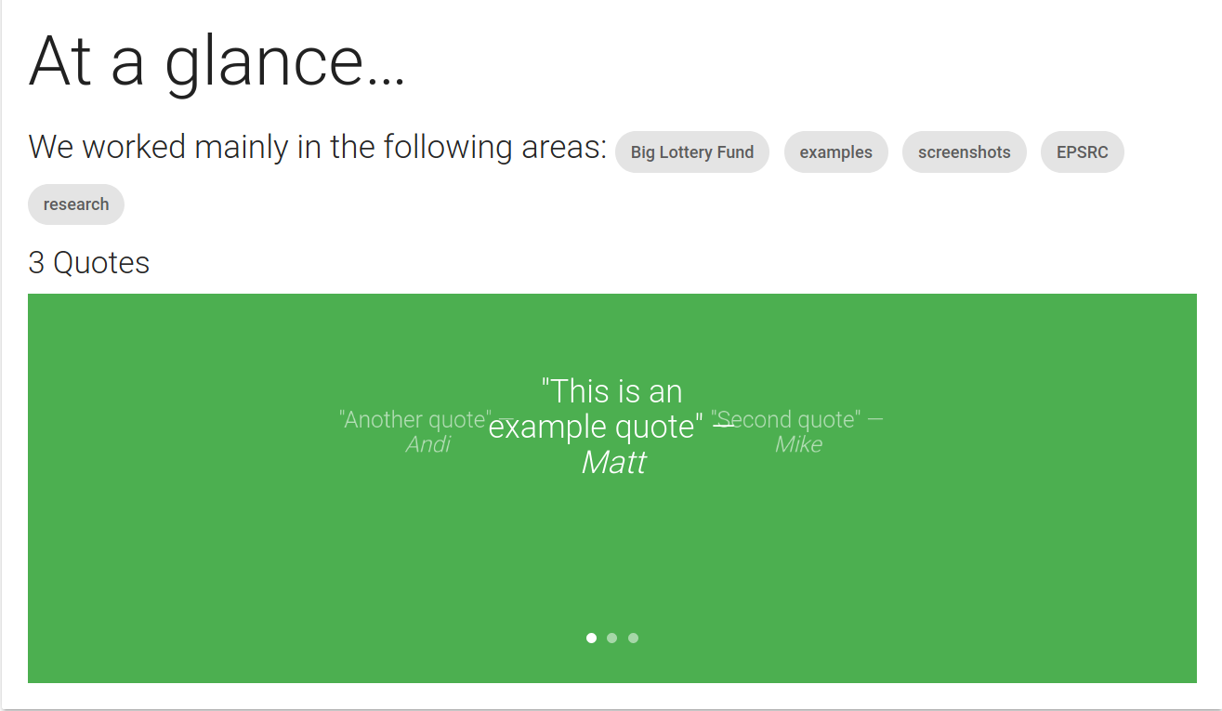
Figure 5.30 - Tags Summary and Quotes Gallery
Finally, it was possible to include summaries of work and of costs by their grant (Figure 5.31). This would take the most used tags attached to items that have been associated or “costed” to income during the time period. This was requested by Mick in order to understand how he had spent his current budget that month as this was something he was using his spreadsheet for. The tags presented on the report again linked to searches that would allow a viewer to explore the individual items used to generate the report.
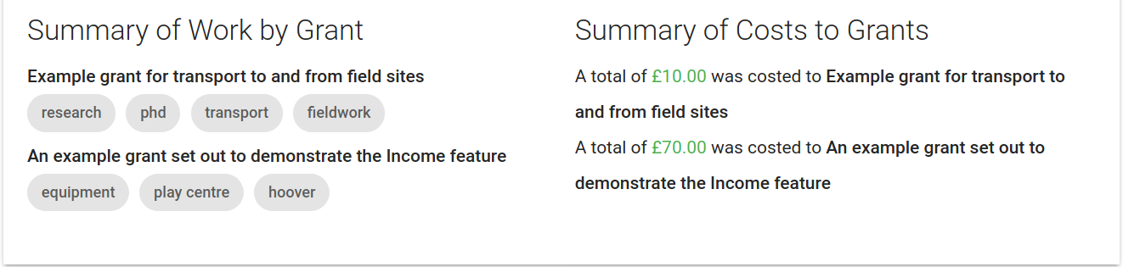
Figure 5.31 - Summaries of work and costs by grant
As the reports were modular, these could be enabled in any configuration to build up a different view or context of the organisation’s activity. Figure 5.32 shows a composite report with many of the elements enabled.
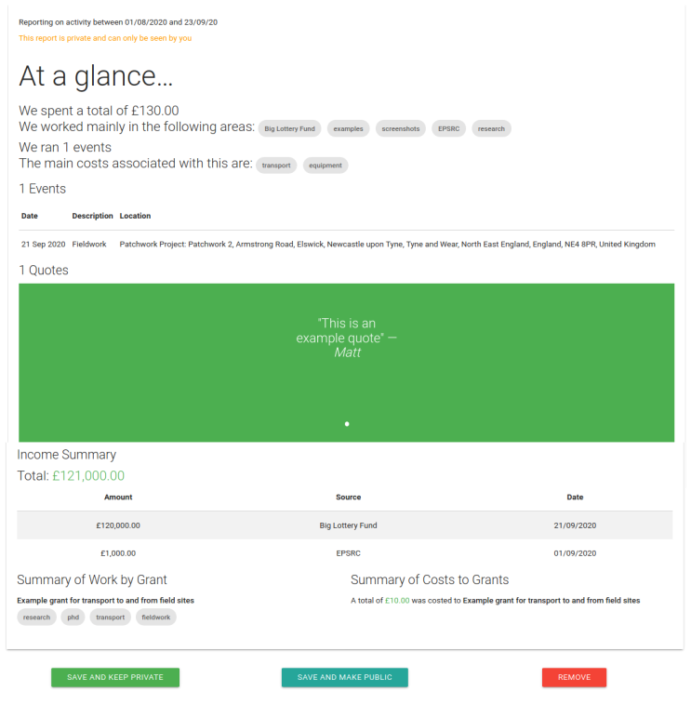
Figure 5.32 - A report with most modules other than the Images module. Note this is a composite image due to the size of the report on the screen
After generating a report Rosemary presents it back to the staff member who generated it who may either discard it entirely, save it for internal use (it isn’t made public), or making it public. This was designed to support one of the original design requirements around building a configurable Transparency by mirroring how various reports are compiled for different audiences. For example Patchwork could generate a report containing only financial information for trustees, and only a summary of images and activities for their beneficiaries’ families and other stakeholders.

Discarded features: public-facing API
The original plans envisioned for Rosemary included a public-facing API which provided endpoints to programmatically retrieve information from the application about an organisation. In this way, other applications could be developed to engage with the data in the system in ways not considered by Rosemary. This would have also supported an envisioned ‘final stage’ of the deployment which included building some lightweight alternative views on the data.
This was discarded due to a mix of concern and apathy on the part of Patchwork and OPC when discussing it. As their work didn’t necessitate a familiarity with the term API it was discussed in terms of what an API allowed – namely that it could support other applications retrieving the data they entered (provided entries were public). At first they didn’t quite buy the idea that this was necessary, and later expressed somewhat mild concern that the data in the system could be used to present an inaccurate view of the organisation. Patchwork also expressed concern about the availability of photos via the API. They didn’t want “just anyone” to be able to access this personal data (especially where young people were concerned) despite usually being keen to be visible. When I, cautiously, dug a little deeper into this I confirmed that most people interacted with photos via Patchwork’s facebook presence; and the Michael Patchy Bell account on Facebook allowed them a degree of control over who could see them.
In order to ensure their continued support, the feature was dropped in case this became off-putting to other organisations in the future as well. Instead, I made sure to discuss with them how they felt about the possibility of data being made available to other applications to make sense of.

Exporting Data
Finally, I did not know the long-term feasibility of hosting Rosemary Accounts on university servers nor whether a participant would run the system in parallel or commit to using it as their sole system for the duration of the evaluation. For this reason I made it possible to export a download of the financial information added to the system (Figure 5.33).
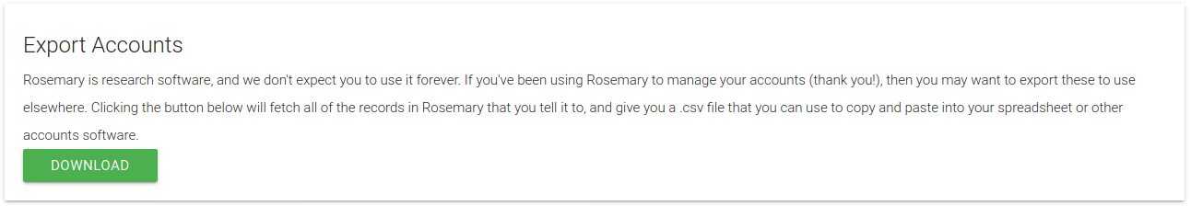
Figure 5.33 - Export option in Rosemary Accounts
The download focused on financial data only as it was deemed that this would be the things that would be most sensitive to loss. Photographs were being duplicated elsewhere (ie on Andi’s dropbox account and the Patchwork Facebook account) and location information was not previously captured by the organisations so sat outside their usual work practice. The export took the form of a downloadable CSV file which could be opened by most spreadsheet software and imported into their existing budgeting tools.

Technical Implementation Details
Rosemary Accounts was built as a web application using common web technologies in order to make it as accessible and as easy to install as possible. One of the design goals behind low-level implementation choices was that an organisation could, reasonably (with some technical assistance), run the platform on minimal infrastructure such as that provided by shared hosting that an organisation may already possess to run their website.
This lead to an implementation choice of building the application using PHP and MySQL database technologies. In practice, the application is built atop of the Symfony PHP framework (Symfony, 2021) in order to make use of good practices and features of the framework. At the time of implementing the latest version of Symfony was 3.2. The visual language of the site was provided by MaterializeCSS (MaterializeCSS, 2021), and was chosen because the Material Design language is also a default on the Android platform and thus Accounting Scrapbook and Rosemary Accounts would share a visual language. The Open Lab deployment infrastructure makes use of Docker (Docker Inc, 2021) to deploy web applications, so a Docker image was also developed to support deployment in the research environment and in the future business environments where this may be preferred.
At a low level, Rosemary Accounts is powered by a Model-View-Controller architecture (Leff & Rayfield, 2001), wherein models (database schemas and PHP Class Objects) were developed for the system and then the user interfaces were provided by views (web pages) which interacted with the models via some PHP code which translated their commands into changes to the underlying models. THe main model developed was based on the Qualitative Accounting standard, with additional models developed to model tags, users and other features such as customers etc. This provided a relational model to support participants linking pieces of information together.
The source code for Rosemary Accounts is available online.

Summary of the Design Rationale
Through fieldwork methods, design workshops, and a user-centred iterative design process I developed systems that sought to address the design requirements raised in the previous chapter. Core to these requirements were the tenets of worker control and flexibility, as well as the need to delivery a flexible Transparency, and to demonstrate context through linking data in order to communicate the complexity of the world that charity work and spending is situated in.
To address these requirements the design took a decentralised architecture as a core feature. This decentralisation has seen precedent in addressing similar concerns in the realm of the social web via heterogeneous systems in both the Fediverse and the Indieweb. Lessons from these movements were applied to this context in order to embed the flexibility and worker control required. Underpinning these systems is a shared data standard, Qualitative Accounting, used for communicating information in a standardised way while allowing for its presentation and manipulation to be separate concerns. The key features of this standard were developed collaboratively with workers at Patchwork through a brief reflective process informed by both my experience of the setting and their feedback on data schemas that were presented to them.
Two tools were then developed around the collection, exchange, and use of Qualitative Accounting data. The first of these was Accounting Scrapbook; a collections based application built around a scrapbooking metaphor that was designed to facilitate the easy capture and tagging of information by workers on-the-ground. This was heavily informed by observations of Patchwork’s work-practice as well as consistent feedback from the staff members who were most likely to use the system. Following this Rosemary Accounts was designed to build on Patchwork’s administrative work practice by acting as a receiver of the data collected by Accounting Scrapbook. It built on existing design standards and metaphors of commercial accounting systems and social media; and also provided interfaces supporting the curation and linking of Qualitative Accounting information. Further to this it provided interfaces designed to support the release of information to the public to support them understanding how individual items are linked to contexts. This was informed in large part by my observations of Patchwork’s administrative work during earlier fieldwork but there were also contributions from Patchwork staff as well as reviews by Community Project Gateshead and OPC.
I now turn to reflect on the insights from doing this design work, and how this may inform design when addressing these matters in the future.

Reflections on designing digital Transparency tools in charities
This section reflects on features and discussions in the design process in order to contribute to the design requirements of software in this space. In reflecting on the design process I comment on how Patchwork and the other organisations engaged with the subject of the design, and in addition to this I comment on how future design processes may be structured when operating in this space.

Building metaphors and supporting mapping - work for standards
With communication of data being core to the interactions and architecture of the systems developed a large portion of the important design work surrounding both the tools and the data itself was around the language used and the metaphors present in the tools.
During this design process this first became apparent when attending to the QA standard. To achieve this I took an established good-practice resource for building data models, schema.org (Schema.org, 2021a), and presented these models to Patchwork. In nearly all cases when Patchwork were shown these schemas they were confused as to the terminology and metaphors used. This is most apparent in when Mick called out the “useless rubbish” in the MonetaryAmount schema (Schema.org, 2021b) and we pared back the technical information to address the needs of Patchwork, but is also observable in Patchwork’s responses to the Place schema (Schema.org, 2021c) which became the Location object in QA and the Quotation schema (Schema.org, 2021d) which became Quote. In addition to the content of each of these schemas the names also changed. This was both to reflect the divergence from the existing model but also to give Patchwork input as to the metaphors used to describe their data. This benefited the process by aligning the model closer to Patchwork’s work practice through using their language, and benefited their understanding of what the data was trying to model by allowing them to configure the model to their needs. Effectively allowing them to map their work practice onto the elements of the standard.
This mapping later became apparent in the design of the tools Accounting Scrapbook and Rosemary Accounts. In designing Accounting Scrapbook a collections metaphor of “envelopes” was taken from my existing exploration of mobile budgeting apps but this turned out to be “weird” and too formal to communicate the performance of youth work. I later conceived of the scrapbooking metaphor which, although not existing as an activity in Patchwork, was accepted by the staff with Dean praising and confirming the metaphor as appropriate. In a similar case when designing Rosemary Accounts Patchwork lacked a metaphor for what this application was attempting to do. Knowing they wouldn’t benefit from an academic description of a data store, or interfaces to curate data, I instead clumsily described it was “Sage accounts + Facebook”. In practice, Rosemary was acting as a datastore of information with interfaces developed on top of it. These interfaces used language from Patchwork’s practice of accounting and budgeting (for example “costing” spends to grants), as well as design elements common to social media feeds to support people engaging with data (e.g. a timeline).
Finally mapping in-and-of-itself became a key interaction within Rosemary. As described earlier; a requested feature was the ability to load an existing spreadsheet into the system to load in existing data. This required a mapping stage that I had to either: perform myself; ask the user to perform; or otherwise facilitate in some way. The result of this was the user-driven, but Rosemary-supported, mapping stage during importing data (Figure 5.17). The notion behind a standard is to prevent the need for mapping in order to allow data users (and by extension, the public) to use data in the same format from many different publishers or sources. I myself have called for the use of standards in order to benefit data users (Marshall et al., 2016), but what this doesn’t account for is the material reality that important data currently exists in heterogeneous formats and that it is work to do this mapping.
In the scope of this research, I provided an interface for facilitating this mapping however it remains a question as to: how this will occur in the future; what tools or digital systems may facilitate it; and how it will be enforced or encouraged. In doing the above design work, it becomes obvious that well-meaning Transparency efforts centred around the production of open data need account for the labour it will take. Data and digital systems may provide the means to a “configurable Transparency” as outlined in Chapter 4, however design should take steps to avoid burdening workers with an additional load of Accountability work in the form of data work. In the future funders, the state, or stakeholders may exercise controllability as a means of Accountability (Koppell, 2005) to demand charities provide data about their work. The relevance of standards is important so that these stakeholders are given a common means of understanding this data, however there is a risk of replacing one form of hegemony (ie that of Sage Accounts) with another.
To address this we should consider how open data infrastructure tools and platforms are designed, with particular attention to the performance of mapping work. Who performs it? And which tools, interfaces, or services are provided to those workers to support them?

Who designs Open Data infrastructure, tools and platforms?
This need for mapping work and and building metaphors to accomplish the open data and Transparency goals of the design opens up the question of how open data infrastructure, tools, and platforms are designed in-situ and who has a role in designing them.
There was an apparent discrepancy between the central role that the QA standard played and the enthusiasm for contributions while designing it. Part of this was likely due to the setting: similar to the design workshops which took place in the central Patchwork offices under the context of other work. The actual input I had from Patchwork around QA totalled around 90 minutes across the space of several individual sessions. Ongoing around us was the mundane reality of youth work; drop-ins, trustee visits, and planning work all lent their interruptive quality to the performance of design activity. A large part of the design process was myself synthesising discrete comments from Patchwork asynchronously and then “checking” this with them. Given the nature of my prior fieldwork I was comfortable with this process however it rattled my conception of a worker-lead design process that I had originally envisioned. Even when I managed to solicit opinions on my work these were little more than affirmations that things made sense or looked good; this confused me as I understood Patchwork to be generally quite comfortable with proffering critical feedback.
The result of this contradiction is that a core part of the overall system architecture ie the shape of the data, did not have what I would call participatory input from the team. This concerned me at the time of performing this design work and more recently there has been criticisms about who holds the power when designing open data infrastructure (Brandusescu et al., 2020). As I noted in an earlier section, there was an initial burst of enthusiasm when designing Accounting Scrapbook which resulted in a process that resembled a somewhat more collaborative exercise. Since by this point I had been part of Patchwork for over six months, I was able to interpret why this might be. Contributing to the design of an on-the-ground tool that proffered a tangible thing to interact around and that the staff could conceptualise as part of their daily work practice felt like a more worthwhile use of their time. Being able to conceptualise of these tools offered them a chance to keep my design practice accountable to them as stakeholders in its performance, and account-able to them in the sense that they could account for it as part of their natural reflexivity as members of the setting (Button et al., 2015).
This enthusiasm for the design work faded after a while but notable to me was that I ended up iterating on the QA standard as a result of later input into the tools. The key example of this was the shift from media being a single item to allowing for an array of multiple items. This was informed by the feedback on tooling, which was informed by practice. Andi did not request that the QA standard accommodate this but instead that she could assign multiple photos to an item in Accounting Scrapbook. This meant that, through me, the standard was affected and changed by the input of Patchwork staff albeit indirectly. Andi did not comment consciously on the design or affordances of QA data, but her concerns were brought about because of the material conditions of the standard and she was directly commenting on them. A similar thing occurred when Community Project Gateshead and Patchwork commented on the risks associated with third-party observation of their data by those without the context to understand it. Despite clear ideological commitments to Transparency and Accountability from both Patchwork and Community Project Gateshead; they agreed that the dataset needed to be curated and presented carefully lest this lead to an incomplete picture or warped view in the eye of the beholder.
The contribution of this case study to designing open data standards and infrastructure within charities is that they may not care about open data so much as they care about being able to do their jobs. Erete et al’s case study of Non-profit Organisations (NPOs) using open data to undertake storytelling (Erete et al., 2016) provides key take-aways that work should be done to make data accessible and provide links between experts and NPOs. My experience with Patchwork, Community Project Gateshead, and OPC reframes this interaction as being less concerned with the data aspect of this relationship and more concerned with the organisations’ ability to engage with funders and stakeholders. If open data is the means to facilitating this; then this is more exciting for open data enthusiasts and Human-Data Interaction researchers than it is for the charities and NPOs.
Further to this, explicit care should be taken on issues of safeguarding sensitive, personal, or mission-critical data that may be captured in the system. In the design of these tools, participants explicitly raised concerns about the “open by default” nature of sharing items like spending and photographs which were uncurated and thus may contain photos of service users. This system is designed to be decentralised, so this becomes even more pertinent as once data has been shared with other actors (systems, people) in the system it cannot be retrieved or revoked. This again points to issues around data control highlighted by McAuley et al in the ‘Dataware Manifesto’ (McAuley et al., 2011) around embedding rules for explicit use-cases of data into the design of the system, and storing all data in a pesonal ‘data locker’. Yohannis et al. have done further work on decentralised peer-to-peer data vaults, which includes automatic model generation for developers looking to build such applications (Yohannis et al., 2020) which may provide a technical solution to this. Other issues may be that of bad actors falsifying their identities to gain access to data, where permission is granted through deceptive practices. Lessons may be drawn here from how large-scale financial institutions such as banks trade data; as they must comply with a complex set of security requirements as stipulated by national and international banking regulations (Norvill et al., 2020).
This said; it is undeniable, given the growing importance of data in everyday life (Elsden, Mellor, et al., 2016; Crabtree & Mortier, 2015), that the careful design of open data infrastructure, tools, and platforms is essential if it is to meet the needs of stakeholders and not impose too heavily on workers whose job it is to produce it. The increase in calls for “algorithmic Transparency” to concern the human involvement and data models (Diakopoulos, 2016; Olhede & Rodrigues, 2017) of digital systems that increasingly govern civic life is presented a challenge through the experience of this design process. Namely – if it is important that design processes for open data infrastructure, tools, and platforms are participatory and inclusive but the workers who are centred as participants in this design process cannot spare the effort to participate or otherwise feel unable or unmoved to do so… then how should design be organised in these spaces?

Vanguard Design in civic spaces
As I have made clear, the performance of design work in this space was threaded with challenges that were inherent in the setting. I approached the design space with notions of Participatory Design, but lack of worker availability and the obvious inappropriateness of methods such as the design workshop lead me to explore design questions. Namely; how participation could be achieved in this setting? And how I could ensure that Patchwork could contribute meaningfully to the design?
Participatory Design (PD) as a movement has its origins in the culture of Scandinavian technology design (Floyd et al., 1989). Its key characteristics that differentiate it from other design philosophies are centred around a devolution of power from the designer to those being designed for; this is generally accomplished through methods intended to bring the end-user of a design “into” the design space as co-designers and decision-makers (Schuler & Namioka, 1993; Kensing & Blomberg, 1998). This can take many forms, and can extend to allowing these co-designers to set the goals for the design itself. Methodologically, PD defines the design process as research in-and-of-itself (Spinuzzi, 2005). This contrasts with other design methodologies such as User-Centred Design which, while centring the end-user, does not devolve control and decision-making to them. Since working in charities is an inherently political space (Hansmann, 1980; Feis-Bryce, 2015) it is also important to acknowledge the political origins of PD. One of the original contradictions that PD was born of was that which was between a heavily unionised workforce and the implementation of technologies in the workplace. The synthesis of this contradiction was PD which had at its core a goal to “upskill” workers in matters of technology design, giving them and their trade union representatives a better position for collective bargaining (Kensing & Blomberg, 1998). PD as a project maintains this characteristic despite the declining role of union struggle since its conception and PD’s application to other, less-antagonistic, settings. In short; its goal of bringing people into the design space and teaching them how to do design work in their context has not wavered.
I originally sought to apply a PD approach to the design process. My early workshops are clear examples of this as I constructed exercises to bring forth Patchwork’s goals, and fears, for the systems that I hoped to develop. Later on during an iterative design cycle I attempted to engage them in co-constructing the QA standard and its tooling. As it manifested; Patchwork staff were too tired to engage in workshop activity and often distant when discussing core concepts of the system – caring only for the performance of their work rather than a design exercise, but proffering feedback when I requested it. We were consistently interrupted and distracted. If this sounds admonishing of them I wish to clarify that it is not – I thoroughly enjoyed this design process despite the numerous frustrations. It became obvious to me throughout this process that although Patchwork were willing to take part in design exercises for my sake; the material conditions of the space (labour-intense, dynamic, shifting) and how they conceived of my role there meant that they did not feel the need to take up the design mantle as conceived of by PD. That is; they did not see a need to upskill in design or enter decision making when they could devolve this to me. Speaking in terms of work practice; design work was not account-able to them whereas my position as a member of the setting who did this work was account-able (Garfinkel, 1967). Their conception of my role there was as a volunteer, a researcher, and as someone who would build them something. Their role in this process was to accommodate me doing so, and to proffer feedback when necessary to keep me Accountable (and account-able) to them but largely trusting me to have their best interests at heart. It is in having their best interests at heart, and being embedded in the setting, that I could see how the contradiction between the need to do design work, and the need to get on with the real work of running Patchwork needed to be reconciled.
I am not the first to try and reconcile these contradictions and think about how PD operates in various modalities. Kensing and Blomberg explicitly address how differing socio-economic climates change the nature of participation; particularly contrasting the European context with the less-unionised USA, as well as Europe following the decline of trade union power (Kensing & Blomberg, 1998). More recently, Vines et al wrote on ‘configuring participation’ (Vines et al., 2013). In this Vines et al acknowledge the goals of PD as sharing control and sharing designer-expertise in the design space, but argue that HCI researchers and designers may eschew traditional notions and methods of PD and instead “engage in acts of configuring participation”. This, they argue, reflects the goal of designing the process of participation itself – providing opportunities for asking questions about the initiators and beneficiaries of design, the forms of participation, and the sharing of control (Vines et al., 2013). These are indeed important questions and challenges about the concerns of participation in design but it leaves these unanswered at the end of the paper; which raises opportunities for exploitation. This could have the effect of broadening and diluting what can be called PD to effectively anything as the questions and challenges put forward potentially reduce the concept and values of participation to a set of dials that may be adjusted to suit the researcher’s lack of capacity, or willingness, to immerse themselves in the setting to gather the materials necessary to build a participatory process as originally conceived (Floyd et al., 1989; Kensing & Blomberg, 1998). Thus while it is tempting to use this work to portray my design process at Patchwork (and beyond) as participatory, I feel that the important questions raised by Vines et al are better addressed by explicitly forefronting the contradictions between the democratic, worker-focused, aims of PD and the labour-scarce material conditions in these settings.
A key characteristic of design process here is that Patchwork effectively nominated me as design lead when I offered them the PD mantle. They trusted me to support their work as I understood it, based on their accounting of me from the perspective as a member of the setting (albeit a newish one, and one with ties to academia). By the time design had started in earnest I had spent the better part of 6 months at Patchwork and was known by name by not only the staff but trustees, beneficiaries, and their wider community of stakeholders. Mick would often introduce me in ways such as “Matt, who thinks he’s an academic but really just comes here to hang out and take part” or alternatively “Matt’s thinking about new apps and stuff that can help us do reporting” and it is arguable that as I spent more and more time at Patchwork my position transitioned smoothly from ‘outsider’ to ‘member’ my competence in the setting grew. Patchwork’s ability to account for me and my work similarly grew. This bears surface-level resemblance in part to the arguments made by Fuller (Fuller, 1999); where becoming “part of the action” was the synthesis in addressing the conflicting roles encountered through the performance of ethnographic research. Similarly in Being Native versus Going Native (Kanuha, 2000), Kahuna centres the conflict of being a member of a particular identity-groups as well as performing the role of researcher and grapples with a contradiction of the cultural need to attend dinner with a respondent and the academic-inappropriateness of doing so. During the time-period described in this chapter I went on a climbing holiday with Patchwork. Their invitation to me and my acceptance of it is evidence of the orderly construction of the setting between two members, indicating that this shift had occurred. Unlike Fuller or Kahuna, however, I did not struggle with differing identities and embraced wholeheartedly my work doing research, design, and membership of the setting at Patchwork.
It is tempting to point to my acceptance as a member of the setting, point to traditional PD literature about democratic control by settings members, and proclaim “Rejoice – PD has been achieved”; but the characteristics of this particular configuration should be explored. With the bulk of technical implementation and design decision-making resting with myself, but with clear means of Accountability and Transparency (Koppell, 2005) between myself and Patchwork enabled through my being a member of the setting and thus naturally account-able to them (Garfinkel, 1967; Button et al., 2015) this meant that conceptually I was acting as their vanguard for these matters.
Vanguardism is a concept wherein an organised subset of a social group act and agitate on behalf of the rest (Lenin, 1902). It is based on the notion that the majority of a population cannot work on particular tasks or social activism full-time, nor develop the theoretical notions to underpin them. Importantly, though, members of the vanguard are members of the larger group that they serve and are accountable to the masses that they are leading. In this way vanguardism also protects against the opportunism of individuals who seek to gain political influence (Lenin, 1902).
Applied to the design space, vanguardism offers a configuration by which to conceive of the way design work was organised and accounted for at Patchwork. As evidenced I was a member of the setting but I was unique within that setting as possessing design and technical expertise. My long-term engagement and membership meant that my interests were aligned with that of Patchwork. My participation in the setting wasn’t just providing materials for me to use to inform design and inform this research, but a goal was to provide for the setting a design that they could make use of in their work. Patchwork’s staff, and community, trusted me to be their “professional designer” as part of my role – and engaged me when I did so despite struggling with more idealised notions of participation in PD when these were presented.
I’d therefore like to propose an initial synthesis of Vanguard Design for application in civic spaces such as these. This configuration of design explicitly acknowledges that there are contradictions between PD and its application in this type of civic settings, where design work competes with more pressing and potentially life-altering matters (such as the performance of youth and community work). Instead of conceptualising of the designer as separate from the setting, it explicitly requires that the designer or researcher be fully engaged in the setting and that they wholeheartedly align with the interests of the members of the setting. In a more radical or overtly political form this may centre these interests as part of a struggle in civic spaces. In order to do this it must also be careful to rally against the opportunism of the academy and of HCI. These have a tendency to enter settings and leave them once design has been “accomplished”; generating research insight but not contributing materially to the struggles of the members in those settings. To ensure this; the designer must be accountable to other members of the setting, and the performance of their design work must be account-able as part of the setting’s social order. In this way, a designer or group of designers within the setting may act as a vanguard on behalf of the other members.
In short; if future participatory engagements with front-line civic spaces akin to charities like Patchwork are to be performed the design work should take on a character of Vanguard Design. In these cases the designer or researchers must effectively become part of the setting and either organise its members or, that not being feasible, align their goals to that of the shared setting to organise design on their behalf. This must be done in a way that is accountable to the setting’s members. This raises future questions for the performance of Digital Civics work which I explore later in Chapter 07.

Summary
This chapter has presented an account of the design work that was performed in order to develop systems whose characteristics were outlined in the previous chapter. The design activities were discussed before a design rationale and overview of the systems was presented, and finally I discuss considerations for designing digital Transparency tools in charities.
These considerations cover three aspects of the design space which I explore in turn. The first is how work on data standards and interfaces to data must develop adequate metaphors and tools to “map” these concepts and support this mapping as an activity. The second is that with the growing importance of data as part of everyday life, who is doing the design work for open data infrastructure, tools, and platforms? Finally, I explore the implications of attempting a participatory approach to design in this type of civic space and suggest Vanguard Design as a concept that may assist organising future work.
The next chapter of this thesis outlines the process of evaluating the tools that were discussed in this chapter and exploring the implications of this evaluation.

Deploying and Evaluating Accountability Tools
This chapter presents an empirical account of deploying and evaluating the novel accounting systems produced in the previous chapter, and the design requirements that arise as a result.

Introduction
Chapter 4 outlined the ‘Accountability Work’ that is performed in a charity and its implications for design, and Chapter 5 presented the design process that made use of that material to build systems. This chapter picks up immediately following its predecessor by discussing how the systems seen in Chapter 5 were deployed and evaluated.
I first introduce the ways in which the systems were deployed and evaluated, accounting for problems in the deployments and how these were overcome to ensure that the systems could be evaluated properly. I also give a brief over of the organisations involved in the study to contextualise the findings; introducing some new participants who are not charity workers themselves but who operate in this space as stakeholders and partners. Their presence supports the evaluation of the tools from additional perspectives.
I then present the key findings of the evaluation, grouped by three main areas of focus: the barriers to system use in everyday work practice; the key work practice of ‘tagging’ items to account for them; and how external stakeholders use materials provided by charities to construct narratives for Accountability. I then discuss the key take-aways from the evaluation by elaborating on how systems need to support mutually-defining nature ‘Accountable Objects’ as well as lessons for representing these in data structures, and how interfaces may be designed to support interactions with such data.

Deploying Qualitative Accounting tools
This study and evaluation covers a staged series of evaluations of the tools designed in Chapter 5 across mid 2017 to late 2018. This comprises of three sets of deployments with participant organisations Patchwork and OPC as well as a separate short series of interviews with other stakeholders. This is visualised in Figure 6.1.
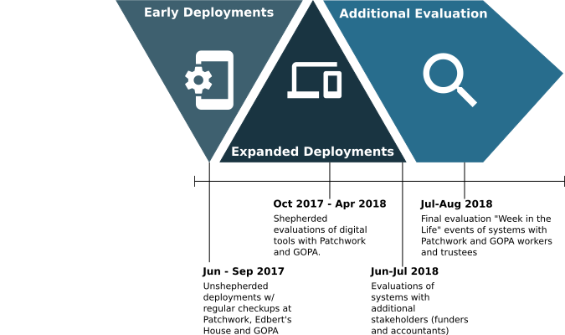
Figure 6.1 - Timeline of deployments and evaluation
The organisations that participated in the deployments were Patchwork, Community Project Gateshead, and Older People’s Charity (OPC). The latter two of these were introduced briefly in Chapter 05 as participants who also contributed to the design process alongside Patchwork. They were involved in evaluation as a natural continuation of their participation and to evaluate whether the systems which had primarily been design with Patchwork in mind could be deployed effectively in organisations with other working practices.
All three of these organisations participated in the early stages of deployment in June 2017 (Labelled unshepherded deployments in Figure 6.1), however after this initial set of evaluations Community Project Gateshead needed to drop out of the study due to constraints on worker time. The administrative staff member who was the most directly involved in the study was moving to another city and Community Project Gateshead felt that they couldn’t spare the additional labour to train up another member of staff to take part in the study atop their existing duties. This stage of evaluation was mostly “hands off” and involved regular check-ins with the organisations and informal interviews captured through field notes.
The early deployments resulted in some changes to the Qualitative Accounting (QA) standard, Accounting Scrapbook, and Rosemary Accounts applications which were covered in the previous chapter. These changes were then followed with a second series of deployments with Patchwork and OPC across a longer period of time from October 2017 to April 2018. The methods used in this stage of evaluation were more involved in order to ensure that the systems were being used and overcome challenges to performing the research that I encountered in the previous stage. These are discussed in Chapter 03 as well as in the following sections in detail.
I then turned to seeking other stakeholders in charity Transparency and Accountability to show them the systems and and further evaluate them, in relation to their needs as organisations and stakeholders within the charity accounting process. Four organisations or participants were involved in this evaluation: Patchwork’s former accountants (which they’d explicitly left during the events in Chapter 04); their new, independent, accountant who signed off their accounts yearly; a local Community Foundation (small local funders); and a representative from the Big National Funder (now the National Lottery Community Fund). These took the form of semi-structured interviews and show-and-tell sessions with participants that were recorded and transcribed. Sadly the interview with the Big National Funder was lost when the data was corrupted before it could be backed up and thus I do not draw upon it in the corpus of data presented in this chapter.
Finally, since I felt that the evaluation could benefit from further engagement I constructed a short final “challenge” to Patchwork and OPC to stimulate system use. This lasted about a week and I interviewed each organisation about their experiences before holding “exit interviews” at the conclusion of the research with both Patchwork and OPC to reflect on its performance overall and elicit final reflections.
I now turn to describing in greater detail the people involved at each stage of the evaluation, and the characteristics of each of these evaluation stages. I cover the rationale for each as well as the methods and data that resulted from them.

Participants and People
This evaluation encapsulated deployments with several organisations and contact with people within them in addition to my main collaboration at Patchwork. I briefly introduced Community Project Gateshead and Older People’s Charity (OPC) in Chapter 5, however as I will be reporting on quotes and observations of individuals it’s important to be able to identify key participants in these organisations. Unlike Patchwork Community Project Gateshead and OPC didn’t give permission for me to use their real names in reporting this research; so I have assigned them pseudonyms which are reported in Table 6.1.
Table 6.1 Participants in deployments across Community Project Gateshead and OPC
Pseudonym | Organisation | Role / Position
Martin | Community Project Gateshead | Administrator
Heather | OPC | Administrator
Chris | OPC | Project Manager
Laura | OPC | Session Worker
Further to this, I will also account for individuals from the interviews with stakeholders. As noted the nature of the organisations involved in this stage were involved in the more legal forms of Accountability and Transparency such as the “Community Funding North East”, the National Lottery Community Fund (then the ‘Big National Funder’) (The National Lottery Community Fund, 2021), Patchwork’s former accountants “Charity Accountants Newcastle”, and their new accounts examiner who is independent. I have noted these participants in Table 6.2. I have pseudonymised all organisations for reporting.
Table 6.2 Participants in the Interviews with Stakeholders portion of the evaluation
Pseudonym | Organisation | Organisation Type | Relationship to Patchwork
Alan | Charity Accountants Newcastle | Accountancy firm specialising in charities | Charity Accountants Newcastle were Patchwork’s former accountants
Barbara | N/A | Independent | Patchwork’s current accounts examiner
Charlie | Community Funding North East | Local Funding Organisation | Patchwork have received funding from this organisation before
Darren | Big National Funder | Large National Funder | Patchwork have received funding from this organisation before

The stages of deployment
The initial deployments of the systems occurred in June 2017 following the conclusion of the design period described in Chapter 5. These deployments spanned the three organisations (Patchwork, Community Project Gateshead, and OPC) that had participated to varying degrees in the design process. The goal of this deployment was to see how each organisation would (or could) make use of the tools that we had built; with each organisation having different modes of working, different reporting needs, and different working patterns — this was a good test to determine whether the systems were indeed flexible enough to be appropriated in each settings.
After giving each organisation an initial introduction to the systems (including a tutorial and a Q&A session) I hoped to take a “hands off” approach to the deployment to avoid influencing how staff may use or not use the tools. I arranged with each organisation a rhythm for checking in on the progress of the deployments to reflect with them and offered to adjust systems in response to their needs if required. These began fairly ambitiously with weekly check-ins at Patchwork integrated into my regular volunteering and field visits, while at Community Project Gateshead and OPC I arranged a fortnightly staggered check-in. This meant that on any given week I would check in with Patchwork and either Community Project Gateshead or OPC. As the check-ins progressed it became clear that the staff were not engaging with the systems much and in some cases not at all. This did provide material on my new partner organisations and reasons that the staff were unable to sit down and use the tools, however I was initially surprised at Patchwork’s lack of engagement with “Accounting Scrapbook”. Throughout my regular field visits I saw that this was largely due to Patchwork’s busy summer schedule and workload of the staff.
As we approached September I realised that three months of deployment had yielded little engagement but fair insight into the challenges of deploying these systems in on-the-ground environments. I decided to change tack and performed a quick reflective interview with each organisation to conclude this stage of evaluation and using this direct feedback implemented changes to the systems (namely to the media functionality noted in Chapter 5). Following these changes and the initial deployments I tried to design the next stage of deployments to account for the non-use of systems I’d seen in the initial round. These expanded deployments were more structured in nature and involved more intervention, and had the goal of directly demonstrating the usefulness of the systems through directed use. At this point Community Project Gateshead needed to drop out of the study citing capacity issues.
One of the key insights from the prior stage of evaluation was that some organisations didn’t have an instinctive idea on when or how they were supposed to make use of the systems. This was mostly prevalent in OPC where staff were not involved in design stages, however was also present among Patchwork staff (Sonia and Lynne). To address this I structured my deployment around the performance of Co-operative evaluation methods (P. C. Wright & A. F. Monk, 1991a) and outlined a series of tasks (Figure 6.2) to guide staff through use of the systems and elicit reflections. The tasks were designed to be completed independently by staff, on a weekly basis to account for scheduling issues. I would then discuss each task with each organisation at the end of the week. After a month of these tasks, however, it became clear that the organisations were still not using the systems on their own prerogative. To work around this I established a rhythm where I would visit each organisation and we would undertake these tasks as a more traditional think-aloud co-operative evaluation (P. C. Wright & A. F. Monk, 1991a, 1991b). At Patchwork I’d visit Lynne explicitly in addition to my regular field visits, while at OPC I would visit on a monthly basis to work through several tasks at a time. Stretching the evaluation over this time period also meant it was subject to the interruptions of daily life and the evaluation period extended into April of 2018. During these deployments I collected field notes while the think-aloud exercises were audio recorded and later transcribed. Unfortunately the audio data of several of my sessions with Lynne were corrupted beyond retrieval before transcription and these were lost, however several field notes survived.
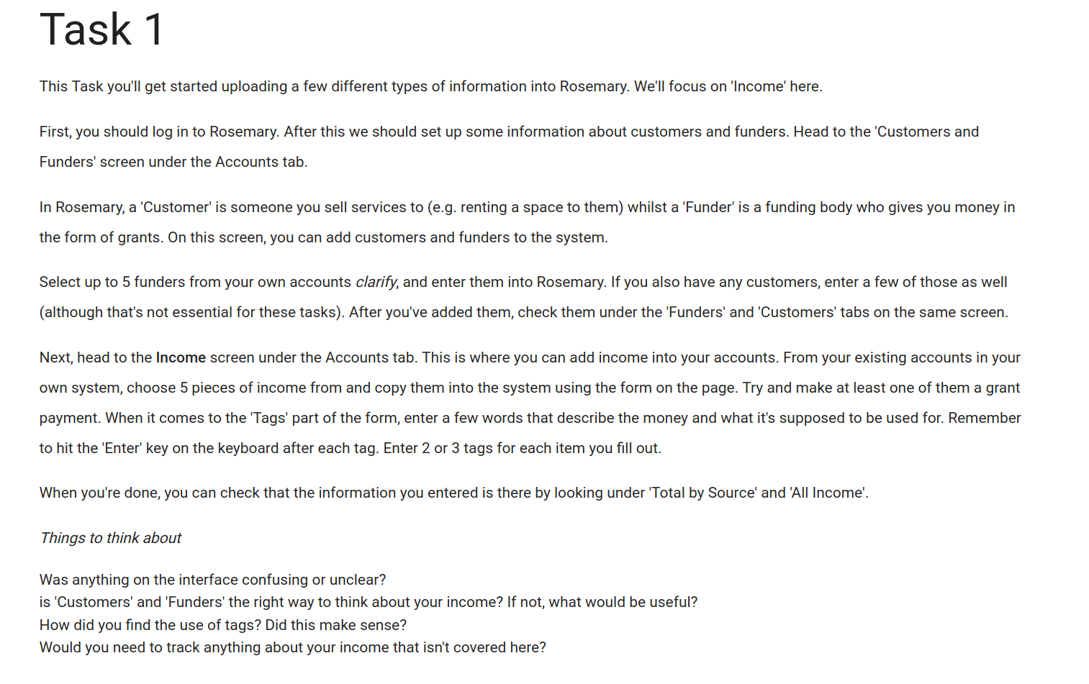
Figure 6.2 - An example task to guide users through the system
In the summer of 2018 I also set out to get a broader perspective on the systems that had been deployed. My efforts thus far had given me a good sense of how the systems could support the work practices of staff in organisations such as Patchwork and OPC; but the other half of Transparency and Accountability requires someone to observe the subject (Oliver, 2004). Therefore I wanted to explore if the features and interfaces of data within Rosemary Accounts went some way in supporting this. To accomplish this I undertook a short show-and-tell session with four different potential stakeholders in a local charity’s ecosystem (described in Table 6.2): two accountants who would want to interrogate financial data to “sign off” accounts; and two representatives from charity funders (one local and one national). These participants were chosen because they represented the existing formal Transparency and Accountability pathways that Patchwork and OPC would need to engage with. Chapter 4 shows how Patchwork saw themselves as directly accountable to their immediate community and throughout my fieldwork I witnessed many examples of this; for this reason I felt that it was more pressing to understand the needs of stakeholders and actors that held more formal or procedural stakes in charities as this was a missing piece of the puzzle. I wanted to keep the research as contextually-grounded as possible and got enthusiastic permission from Patchwork to chase up some of their funders and their accountants both past and present. The result was a spread of participant perspectives with diverse organisational work practices that had experience and direct stakes in Patchwork to ground their evaluation of the systems.
With these stakeholders I performed a total four separate semi-structured interviews; one per participant. We sadly couldn’t organise a group session due to a matter of logistics. During the interviews I began by asking questions to understand how each participant conceived of their work and what their role in the organisation was, as well as what they thought a charity’s responsibilities were to them as stakeholders. The interviews were conducted in a range of settings; mostly the offices of those organisations however Barbara visited Open Lab and I interviewed Darren in a café before he caught a train. In each case I interviewed a single person but during the interview with Charlie at the Community Foundation fetched his colleagues to contribute to the session. In all cases I audio recorded the interview and took notes, however the interview with Darren (Big National Funder) was lost soon after it was performed due to an accident. This meant I was unable to draw upon this interview in the corpus of data in this chapter as my notes were not sufficient when alienated from the recording.
Finally, having been engaged more fruitfully with OPC and Patchwork throughout 2018 I sought to trial a reduced form of the original deployment I had envisioned from 2017. This was in order to see whether their engagements with the systems had resulted in them seeing their value or if barriers to use were otherwise removed. After establishing the feasibility of this with the teams we commenced in July 2018. These deployments were presented as a task to capture a “Week in the life” of each organisation and were relatively successful; seeing engagement from staff at each organisations. I then followed each up with an exit interview which were both pleasant and informative. These deployments and exit interviews gave me a final chance to speak to staff about their experiences using the tools and their reflections of the research as a whole. It also provided copies of their data from the systems in the form of screenshots and database copies which were useful for me to explore how they’d interacted with the tool independently.

Evaluating new Accountability systems in the field
These accounts focus on key findings from the evaluations and deployments. I first consider the challenges and contradictions in adopting the system. Secondly I report participants experiences of tags; a key element of the design. Finally I focus explicitly on how the the involvement of participants in Table 6.2 highlighted needs to balance monitoring and reporting as well as providing material for them to construct narratives to others in a chain of Transparency and Accountability.
In each of these sections I present my own ethnographic observations of the participants as well as direct quotes taken from interviews or sessions.

Challenges and Contradictions in adopting the system
It should be clear from the previous sections in this chapter that the deployment of the systems did not go particularly smoothly and required several attempts to see strong engagement. Although I had a role to play in this lack of engagement, there were also conditions in the settings that created this that are worth highlighting. This is because they should be addressed to inform future design of either tools similar to these or within setting such as these.

Match with existing work practice
The purpose of conducting the work practice study in Chapter 4 was to then use these accounts of how the members of Patchwork organised their work to accomplish Accountability and Transparency within the setting. Despite the fact that I had been embedded within Patchwork for over a year, and had used these accounts to support the system designs (as reported inChapter 5), I found that there was still a tension in some areas of work practice where the system was intended to be used.
Rather mundanely, ease of use was a key factor in the low uptake of the system. This was mostly reported by workers at Patchwork who, despite being more involved in the system design, still reported that this was a barrier to system use. The ease of collecting data via the Accounting Scrapbook interface proved to be a barrier for many of the workers at Patchwork as the system struggled to communicate its internal state and support staff in recognising what content they had already contributed:
Andi: “Some things were easier, like putting up photos, but because it didn’t always show you what photo it was […] Then you weren’t quite sure, you know? Also, there were some things where you created things and then you weren’t sure what you’d created, do you know what I mean? So, things like putting an accounting spend, like say you’re going underneath it, ‘Oh, I really should put that into a such and such folder’, which you didn’t have. So, then you’d have to go back and create that.”
Andi here describes bugs in the Accounting Scrapbook application around photos not displaying properly which meant that she didn’t know which photographs she had. This had implications for her work-in-the-moment as she didn’t know which activities had been accounted for, in what ways, and she could not do the important work of curating the dataset to later provide an account.
Andi also critiques the workflow that was imposed by Accounting Scrapbook with regards to the collections (“Oh, I really should put that into a such and such folder, which you didn’t have. So, then you’d have to go back and create that”). This was also separately picked up on by Mick:
Mick: “I have forgotten which folders I did not have. Then I would be like, ‘Oh, right, I need to put this in the bike folder. Oh, there is not a bike folder,’ and I cannot add a folder at that point”
The application requires that a collection is created in order to then place items into it. This was an important step in the design as a collection is required to be “tagged” with metadata, to support generating rich contexts around an item. However, this presented a contradiction with how Patchwork account for their work internally as Andi and Mick each describe wanting to create new collections on-the-fly as new dimensions of their work become apparent to them in-the-moment. The application provided a barrier to this part of work practice around accounting for these dimensions and thus actively slowed the work practices that the system was originally designed to support.
The conceptualisation of their work also meant that Patchwork and OPC experienced other usability issues concerning the language in some areas of the systems. This was also noted in Chapter 5, but is discussed in more depth here:
Andi: “The ‘events’ one was a bit confusing, I don’t think I understood what you were seeking in there. So, I suppose, it’s funny, if you look at a group activity… So, maybe you could put ‘activity’, rather than ‘event’, that would have had a different meaning to us. ‘Event’, to us is, like, I don’t know… Like, a fun day, something big, something that you’re planning towards, but then, everything we do has got planning towards. I suppose, because Patchwork is a really busy project …”
This forefronts something that was not captured during the design process; that Patchwork’s organisation of their work considers larger public-facing events such as a “fun day” differently to activities that are ongoing as a staple of their work. This language may come from their use of Facebook which has provision for public events in the platform. Importantly, Patchwork acknowledge that both “events” and “activities” take work to plan which means that they should be accounted for. This was also reported at OPC:
Heather: “It’s like once a year […] The things like Tai Chi are more activities than events, I always think of events as a one off.”
Heather’s statement affirms Andi’s conceptualisation of the dichotomy of “Events” and “Activities”. The Tai Chi example mentioned by Heather is a regular activity performed at OPC’s main offices, comparable in scope to Patchwork’s group activities with young people. This simple misalignment of language as used by the systems’ interface in contradiction with the mundane, and account-able, way that settings members conceptualise their work was evident elsewhere in the system as well:
I managed to catch up with Lynne and Mick today re Rosemary, which I think Lynne was glad of as she’s been sitting on some questions apparently. We discussed the costing screen and how she didn’t realise it was related to ‘funding source’ despite the design of the screen forefronting the grants and the spends. I’d checked my interpretation of costing work w/ Mick earlier when designing the feature and he seemed OK with it at-a-glance, but clearly Lynne has a different way of doing it. There were also some misc things around auto-completion for tags and not realising she should tag financial stuff as ‘[she] knew others were tagging photos’; and she was stressed out at having to maybe use numbered budget codes.
The original interface for doing ‘costing’ was designed after Mick had demonstrated this during my initial fieldwork (Chapter 4). While it was based off of Mick’s demonstration this was poorly translated across to Lynne’s later engagement with the spreadsheet. Not being able to access Lynne had resulted in the design of this feature without a fully grounded understanding of how she made sense of her work. Further to this she highlighted usability issues with tags not auto-completing; meaning she had to retain a working knowledge of the organisations tags in her head when using the system. Importantly while Rosemary provided the flexibility to use numbered budget codes or not; Lynne was worried that Rosemary was imposing a normative practice of budget codes and was hesitant to use the system. There was also confusion as to whether she should be tagging the financial entries such as income/expenditure. Tagging things in this way was not part of her regular work practice and while other members of staff were engaged with social media, Lynne was not. This created a conflict in her expectations of what was required of her by the system and forfeited her agency to appropriate and use the system in a way she wanted and organise her work practice around it.
This presents an internal contradiction in the system; the original purpose of the tags was to allow Patchwork (and other organisations) to appropriate the tagging mechanism to flexibly organise and curate their data but when that flexibility is achieved through an interface that is abstracted from existing work practice it actually hinders engagement. Use of new systems generally requires introductions and training but this flexibility was, in-part, an attempt to undermine this need by providing a set of interfaces which could be appropriated by a worker with their own work practice. It remains an open question as to what would occur if the system was less flexible and mandated the tagging process in Rosemary; imposing new work practice but possibly leading to less dissonance as to how the system was designed to be used.
Other issues which had an effect on practice were around the collection and sharing of data which would be used for reporting. The staff at Patchwork did this as part of everyday work practice and Account Scrapbook was designed to support this by providing interfaces to facilitate sharing collections of items; in this case with the Rosemary Accounts system. This was most apparent when staff considered the collection of photos which, as noted throughout this thesis, is an foundational example of this practice. Sonia discussed with me the drawbacks of an earlier version of Accounting Scrapbook which only supported attaching a single photo:
Sonia: “If that is going to be one-by-one then, no, I will not do it […] But, if you could quite a few together… I remember when WhatsApp only used to allow you to do 10, that was really frustrating. Because sometimes the signal would be running low and then that crashes it. But if it is a good few together then I do not see why not.”
Sonia emphasised the importance of being able to transmit a large number of photos to Andi here, something she achieves by sending them via a messaging application, and that Accounting Scrapbook’s provision for only capturing a single photo at a time was a distinct barrier to her. This, alongside similar feedback from Andi, lead me to re-designing this section of the interface. I detail in Chapter 5 how adjustments were made to allow for multiple images to address this limitation and the Accounting Scrapbook app was re-deployed. However Mick reported that there still existed a tension in capturing the multi-faceted nature of Patchwork’s work using the interface:
Mick: “So, for example, I ended up repeating myself, as in, that was the annoying thing… again, again and again. For example, you could be having a spend, having an activity, taking a photograph, and they are all the same thing.”
Here Mick was explaining how he didn’t like having to add separate items to describe what he conceived of as facets of a particular tangible moment or thing to be captured. Accounting Scrapbook provided interfaces for collecting different types of information as discrete items (e.g. spends, activities, photographs) which could be linked together through tags; however, the underlying data structure would have allowed each of these to be added as dimensions onto a single item but this would have also made it more difficult to re-use and recombine specific pieces of data such as an individual quote or image. This presents a contradiction between two competing models of dimensionality with regards to modelling an accountable object. One the one hand there is a clear desire from the workers to capturing a richer, multi-faceted, example in-the-moment; fleshing this out in a single ‘item’ or context. On the other there is the previous design requirement to capture discrete items which can be recombined or assembled to provide context based on later reporting needs; which would lend itself to a greater flexibility in how staff organise and present their Accountability through these more discrete and reusable examples.

Coordinating with others and replication of work
I observed that one of the key barriers to adoption of the system was lack of provision to support their work practices around coordination and co-operative tasks. Dean was the first to express this in summary in an interview:
Dean: “Surely that’s got to be an easier way for everybody to use one tool.”.
Dean was referring to the fact that there was a separation between the two systems that he, Andi, and Sonia were using (Accounting Scrapbook) as opposed to the other system, Rosemary Accounts, that was being utilised by Lynne and Mick for the curation stage:
Dean: “The week after, it just so happened that I bought a couple of things and got receipts, so I got to play with a couple of the tools and then it made more sense. I logged into Lynne’s computer a couple of times, just to check that stuff was going through. It is detailed in quite a good report and stuff. I can certainly see a use for it.”
While Dean reports on the potential usefulness of the systems in the future, he explicitly says that he logged into Lynne’s computer to check whether the items were going through. This shows that he needed affirmation that his contributions were being added to the team’s central repository of data and was abstracted from this by not having explicit access to the tool in order to engage with these objects in a larger context. Andi also reported similar feelings of abstraction alongside concerns that the act of sharing to Rosemary was far-enough removed from her existing practice so as to feel like replication:
Andi: […] at the minute, it does feel like replication. I go on a website and put photographs up, but that’s not into the ether, the purpose of that is to share it with the groups, families, young people, community. So, there’s a wider purpose to that than just my own benefit of just having photos. The same with, like, quotes and things, it would be a useful place to store quotes, because that’s one thing that we always like having, I’m the one who remembers them, but that’s because I write them down somewhere. I’m sure other people hear stuff and whether that’s a better way of collecting quotes, that would be good.
Andi and Dean report alienation from the end result of the collection stage where they’ve contributed items towards repository of data but are removed from seeing what happens with their contributions; similar to how factory workers on an assembly line are alienated from the end-product. Dean needed to log into Rosemary Accounts, an interface originally designed for Lynne, while Andi describes her contributions as going “into the ether”. Importantly Andi also contrasts this with her existing practice of sharing photos for a specific purposes of sharing directly with people she feels Patchwork are accountable to. This presents a contradiction to how Patchwork reported photographs being used earlier (ie in Chapter 4) where they’re explicitly used as multi-purpose, reusable, objects to provide Accountability.
The production of the annual report, a key event in Patchwork, relies heavily on both: discrete contributions towards a shared set of reusable quotes and photographs; and a collaborative process to curate these into the report itself. Despite being at Patchwork for some time I’d sadly not been around when a report was physically produced, so I asked Dean during an interview how the curation of work was done:
Dean: That’s a team effort, again. We’ll have an away-day, where we write a report, choose photos, then we send it up to the printer."
Here Dean gives a glimpse into how the work of creating the report is organised; it’s conceptualised as a discrete activity in the Patchwork calendar with its own practices (having an “away-day”) and photos and quotes are chosen collaboratively as a team. This presented a contradiction to how Dean, Sonia, and Andi had described their alienation from the process of mundane collection that was supported by Accounting Scrapbook, however. The everyday work practices around collection and curation is made clearer when Andi says “I’m the one who remembers [the quotes]”; indicating that this responsibility is devolved to her by the group.
This devolution of responsibility for curation of particular things (e.g. spends, photos) thus forms an important part of the work practices surrounding Accountability at Patchwork that the systems didn’t adequately support. While Accounting Scrapbook allowed the sharing of collections including photographs to Rosemary Accounts this did not match how Patchwork wanted to organise this work:
Sonia: “But then what is Lynne going to do with the photos? […] If I have [sent photos to Lynne] then I am still going to have to send photos to Andi because of her… Do you know what I mean?”
Dean: " […] in terms of what, the photos themselves, Andi does the photos on an evening, late evening […] Right, so she, sort of, collates everything; she’s got the database, which is easier. However, I think that’s going to be coming my way soon; I’m getting a laptop, and evening workloads are coming. So, to be honest we probably should share the burden of putting photos and stuff on, etc."
Both Sonia and Dean describe the key, devolved, role that Andi has in curation of particular items used for presenting accounts and how, by abstracting this, the systems were not facilitating this work practice. Rosemary Accounts was designed and presented as being more supportive of Mick and Lynne’s reporting needs; but didn’t account for the more peer-to-peer management performed through devolution such as we see with Andi’s curation of photos (this is also reported earlier when Sonia notes sending photos to Andi via a messaging app). Sonia picks up on this when she challenges what the use of sending photos “to Lynne” via the system is when it is a job of work to send these photos to Andi for processing.
Importantly, Dean recognises that the work of curating the photos is work that could, or perhaps should, be shared at Patchwork. He does this both through use of the term “burden” but also provides foresight into the fact he will be expected to participate in this work before long: "“I think that’s going to be coming my way soon; I’m getting a laptop, and evening workloads are coming.. Andi’s earlier example also hints at the transferrability of this work when discussing quotes: ”I’m sure other people hear stuff and whether that’s a better way of collecting quotes, that would be good.". This shows that while the interfaces provided in this iteration of the systems didn’t support the work practices adequately; the desire to coordinate and collaborate in curation and collection is still work that it is desirable to support in the setting. I also saw that this was not exclusive to Patchwork’s work practice but also shared by the staff at OPC, as this conversation between myself and two staff demonstrates:
Heather: I think the pictures. If we all had that app on our phone, every time we took a picture, say if we nipped in, and took a picture of the tea dance, then it would all be in one central place with the dates on. Then you just go, ‘I want the pictures between April and March,’ and they would all be in the same place and Laura’s not going through…
Chris: And you would be choosing from a pre-existing list of hashtags rather than unlimited.
This exchange shows that while Rosemary Accounts was structurally a repository of information and photographs, the abstraction of this from the daily work of the team alienated them from it and they couldn’t coordinate in curating the photos from which to derive their reporting or other forms of Transparency and Accountability. Chris’ statement that choosing from a “pre-existing list of hashtags rather than unlimited” gives another dimension to this coordination; that the language and categories used to describe their work is also shared and organised in the setting. That Accounting Scrapbook has no knowledge of tags that were being used across the team thus provided an additional barrier.
This need for coordination was also expressed when discussing and observing the use of tags throughout the system, which I now turn to describing in full.

Drowning in tags
One of the main characteristics of the design of the system was the support for ‘social media style’ tagging of individual items. The rationale behind this is described in detail in Chapter 5, but the intention was fundamentally to support a flexible way of generating indirect links between items which could then be used to support the configuration and contextual interactions outlined as requirements in Chapter 4. It follows, then, that the act of ‘tagging’ and the management of tags formed a substantive part of the evaluation.
I found at Patchwork there was an initial ambiguity reported over whose role it was to be tagging particular things as part of their engagement with the system. For example, Lynne was using Rosemary Accounts and uploading information to it unshepherded and, when I asked about her experiences, she questioned what relevance the tags had for her and what was expected of her:
Lynne: “Yes. When it says ‘tags’, is that something further down the line, when you have been talking about tagging it to photos or tagging it to…?”
Lynne explicitly asks if there’s a stage ‘further down the line’; essentially demonstrating that she does not know whether she should be part of the tagging process or not, as well as querying whether the tags were relevant for the financial data she was inputting to the system. The act of ‘tagging’ items was an entirely new concept for Lynne, who didn’t engage with Patchwork’s social media in a way similar to Andi or Dean. She also knew from our previous discussions that the systems were intending to support collaboration and asked about whether the tagging was “further down the line” and thus something that another member of the team would be concerning themselves with. Since she was also removed from the performance Patchwork’s direct delivery work, she also did not think about or account for spending in the same rich way that the other workers did. The system, or at least the interface in Rosemary Accounts, was therefore not set up to support her in understanding the purpose of tags or what was expected of her in inputting the financial information.
Despite the rest of the Patchwork staff being familiar with social media, this difficulty in understanding the role of tags was also present with other members of the team who were using Accounting Scrapbook. Andi discussed with me how she initially struggled with tagging using the app:
Andi: “I also didn’t know about tags, so at first, the tags, they were sentences and I didn’t realise you’re supposed to put them all as one thing. I, sort of, worked that out, because I was thinking, ‘Oh, this can’t be right.’ Then I thought, Oh, that’ll be what it is.’ So, they probably make more sense later on.”
Here there is a direct contradiction between: how the interface of Accounting Scrapbook both required Andi to add tags to an item to communicate its context, or the dimensions of the item’s status as an ‘accountable object’; and how the interface also failed to communicate the purpose or role of this. Andi produces a work-around where she adds an item and fills the mandatory tag input with sentences in order to add the item, until she realises how tags worked as individual words that added context to an item. This adds weight to Lynne’s highlighting of this problem that the purpose of the tags are not made clear through the interfaces of the system, but also shows how they were less appropriate-able than initially thought. Andi says that she thought “they probably make more sense later on” which would indicate that she is not appropriating the tags to convey her thoughts on how an item in the system could be used to account for various elements of her work. This is also conveyed by her initial use of the tags field to write complete sentences; effectively using it to add an additional long-form description of the item rather than thinking about it in terms of its accountable dimensions.
The accountable dimensions of an item or ‘accountable object’ was also a matter of discussion when participants were reflecting on their use of the system. Opening up questions of what constituted an appropriate tag, how granular a tag should be, and how many tags should even be allowed:
Working with Heather (OPC) we were running through a task on Rosemary where she had to upload some images and tag them with things. The image was of a member of the OPC community holding a lettuce that they’d grown in the centre’s garden area. I prompted Heather to think about tags and she tagged the entry with three or four tags including ‘lettuce’. Later when I was stewarding a reflection on the tags used; Laura, announced “Who put, ‘Lettuce’?”
The above vignette illustrates how Laura could not account for Heather’s tagging of an item with ‘lettuce’ despite being a member of the same setting, and a worker at the same organisation. This shows that, around the new work practice of tagging, there was still an open question as to how an item should be tagged and thus what its accountable dimensions were. Laura’s exclamation indicates that, to her, there is an organised and orderly way of deciding what constitutes an ‘accountable object’ to report. This must, ironically, be made account-able as work practice in order to determine what the elements of a discrete item constitute its nature as something worth recording or reporting. Clearly “lettuce” had no immediate bearing on OPC’s funding and reporting requirements.
Laura went on to give examples of tags that she described as “Black and White” or unambiguous. Examples of these were “Art Group”, “Social Event”, and “Greggs Foundation”. She also then qualified her original contention with the tag “lettuce”:
Laura: “I can’t see a reason for the ‘Vegetables’ tag. Because we will never go, ‘Hey, blog every picture we have got of vegetables.’ I am a fan of less is more… In terms of tags, because – this is just my personal – it makes me really anxious. I like systems to be really tidy … I want there to be 15 tags. I don’t want there to be one picture with, ‘Vegetables’ tagged on it and nothing else. If there is a tag, I want it to be used frequently. Because there is too much room for error there. If I tagged that, ‘Vegetables’, but didn’t tag it, ‘Garden’. If I tagged it, ‘Lettuce’, but didn’t tag it, ‘Tesco’, because they paid for the thing, then we would never find that picture.”
Laura tells us that the language used to attribute the characteristics, position, and context of a discrete item is tied directly to how OPC account for their work to others. There is a negotiation of ‘what is worth reporting’ as Laura cannot understand the motivation for deciding upon ‘vegetables’ as a dimension of their work as that is not something that anyone else is interested in. Laura also relays how this feeds into her work practice of going through previously collected records and searching for them; wanting the system to be tidy and worrying that “we would never find that picture” when it came to reporting on it. Underpinning this practice is the need for the tags to be of a shared language; Laura comments that she doesn’t want to encounter a picture with the tag “Vegetables” “… and nothing else”. This demonstrates her understanding of the collaborative potential of this type of practice and how it may go wrong if people are not on the same page:
Laura: “I think we should agree as a group what our pool of tags is.”
This shows that an unsupported part of the account-able work for doing the tagging and curation was the collaborative development of either shared codelist (similar to budget codes), or of an agreement as to what the dimensions of their work are. This requirement to actually account for the tags, or dimensions of an ‘accountable object’, effectively gives a tag the dual-role of existing as something that can be used to describe something else; but also something that should be accounted for. The work of inputting the data, including tags, is distributed and there is coordination work involved; the dimensions of an ‘accountable object’ must be themselves account-able to everyone engaging with them. Laura’s idea for achieving this is to agree a shared vocabulary and to limit the potential set of tags to ones that are “used frequently”, meaningful and account-able to the team, and thus supportive of the work involved in curating items and reporting on their work.
Laura demonstrates how making the work practice of tagging account-able by restricting choice actually frees her to use tags flexibly which would be paradoxical if it did not remove the ‘room for error’ for her when accounting for her work. Laura went on to say how she would organise tags in the system, and around an activity:
Laura: “No. I want, ‘Tea dance’, ‘Community garden’, ‘Social groups’, ‘Volunteers’, ‘Board’. What else do we need? ‘Staying steady’. I would like a tag for each class or activity that we offer […] A tag for each funder. A tag for the three main points, and then a tag for each of the five ways to well-being. […] If Greggs came along and said, ‘We want to know about the community garden.’: ‘Greggs’, ‘Community garden’, ‘17-’18’. That’s it. No, ‘Lettuce’. No, ‘Vegetables’”
She lists several dimensions including the name of the activity itself and some key characteristics; the larger project (‘Staying steady’) from which the activity derives which would tying together a project as a context with the discrete activities that make it up. Laura then states that the funder needs to be a dimension of the item and that a tag for each funder would be the way to achieve this. The example she gives of the funder (Greggs) asking for reporting on the community garden demonstrates how this would work in practice; listing the key tags and dimensions that she would need to retrieve the materials for reporting and account for that work. Interestingly Laura also outlines how she would account for what she described as the “three main points” of an activity. In the context of the conversation Laura is referring to the aims of the project or activity and the ‘outcomes’; things that are notoriously hard to account for directly.
Laura also mentioned the ‘five ways to well-being’ which is OPC’s framework or theory of change and it forms a central, driving, part of their work. This shows that there is an established account-able vocabulary that could be ‘ported’ across to the system and the work practice of tagging. This shows the important, mutually-defining, relationship that the activities and the tags or dimensions have; an activity is defined by accounted for through its dimensions (here funders, outcomes, projects etc) which are in turn defined and made meaningful to OPC by the activities they allow them to account for. This means that the dimensions which are used to account for activities, spends, and other ‘accountable objects’ form something discrete ‘accountable objects’ in-and-of-themselves. This is to say that they in turn must be account-able, accounted for, and understood by members of the setting in order to be used effectively for insight into their work and activity.
The organised, collaborative, and account-able way of establishing these dimensions of their work as ‘accountable objects’ ahead of time also needs to accommodate the practice of recognising and recording dimensions of the work as-it-occurs to staff during the tagging process. The latter of this potentially contradictory pair was noted earlier by Mick when discussing how the systems didn’t support this for him, but Dean elaborates here:
Dean: “But I like the tagging. But it just gets the workers thinking about what they’re actually- you know, what occurred in that sessions, and what you’re recording some of the soft stuff as well, so the soft- you know, you’re having a one-to-one conversation about sexual health, or confidential stuff, or… You know, you’re just tagging stuff, or linking them to quotes, which you can link to particularly the annual report later on in the year. I think that would be- that is how I envisage usefulness of it.”
Dean describes how some of more intangible elements of Patchwork’s work (“the soft stuff”) comes about through the reflective process that is prompted by tagging and trying to discern what the dimensions of his work are. This poses a challenge to Laura’s outlining of a more rigid and account-able system. Dean demonstrates how he can conceive of tagging as a worthwhile piece of work practice itself (“you’re just tagging stuff”) that’s used for multiple purposes. Firstly, to tie together otherwise disparate pieces of Patchwork’s activity, and secondly to provide language for the deeper value and outcomes of their work that could potentially be made account-able to others.
The practice of recording emergent or newly-apparent dimensions of work on ‘accountable objects’ was also something I discussed with OPC during the investigation. Laura discussed with me how this is not contradictory to her stated need for a well-defined framework and synthesises a potential way forward that is rooted in work practice:
Laura: “Yes. As long as we have got room to add new things when they come in, but as long as it is understood that adding new things has to fall in line with the same protocol or whatever that we have already got in place, I can’t see [why not]”
Laura here explicitly outlines the need to establish a protocol for developing new dimensions or tags as ‘accountable objects’ within the setting. The existing vocabulary is used as a basis to decide upon the validity or membership of a new tag as something that can be accounted for and in turn be used to account for their work. This poses an interesting question when it comes to deciding the vocabulary that is useful to funders; earlier in this section Laura establishes that she would appropriate tags to describe the funder of an item and that this funder would be interested in a particular aspect of their work (the Community Garden). This means that there must be a way that this vocabulary could be established as a matter of practice between the funder and the organisation. This means that the account-able nature of these dimensions and of their work within the organisations also becomes account-able to those to whom they have reporting obligations. I got insight into how this occurred during my exit interview with OPC where I asked how the language used by Laura to describe her work was established:
Laura: “Yes. That is the language that we speak for the remainder of that funding period. We know, from day one of getting that money what it is that we are going to have to report on in a year, two years, three years. We can front-load that when set up the tags for that project, for that funder.”
Chris: “There is a significant lump of your funding application which is about how you are going to measure it, what you are going to measure, how you will demonstrate this, how do you know that this has worked? Far more than was previously, it was just a case of, ‘What do you want to do?’ ‘Oh canny.’”
Laura confirms that the language and terminology used for the reporting is established through interactions with the funders and that these dimensions are going for form ‘accountable objects’ that are applied to their work going forward. Laura then explicitly says how she would interact with the systems in this situation; by front-loading tags and thereby ensuring that these dimensions of their work are established for use within the organisation. Chris also adds to this that large part of the funding application process is establishing “how you are going to measure [your activity]” and account for the outcomes to them; meaning this collaborative process involves some configuration of the ‘accountable objects’ that must then be reflected in the dimensions that OPC use to account for their work.
With the funders and other stakeholders potentially having such an impact on the dimensions of an ‘accountable object’ that are used to make an organisation Transparent and Accountable; I will now be turning to focus on the needs of these stakeholders to understand what configuration and interactions the systems need to support.

Stakeholders, stories, and spreadsheets
One of the original purposes of the systems was to explore the requirements of interfaces to allow charities and organisations to present accounts of their work and their spending to others. As explained throughout this thesis; charities have obligations to stakeholders such as funders as well as presenting documentation on their accounts to the UK Charity Commission which are structurally enforced. Therefore I began to explore their needs and perceptions of the system during the evaluation in order to understand whether it supported these interactions.
This part of the evaluation revealed that central to the needs of funders was the ability to understand the work and financial practice of a charity in narrative terms. This was particularly true of the Tyne and Wear Community Foundation, as Charlie revealed how they sat as a link in a chain of Accountability; with the funders themselves being accountable to others such as donors or larger funders. Part of their work to account for the funds that they were responsible for was to produce an ‘Impact Report’, which relies on the funder being able to use materials provided by grantees to feed into this larger account:
Charlie “Now the impact report has got two purposes really, from our point of view. Its purpose is to ensure that the donors know what’s happening with their money. So they get stories, they get some of the data, you’ve helped so many people, you’ve addressed these issues but they also get the words of the people that actually got the money. They get to see some of them and that kind of thing.”
This shows these accounts in the ‘impact report’ are narrative in nature and focus on the stories, a key feature is the careful framing of specific issues that are important to the donors which is accomplished with “data” being used as part as part of the narrative rather than standing on its own without context; contributing its relevance as a dimension of, and evidence for, the ‘accountable object’ which the donor is actually interested in. Further to this, the importance and relevance of quotes as a means of establishing this narrative is reinforced when Charlie relates how the donors will “get the words of the people that actually got the money”, demonstrating that charity workers such as Dean are indeed tuned in to the ability of this type of data to tell their story.
A charity’s ability to provide useful accounts of work to the funder was shown to have a direct effect on how the funder interacts with them in the future; and how likely they are to receive further funding from them. This ability to present narratives to the funder was shown to, in the funder’s eyes, belie their professional competency at accomplishing their work:
Charlie: “We identify good groups who feedback, invest in them early on, build them up. Then you’ve got organisations in each area which are more sustainable than you might otherwise have.”
Charlie makes it very clear that charities and other groups who are able to produce good reports and good narratives (which can then be reported upstream) get the cash. This results in a positive feedback loop whereby the organisations that are successful at telling a story will be the ones they “invest in” and built up. This is framed as being sustainable, indicating that the funders believe that the presentation of a good narrative may be tantamount to professional conduct generally and an overall indicator of quality as it relates to their work. Essentially; if the narrative of work is account-able to the funder and useful to them as an ‘accountable object’ in their own practice then this results in the charity being seen as trustworthy and reliable.
It became clear throughout the conversation that making the work account-able between a funder and a grantee was itself organised work as they negotiated language around objectives for a piece of funded work. This is supported through a systemic requirement to agree on these objectives before work can proceed:
Charlie: “We, at the moment, and it can always change again, we at the moment specify one, two or three objectives. So effectively while things work and it’s, like, have you met the objectives? Have you done 12 workshops in a 6 month period with 15 kids? That’s almost your tags.”
Charlie details how the funder and the grantee organise objectives as part of the grant which is how the organisation then reports on their performance. This shows again the mutally-defining relationship between a dimension of work and an activity; where the former is an attribute of the latter ‘accountable object’ which indicates its relevance to particular parties (in this case the funder) but can itself become an ‘accountable object’ when an overhead view must be taken. Charlie also hints at the type of “data” that is important to the funder; the number of workshops and attendees at them implies a form of monitoring which was not part of the systems designed for this research, and presents a contradiction to Mick’s testimony in Chapter 4 that nobody looks at monitoring information. Focusing on the systems I was presenting, Charlie explicitly and instantly saw the role of tags as things which could used to represent this (“That’s almost your tags”). This would mean that he shared Laura’s view that they could be used to model the objectives of a grant and provide a common vocabulary that is account-able to both parties. He went on to clarify how this may work for him:
Charlie “So I’m going to have a tag for this objective, a tag for that objective.’ Then you could say, okay, from your end would you be wanting to click on this objective and see, ‘Oh, here’s your 12 workshops.’”
Charlie further ties the status of objectives and tags together as ‘accountable objects’ by demonstrating how they’re used to explore the work of the organisations from the funder’s perspective. By selecting the dimension of work they’re interested in they can explore the individual items that make it up, but ultimately it is the larger view that is important and is forefronted; the details are readily available but the curation work, having been performed downstream by the charity, frames these in context for the funder to make use of.
The systems that support this work were also discussed; demonstrating how the charity must interact with a funder’s system to package and send the information to them. This allows the funder to collate all of the information and data on charity work to report to donors on the funds that they manage:
Charlie: “At the end of the year they get a reminder […] using the same system they used to apply, they feedback to us, did they achieve their three objectives? … We also asked them for information about their impact which can be anything from- it’s generally a written report photographs but it could be a video, it could be anything that they want to give us really. Then we use that data, we gather it up every year into an impact report.”
This reveals some mundane, but important, aspects of how this work is being accomplished now. Firstly, the reporting process is currently being supported with a digital system, and that the format of the report is flexible. Charlie relays how discrete items are useful contributions towards the narrative which describes how a charity accomplishes their objective; and as such draw their meaning from it. The funder will then perform some curative work of their own to organise these discrete ‘accountable objects’ into their own impact report which is used to give an indication on the impact of a particular funding stream.
An interesting element of this practice I gleaned insight on was how the ‘charity accounts’ (ie the financial records) were not seen as separate to the narrative aspect of a charity’s conduct but in fact contributed directly to it as an ‘accountable object’ in and of themselves. From the perspective of the accountants, the review and ‘signing off’ of charity accounts was actually not a pressure on the charity to become accountable in another way, but to contribute material towards their narrative to the funder:
Alan: “The charity commission don’t have time to check anything; the main purpose of charity accounts is really for funders […] One of the key things they’re looking for is the balance which is the main income and expenditure or profit and loss of a charity, […] You know, that the accounts were done correctly and the correct notes are there and stuff. Then obviously if [they are] and it’s a nicely-presented document, it’s telling the story”
Alan, an accountant at a firm, makes evident the role of the signed off accounts; they’re not used by the regulatory body (Charity Commission) to make decisions about financial management or inspection; that responsibility is deferred and entrusted to the examiner / auditor. The role of charity accounts as a discrete and tangible boundary object is to encapsulate a charity’s financial management into an ‘accountable object’ which may then be attributed as part of an charity’s work. This is then woven into the narrative that the organisation is trying to tell (or sell!) to funders and ultimately does not sit as a separate form of Accountability. This is shown clearly when Alan states that the document is “telling the story” to those who will be looking at it in context with the charity’s other work.
Because the systems were designed to support the work of becoming Transparent and Accountable to the accounts examiners and provide materials for constructing this ‘accountable object’ I wanted to understand a little of the work of interacting with these materials. This was to unpick how the ‘accountable object’, which encapsulates the financial management of a charity was produced through its individual financial records. The fulcrum of this was the act of financial reconciliation. This is the matching work between various artefacts (bank statements, receipts, etc) which provides evidence that a charity’s expenditure was appropriate and reported correctly. This was spoken of by both Alan and Barbara as a key interaction that they needed to be supported by a system in order to accomplish their investigation or inspection work and thus ‘sign off’ on accounts:
Alan: “First of all, we can actually re-perform it, which obviously we don’t really want to do that. The second way we can do it, if it was on Sage, we can see that it’s been reconciled. If it’s on Excel we can do a thing called a bank reconciliation calculation. Where we take the opening bank balance, we take the closing bank balance, we see what has been through the bank and what has come out of the bank, and the two things should then balance off.”
Alan describes several methods that they can use to determine whether an item of expenditure or income has been appropriately reconciled. One of these is to perform reconciliation work themselves (Figure 4.4) but that is undesirable to him, and that if it’s presented in Sage he can see that an expenditure line is reconciled (recall that Mick’s utterance in Chapter 4 demonstrated some knowledge of this practice). He then details how a calculation may be performed on spreadsheet-based systems, where an automatic reconciliation has not already been performed by software – this involves some level of manual calculation but also leverages the existing reconciliations that are in place.
From this we see that the reconciliation of records is understood work where the goal is to effectively check whether the individual transactions in a charity’s financial records are genuine, and that the totals in the accounts are a reasonable match. Rosemary did not support this type of interaction as it was deemed out of scope for the system but, given the importance of this work to producing ‘signed off’ accounts this indicates that its absence would present a contradiction to achieving an effective narrative around financial management.
Alan describes how he can reconcile a charity’s accounts that are in a spreadsheet format using a calculation. This was interesting to me as Patchwork infamously contended with Alan’s organisation in Chapter 4 around the formatting of their spreadsheet where Lynne marks transactions as reconciled. How these reconciliations are recorded in the data is important as material to support this work, as Barbara reflected on her current engagements with Patchwork’s spreadsheets and modified it to suit her own practice:
Barbara: “[…] Whoever designed this spreadsheet is pretty clever but I don’t think Michael or Lynne have got the nous to actually- I mean I would be able to add whatever. I’ve used spreadsheets for years but I don’t think they- they do what they were trained to do with it but they haven’t got the skills to take it to the next level. When I get it, I basically modify it quite a bit at my end, put columns in and do whatever, sort it by different things.”
Barbara relates how the spreadsheet can be “set up” or designed by an individual to support the work of others, but that the ability to modify and adapt it remains a specialised skill in this context; and one that Patchwork are lacking in-house support for. She then gives a brief overview of her work in “pre-processing” the data to make it ready to engage with. In this way we see how Barbara used the inherent flexibility within the spreadsheet as a resource that may be manipulated to adapt and better suit her work practice to check over the accounts. This provides insight into how the data structures and the interfaces around them may be oriented to suit particular work practices while retaining their semantic meaning, but more importantly demonstrates how there is a “burden” where interacting with the data is concerned — and one that may be shifted between the different parties. From Alan’s earlier statement he is clearly most comfortable receiving data in a format that is account-able to him already via systems such as Sage; implying that the burden is on the producer of the data to present it in a particular format. On the other hand Barbara is comfortable assuming the burden by manipulating the system to suit her needs, and she can reconfigure the presentation of the data herself into a format that she is capable of working with and which ultimately shows she can reshape the information to make it account-able to her.
This shows how the format and presentation of the data forms an ‘accountable object’ in this case, in much the same way other dimensions of the data do. The data needs to be understandable and account-able to the parties who must engage with it, before the financial data’s position as an ‘accountable object’ in its own terms is accessible and apparent to them so that it may ultimately contribute towards the charity’s narrative as a trustworthy charity worthy of funding.

Design Lessons from the Deployments
This section reflects on the findings from the deployment and distils them into lessons for future work in designing systems that have concerns of Transparency and Accountability. In doing so, I first focus on the underlying mechanisms by which ‘Accountable Objects’ in a system operate in a mutally-defining fashion and how this must be supported at a system level. I then present how this may be accomplished by modelling the ‘Commitments’ and ‘Actions’ within data structures, and finally how the existing work practices around collaboration may be catered for by designing new interfaces and making use of existing ones in new ways.

Support the mutally-defining nature of Accountable Objects
Throughout my findings I have have referred to ‘Accountable Objects’ as discrete and palpable things which are accounted for in some way by the workers and stakeholders. Examples I give of these Accountable Objects are: activities performed by charities as part of their work; the data that represents that activity; the dimensions of that activity that give it meaning; the tags that represent that dimension; the objectives agreed between a funder and grantee; and other items such as a set of ‘signed off’ accounts. These Accountable Objects are the result of an organised, account-able (in the sense of being able to be accounted for by members of the setting (Crabtree et al., 2012)), practice of collaboration between workers within a charity and also between a charity and grantee to establish the haecceities (Crabtree et al., 2012) of Accountable Objects; that is it begs the question of what makes them Accountable Objects in the first place?
I have shown how in this system tags are used to delineate the dimensions of something to be accounted for (e.g. an activity, or a spend), and that these allow Accountable Objects to be account-able to others through these dimensions. As has hopefully been demonstrated through this thesis, a single activity could embody a multitude of different dimensions which are meaningful to different audiences at different times and in this sense they represent a ‘boundary object’ to interact around (Leigh Star & Griesemer, 1989). Boundary objects are both plastic in the sense that they may be interpreted differently across different communities or in different contexts, but integral in that they are immutable and retain an identity across contexts so that they can be individually recognised. The ‘coherence’ and account-ability of a boundary object is, however, dependent on the performance of the ‘invisible work’ that it encapsulates (Leigh Star, 2010; Crabtree & Mortier, 2015). This in turn means that the objects do not simply carry meaning but also carry the organised interactional work that makes them account-able (Crabtree & Mortier, 2015). I demonstrate some of this work in action when I present how various members of the settings at Patchwork and OPC engage with their work. Laura has a very firm stance on what constitutes a dimension of an Accountable Object that needs to be accounted for; definitely not ‘lettuce’. She also professes a desire to develop a shared, account-able codelist of terms and Charlie, as a funder, engages in work to establish concrete terminology and ‘objectives’ for work to be performed. In this sense the dimensions of an activity each exist as boundary objects in and of themselves which embody this work. This resembles the behaviour from other studies around tagging, notably the differentiation between “Categorizers” and “Describers” in tagging practices as described by Körner et. al. (Körner et al., 2010) and the “ethnoclassification” described by Murison wherein individual users can tag group resources on messageboards (Murison, 2005). Further to this, in a study of tag-based enterprise services for different aspects of enterprise work (e.g. booksmarks, documents, people, etc) Muller describes issues of shared vocabularies and recommends tag integration (Muller, 2007); the individual phone applications of Accounting Scrapbook could not share tagging vocabularies and therefore each person using the application could not see how their colleagues were using the app or contribute to a full group store of tags. That tags must be accounted for on their own terms also gives to them the status of Accountable Object and demonstrates that one of the haecceities of an Accountable Object is that they exist in a mutally-defining relationship with other Accountable Objects.
This is evident in the way we see that Accountable Objects are dependent on other Accountable Objects: it is impossible to know which activities are worth accounting for without knowledge of its dimensions, but those dimensions are not present without a definition of the work as an example of them in practice. Each the activity and its dimensions exist in a mutually-defining relationship. A key part of this mutually-defining nature is seen when dimension of an activity rises to prominence as the Accountable Object which must be accounted for in the given moment. This occurs when Laura and Charlie demonstrate that they need to establish the ‘shared vocabulary’ around tags and objectives. In practical terms the discrete activities then transform into being dimensions of the Accountable Object that is the “tag” or “objective”, but by the same token; keep their status as Accountable Objects themselves.
The notion of ‘accountable artefacts’ is one that has been discussed within HCI before (Benford et al., 2016). Benford et al detail an object which has a presence in both physical and digital space, where the digital record grows over time and is built upon mappings from various physical properties to parts of the digital record (Benford et al., 2016) This differs somewhat from my definition of an ‘Accountable Object’ as it lacks the mutally-defining relationship to other objects and the two halves of the artefact (digital record and physical object) are arguably understandable on their own terms, but is nonetheless useful to demonstrate how things which exist in the real world and digital space may be interacted with as a single boundary object. Benford et al detail how the concerns of ‘accountable artefacts’ are that of provenance (origins) of the artefacts and the ability to associate them with rich stories — something unarguably related to the reporting of charity work and spending. Erete et al demonstrate that charities can make use of open data to establish narratives about their work with the support of digital systems. (Erete et al., 2016), and Elsden et al open the question of whether contextualisation should be occurring through data or the conversation around it (Elsden, Mellor, et al., 2016). However, the mutually-defining relationship between Accountable Objects could be built into systems by explicitly modelling the links between entries and their dimensions. This would have the benefit of not providing a contradiction with this nature and leveraging it for sense-making.
Building mutually-defining nature of Accountable Objects into systems and interfaces would also benefit the process of sense-making and understanding around charity data by transforming a mass of linked Accountable Objects into an account-able view of an organisation as a whole; each additional, mutually-defining, Accountable Object which both inherits meaning and gives meaning to its peers transforms a quantified ‘mass’ of records into a qualitative, broader, and more nuanced understanding of a charity’s work.

Model Commitments and Actions towards them
One of the key parts of the nature of Accountable Objects we see in play is the relationship between discrete actions towards an established and agreed-upon aim, outcome, or important dimension of the activity. The Qualitative Accounting Data Standard which underpinned the systems and the Accountable Objects within them took as its base metaphor only discrete ‘items’, although these could be linked via ‘tags’. Since ‘tags’ represented account-able dimensions of work which were themselves Accountable Objects; this shows that they should be given more support within the underlying structures.
Importantly we see how these dimensions of activity as Accountable objects are negotiated between funders and grantees as ‘objectives’. Charlie explicitly draws a link between the systems tags and the objectives agreed upon between the funder and the charity. In addition to this OPC have an existing theory of change which they’ve established as something that needs to be accounted for, and is account-able to them. This sits outside (or at least goes beyond) the scope of an ‘objective’ agreed upon between a funder and grantee. It could be said to encapsulate their commitment(s) to their community and beneficiaries as a discrete element of their work. Both of these go to show that modelling only discrete actions through the Qualitative Accounting data structures did not provide for capturing the commitments a charity makes and their actions towards them.
There is some evidence of parallel approaches being taken already within HCI and the Third Sector. Beltran et al discuss their platform for ‘conditional donations’ known as Codo (Beltran et al., 2015). Through the Codo platform it was possible to synthesise a ‘grammar’ of conditions that defined when funds were to be released or returned. A similar, yet distinct, approach is explored by Elsden et al with ‘Programmable donations’ (Elsden et al., 2019). Here Elsden at al engage with ‘escrows’, third-party services or entities which hold funds until particular conditions are met and the beneficiary is reimbursed. Elsden et al unpick the ‘conditions and triggers’ that individuals use to determine their contributions and highlight the importance of escrows as being immutable and able to “preserve present intentions into the future” (Elsden et al., 2019).
While the systems I designed and deployed here are not concerned with donations and meeting conditions, both Erete et al and Elsden et al contribute important insight into how particular forms of ‘pledges’ may drive charities to particular actions and that it is possible to represent commitments in data, in a way that is useful and account-able. This would then enable others to interact with them and understand them later. The direct implications for Qualitative Accounting data standard as presented in Chapter 5 are simply that it must be iterated upon to explicitly forefront the commitments made by an organisation, and that the discrete items of work (photos, spends, activities, etc) may then be linked and presented as actions towards those commitments. For example: a commitment by Patchwork to provide employable skills for young people could be captured, and then a variety of activities, media, and quotes could be linked to this as actions towards this.
To keep in with the mutually-defining nature of Accountable Objects with ‘Commitments’ and ‘Actions’ there should also be embedded in the data models a way to represent this through links. Further to this, ‘Commitments’ as discrete Accountable Objects may come from many different places; as a funder negotiates commitments in the form of ‘objectives’ with a grantee, but also OPC have encapsulated their commitment to beneficiaries as a framework and important context from Chapter 4 is that Accountability to the immediate community is perceived as a commitment by members of Patchwork. However re-framing the loose groupings of ‘tags’ present in Qualitative Accounting’s models into explicit ‘Commitments’ and ‘Actions’ helps to shift the burden of interpretation back from those making sense of the data and makes it easier to explore. This shifting of a burden is discussed in the practice of designing data standards (Open Data Services Co-operative, 2017) as sitting between ‘data owners’, ‘intermediaries’, and ‘users’ of data. Where data is unstandardised the burden falls on the ‘users’ to bulk of the interpretation work; and this is evidenced when Barbara engages in manually reconfiguring Patchwork’s spreadsheet to suit her need. A shift in Qualitative Accounting away from loosely joined ‘items’ towards a model of linked-but-flexible ‘Commitments’ and ‘Actions’ would create a bit more work for the charity to do in curating and organising their data in this way; but would make the data more meaningful and account-able to others and support their engagement with it.
In practical, data-structure, terms this would require the ability to identify discrete Accountable Objects and draw relations between them which belies the need for identifiers. Identifiers are crucial in information infrastructure as it allows the relationships between discrete items to be drawn (Lynch, 1998; Eriksson & \AAgerfalk, 2010). Further to this, drawing identifiers from shared codelists of identifiers (e.g. UK charity numbers) would allow the data to be combined and seen in context alongside related data sets such as 360Giving (Open Data Services, 2020; 360Giving, 2020a).
Finally, both Dean and Mick each understood the multilayered value of their work and the reflective process involved in accounting for it; where dimensions of their work became apparent only in the accounting process. This demonstrates that in any system modelling ‘Commitment’ and ‘Action’ at its core must also provide the ability to account for dimensions of work which are not yet established as negotiated commitments but may become such in the future. I turn now to describing these collaborative and reflective interactions that interfaces must support in order to make it possible for workers to collect and curate Accountable Objects more effectively.

Interfaces must support collaborative Accountability Work
One of goals of the system was to support workers in charities collecting and curating data on their work and spending to contribute towards a larger narrative; however as shown in the evaluations of the systems this was not accomplished sufficiently by the interfaces. If systems are to model commitments and actions in order to support the nature of Accountable Objects, then they must also support the collaborative and organised work practices that surround them.
One of the clearest barriers to collaboration in the systems was the positioning of Rosemary Accounts as an ‘administrative tool’ and the provision of interfaces oriented towards certain staff concerned with formal reporting such as Lynne, Mick, and Heather. The issues highlighted by the staff show clearly that this needed to be reframed as a data store to which everyone contributed and everyone had access. This is exemplified when Dean explicitly reports that he needed to know where his data was going, and how he wanted everyone to use one tool. Previous digital platforms such as App Movement by Garbett et al (Garbett et al., 2016) may provide lessons in understanding how systems may be designed with collaboration in mind. While it is not concerned with the curation of data, App Movement demonstrates that communities may be supported in collaborating over producing a shared digital artefact; in the case of Patchwork and OPC this may be a shared dataset about their work where the communities are self-creating as being comprised of each setting’s membership. In the scope of data systems, Puussaar et al showcase Data:In Place (Puussaar et al., 2018) which supported interactions between citizens accessing existing data but also contributing to it in a way that that was apparent and meaningful to them.
This also brings the importance of the ‘negotiability’ of data into focus, as an interaction between people and data (Crabtree & Mortier, 2015). Mortier et al articulate ‘negotiability’ of data as a challenge for Human-Data Interaction (HDI), and this is further illustrated by Bowyer et al in the context of ‘Family Civic Data’ (Bowyer et al., 2018). In this context, it is not enough to provide interfaces for interpreting data but to allow an interaction where data may be discussed and situated as a matter of conversation. While the information contained by the systems discussed here does not necessarily pertain to personal information in the traditional sense, it does collectively represent data about the staff at the charity and as such the lesson holds that they must be able to see it and negotiate with it to ensure that it is telling the correct narrative. Rosemary Accounts and Accounting Scrapbook, with their one-way interactions tailored for use in separate work practices failed to present at all ‘the data’ which had been collectively sourced from the staff and contributed towards the communal pile, and it was not available as a resource for them to use. Without Andi or Dean’s ability to engage with the data as they would’ve normally done (photos, quotes etc) they were prevented from appropriating the technology (Dix, 2007), and the lack of visibility over the collective dataset also represented a failure to adequately support a situated Horizontal Transparency (Heald, 2006) between members of staff, and also between the collective staff and the dataset.
This simple realigning of interfaces around collaboration, and shifting Rosemary Accounts from being oriented towards ‘administration’ towards being a communal data store may also address some of the collaborative issues around ‘tagging’. If the systems and interfaces supported a two-way communication between a datastore and a re-designed Accounting Scrapbook this would allow staff visibility not only over the collective dataset but also on the Accountable Objects that were the tags and dimensions being used to describe it. This would allow them to coordinate over this and support the ordered way that these dimensions of work are made account-able to members of staff. However, there may still be the need to provide more specialised interfaces to the system which are ‘configured’ for specific engagements (Marshall et al., 2018) (also Chapter 4). Lynne’s interactions with Rosemary Accounts was fraught due to lack of account-ability around tags as she wasn’t sure what her role in ‘tagging’ items was. They did not fit into her work practice and she was focused on porting the financial information from her spreadsheet. Outside of the charity, other actors performing the work of ‘signing off’ on accounts require particular interfaces aligned to their work practice as well. This is shown when Barbara and Alan both wish the data to be presented to them in a particular format and using their own tools; although it is notable Barbara is comfortable manipulating the data to suit her ends while Alan prefers it to be ‘pre-packaged’. In the context of designing systems, this type of interaction may be supported by drawing upon lessons from Unplatformed Design (Lambton-Howard et al., 2019, 2020) where Lambton-Howard et al show that existing platforms and services may provide design material for developing new interactions. It was my aim in the design of the systems in Chapter 5 to explicitly challenge existing monopolistic platforms and provide a set of inter-operable tools, however it is an undeniable fact that many workplaces and work practices make use of proprietary systems to accomplish tasks. The synthesis of these two opposing forces should be to focus on further developing ‘Transparency infrastructure’ to support the transmission and manipulation of data using interfaces and systems that are already in use.
This does not necessarily sit in contradiction with other interface requirements I’ve outlined in this section. In this study I designed systems to support existing work practices around sharing of data around a workplace, but a key lesson from the deployment is that people are already performing some work with existing tools; such as spreadsheet systems. If there were a way for Lynne to engage with Rosemary Accounts , or a more datastore-oriented successor, then there is no reason that Lynne’s existing toolkit could not act as her interface to the system. As it stands the system could ingest spreadsheets, and it would be reasonable to develop a two-way system that allows Lynne to manipulate records using her tools. In a similar way I highlighted how the sharing of photos via Accounting Scrapbook was experienced by staff as a replication of their work; since they were already sharing these things via chat platforms to post on social media. While it can be postulated that this practice may recede if there was a collaborative way to do this via a shared datastore; it’s also possible that it could work the other way and simply pull information to a central place. That way staff could engage in existing practices without much intervention at all and using their existing tools as interfaces to the system.
The use of such existing tooling to contribute to a set of data also reflects existing open data practice, where publishers of grants data and procurement data may do so via spreadsheet formats, for it to be converted to other formats using infrastructure (Open Contracting Partnership, 2020; 360Giving, 2020b). Although since I am discussing active manipulation of the data via a variety of systems and interfaces with different actors both within and surrounding an organisation, this echoes the concerns of the Dataware model discussed by McAuley et al (McAuley et al., 2011), where the shared resource is held as an organisational-equivalent of the Dataware ‘personal data store’; including systemic provisions for devolved access and manipulation. This will need to be accounted for if future design work seeks to support the collaborative processes of collecting, curating, and working with data on charity work and spending.

Summary
This chapter has provided an account of deploying and evaluating the systems that I previously designed in Chapter 5, using the materials for design that were uncovered in Chapter 4. I introduced the participants and manner of evaluation before discussing the key findings from the deployment and how these provide further material for design. These were: to support the mutually-defining nature of ‘Accountable Objects’ in systems to leverage the way that discrete items in a system and their dimensions are mutually-defining; to model ‘Commitments’ and ‘Actions’ explicitly in data to support drawing these links and allow for the relationships between established objectives as ‘Accountable Objects’ and activities to be made explicit in the data; and to provide interfaces that afford workers and staff to collaborate on datasets together by making them aware of the data and supporting their existing digital tools as interfaces.
Chapter 5 also touched upon the performance of design work in these spaces and how it may be adjusted to accommodate the challenges of small charities with limited time and attention for the design of systems. As can be seen in section 6.2.2 the deployment and evaluation of these systems also presented similar challenges. These will be picked up and discussed in context within Chapter 7, as I now turn my attention to highlighting the contributions of this thesis as a whole.

Discussion

Introduction
This chapter makes explicit the contributions of this thesis by drawing together the key findings and discussion points from across the different stages of the research. I take in turn each of the three areas of contribution that I first outlined in Chapter 1, being:
- Accountability Work
  - R1: How are the financial practices and Transparency obligations of a charity manifested in daily workplace practices?
- Data and Interfaces for Transparency and Accountability
  - R2: How may data be structured to represent the work and financial life of a charity?
  - R3: What are the interface requirements for systems that interact with data concerning the work and financial life of a charity, such that it is simple to capture, curate, and make use of this data?
- Designing Digital Technologies in charities
  - R4: How should design work be performed in civic organisations such as charities so that they can participate in design while operating with limited resources?
For each area I present a brief summary of the thesis’ work in each of these areas and then dedicate a section to each contribution that this work makes.

Accountability Work
The thesis’ contributions in the area of ‘Transparency and Accountability’ were motivated by the contrast between: the fact that there is a wealth of literature defining each of ‘Transparency’ and ‘Accountability’ as broad terms e.g. (Oliver, 2004; Schauer, 2011; Hood, 2010); and the fact that there was seemingly no understanding of the daily activities that attend to ‘Transparency’ and ‘Accountability’ as a matter of work practice. This concern was presented in the first research question of this thesis: R1 How are the financial practices and Transparency obligations of a charity manifested in daily workplace practices?.
I first addressed this research question through my initial fieldwork activities at Patchwork in as reported in Chapter 4. This phase of research was explicitly geared towards answering R1 and, in doing so, providing design materials for developing digital systems. I revealed here how ‘Accountability Work’ as experienced by charities involved both individual staff members and the organisation collectively responding to a variety of pressures stemming from the fact that they must be accountable to different stakeholders in different ways; some of which lay in direct contradiction to each other. This contributes to a state of ‘Multiple Accountability Disorder’ (Koppell, 2005), as a charity such as Patchwork must account for their spending, their activity, and also must account internally for the ‘hidden work’ that occurs before other activity. There are a variety of work practices employed to navigate this and digital systems are shown to play a supportive role, but one steeped in the political economy of the technologies themselves as a ‘means of production’; charities such as Patchwork are often asked to use expensive software tools to seemingly support the work of others, and use social media platforms to distribute information on their activity. The underlying information and formats are often inflexible and create additional work for a charity to present an account of themselves to different stakeholders.
Chapter 6 also contributes findings towards this question, as the deployment of new digital systems (designed in Chapter 5) provided new interactions that unpicked how Accountability Work is underpinned by interactions around ‘Accountable Objects’ which are mutually-defining, contextual, and exist in a mutually-defining relationship with each other. These Accountable Objects are negotiated and account-able to charity staff and immediate stakeholders such as funders as they are the result of structured and organised work performed as everyday work practice.

C1a: Accountability Work in charities
The first contribution of this thesis is the provision of ‘Accountability Work’ as a definition to encapsulate the work practices of organisations as they pertain to their Transparency and Accountability requirements.
Chapter 4 introduces Accountability Work as a set of work practices that underpin activity to address Transparency and Accountability obligations within a small charity. It may be organised loosely into three intersecting areas: financial practices around spending and income; accounting for activity; and accounting for hidden work that must be performed but cannot be captured or presented in a traditional way. Each of these key areas of Accountability Work is supported by discrete sets of organised work practice such as: the structured capture and reconciliation of financial records (Figure 4.4); the curation of photographs and quotes as qualitative records; and in-situ interactions with members of the community. Everyday activity takes on a character of Accountability Work, as is seen when Patchwork are shown to control access to the finances through cards, and how they establish an account-able way to determine whether a spend is appropriate among staff. Accountability Work also permeates the everyday social settings of staff members and how their identity as a worker in the organisation is organised and constructed in the community; staff do not see their position in the community of beneficiaries as immediately separate from their daily workplace, and account for their work as part of their everyday lives in their local surroundings. In this way, Accountability Work builds on notions of “Articulation Work” (Strauss, 1985, 1988) by elaborating on how people in a setting engage in interactional work to make the organisation itself accountable for its project aims and outcomes.
Chapter 6 furthers the contributions of Accountability Work by forefronting how it is organised around ‘Accountable Objects’. These are discrete objects like Boundary Objects (Leigh Star & Griesemer, 1989) in that they may be used to support various interpretations of work, but their coherence also belies the fact that they are the result of negotiated and organised work to make them account-able to members of the setting. In this way Accountable Objects are the result of interactional work by charity staff, funders, and other stakeholders to determine what must be accounted for in a charity in an account-able way. A key characteristic of Accountable Objects is that they are immersed in context given to them by their various dimensions, for example an activity or spend is contextualised by which funding it falls under, which goals or aims it seeks to address, and which values are embedded in it. When situated in a workplace, these dimensions need to be accounted for in a similar way in order to support constructing narratives around a charity’s work (Erete et al., 2016); and in this way these dimensions become Accountable Objects themselves and take on a mutually-defining relationship with other Accountable Objects. This is explored more thoroughly in Chapter 6.
Accountability Work and Accountable Objects also contribute to the existing literature on Transparency and Accountability by describing how they are accomplished on the ground using members methods, particularly in charities and other Third Sector Organisations. Previous literature provides lenses which provide historical context (Hood, 2006) and typologies of Transparency and Accountability (Koppell, 2005; Heald, 2006), as well as exploring the relationship between the two (Fox, 2007; Hood, 2010). These are important because they allow an understanding of the aims and motivations of Transparency and Accountability, and an understanding of their methods and mechanisms. Accountability Work takes this down to the level of daily work practices and shows how Accountability and Transparency are accomplished on the ground as a matter of structured organised work and thus how they are built into the social world of an organisation that is tasked with being ‘Transparent and Accountable’. Furthermore, the literature surrounding Transparency suggests that its three key components are having something to be observed, someone to observe it and a means of supporting that observation (Oliver, 2004); the contribution of Accountable Objects to this unpicks the mechanisms by which the observers negotiate and determine what is to be observed, and how to account for it. It also supports an understanding of how phenomena like Passive Transparency (Oliver, 2004; Schauer, 2011) and Fuzzy Transparency (Fox, 2007) are the result of not providing account-able Boundary Objects; where Accountable Objects are not understood or supported they cannot be mutually defining and cannot support a qualitative, narrative, understanding of an organisation’s work and spending.
Accountability Work, therefore, facilitates design engagements with workplaces which must be ‘Transparent and Accountable’ as an organisation by describing the work practices that systems should seek to support and how they are underpinned by Accountable Objects.

C1b: Design recommendations for Transparency and Accountability
The next contribution of this thesis in the space of Accountability Work is a set of design recommendations for digital systems to operate in organisations with Transparency and Accountability requirements.
The first set of design recommendations for Transparency and Accountability are based on my ethnographic study of work practice and are described in detail in Section 4.4. Systems should be striving to support the communication of an organisation’s accomplishment of work towards goals in such a way that the context of an action or spend is made obvious to an observer, acting as an ‘organisational accounting device’ (Dourish, 2001). In doing so care must be taken to ensure that this isn’t used to manage the productive labour of a worker, but instead provides material that support different ways the organisation must be accountable to other actors (Koppell, 2005; Fox, 2007). This may be supported by interfaces and systems enabling the configuration of Transparency, as charities may feel compelled to frame their reporting to meet expectations (Lowe & Wilson, 2015) which requires additional work. Providing ways to support this configuration minimises the work needed on behalf of the organisation to become transparent, and also supports the production of more active and communicative forms of Transparency that are predicated on context (Oliver, 2004; Schauer, 2011). This may be achieved practically through the provision of discrete and inter-operable tooling that allows organisations to collect and curate an organisational dataset which can later be configured, perhaps taking the form of Open Data. The tools should be simple to use, free of charge, and based around existing work practices and the resulting data should support the creation of contexts by linking individual items together to reflect the complexity of engaging in this work (Lowe, 2013). This leverages data’s ability to act as a Boundary Object (Crabtree & Mortier, 2015; Leigh Star & Griesemer, 1989) to provide alternative lenses on work and spending (Elsden et al., 2017).
Section 6.4 builds on these recommendations following the evaluation of systems which sought to embody them. The findings from Chapter 6 forefront that staff within organisations require the interfaces to support their collaboration so their individual contributions to the dataset are transparent to them and they may appropriate the technology properly (Dix, 2007), or that they should use their existing tools to engage with the dataset with the tooling operating as a means to provide interoperability between systems (I discuss this in more depth in Section 7.3.3). This also opens the question of ‘what level’ design work should sit at. Lessons from Dow et al regarding operating from the ‘Middle Out’ (Dow et al., 2018) are applicable here in that charities will be forced to engage with the systems and models that funders provide because they are accountable to them (Koppell, 2005). Funders have existing practices around publishing open data around grant funding (360Giving, 2020a), so it is feasible that they could take the responsibility of preparing open data about the activities that are reported to them. If design work engaged funders in a productive way then they could dictate the use of systems which supported this work, which may result in less overall burden on charities.

Data and Interfaces for Transparency and Accountability
My contributions in the area of ‘Data and Interfaces for Transparency and Accountability’ stem from two tightly related research questions: R2 How may data be structured to represent the work and financial life of a charity?; and R3 What are the interface requirements for systems that interact with data concerning the work and financial life of a charity such that it is simple to capture, curate, and make use of this data? These questions emerged as a concern because of the intersection of Open Data with matters of Transparency and Accountability, with contemporary Transparency being ‘computer-mediated’ (Meijer, 2009) and growing evidence that Open Data was an effective means to support civic engagement (Coleman et al., 2013; Goldstein, 2013; Gordon & Baldwin-Philippi, 2013), although not without challenges (Cornford et al., 2013).
While Chapter 4 began to pick at insights around data and interfaces for it, these research questions were explicitly addressed together as a concern for design in Chapter 5. In that chapter I document the design and development of decentralised systems that were built for the collection, curation, and presentation of data concerning charity work and spending; with a shared data standard, Qualitative Accounting, being used to define the models and facilitate communication between the systems.
Later in Chapter 6 these interfaces and the data which supported them were evaluated through several phases of deploying the systems within two front-line charities and using co-operative evaluation techniques, which lead to further insight on both the underlying data models that could support capturing and presenting charity work as well as the interfaces that would allow for its capture and curation in workplaces. This chapter also saw the interfaces being evaluated by external stakeholders such as accountants and funders, giving insight into the requirements needed to support them interacting with the data.

C2a: The Qualitative Accounting Data Standard
The development of the Qualitative Accounting Data Standard throughout Chapter 5 is the first contribution of the thesis towards ‘Data and Interfaces for Transparency and Accountability’. It is a prototype, lightweight, data standard that responds to my previous contributions to HCI literature regarding data standards for charity Transparency (Marshall et al., 2016) as well as the design requirements for Accountability Work set forth in Chapter 4 and the resulting publication (Marshall et al., 2018).
While it must be acknowledged that the design process in Chapter 5 was characterised by needing to work around the busy schedules of my participants, the Qualitative Accounting Data Standard was the result of working with front-line charity workers to design data that could represent key features of their work practice and Accountability requirements as they understood them. Each of the fields and structures represent a discussion with members of a charity setting to model their activity, and as such the Qualitative Accounting standard represents a contribution to the areas and structure of data that needs to be captured if a digital system is to represent charity work and spending.
The fields, structures, and design rationale for Qualitative Accounting are documented fully in Section 5.4.2, but in summary show that charity activity and spending could be modelled using a single activity or ‘item’ as the base metaphor with the key features of Accountability Work modelled as fields and structures branching of from it. These are: financial data such as income and expenditure; quotes; media items such as photos and videos hosted on the web; geographic locations to represent activities. Quotes in particular were seen to be appreciated by charity staff and funders in Chapter 6 when the model was evaluated through deployment. Further to this a free space should be dedicated to giving additional description to support contextualisation. Individual items can be given context via the use of tags similar to how posts work on social media platforms, which adds metadata to them and allows items to be grouped semantically and searchable without requiring direct links between items (Zappavigna, 2015; Panko, 2017).
Qualitative Accounting also contributes a lightweight protocol for sharing information in a decentralised way which allows for other interfaces to be quickly developed, to make use of an existing data ecosystem to support new interactions with the data at a later stage when new stakeholders and their needs may be engaged with design. Later stages of design will likely need to iterate on both this, and the Qualitative Accounting model to make best use of the insights drawn from the evaluation stage of this research however Qualitative Accounting still contains contributions for the shape of data concerning charity work and spending.
It should be noted here that Qualitative Accounting, as a data model, simply provides a structure and a mechanism for sharing information. This by itself may generate only a Passive Transparency (Oliver, 2004; Schauer, 2011) unless other systems take it up and put it to use, presenting it in ways that are appropriate for supporting stakeholders to do their sensemaking. Systems, both social and technical, then need to do other work to support the appropriate Accountability pathways of the organisation (Koppell, 2005) since Transparency is not a guarantee of Accountability (Fox, 2007).
During this research, the Qualitative Accounting data standard did not manifest as a technical artefact in and of itself, being a set of rules to format data so that it is conformant to the standard. Other data standards for open data such as the Open Contracting Data Standard (Open Contracting Partnership, 2021) and 360Giving (360Giving, 2020a) are standards that are developed collaboratively and in the open. This is achieved by modelling the rules of the standard using a vocabulary such as JSONSchema (JSON Schema.org, 2021)to develop a canonical “schema” which embodies the standard, and then hosting it online in a collaborative space such as Github to be continually developed. Any future work on the Qualitative Accounting standard should endeavour to follow this good practice by developing a technical artefact to embody the standard and support collaboration in a similar manner.

C2b: The Commitment-Action Model
The Commitment-Action Model represents lessons learned from evaluating the use of Qualitative Accounting in the field and contributes further lessons on how to model charity work and spending in order to support sense-making.
The Commitment-Action Model builds on Qualitative Accounting by explicitly identifying Accountable Objects and works with their mutually-defining nature. Full details on this can be found in Section 6.4.2, but concerns the contradiction between needing to understand explicitly the aims and objectives of a charity and how they worked to achieve them against the ‘tagging’ model that was implemented in Qualitative Accounting. In practice, the tagging model was too unstructured and presented challenges to staff collecting data and tagging it, made it difficult to curate, and presented problems when thinking about what tags were appropriate. This contradiction is resolved when more structure is added to the data to model ‘Commitments’ as well as ‘Actions’ towards them. An ‘Action’ may be a spend, the performance of an event, or some media such as a photograph representing such. This additional structure allows ‘Commitments’ and ‘Actions’ to add context to each other, and represents a shifting of the ‘burden of interpretation’ back to the data collection stage rather than the end-user of the data such as the funder or the general public (Open Data Services Co-operative, 2017).
The Commitment-Action Model does not represent a data standard as such yet, but could be realised as one in the future. Either by contributing its lessons back towards Qualitative Accounting directly or through synthesising the two into something which does not have the former’s namesake. In order to realise this it would need strong identifier practices for each of the ‘Commitments’ and ‘Actions’ (Open Data Services, 2020) to draw the links between the two. Importantly, however, Chapter 6 also saw praise for ‘tagging’ and the need to account for emergent dimensions of work through reflective processes. This means that any data standard implementing the Commitment-Action Model would need to account for these things while still modelling ‘Commitment’ and ‘Action’ explicitly. This could still be achieved by tags, but their role in the overall model would need to be explored. Using the Commitment-Action Model and Qualitative Accounting to build a new data model also provides opportunities for interoperability with other, related, datasets such as those concerned with charity funding (360Giving, 2020a); which allows a dataset concerning charity work and spending to be positioned to contribute towards larger narratives.
One key warning is that any digital system implementing the Commitment-Action Model does need to be careful not to skew systems towards the collection of ‘outcomes based reporting’ (Lowe & Wilson, 2015) and commitments need to be tailored towards performance of work in an area. The idea is not to monitor outcomes and tie them directly to actions, but to present information about work performed towards a goal and support the narrative of a charity in contributing effort towards that goal.

C3a: Design recommendations for interfaces which support the collection of data pertaining to work and spending in charities
While Qualitative Accounting and the Commitment-Action Model contribute lessons for how data about charity work and spending should be modelled in digital systems, the third contribution of this thesis towards ‘Data and Interfaces for Transparency and Accountability’ is design recommendations for interfaces that support the collection of this data.
These contributions are touched upon at several points throughout the thesis. In Chapter 4 I show how any interfaces need to be designed to support the organised Accountability Work that occurs in charities. Namely, interfaces need to be flexible to adapt to the needs of workers and embed values of worker control to avoid the misuse of the systems for monitoring worker activity (Harper, 1992; Pine & Mazmanian, 2014), and should support them collecting information as they go about their daily work practice. The importance of linking discrete items of work should be supported as well, although following the evaluation in Chapter 6 this should be framed as supporting the relationships between Accountable Objects described earlier in this chapter
Chapter 5 continues with contributions on how to realise these recommendations as interfaces in systems. Building from the recommendation for using standardised data (Marshall et al., 2016), the systems made use of Qualitative Accounting as a data standard to facilitate which forefronted the need to build in the correct metaphors and support the mapping work towards a standard. This avoids needing to replace current systems, and allows data to be collected from different places and transformed into a standardised format. However, this requires a strong understanding of the work practices that these metaphors encapsulate. In practical terms, I have shown how charity workers are comfortable using apps on mobile phones such as Accounting Scrapbook to collect data, and can engage productively with web systems such as Rosemary Accounts but the use of their existing tools such as spreadsheets was important to allow for the importing of financial data in particular. Further to this, interfaces need to facilitate charity workers doing their existing jobs, as collecting open data is a secondary concern to them in this context.
Chapter 6 provides further contributions following the deployment and evaluation of the systems. I show that, after being used by charity workers and evaluated by stakeholders, there is a need for various dimensions of activity to be account-able. This leads to interfaces for collecting data to be more collaborative, and while the flexibility requirements from earlier findings still stands this collaboration could be implemented as a shared data hub or repository with the appropriate access rights for members (McAuley et al., 2011). Built into the interfaces should be a way to interact with the shared dataset rather than just contribute towards it, as staff reported key challenges understanding how others were tagging or organising data, and clearly understand which items they have already contributed to the communal datastore. Additionally, the production of bespoke interfaces for collecting data such as those designed in Chapter 5 is useful but there should also be a provision for using existing tooling (e.g. spreadsheets, accounting software, social media platforms) as the interfaces for collecting data in the manner of ‘Unplatformed Design’ (Lambton-Howard et al., 2019, 2020). This could be realised by building data infrastructure to facilitate conversion from spreadsheet formats in this case, but could also hold true for other forms of data such as harvesting data from social media accounts that are already used by charity staff to discuss their work.

C3b: Design recommendations for interfaces that support the presentation of and interactions with data pertaining to work and spending in charities
Once a dataset is collected and curated it will require interfaces in order to interact with it, which leads to the next contribution of this thesis; a set of design recommendations for interfaces to support presenting and interacting with data pertaining to work and spending in charities.
As with C3a, these design recommendations are built from the engagement with charities across the thesis and as such begin taking shape in the fieldwork performed in Chapter 4. From the initial study of work practice I have shown that a configurable Transparency is required to support Transparency and Accountability in charities, so that the results of the data collection may be presented in a way that makes sense to the various forms of organisational Accountability that they experience (Koppell, 2005). This requires a set of interfaces to be built around linked data, and to be tailored for specific use-cases.
Chapter 5 saw the design and implementation of interfaces supporting the presentation of and interaction with data around charity work and spending. Here I showed how charities and staff may be concerned about how “unfinished” datasets may be misinterpreted, and also cite privacy concerns around images or details of vulnerable people they’re working with. This was resolved by the implementation of a ‘reports’ feature to support a narrative around a charity’s work in a given time frame and given a certain set of criteria, building the ‘configuration’ of Transparency into the system. This also raises questions of how access is granted to external stakeholders, to allow them to interact with the data via interfaces that are built for their needs. (McAuley et al., 2011).
The need to present information as contextualised narratives is shown in Chapter 6 by the presence of Accountable Objects; as the “in-progress” accounts wouldn’t make any sense without important contextualising information which needed to be added. In Rosemary Accounts this was accomplished through the reports feature, however more importantly this centres the storytelling and narrative capabilities of interfaces as a key feature of interacting with data, something that is shown to be important for charities generally (Erete et al., 2016). Quotes were seen throughout the design and evaluation process to be an important key piece that charities didn’t have other ways of collecting about their work and should be accounted for. Dow et al provide considerations for deploying an in-situ ‘feedback’ system, ThoughtCloud (Dow et al., 2016, 2017) which could provide further insight into how to interact with this type of information. As with collecting data, it may be effective to take lessons from ‘Unplatformed Design’ (Lambton-Howard et al., 2019, 2020) and provide systems which take as their interfaces the tools which charities and stakeholders are familiar working with. The most pressing example I show is that of spreadsheets, which were used for both data collection and interaction to ‘sign off’ an account. It is feasible that the import/export functionality built into Rosemary Accounts could be extended to allow interactions with the data via existing systems and programs. This may, though, require buy-in from existing proprietary systems (i.e. Sage Accounts), which could present a challenge in some areas.
Supporting people interacting with a shared dataset using their own tools is present in existing open data practice. In the realm of procurement data in the Open Contracting Data Standard (Open Contracting Partnership, 2020), data is standardised and available via API endpoints, but there are guides to interacting with it in common data tools (Open Contracting Partnership, 2018; Parra, 2018). Given the importance of narratives and storytelling to contextualise this data, there would again need to be a decision as to how ‘open’ this data is or whether it is simply standardised and shared amongst those in the sector to address their common concerns. This would make acts of reporting to funding bodies easier, and give funders a better way to understand charity data. Targeting the data towards a particular group of stakeholders may provide a way forward with dealing with the lack of data use or ‘armchair experts’ seen when data is opened up generally; meaning that otherwise noble open data efforts are not effective since they do not see use (Cornford et al., 2013). Building interfaces directly for stakeholders would require an understanding of their work practices, but also provide a self-forming community of people who would use the data. This mirrors what’s been seen in the case of community commissioning platforms such as App Movement (Garbett et al., 2016) where apps could be generated by users of the platform; providing a ready-made group of potential users who have some form of buy-in. As has been noted, in the realm of charities and open data, funders have already been seen to collaborate on open data for charity funding (360Giving, 2020a) so may provide a fruitful space to target design work for interfaces around charity work and spending. Again, it must also be emphasised that since it is very difficult to measure outcomes (Heald, 2006; Lowe & Wilson, 2015) any interfaces should be focused on providing interactions that support charities telling their story in performing actions towards their goals and commitments.
The difference between Transparency and Accountability (Fox, 2007) will be key when designing these interfaces. The presentation of information would simply be a Passive Transparency whereas the contextualising process that is given through allowing narratives to be constructed, or work explored thoroughly in context, may go some way to providing an Active Transparency (Oliver, 2004; Schauer, 2011). This, however, does not guarantee Accountability in and of itself and these systems should also consider which forms of Accountability they are being asked to support. Systems could be designed to support Answerability (Fox, 2007), where people can ask questions and demand answers of a charity. Or it could be designed to demonstrate their responsibility or responsiveness (Koppell, 2005) of an organisation.
Finally, some thought should be given to the challenges of protecting sensitive or critical data in a decentralised system. This thesis is not focused on securiety or privacy, however it did uncover a challenge around safeguarding sensitive data during the design phase; which should be addressed in future development. Participants were concerned that sensitive data such as photographs of young people, information about service users, or sensitive information about finances and budgeting could be retrieved. The core message in this contribution is that information exchanged and published should be that which the organisation wishes to be made available to selected parties, or publically available in some cases. Future designs should build explicit security measures into the systems to ensure the protection of this information. A potential solution to this is taking lessons learned from Rosemary Accounts and apply these to self-hosted instances which are not designed for multiple organisations. These could explicitly verify and authenticate third party users such as funders, trustees, or other stakeholders to ensure that only appropriate parties may access the information without it leaving the system. This begins to resemble McAuley et al.’s ‘Dataware Manifesto’ (McAuley et al., 2011), with explicit permissions for particular groups (or systems) using the data in specific ways.

Designing digital technologies in charities
This thesis sits in the context of being performed within the Digital Civics programme at Open Lab, Newcastle University (Olivier & Wright, 2015). As discussed in Chapter 2; this term has been used internationally to encapsulate a broad area of work, but one that is generally concerned with civic matters and the role that system design and digital systems may play in these matters. Early examples of work held up as Digital Civics at Newcastle were projects attending to: deploying commissioned, situated electronic posters to gather community feedback on issues (Vlachokyriakos et al., 2014); utilising crowd sourcing for commissioning music videos (Schofield et al., 2015); supporting mothers identifying breast-freeing friendly (or unfriendly) environments (Balaam et al., 2015); and producing a platform to support the co-design and production of mobile applications (Garbett et al., 2016).
Several of my Digital Civics colleagues, alongside myself, have been engaging with the charity sector in the UK as part of our work (Strohmayer et al., 2019; Bellini, Strohmayer, et al., 2019; Dow et al., 2016). Charities are inherently a civic space, sitting as they do outside of the private and public sectors (Hansmann, 1980; Salamon, 1994) and engage in areas that are of interest or concern to Digital Civics work. Given that Digital Civics work is often reflective on the subject of design’s application within a setting (Strohmayer et al., 2019; Bellini, Strohmayer, et al., 2019), and given that charities do important work with increasingly sparse funding (Radojev, 2018), this leads me to ask R4: How should design work be performed in civic organisations such as charities so that they can participate in design while operating with limited resources?
My insight into this begins in Chapter 5 when I began design work in the context of Patchwork, after having been there a year. I struggled to engage them in what I was trying to do as a Participatory Design Process. My reflections on trying to apply Participatory Design principles in this setting lead to the development of my first contribution in this area; Vanguard Design as a model for doing design work in these spaces. In Chapter 6, I document how the evaluation process was also competing for attention and required more active engagement from me to shepherd than I’d initially hoped.
In Section 2.2.2 I introduced the terminology of ‘Third Sector and Social Economy’, abbreviated as TSSE throughout that chapter. This was a device to encapsulate the myriad ways that Third Sector Organisations such as charities are enshrined in law, are structured, and attend to their activity so that they could be discussed effectively. As noted in Section 3.4, I engaged specifically with small front-line organisations legally classed as ‘charities’ within the UK. While I believe that my contributions are broadly applicable to charities and Third Sector Organisations internationally, future researchers may wish to test these contributions and further this work in other types of organisations that I put forward as belonging to the TSSE.
In the following contributions I set out how Vanguard Design may be applied in Digital Civics by taking the initial lessons from design work, and updating them with experiences from the evaluative stages of the research. I then draw from my Digital Civics contemporaries and apply reflections from my own research to contribute lessons for Digital Civics researchers who are engaging with charities.

C4a: Vanguard Design in civic spaces
I first put forward Vanguard Design in Section 5.5.3, and the circumstances leading to this synthesis are documented more fully there. Vanguard Design is my method to reconcile the contradictions in performing design work in a civic organisation such as a charity. During the initial design process I attempted to build in a Participatory Design (PD) character (Muller & Kuhn, 1993), born of the thesis’ Marxist-Leninist values and their alignment with the original concerns of PD within the trade unions of Scandinavia (Floyd et al., 1989). This was attempted through design workshops based around the Futures Workshop method (Jungk & Müllert, 1996), followed by extended design crit sessions (Goldschmidt et al., 2010) across a number of months.
In Section 3.5.2 I detail how, despite my PD leanings and the Marxist-Leninist values in the research, I chose to label the design process as User-Centred-Design (UCD) rather than PD because of the way design work was performed in Chapter 5. In short, the design activities were limited due to the material conditions of the organisations I was working with and within: Patchwork were focused on the performance of their critical work and any attempts to engage in explicit design activities with them competed with this. As a result, rather than attempt to misconstrue my activities as a more ‘configured’ form of participation (Vines et al., 2013), I instead acknowledge my central role in making design decisions based on my membership of the setting at Patchwork, thanks to my extended fieldwork with them. To elaborate, this was bound up in their expectations of me and my role within the organisation at that point. Every member of the team at Patchwork were to apply their skills towards supporting the community, and one of the key skills I possess which the members did not was designing and implementing digital technologies. Vanguard Design thus arose as a way to describe how design was organised as a part of account-able piece of work practice within a setting, and does not stand as a criticism or in competition with PD methods; but the application of PD principles to the material conditions of a space when its members cannot participate in traditional design activities. I outline in detail how Vanguard Design is defined in Section 5.5.3, but its key characteristics are that: the designer is a member of setting and as such their work as a designer is account-able to other members of that setting (Crabtree et al., 2012); and their understanding of a setting’s interactional work and alignment with its values as a member of it allow them to act as a vanguard on behalf of the other members (Lenin, 1902), as they are directly accountable (and account-able) to them.
Following my initial synthesis of Vanguard Design in Chapter 5, I relayed in Section 6.2.2 how the deployment of systems was also challenged by the need to navigate around the daily realities of work in small front-line charities. While this was perhaps frustrating for me at the time, it shows how the conditions that lead to Vanguard Design remain concerns at later stages in the design process. HCI literature has presented different ways to deploy systems in the past and what the challenges of these deployments are (Eason, 1989, p.158), such as phased introductions or the running of new systems ‘in parallel’. In this Eason puts forward that work may be impacted by the introduction of a new system entirely during a ‘Big Bang’ move to a new system, or by the duplication of work during a parallel deployment, and this may result in loss of operating capacity temporarily as staff are placed under strain. This was manifested in my deployments during this research and poses a challenge in how to go about this in practice; charities often perform critical duties with limited resources, and disruption to those has the potential for negative effects to their beneficiaries. In the realm of Digital Civics, my colleagues Bellini et al and Strohmayer et al have been engaged with charities that work with domestic violence perpetrators (Bellini, Strohmayer, et al., 2019; Bellini, Rainey, et al., 2019) or provide crucial sex work support services (Strohmayer et al., 2017, 2019) respectively; any negative consequences from a deployment could be disastrous for the safety of vulnerable people. Even in the context of Patchwork or OPC, any additional effort expended by staff to evaluate systems may impact on their ability to seek funding, or to respond adequately to emergent issues.
Lessons from Durrant and Kirk on ‘Ethical Responsiveness’ (Durrant & Kirk, 2018) may be most applicable here; through the presentation of case studies from HCI engagement in the context of the Rwandan genocide Durrant and Kirk provide lessons for good research practice in sensitive settings with multiple stakeholders. Although lessons in ‘anticipating change to research activities’ strikes resonance with me, perhaps most poignant in the context of my research is their discussion of establishing a ‘dialogical understanding’ with research partners and understanding what it means to ‘be answerable to others’. Kirk and Durrant explicate how they became part of the network of actors in the space and this was present in their everyday face-to-face interactions with the building of trust into interactions and design work. This reflects what I establish with Vanguard Design in that by becoming part of a setting the researcher will not only be able to take account of the everyday work practices that they need to be sensitive to, but in turn make design work and themselves accountable (and account-able) to their research partners. It is this alignment of values, shared understanding, and design work being performed as part of the setting which characterises Vanguard Design in practice throughout the design and system evaluation process.
Vanguard Design’s roots in PD mean that it should be concerned very explicitly about ethical responsiveness and ethical responsibility in these research settings, but also should develop as a praxis in order to ensure design work is accomplished successfully, and the setting enriched as a result. A ‘Vanguard Party’ (Lenin, 1902) describes the role of a cadre of revolutionaries in coordinating and acting on behalf of the working class as a whole who are otherwise occupied, and it is a characteristic of Vanguardism that they must fully understand the concerns of that class. When applied to Vanguard Design it becomes the job and responsibility of the designer(s) as vanguard in settings to understand fully and aims and work practices of the organisations they’re within and contribute design work as labour to them, as well as support in coordinating efforts of the organisation as a regular member of that setting. This will require the development of practical tools and methods to accomplish design work in each setting, which sadly stands as an open challenge at the conclusion of this research. In is the task of Vanguard Design’s future design work to embed its principles in practice where they are applicable and to test such methods and principles in the crucible of design practice. Methods will need to be different in each setting, and Vanguard Design should not be seen as a wholesale replacement for PD methods in charities as it emerges from a specific set of circumstances i.e. that you are embedded as a member of the setting, and what you’re doing is account-able to them. Further developments in Vanguard Design could (and should) explore ways to support making the accomplishment of design work in a setting account-able to other members. In my research this occurred through an extended engagement and positive relationship with Patchwork, but these circumstances should not be taken for granted. Lessons in vanguardism should be drawn from other sources, such as the organisation of a ‘mass line’ which provides a framework with which a vanguard may engage ‘the people’ (here the members of the setting) and implement action based on their collective input (Amin, 2014).
One of the potential drawbacks of Vanguard Design lies in its roots within Participatory Design (PD) principles, as outlined in Chapter 5. Spinuzzi writes of PD that it has several limitations in its method, with one of the core criticisms being that PD may not lend itself to radical change in an organisation and instead be better suited to a gradual evolution of circumstances (Spinuzzi, 2005). This in and of itself may not be a bad thing, and may lead to a more sustainable change in the organisation as the designers are embedded over a longer period of time. However, the specific, long-term, and embedded configuration of Vanguard Design also means that one of its major potential drawbacks as a design methodology is its requirements to be fully immersed in the setting. This raises two major potential pitfalls for Vanguard Design projects: firstly, the commitment required to engage an organisation to the point where one can be considered a member of that setting; and secondly, the potential issues of accountability and trust of the vanguard themselves once they have achieved that status. With respect to the first concern, that of commiting resources enough to achieve the status of the first place, it should be clear that this requires significant long-term investment in the partner organisation from the perspective of both the academy and the researchers and designers who are embedded within it. Indeed they should be considered a shared resource between the organisation in which they are embedded and the academy, since their values align and they are by definition organising design work to benefit the organisation as well as contributing research. This may require a general shift in the way that some HCI and CSCW work is performed, in order to engender the long-term relationships required which may not be attractive to some institutions. This also raises the second potential pitfall; the accountability of the vanguard themselves. The individual(s) making up the vanguard in this sense will experience being a member of two organisations, something common enough, although carrying the risk of experiencing personal conflict while performing research as an ‘insider’ (Kanuha, 2000). In addition to this, though, it concentrates a lot of power within the hands of the vanguard performing design. This could be seen as a risk where bad or malicious actors gain the trust of an oraganisation and set themselves up as ‘vanguard’, while exploiting them for personal benefit and not designing with their best understanding of the setting and the members’ best interests at heart. In this sense, issues of how the vanguard becomes Accountable are brought to the fore.
Chapter 5 discusses how the actions and design work of the vanguard should be somewhat account-able to the members of the setting, in the sense of work practice (Crabtree et al., 2012). However the higher-level notions of Accountability will still apply (Koppell, 2005). This requires firstly that the vanguard is fully Transparent, open, and honest with their design process and takes measures to ensure that members of the setting understand the process. This will require a more active form of Transparency, in order to make themselves account-able to the members (Oliver, 2004; Schauer, 2011). Another issue that will need to be navigated is that the vanguard will need to be Accountable to many different stakeholders in the design research, potentially in different ways. To what extent they are liable to the organisation they’re working in vs the academy, whether their research goals are set (controlled) by the academy or from the members of the setting, and how responsive they can be to these stakeholders may set them up for experiencing Multiple Accountability Disorder themselves (Koppell, 2005). Explicit care should be taken in order to avoid this and determine primacy of stakeholders in particular cases where one finds oneself doing Vanguard Design.
In this sense the future of Vanguard Design may be best thought of not as a design methodology that can be taken up as a practical goal at the start of a research or design project, but a mantle that becomes available to researchers and designers once certain conditions have been met. This may make it more appropriate for approaching design practice from the position of already being a member of a group, rather than a professional researcher or designer.

C4b: Lessons in engaging charities for Digital Civics
As noted, several of my Digital Civics colleagues and I have been engaged with charities and other Third Sector Organisations throughout the course of our research. My performance of work with Patchwork and later OPC shares some characteristics of work with my colleagues, and differs in others. I therefore wish to make explicit some of the lessons for Digital Civics research so that it may be performed effectively in these spaces. I put forward in this contribution that Digital Civics researchers may engage effectively with charities by embracing the political nature of their work to challenge narratives.
The original framing of Digital Civics as presented by Olivier and Wright (Olivier & Wright, 2015) involves changing the ‘transactional’ model of public services to a more ‘relational’; where services and political thinking may be ‘co-produced’. This is made manifest in the early Digital Civics work, which utilised co-design to build platforms such as AppMovement (Garbett et al., 2016), Bootlegger (Schofield et al., 2015), and Postervote (Vlachokyriakos et al., 2014). These platforms were centred around the act of commissioning, where artefacts such as mobile applications, music videos, and physical-digital voting tools could be co-produced by and for the needs of those who would use them. As I note in Chapter 1, Digital Civics emerged against a backdrop of austerity in the UK which has seen the rise of foodbanks to address people not being able to eat (Loopstra et al., 2015) and negative overall effects on the health of the UK population (Stuckler et al., 2017).
In the middle of all of this are charities, who often step up to fill the gaps left by a retreating government and which the private sector may not be trusted to deal with due to its motive of capital accumulation (Hansmann, 1980; Salamon, 1994). this makes charities inherently political spaces and there are voices in charities and Third Sector Organisations which argue that this should be forefronted in charity activity (Feis-Bryce, 2015). Further to this, austerity has also shrank charity sector funding (Radojev, 2018) and overall there are efforts to transform charities into ‘Social Enterprises’; effectively marketising them and appropriating them as tools of capital which risks their ability to operate and perform the work that they do (Eikenberry & Kluver, 2004). I put forward that one of the shortcomings of the original framing of Digital Civics is that it takes austerity as granted. Olivier and Wright did acknowledge that “in these times of austerity there is a risk that digital civics might be misconstrued […] as finding ways of making citizens do it for themselves” but this notably lacks a challenge to the status-quo of austerity itself. This presents a challenge for Digital Civics researchers as a whole, as not explicitly challenging this narrative in their research may indeed be construed as unwitting apologism for austerity politics. This is especially true in charities.
This may mean that Digital Civics as a whole, but particularly in charities, could draw lessons from Fuad-Luke’s conception of ‘Design Activism’ (Fuad-Luke, 2013); which he defines as design being applied to create a counter-narrative aimed at creating a form of positive change. This is admittedly a broad definition, but the presence of a ‘counter-narrative’ is an important stipulation in the context of charities, Digital Civics, and austerity politics as I have shown that the original conception of Digital Civics may take austerity as granted. Work in charities may not address them as an inherently political space and this sadly softens the potential impact of the work to effect change in this manner.
Digital Civics researchers in these spaces may be required, therefore, to navigate their own political leanings and ensure that these are aligned with the work they’re doing within charities. This can be done by engaging in ‘ethical responsiveness’ (Durrant & Kirk, 2018) in cases, but may also be done by assuming the Vanguard Design mantle if the conditions are appropriate. Thankfully, there is no paucity of Digital Civics work that challenges narratives effectively to draw further examples from. Bellini has constructed a very fruitful long-term partnership with organisations to design for domestic violence perpetrator programs (Bellini, Rainey, et al., 2019; Bellini, Strohmayer, et al., 2019) and Strohmayer has worked to lend her support to sex-worker support programs (Strohmayer et al., 2017, 2019). Both of these spaces are inherently political anyway, but become more so when they’re acknowledged as taking place at the intersection of Digital Civics research and charities. Further to this Digital Civics work performed in challenging the political-economy of global food networks is seen in Prost’s work in engaging with and providing infrastructure for ‘Food Democracy’ at a local level (Prost et al., 2018, 2019), addressing austerity explicitly via the solidarity economy in Greece (Vlachokyriakos et al., 2018), and supporting refugees in Lebanon (Talhouk et al., 2018; Talhouk, Montague, et al., 2019; Talhouk, Balaam, et al., 2019).
Acknowledging politics and challenging narratives in Digital Civics research in charities may present a challenge for some researchers, particularly those who are deeply reflexive and struggle with concerns over how their participation in such political activity may indicate ‘going native’ (Kanuha, 2000). I would instead argue that it belies being ‘part of the action’ (Fuller, 1999) and allows them to operate as a design vanguard in these spaces. In doing this, we allow Digital Civics to overcome its initial omission of acknowledging the role of political-economy and ask deeper, more radical, questions. Relational models as originally presented in Digital Civics may allow it to ask how to design better services that are more targeted to people’s needs, but forefronting the political nature of the space allows it to acknowledge that service provision is in fact a relationship, and equips it to ask What is the citizen’s relationship with a state that is increasingly absent? as it is under austerity. To paraphrase Lucy Parsons; never be deceived that the rich will allow you to design away their wealth (Ahrens, 2004). At the end of the day Patchwork are still a charity attending to the neglected people of Benwell in Newcastle, and without challenging this state of affairs or providing materially for their work; Digital Civics risks losing a huge potential for positive change. We can’t design away their wealth; but we can apply design and Digital Civics research in a manner that has us acting in solidarity with those who need it and challenges the narrative that this is the way the world should be.

Summary
In this chapter I have made clear the main contributions of this thesis and how they address the research questions I outlined at the beginning of this work. I have made contributions in three areas of concern: Accountability Work; Data and Interfaces for Transparency and Accountability; and Designing digital technologies in charities.
My contributions in the area of Accountability Work consist of a definition of Accountability Work and how it is organised on the ground as a matter of work practice that addresses Transparency and Accountability obligations in charities. In doing this I also explicate how this work centres around Accountable Objects, and I provide design recommendations for supporting Accountability Work in digital systems.
Secondly, I provide contributions for designing data and interfaces for Transparency and Accountability. I first provide a prototype model for data in the Qualitative Accounting Data Standard which outlines the types of activity that need to be modelled and a proposal for supporting decentralised systems. I then build on this by contributing how the Commitment-Action Model may be used to iterate on the former. I then turn to how interfaces may be developed around this data and contribute separately on how interfaces may support the collection of data around charity work and spending, and then how interfaces may support interactions this data.
Finally, I contribute two things for Designing digital technologies in charities. The first of these is an application of design which I have termed Vanguard Design to reflect the role of the designer within the settings they design in. I then take account of this research within the context of Digital Civics and contribute lessons for Digital Civics researchers, suggesting that they embrace the political nature of their work to more effectively challenge narratives.
I now move to conclude this thesis by reflecting on how future work may take forward these contributions and organise design activity in these spaces.

Conclusions
This chapter concludes the thesis. I first present a summary of work that was described in the previous chapters and remind the reader of my contributions. I then reflect on the performance of this research as a whole and its limitations, and what might have been done done differently, before discussing opportunities for future research. Finally I make some closing remarks.

A summary of work presented in this thesis
In this thesis I have presented a research project which aimed to explore, and design for, the realities of ‘Transparency and Accountability’ as they were experienced on-the-ground in charities in the UK. I did this by first situating my research as related to Digital Civics and HCI, Transparency and Accountability, Charities and Third Sector Organisations, and digital technologies such as Open Data (Chapter 2). I then presented my research methods and epistemic framework with an overview of how the research was conducted (Chapter 3). The research project was discussed in three chapters which detailed the initial investigations into work practice (Chapter 4), the design process that followed this and resulted in the development of some digital systems (Chapter 5), and then evaluated with charity partners and stakeholders (Chapter 6). Finally I presented a discussion of these in context with the research as a whole and took account of the contributions this work makes (Chapter 7).
This thesis was framed around the following research questions, and makes the following contributions:
- Accountability Work
  - R1: How are the financial practices and Transparency obligations of a charity manifested in daily workplace practices?
    - C1a: an account of work practices (Accountability Work) in a small charity as they pertain to their Transparency and Accountability requirements, and how they are underpinned by the relationships between Accountable Objects.
    - C1b: design recommendations for digital systems seeking to operate in organisations with Transparency and Accountability requirements.
- Data and Interfaces for Transparency and Accountability
  - R2: How may data be structured to represent the work and financial life of a charity?
    - C2a: the Qualitative Accounting data standard. This is a prototype data standard and model for decentralised systems to share data around charity work and spending.
    - C2b: the Commitment-Action Model for representing charity work and spending in relation to specific goals. This could be realised as a future update to Qualitative Accounting. This results from a thorough field test of Qualitative Accounting and represents an iteration overcoming its shortcomings when put to use.
  - R3: What are the interface requirements for systems that interact with data concerning the work and financial life of a charity, such that it is simple to capture, curate, and make use of this data?
    - C3a: a set of design requirements for producing systems and interfaces that support the collection and curation of data pertaining to work and spending within charities.
    - C3b: a set of design requirements for producing systems and interfaces that support the presentation of and interactions with data pertaining to work and spending within charities.
- Designing Digital Technologies in charities
  - R4: How should design work be performed in civic organisations such as charities so that they can participate in design while operating with limited resources?
    - C4a: Vanguard design as a model for design in civic spaces. This model attempts to address the contradictions of wanting to perform Participatory Design in settings where members are unable to contribute to traditional design activities due to institutional demands.
    - C4b: lessons for Digital Civics researchers who seek to engage in charities and similar spaces in addressing specific challenges around motivation and participation.

Reflections on the implementation of this research
It is traditional to reflect on the limitations of the research and suggest ways that I could have performed it differently if given the opportunity. It’s difficult to imagine this as having ended in a place where I continue to be close to my main partners following the conclusion of the research; I do not think I’d want to be anywhere else. This said, there are several pragmatic decisions that could have shaped the research and worked around some of the limitations of my methods.
One of the key characteristics of the research was that Patchwork, a single charity, formed my main research partner thanks to the longitudinal nature of their involvement and my early ethnographic work inside the organisation. This meant that all of the initial findings were focused, quite rightly, on their work practices and needs. Therefore the design and later evaluation stages focused on their experiences with the technology alongside OPC and the other stakeholders (funders, accountants) seeing the technology for the first time. This was an explicit decision on my part to forefront the needs of charity workers, however it would have been undeniably useful to engage funders in a dialogue during the design work. This could’ve potentially made some of the findings from the evaluation stage available at an earlier time, and driven use of the system by getting ‘buy-in’ from a funder earlier on. The funder could then have perhaps stipulated use of the systems as a condition attached to a smaller grant.
The choice of Patchwork as the main research partner, and OPC as a secondary partner, could also be conceptualised as a limitation of the study. Patchwork are typical of a small, frontline, charity in that they are consistently very busy attending to the matters of their everyday concern. The lack of system uptake is possibly a ressult of this choice of partner organisation. The same is true of OPC as they are also a small charity who do front-line work and are very busy. In many of the interviews and field visits I’d set up with the staff both at OPC and Patchwork, we were often interrupted by the emergent needs of service users or another small crisis precipitating around the space. It’s possible that if I had chosen to work with several larger organisations with dedicated teams, that this may not have occured. However I believe that forefronting the daily lives of small organisations in my work was the right thing to do, as to work with larger charities may be criticised as lending resources to those that already have them while ignoring the potential for designing with frontline organisations who are in need of additional support. Again, focusing efforts on a single organisation here may be an objective limitation of the study; as if the study had contained more participants during the design and evaluation phases then there could well have been greater uptake of the system and new design insights revealed.
One opportunity that may have drawn from this approach would have been to attempt to curate a team of charities at the beginning of the research. This may have drastically altered the methods used to engage in the initial ethnographic work as I would not have been able to get as ‘deep’ into Patchwork as I have done. This would’ve presented the opportunities to see more examples of Accountability Work in other organisations and within the context of Charity Partnerships (groups of charities bidding and working collectively), but the nature of investment required for ethnographic in this research was such that if I had tried to scale this to multiple partner organisations this would have been challenging. A consequence of this is that the thesis may have focused simply on understanding Accountability Work in multiple organisations and this would have meant sacrificing the prototyping and deployment of the tools documented in Chapter 5 and Chapter 6. This would have also meant sacrificing the insights into Vanguard Design and the nature of Accountable Objects which are documented in this thesis as it stands; meaning a large amount of current practice around charity work and designing in charities would have been omitted.

Opportunities for future work
The conclusion of this research presents several opportunities for future work to be performed in this area, either under the banner of Digital Civics or more broadly as a concern for HCI, CSCW, and system design.
The first and most obvious area for future research is the engagement of charity funders to understand more dimensions of Accountability Work. I would recommend that work in this space is started by understanding the work practices of a funder around charity data; which should be addressed with an ethnographic study of work practice. However, any systems designed to address this should be done collaboratively and ideally involve charity workers and workers in funders both. This would ensure that new systems for Transparency and Accountability do not simply represent “more hoops to jump through” for those engaging in Accountability Work in charities. This also fosters a more collaborative and co-operative relationship between funders and charities, which can only be a good thing and would move this work one-step closer to being in touch with the original funders and donors of the money. Finally, I have noted at several points that I have only worked within charities as an example of organisations within the Third Sector and Social Economy; there are a multitude of different organisations which may be described in these terms and work should be performed with them to understand and address their needs as they may differ from UK charities in several places.
Another key area to explore is whether either Qualitative Accounting or a successor to it which embeds lessons from the Commitment-Action Model is viable as a data standard to collect and share data about charity work and spending. This presents opportunities not only to researchers interested in Transparency and Accountability, or in charities, but to those interested in Human-Data Interaction, open data, and data standards more broadly. I note in Chapter 7 how there are opportunities to draw connections to existing open data about charity funding published in the 360Giving data standard. This should be factored into future work to open up cross-standards and linked data opportunities in the sector.
There are further opportunities still when considering the relationship between Digital Civics research and charities. I am still a trustee of Patchwork and speak with them regularly. It is not infeasible that, should opportunities for future research be presented, that I am in a position to continue to support them. It is my intention to develop the systems further and make them more useful to Patchwork anyway, as they’ve expressed interest in this to me since 2018. I am keen to help support their work regardless. The application of Vanguard Design should also be explored further both within the charity context and outside of it, to further develop its theory and practice through continued application. The political nature of Digital Civics research both in charities and more broadly should also be fore-fronted. There are other HCI researchers performing work in charities, and I worked with many of them during a workshop we hosted at CHI’18 (Strohmayer et al., 2018); it should be explored whether work within charities makes something inherently Digital Civics research, or whether the domain of ‘Third Sector HCI’ needs to be mapped and defined more thoroughly.

Closing remarks
This work began in the midst of tense austerity politics in the United Kingdom, while the charity sector was experiencing large amounts of strain as they struggled to fill the gap left by retreating government services. Since then things have become increasingly complex at both national and global scales as major political changes have come to the UK, and beyond, over the last few years; with many more still to occur. As this change occurs, Transparency and Accountability will be more important than ever before.
Open Data is currently in the zeitgeist, with many international efforts to produce good open data around many topics. These include Third Sector funding with 360Giving (360Giving, 2020a) but also around government procurement with the Open Contracting Partnership (Open Contracting Partnership, 2021), and company ownership steered by Open Ownership (Open Ownership, 2021). This is great news, and something that bears well for Transparency and Accountability in general if the trend continues and open data can overcome its data-use problem to become part of everyday life. I hope this is the case, as the era of COVID-19 has seen massive amounts of emergency procurements made under measures which bypass current procurement regulations, leading to opportunities for corruption (Editorial, 2020). Amidst this, the charity sector has been hard at work but is also facing unprecedented challenges both to charities’ funding security and the ways in which they perform their work. From my vantage as a trustee at Patchwork I have seen them engaged tirelessly in food distribution, taking measures to combat the loneliness in their community, and ensuring that the young people of Benwell stay safe and socialised.
I hope to have shown you through this thesis that charity work is important work, and that helping charities become more ‘Transparent and Accountable’ has a multitude of benefits. Not by holding them against the wall and demanding where your £10 donation has gone, but by understanding the ways in which their work is performed and accounting for their role in addressing the gaps left by the state and the market that impact so negatively on the lives of our communities.

Bibliography
360Giving (2020a) 360Giving Data Standard documentation.
360Giving (2021a) Benwell Young People’s Development Group. 360Giving GrantNav
360Giving (2020b) Spreadsheet format - 360Giving Data Standard documentation.
360Giving (2021b) The Patchwork Project. 360Giving GrantNav
Ahrens, G. (2004) Lucy Parsons: Freedom, Equality & Solidarity, Writings & Speeches, 1878-1937.
Ainsworth, D. (2015) Kids Company had only a fraction of the beneficiaries it claimed, according to newspaper report. Civil Society News
Allen, L. (2015) Losing face? Photo-anonymisation and visual research integrity. Visual Studies. 30 (3), 295–308.
Amin, S. (2014) Popular movements toward socialism.
Andersen, K. (2013) 'Making magic machines', in 10th European Academy of Design Conference. [Online]. 2013
Anderson, J.M. (1991) Reflexivity in fieldwork: Toward a ferninist epistemology. Image: The Journal of Nursing Scholarship. 23 (2), 115–118.
Anderson, R.J. (1994) Representations and requirements: The value of ethnography in system design. Human-computer interaction. 9 (2), 151–182.
Anheier, H.K., Gerhards, J. & Romo, F.P. (1995) Forms of capital and social structure in cultural fields: Examining Bourdieu’s social topography. American journal of sociology. 100 (4), 859–903.
Anheier, H.K. & Hawkes, A. (2009) 'Accountability in a globalising world: International non-governmental organisations and foundations', in Leadership in sozialen Organisationen. [Online]. Springer. pp. 193–212.
Balaam, M., Comber, R., Jenkins, E., Sutton, S. & Garbett, A. (2015) 'FeedFinder: A Location-Mapping Mobile Application for Breastfeeding Women', in Proceedings of the 33rd Annual ACM Conference on Human Factors in Computing Systems. CHI ’15. [Online]. April 2015 Seoul, Republic of Korea: Association for Computing Machinery. pp. 1709–1718.
Balter, B. (2015) 6 motivations for consuming or publishing open source software. Opensource.com.
BBC News (2015) Collapsed charity Kids Company given 46m in public cash. BBC News.
Bellini, R., Rainey, J., Garbett, A. & Briggs, P. (2019) 'Vocalising Violence: Using Violent Mens’ Voices for Service Delivery and Feedback', in Proceedings of the 9th International Conference on Communities & Technologies - Transforming Communities. C&amp;T ’19. [Online]. June 2019 Vienna, Austria: Association for Computing Machinery. pp. 210–217.
Bellini, R., Strohmayer, A., Olivier, P. & Crivellaro, C. (2019) 'Mapping the Margins: Navigating the Ecologies of Domestic Violence Service Provision', in Proceedings of the 2019 CHI Conference on Human Factors in Computing Systems. CHI ’19. [Online]. May 2019 Glasgow, Scotland Uk: Association for Computing Machinery. pp. 1–13.
Beltran, J.F., Siddique, A., Abouzied, A. & Chen, J. (2015) 'Codo: Fundraising with conditional donations', in Proceedings of the 28th Annual ACM Symposium on User Interface Software & Technology. [Online]. 2015 ACM. pp. 213–222.
Benedictus, L. (2015) For love or money: Should charities pay stars like Binky Felstead? the Guardian
Benford, S., Hazzard, A., Chamberlain, A., Glover, K., Greenhalgh, C., Xu, L., Hoare, M. & Darzentas, D. (2016) 'Accountable artefacts: The case of the Carolan guitar', in Proceedings of the 2016 CHI Conference on Human Factors in Computing Systems. [Online]. 2016 pp. 1163–1175.
Beresford, P. (2015) How did Kids Company get so far away from those it was meant to help? the Guardian
Bhai, M. (2005) Charity or Socialism? In Defence of Marxism
Biham, E., Chen, R., Joux, A., Carribault, P., Lemuet, C. & Jalby, W. (2005) 'Collisions of SHA-0 and Reduced SHA-1', in Ronald Cramer (ed.) Advances in Cryptology 2005. Lecture Notes in Computer Science. [Online]. 2005 Springer Berlin Heidelberg. pp. 36–57.
Birch, D.G.W. & Parulava, S. (2018) 'Chapter 17 - Ambient Accountability: Shared Ledger Technology and Radical Transparency for Next Generation Digital Financial Services', in Handbook of Blockchain, Digital Finance, and Inclusion, Volume 1. [Online]. Academic Press. pp. 375–387.
Bizer, C. (2009) The Emerging Web of Linked Data. IEEE Intelligent Systems. 24 (5), 87–92.
Black, A. & Burstein, R. (2013) 'Local Scale and Local Data', in Beyond transparency: Open data and the future of civic innovation. [Online]. pp. 173–181.
Bloom, G. (2013) 'Towards a community data commons', in Beyond transparency: Open data and the future of civic innovation. [Online]. pp. 255–270.
Boer, L. & Donovan, J. (2012) 'Provotypes for participatory innovation', in Proceedings of the designing interactive systems conference. [Online]. 2012 pp. 388–397.
Borzaga, C. & Defourny, J. (2004) The emergence of social enterprise. Vol. 4. Psychology Press.
Bowers, J. (1994) 'The work to make a network work: Studying CSCW in action', in Proceedings of the 1994 ACM conference on Computer supported cooperative work. [Online]. 1994 pp. 287–298.
Bowyer, A., Montague, K., Wheater, S., McGovern, R., Lingam, R. & Balaam, M. (2018) 'Understanding the family perspective on the storage, sharing and handling of family civic data', in Proceedings of the 2018 CHI Conference on Human Factors in Computing Systems. [Online]. 2018 pp. 1–13.
Bradbury, D. (2011) In plain view: Open source intelligence. Computer Fraud & Security. 2011 (4), 5–9.
Brandusescu, A., Canares, M. & Fumega, S. (2020) Open data standards design behind closed doors? ILDA
Bright, M. (2015) Kids Company: A charity so toxic everyone who supported it is tainted | Martin Bright. the Guardian
Bruns, A. & Burgess, J.E. (2011) 'The use of Twitter hashtags in the formation of ad hoc publics', in Proceedings of the 6th European consortium for political research (ECPR) general conference 2011. [Online]. 2011
Burrows, J.H. (1995) Secure hash standard.
Button, G. (2012) What does ‘work’ mean in ‘ethnomethodological studies of work?’: Its ubiquitous relevance for systems design to support action and interaction. Design Studies. 33 (6), 673–684.
Button, G., Crabtree, A., Rouncefield, M. & Tolmie, P. (2015) Deconstructing ethnography. Towards a social methodology for ubiquitous computing and interactive systems design. Dodrecht: Springer.
Button, G. & Sharrock, W. (1998) The organizational accountability of technological work. Social studies of science. 28 (1), 73–102.
Camp, L.J. (2006) Varieties of Software and their Implications for Effective Democratic Government.
Chakrabarty, D. (2014) Climate and capital: On conjoined histories. Critical Inquiry. 41 (1), 1–23.
Charity Commission for England and Wales (2017) Independent examination of charity accounts: Directions and guidance for examiners (CC32).
Charity Commission for England and Wales (2021) PATCHWORK PROJECT - Charity 1157186. Charity Commission For England and Wales
Charity Commission for England and Wales (n.d.) Search the register of charities. Register of Charities in the UK
Christensen, D.E. (2011) ‘Look at us now!’: Scrapbooking, regimes of Value, and the risks of (Auto) ethnography. The Journal of American Folklore. 124 (493), 175–210.
Coleman, E., Goldstein, B. & Dyson, L. (2013) 'Lessons from the London Datastore', in Beyond transparency: Open data and the future of civic innovation. [Online]. pp. 39–50.
Corbett, E. & Le Dantec, C. (2019) 'Towards a Design Framework for Trust in Digital Civics', in Proceedings of the 2019 on Designing Interactive Systems Conference. DIS ’19. [Online]. June 2019 San Diego, CA, USA: Association for Computing Machinery. pp. 1145–1156.
Corbett, E. & Le Dantec, C.A. (2018a) 'Going the Distance: Trust Work for Citizen Participation', in Proceedings of the 2018 CHI Conference on Human Factors in Computing Systems. CHI ’18. [Online]. April 2018 Montreal QC, Canada: Association for Computing Machinery. pp. 1–13.
Corbett, E. & Le Dantec, C.A. (2018b) 'The Problem of Community Engagement: Disentangling the Practices of Municipal Government', in Proceedings of the 2018 CHI Conference on Human Factors in Computing Systems. CHI ’18. [Online]. April 2018 Montreal QC, Canada: Association for Computing Machinery. pp. 1–13.
Cornford, J., Wilson, R., Baines, S. & Richardson, R. (2013) Local governance in the new information ecology: The challenge of building interpretative communities. Public Money & Management. 33 (3), 201–208.
Correa, A.S., Correa, P.L., Silva, D.L. & Silva, F.S.C.D. (2014) 'Really Opened Government Data: A Collaborative Transparency at Sight', in Big Data (BigData Congress), 2014 IEEE International Congress on. [Online]. 2014 IEEE. pp. 806–807.
Crabtree, A. (2004) 'Design in the absence of practice: Breaching experiments', in Proceedings of the 5th conference on Designing interactive systems: Processes, practices, methods, and techniques. [Online]. 2004 pp. 59–68.
Crabtree, A. & Mortier, R. (2015) 'Human data interaction: Historical lessons from social studies and cscw', in ECSCW 2015: Proceedings of the 14th European Conference on Computer Supported Cooperative Work, 19-23 September 2015, Oslo, Norway. [Online]. 2015 Springer. p. 3.
Crabtree, A., Rodden, T., Tolmie, P. & Button, G. (2009) 'Ethnography considered harmful', in Proceedings of the SIGCHI Conference on Human Factors in Computing Systems. [Online]. 2009 ACM. pp. 879–888.
Crabtree, A., Rouncefield, M. & Tolmie, P. (2012) Doing design ethnography. London; New York: Springer.
Creative Commons (n.d.) CC Licenses and Examples. Creative Commons
dansup (2021) Pixelfed. Pixelfed
Dart, R. (2004) The legitimacy of social enterprise. Nonprofit management and leadership. 14 (4), 411–424.
Davies, A. (2014) 'Does Anonymising Steal the Voices of Researchers and Research Subjects?', in Echoes. [Online]. Brill Sense. pp. 25–33.
Davies, J.B., Lluberas, R. & Shorrocks, A.F. (2017) Estimating the level and distribution of global wealth, 20002014. Review of Income and Wealth. 63 (4), 731–759.
Dawson, A. (2010) Climate justice: The emerging movement against green capitalism. South Atlantic Quarterly. 109 (2), 313–338.
Dayspring Partners (2021) Goodbudget: Budget & Finance - Apps on Google Play. Google Play
De Canniere, C. & Rechberger, C. (2006) 'Finding SHA-1 characteristics: General results and applications', in International Conference on the Theory and Application of Cryptology and Information Security. [Online]. 2006 Springer. pp. 1–20.
Dees, J.G. & others (1998) The meaning of social entrepreneurship. Kauffman Center for Entrepreneurial Leadership.
Defourny, J. & Nyssens, M. (2008) Social enterprise in Europe: Recent trends and developments. Social enterprise journal. 4 (3), 202–228.
Delamont, S. (2009) The only honest thing: Autoethnography, reflexivity and small crises in fieldwork. Ethnography and education. 4 (1), 51–63.
Derek Caelin (2020) Tutorial - How to Subscribe to a Peertube Channel using Mastodon.
DevProf (2012) Performance - Android, calculating SHA-1 hash from file, fastest algorithm. Stack Overflow
Dhanani, A. (2009) Accountability of UK charities. Public Money & Management. 29 (3), 183–190.
Diakopoulos, N. (2016) Accountability in algorithmic decision making. Communications of the ACM. 59 (2), 56–62.
Dickinson, J., Díaz, M., Le Dantec, C.A. & Erete, S. (2019) "The cavalry ain’t coming in to save us": Supporting Capacities and Relationships through Civic Tech. Proceedings of the ACM on Human-Computer Interaction. 3 (CSCW), 123:1–123:21.
Dix, A. (2007) 'Designing for appropriation', in Proceedings of HCI 2007 The 21st British HCI Group Annual Conference University of Lancaster, UK 21. [Online]. 2007 pp. 1–4.
Docker Inc (2021) Empowering App Development for Developers | Docker. Docker
Doctor, V. (2012) What Characters Can A Hashtag Include?
Doherty, B., Thompson, J., Thompson, J. & Doherty, B. (2006) The diverse world of social enterprise: A collection of social enterprise stories. International journal of social economics. 33 (5/6), 361–375.
Dourish, P. (2006) 'Implications for design', in Proceedings of the SIGCHI conference on Human Factors in computing systems. [Online]. 2006 ACM. pp. 541–550.
Dourish, P. (2001) 'Process descriptions as organisational accounting devices: The dual use of workflow technologies', in Proceedings of the 2001 International ACM SIGGROUP Conference on Supporting Group Work. [Online]. 2001 ACM. pp. 52–60.
Dow, A., Comber, R. & Vines, J. (2018) 'Between Grassroots and the Hierarchy: Lessons Learned from the Design of a Public Services Directory', in Proceedings of the 2018 CHI Conference on Human Factors in Computing Systems. CHI ’18. [Online]. April 2018 Montreal QC, Canada: Association for Computing Machinery. pp. 1–13.
Dow, A., Vines, J., Comber, R. & Wilson, R. (2016) 'ThoughtCloud: Exploring the Role of Feedback Technologies in Care Organisations', in Proceedings of the 2016 CHI Conference on Human Factors in Computing Systems. CHI ’16. [Online]. May 2016 San Jose, California, USA: Association for Computing Machinery. pp. 3625–3636.
Dow, A., Vines, J., Lowe, T., Comber, R. & Wilson, R. (2017) 'What Happens to Digital Feedback? Studying the Use of a Feedback Capture Platform by Care Organisations', in Proceedings of the 2017 CHI Conference on Human Factors in Computing Systems. CHI ’17. [Online]. May 2017 Denver, Colorado, USA: Association for Computing Machinery. pp. 5813–5825.
Dowler, E. & Lambie-Mumford, H. (2015) How can households eat in austerity? Challenges for social policy in the UK. Social Policy and Society. 14 (3), 417–428.
Durrant, A. & Kirk, D. (2018) On Ethical Responsiveness: Being Answerable to Others as an HCI Researcher. Interacting with Computers. 30 (2), 99–115.
Eason, K.D. (1989) Information technology and organisational change. CRC Press.
Editorial (2020) The Guardian view on pandemic procurement: Contracts for cronies. The Guardian.
Eikenberry, A.M. & Kluver, J.D. (2004) The marketization of the nonprofit sector: Civil society at risk? Public administration review. 132–140.
Elgot, J. (2015) Kids Company: Camila Batmanghelidjh’s charity to close amid financial concerns. The Guardian.
Elmblad, S. (2021) How to Use Envelope Budgeting to Manage Your Finances. The Balance
Elsden, C., Durrant, A.C., Chatting, D. & Kirk, D.S. (2017) 'Designing Documentary Informatics', in Proceedings of the 2017 Conference on Designing Interactive Systems. DIS ’17. [Online]. 2017 New York, NY, USA: ACM. pp. 649–661.
Elsden, C. & Kirk, D.S. (2014) 'A Quantified Past: Remembering with Personal Informatics', in Proceedings of the 2014 Companion Publication on Designing Interactive Systems. DIS Companion ’14. [Online]. 2014 New York, NY, USA: ACM. pp. 45–48.
Elsden, C., Mellor, S., Olivier, P., Wheldon, P., Kirk, D. & Comber, R. (2016) 'ResViz: Politics and Design Issues in Visualizing Academic Metrics', in Proceedings of the 2016 CHI Conference on Human Factors in Computing Systems. CHI ’16. [Online]. 2016 New York, NY, USA: ACM. pp. 5015–5027.
Elsden, C., Nissen, B., Garbett, A., Chatting, D., Kirk, D. & Vines, J. (2016) 'Metadating: Exploring the Romance and Future of Personal Data', in Proceedings of the 2016 CHI Conference on Human Factors in Computing Systems. CHI ’16. [Online]. 2016 New York, NY, USA: ACM. pp. 685–698.
Elsden, C., Trotter, L., Harding, M., Davies, N., Speed, C. & Vines, J. (2019) 'Programmable Donations: Exploring Escrow-based Conditional Giving', in Proceedings of the 2019 CHI Conference on Human Factors in Computing Systems. [Online]. 2019 pp. 1–13.
Erete, S., Ryou, E., Smith, G., Fassett, K.M. & Duda, S. (2016) 'Storytelling with Data: Examining the Use of Data by Non-Profit Organizations', in Proceedings of the 19th ACM Conference on Computer-Supported Cooperative Work & Social Computing. CSCW ’16. [Online]. 2016 New York, NY, USA: ACM. pp. 1273–1283.
Eriksson, O. & \AAgerfalk, P.J. (2010) Rethinking the meaning of identifiers in information infrastructures. Journal of the Association for Information Systems. 11 (8), 1.
F-Droig.org (2021) F-Droid - Free and Open Source Android App Repository. F-Droid - Free and Open Source Android App Repository
Feis-Bryce, A. (2015) Why the Third Sector Must Be Political. HuffPost UK
Ferreira, J., Perry, M. & Subramanian, S. (2015) 'Spending time with money: From shared values to social connectivity', in Proceedings of the 18th ACM Conference on Computer Supported Cooperative Work & Social Computing. [Online]. 2015 ACM. pp. 1222–1234.
Field, D. & Sansone, S.-A. (2006) A Special Issue on Data Standards. OMICS: A Journal of Integrative Biology. 10 (2), 84–93.
Field, J. (2003) Social capital. London; New York: Routledge.
Find that Charity (n.d.a) Benwell Young People’s Development Group.
Find that Charity (n.d.b) Patchwork Project. Find That Charity
Floyd, C., Mehl, W.-M., Resin, F.-M., Schmidt, G. & Wolf, G. (1989) Out of Scandinavia: Alternative approaches to software design and system development. Humancomputer interaction. 4 (4), 253–350.
Fox, J. (2007) The uncertain relationship between transparency and accountability. Development in Practice. 17 (4-5), 663–671.
Framasoft (2021) Join PeerTube. JoinPeerTube
Frank, C. (2009) The bankruptcy of capitalist solutions to the climate crisis. Capitalism Nature Socialism. 20 (2), 32–43.
Fredette, C. & Bradshaw, P. (2012) Social capital and nonprofit governance effectiveness. Nonprofit Management and Leadership. 22 (4), 391–409.
Free Software Foundation (2007) GNU General Public License (Version 3). gnu.org
Free Software Foundation (2021) GNU social a free software social networking platform. GNU Social
friendica (2021) Friendica. Friendica
Frumkin, P. (2009) On being nonprofit: A conceptual and policy primer. Harvard University Press.
Fuad-Luke, A. (2013) Design activism: Beautiful strangeness for a sustainable world. Routledge.
Fuller, D. (1999) Part of the action, or ‘going native’? Learning to cope with the ‘politics of integration’. Area. 31 (3), 221–227.
Ganascia, J.-G. (2010) The generalized sousveillance society. Social Science Information. 49 (3), 489–507.
Garbett, A., Comber, R., Jenkins, E. & Olivier, P. (2016) 'App Movement: A Platform for Community Commissioning of Mobile Applications', in Proceedings of the 2016 CHI Conference on Human Factors in Computing Systems. CHI ’16. [Online]. May 2016 San Jose, California, USA: Association for Computing Machinery. pp. 26–37.
Garfinkel, H. (1967) Studies in ethnomethodology. Englewood Cliffs, N.J.: Prentice-Hall.
Garthwaite, K. (2016) Stigma, shame and’people like us’: An ethnographic study of foodbank use in the UK. Journal of Poverty and Social Justice. 24 (3), 277–289.
Garthwaite, K.A., Collins, P.J. & Bambra, C. (2015) Food for thought: An ethnographic study of negotiating ill health and food insecurity in a UK foodbank. Social Science & Medicine. 13238–44.
Gehl, R. (2015) Building a better Twitter: A study of the Twitter alternatives GNU social, Quitter, rstat. Us, and Twister. Fibreculture, Forthcoming.
Github.com (2021) Build software better, together. GitHub
Glassman, M. & Kang, M.J. (2012) Intelligence in the internet age: The emergence and evolution of Open Source Intelligence (OSINT). Computers in Human Behavior. 28 (2), 673–682.
Goldschmidt, G., Hochman, H. & Dafni, I. (2010) The design studio ‘crit’: TeacherStudent communication. Ai Edam. 24 (3), 285–302.
Goldstein, B. (2013) 'Open Data in Chicago: Game On', in Beyond transparency: Open data and the future of civic innovation. [Online]. pp. 13–26.
Goodsell, T.L. & Seiter, L. (2011) Scrapbooking: Family capital and the construction of family discourse. Journal of Contemporary Ethnography. 40 (3), 318–341.
Goodwin, D., Pope, C., Mort, M. & Smith, A. (2003) Ethics and ethnography: An experiential account. Qualitative Health Research. 13 (4), 567–577.
Google (2021) Android | The platform pushing what’s possible. Android
Gordon, E. & Baldwin-Philippi, J. (2013) 'Making a habit out of engagement: How the culture of open data is reframing civic life', in Beyond transparency: Open data and the future of civic innovation. [Online]. pp. 139–149.
Greater London Authority (2021) London Datastore. London Data Store
Greer Murphy, A. (2017) Austerity in the United Kingdom: The intersections of spatial and gendered inequalities. Area. 49 (1), 122–124.
Grierson, J. (2015) Kids Company faces investigation over financial collapse. the Guardian
Guerrero, D.G. (2018) The limits of capitalist solutions to the climate crisis. DEMOCRATIC MARXISM SERIES. 30.
Hales, D. (2013) Design fictions an introduction and provisional taxonomy. Digital Creativity. 24 (1), 1–10.
Hammond, W.E. (2005) The making and adoption of health data standards. Health affairs. 24 (5), 1205–1213.
Hansmann, H.B. (1980) The role of nonprofit enterprise. The Yale law journal. 89 (5), 835–901.
Harper, R. (2009) Inside the IMF. Routledge.
Harper, R.H. (1992) 'Looking at ourselves: An examination of the social organisation of two research laboratories', in Proceedings of the 1992 ACM conference on Computer-supported cooperative work. [Online]. 1992 ACM. pp. 330–337.
Heald, D. (2003) Fiscal transparency: Concepts, measurement and UK practice. Public administration. 81 (4), 723–759.
Heald, D. (2006) 'Varieties of transparency', in Christopher Hood & David Heald (eds.) Transparency: The Key to Better Governance? [Online]. Oxford, UK: Oxford University Press. pp. 25–43.
Heath, C., Jirotka, M., Luff, P. & Hindmarsh, J. (1994) Unpacking collaboration: The interactional organisation of trading in a city dealing room. Computer Supported Cooperative Work (CSCW). 3 (2), 147–165.
Heath, C., Knoblauch, H. & Luff, P. (2000) Technology and social interaction: The emergence of ‘workplace studies’. The British journal of sociology. 51 (2), 299–320.
Hethey, J.M. (2013) GitLab Repository Management. Packt Publishing.
Holloway, J. (2018) What on Earth is the fediverse and why does it matter? New Atlas
Holten Møller, N.L., Fitzpatrick, G. & Le Dantec, C.A. (2019) Assembling the Case: Citizens’ Strategies for Exercising Authority and Personal Autonomy in Social Welfare. Proceedings of the ACM on Human-Computer Interaction. 3 (GROUP), 244:1–244:21.
Hood, C. (2010) Accountability and transparency: Siamese twins, matching parts, awkward couple? West European Politics. 33 (5), 989–1009.
Hood, C. (2006) 'Transparency in historical perspective', in Christopher Hood & David Heald (eds.) Transparency: The Key to Better Governance? [Online]. Oxford, UK: Oxford University Press. pp. 3–23.
Indieweb.org (n.d.a) IndieWeb - IndieWeb. Indieweb.org
Indieweb.org (n.d.b) Micropub Endpoint.
John, N.A. (2013) Sharing and Web 2.0: The emergence of a keyword. New Media & Society. 15 (2), 167–182.
Johnson, I.G., MacDonald, A., Briggs, J., Manuel, J., Salt, K., Flynn, E. & Vines, J. (2017) 'Community Conversational: Supporting and Capturing Deliberative Talk in Local Consultation Processes', in Proceedings of the 2017 CHI Conference on Human Factors in Computing Systems. CHI ’17. [Online]. 2017 New York, NY, USA: ACM. pp. 2320–2333.
Johnson, I.G., Puussaar, A., Manuel, J. & Wright, P. (2018) Neighbourhood Data: Exploring the Role of Open Data in Locally Devolved Policymaking Processes. Proceedings of the ACM on Human-Computer Interaction. 2 (CSCW), 83:1–83:20.
Johnson, I.G., Vines, J., Taylor, N., Jenkins, E. & Marshall, J. (2016) 'Reflections on Deploying Distributed Consultation Technologies with Community Organisations', in Proceedings of the 2016 CHI Conference on Human Factors in Computing Systems. CHI ’16. [Online]. 2016 New York, NY, USA: ACM. pp. 2945–2957.
Joseph, J. & Donnelly, M.K. (2012) Reflections on ethnography, ethics and inebriation. Leisure/Loisir. 36 (3-4), 357–372.
JSON Schema.org (2021) JSON Schema. JSON Schema
Jungk, R. & Müllert, N.R. (1996) Future workshops: How to create desirable futures. London: Institute for Social Inventions.
Kanuha, V.K. (2000) ‘Being’ Native versus ‘Going Native’: Conducting Social Work Research as an Insider. Social Work. 45 (5), 439–447.
Kaufman, S. (2001) Detached youth work. eds. F. Factor, V. Chauhan and J. Pitts The RHP Companion to Working with Young People, Lyme Regis: Russell House Publishing.
Kaye, J.J., McCuistion, M., Gulotta, R. & Shamma, D.A. (2014) 'Money Talks: Tracking Personal Finances', in Proceedings of the SIGCHI Conference on Human Factors in Computing Systems. CHI ’14. [Online]. 2014 New York, NY, USA: ACM. pp. 521–530.
Kensing, F. & Blomberg, J. (1998) Participatory design: Issues and concerns. Computer Supported Cooperative Work (CSCW). 7 (3-4), 167–185.
Kentish, B. (2017) Richest 1 per cent of people in the world now own half of global wealth, study finds. The Independent
King, N.K. (2004) Social capital and nonprofit leaders. Nonprofit Management and Leadership. 14 (4), 471–486.
Kleiner, D. (2010) The telekommunist manifesto. Amsterdam: Institute of Network Cultures.
Koppell, J.G. (2005) Pathologies of accountability: ICANN and the challenge of ‘multiple accountabilities disorder’. Public Administration Review. 65 (1), 94–108.
Körner, C., Benz, D., Hotho, A., Strohmaier, M. & Stumme, G. (2010) 'Stop thinking, start tagging: Tag semantics emerge from collaborative verbosity', in Proceedings of the 19th international conference on World wide web. WWW ’10. [Online]. April 2010 New York, NY, USA: Association for Computing Machinery. pp. 521–530.
Kozubaev, S., Rochaix, F., DiSalvo, C. & Le Dantec, C.A. (2019) 'Spaces and Traces: Implications of Smart Technology in Public Housing', in Proceedings of the 2019 CHI Conference on Human Factors in Computing Systems. CHI ’19. [Online]. May 2019 Glasgow, Scotland Uk: Association for Computing Machinery. pp. 1–13.
Krashinsky, M. (1997) Stakeholder theories of the non-profit sector: One cut at the economic literature. Voluntas: International Journal of Voluntary and Nonprofit Organizations. 8 (2), 149–161.
Kuutti, K. & Bannon, L.J. (2014) 'The turn to practice in HCI: Towards a research agenda', in Proceedings of the SIGCHI Conference on Human Factors in Computing Systems. [Online]. 2014 pp. 3543–3552.
Lambton-Howard, D., Anderson, R., Montague, K., Garbett, A., Hazeldine, S., Alvarez, C., Sweeney, J.A., Olivier, P., Kharrufa, A. & Nappey, T. (2019) 'WhatFutures: Designing Large-Scale Engagements on WhatsApp', in Proceedings of the 2019 CHI Conference on Human Factors in Computing Systems. CHI ’19. [Online]. May 2019 Glasgow, Scotland Uk: Association for Computing Machinery. pp. 1–14.
Lambton-Howard, D., Olivier, P., Vlachokyriakos, V., Celina, H. & Kharrufa, A. (2020) 'Unplatformed Design: A Model for Appropriating Social Media Technologies for Coordinated Participation', in Proceedings of the 2020 CHI Conference on Human Factors in Computing Systems. [Online]. 2020 pp. 1–13.
Laville, S., Barr, C. & Slawson, N. (2015) Kids Company trustees accused of ignoring finance warnings | Society | The Guardian.
Lazenby, P. (2020) Tories flounder as child hunger protests grow. Morning Star
Leff, A. & Rayfield, J.T. (2001) 'Web-application development using the model/view/controller design pattern', in Proceedings fifth ieee international enterprise distributed object computing conference. [Online]. 2001 IEEE. pp. 118–127.
Leigh Star, S. (2010) This is not a boundary object: Reflections on the origin of a concept. Science, Technology, & Human Values. 35 (5), 601–617.
Leigh Star, S. & Griesemer, J.R. (1989) Institutional ecology,Translations’ and boundary objects: Amateurs and professionals in Berkeley’s Museum of Vertebrate Zoology, 1907-39. Social studies of science. 19 (3), 387–420.
Lenin, V.I. (1917) Imperialism, the Highest Stage of Capitalism.
Lenin, V.I. (1902) What is to be done? Burning questions of our movement.
Letters (2016) Kids Company leaves an honourable legacy | Letters. the Guardian
Liebling, A. & Stanko, B. (2001) Allegiance and ambivalence: Some dilemmas in researching disorder and violence. The British Journal of Criminology. 41 (3), 421–430.
Liu, M., Gehl, R.W. & Zulli, D. (2020) Rethinking the ‘Social’in ‘Social Media’: Insights into Topology, Abstraction, and Scale on the Mastodon Social Network. New Media and Society.
Livingstone, N. (2013) Capital’s charity. Capital & Class. 37 (3), 347–353.
Lohmann, R.A. (2007) Charity, Philanthropy, Public Service, or Enterprise: What Are the Big Questions of Nonprofit Management Today? Public Administration Review. 67 (3), 437–444.
Loopstra, R., Reeves, A., Taylor-Robinson, D., Barr, B., McKee, M. & Stuckler, D. (2015) Austerity, sanctions, and the rise of food banks in the UK. Bmj. 350h1775.
Lowe, T. (2013) New development: The paradox of outcomes — the more we measure, the less we understand. Public Money & Management. 33 (3), 213–216.
Lowe, T. & Wilson, R. (2015) Playing the Game of Outcomes-based Performance Management. Is Gamesmanship Inevitable? Evidence from Theory and Practice. Social Policy & Administration.
Lowndes, V. & Gardner, A. (2016) Local governance under the conservatives: Super-austerity, devolution and the ‘smarter state’. Local Government Studies. 42 (3), 357–375.
Lynch, C. (1998) Identifiers and their role in networked information applications. Bulletin of the American Society for Information Science and Technology. 24 (2), 17–20.
MacMillan, K., Money, K., Money, A. & Downing, S. (2005) Relationship marketing in the not-for-profit sector: An extension and application of the commitmentTrust theory. Journal of Business Research. 58 (6), 806–818.
Mann, S. (2004) 'Sousveillance', in Inverse surveillance in multimedia imaging. In Proceedings of the 12th annual ACM international conference on Multimedia. [Online]. 2004 pp. 620–627.
Marshall, M., Kirk, D.S. & Vines, J. (2016) 'Accountable: Exploring the Inadequacies of Transparent Financial Practice in the Non-Profit Sector', in Proceedings of the 2016 CHI Conference on Human Factors in Computing Systems. CHI ’16. [Online]. 2016 New York, NY, USA: ACM. pp. 1620–1631.
Marshall, M., Vines, J., Wright, P., Kirk, D.S., Lowe, T. & Wilson, R. (2018) 'Accountability Work: Examining the Values, Technologies and Work Practices That Facilitate Transparency in Charities', in Proceedings of the 2018 CHI Conference on Human Factors in Computing Systems. CHI ’18. [Online]. 2018 New York, NY, USA: ACM. pp. 275:1–275:12.
Martin, C.J. (2016) The sharing economy: A pathway to sustainability or a nightmarish form of neoliberal capitalism? Ecological economics. 121149–159.
Marx, K., Engels, F., Moore, S. & Aveling, E.B. (1974) Capital. London: Lawrence and Wishart.
Mastodon gGmbH (2021) Join Mastodon. Join Mastodon
MaterializeCSS (2021) Documentation - Materialize. Materialize CSS
McAuley, D., Mortier, R. & Goulding, J. (2011) 'The dataware manifesto', in Communication Systems and Networks (COMSNETS), 2011 Third International Conference on. [Online]. 2011 IEEE. pp. 1–6.
Meijer, A. (2009) Understanding modern transparency. International Review of Administrative Sciences. 75 (2), 255–269.
Microsoft News (2018) Microsoft to acquire GitHub for $7.5 billion. Stories
Monzon, J.L. & Chaves, R. (2008) The European social economy: Concept and dimensions of the third sector. Annals of Public and Cooperative Economics. 79 (3-4), 549–577.
Moosa, D. (2013) Challenges to anonymity and representation in educational qualitative research in a small community: A reflection on my research journey. Compare: A Journal of Comparative and International Education. 43 (4), 483–495.
Morris, S. (2000) Defining the Nonprofit Sector: Some Lessons from History. Voluntas: International Journal of Voluntary and Nonprofit Organizations. 11 (1), 25–43.
Mortier, R., Haddadi, H., Henderson, T., McAuley, D. & Crowcroft, J. (2014) Human-data interaction: The human face of the data-driven society. Available at SSRN 2508051.
Moulaert, F. & Ailenei, O. (2005) Social economy, third sector and solidarity relations: A conceptual synthesis from history to present. Urban studies. 42 (11), 2037–2053.
Mucina, L., Schaminée, J.H. & Rodwell, J.S. (2000) Common data standards for recording relevés in field survey for vegetation classification. Journal of Vegetation Science. 11 (5), 769–772.
Muller, M.J. (2007) 'Comparing tagging vocabularies among four enterprise tag-based services', in Proceedings of the 2007 international ACM conference on Supporting group work. GROUP ’07. [Online]. November 2007 New York, NY, USA: Association for Computing Machinery. pp. 341–350.
Muller, M.J. & Kuhn, S. (1993) Participatory design. Communications of the ACM. 36 (6), 24–28.
Murison, J. (2005) 'Messageboard topic tagging: User tagging of collectively owned community content', in Proceedings of the 2005 conference on Designing for User eXperience. DUX ’05. [Online]. November 2005 New York, NY, USA: AIGA: American Institute of Graphic Arts. pp. 5–es.
My Community (2020) Undestanding Community Asset Transfer.
Nash, R. (1990) Bourdieu on education and social and cultural reproduction. British Journal of Sociology of Education. 11 (4), 431–447.
National Ugly Mugs (2021) National Ugly Mugs.
Nations, D. (2021) What Exactly Is a Retweet on Twitter? Lifewire
Newcastle University (2021) University Ethics Form Version 3.
Nilsson, M. (2005) 'Workplace studies revisited', in 28th Information systems Research seminar In Scandinavia (IRIS 28). [Online]. 2005 Citeseer.
Norvill, R., Hilger, J., Awan, I., Cullen, A. & State, R. (2020) 'Decentralised Compliant Data Trading for Banks', in Proceedings of the 2020 2nd International Electronics Communication Conference. IECC 2020. [Online]. July 2020 New York, NY, USA: Association for Computing Machinery. pp. 121–128.
notriddle (2021) Budget. F-Droid - Free and Open Source Android App Repository
Olhede, S. & Rodrigues, R. (2017) Fairness and transparency in the age of the algorithm. Significance. 14 (2), 8–9.
Oliver, R.W. (2004) What is transparency? New York: McGraw-Hill.
Olivier, P. & Wright, P. (2015) Digital civics: Taking a local turn. Interactions. 22 (4), 61–63.
Open Contracting Partnership (2018) Contracting import and analysis in OCDS format with Elastic tools _EN latest documentation.
Open Contracting Partnership (2021) Open Contracting Partnership. Open Contracting Partnership
Open Contracting Partnership (2020) Serialization 1.1.5 documentation.
Open Data Institute (2017) What is open data? Open Data Institute
Open Data Services (2020) A beginners guide to identifiers: Linking beneficial ownership and open contracting data. Medium
Open Data Services Co-operative (2017) Standards Lab Handbook 0.1.
Open Knowledge Foundation (n.d.) Guide to Open Data Licensing - Open Definition - Defining Open in Open Data, Open Content and Open Knowledge.
Open Lab Newcastle University (2021) Open Lab. Open Lab
Open Ownership (2021) Open Ownership. Open Ownership
OpenStreetMap (2021) OpenStreetMap. OpenStreetMap
Owen, S. (2022) Zxing/zxing.
Panko, B. (2017) A Decade Ago, the Hashtag Reshaped the Internet. Smithsonian Magazine
Parra, R. (2018) Analyzing Open Contracting data - A manual using the R programming language.
Pfaff, B. & David, K. (1998) Open source software is better for society than proprietary closed source software.
Pine, K.H. & Mazmanian, M. (2014) 'Institutional logics of the EMR and the problem of’perfect’but inaccurate accounts', in Proceedings of the 17th ACM conference on Computer supported cooperative work & social computing. [Online]. 2014 ACM. pp. 283–294.
Plowman, L., Rogers, Y. & Ramage, M. (1995) 'What are workplace studies for?', in Proceedings of the Fourth European Conference on Computer-Supported Cooperative Work ECSCW’95. [Online]. 1995 Springer. pp. 309–324.
Prost, S., Crivellaro, C., Haddon, A. & Comber, R. (2018) 'Food Democracy in the Making: Designing with Local Food Networks', in Proceedings of the 2018 CHI Conference on Human Factors in Computing Systems. CHI ’18. [Online]. April 2018 Montreal QC, Canada: Association for Computing Machinery. pp. 1–14.
Prost, S., Vlachokyriakos, V., Midgley, J., Heron, G., Meziant, K. & Crivellaro, C. (2019) Infrastructuring Food Democracy: The Formation of a Local Food Hub in the Context of Socio-Economic Deprivation. Proceedings of the ACM on Human-Computer Interaction. 3 (CSCW), 57:1–57:27.
Putnam, R.D., Leonardi, R. & Nanetti, R.Y. (1994) Making democracy work: Civic traditions in modern Italy. Princeton university press.
Puussaar, A., Clear, A.K. & Wright, P. (2017) 'Enhancing Personal Informatics Through Social Sensemaking', in Proceedings of the 2017 CHI Conference on Human Factors in Computing Systems. CHI ’17. [Online]. May 2017 Denver, Colorado, USA: Association for Computing Machinery. pp. 6936–6942.
Puussaar, A., Johnson, I.G., Montague, K., James, P. & Wright, P. (2018) Making Open Data Work for Civic Advocacy. Proceedings of the ACM on Human-Computer Interaction. 2 (CSCW), 143:1–143:20.
Quackenbush, J. (2004) Data standards for’omic’science. Nature biotechnology. 22 (5), 613–614.
Radojev, H. (2018) Charities ‘taking chunks out of each other’ to raise funds. Civil Society News
Ramos, E. (2013) 'A Journalist’s Take on Open Data', in Beyond Transparency: Open Data and Future of Civic Innovation. [Online].
Randall, D., Harper, R. & Rouncefield, M. (2007) Fieldwork for design: Theory and practice. Springer Science & Business Media.
Ratcliffe, R. (2019) Oxfam failed to report child abuse claims in Haiti, inquiry finds. the Guardian
Realm.io (2021) Realm Home. Realm.io
Reeves, A., Basu, S., McKee, M., Marmot, M. & Stuckler, D. (2013) Austere or not? UK coalition government budgets and health inequalities. Journal of the Royal Society of Medicine. 106 (11), 432–436.
Renegade Inc (2017) Kids Company- What Happened? Renegade Inc
Reuters (2018) Developers flock to GitLab after Microsoft’s purchased GitHub. Deccan Chronicle
Richardson, D., Crivellaro, C., Kharrufa, A., Montague, K. & Olivier, P. (2017) 'Exploring Public Places As Infrastructures for Civic M-Learning', in Proceedings of the 8th International Conference on Communities and Technologies. C&T ’17. [Online]. 2017 New York, NY, USA: ACM. pp. 222–231.
Richardson, D., Jarusriboonchai, P., Montague, K. & Kharrufa, A. (2018) 'Parklearn: Creating, sharing and engaging with place-based activities for seamless mobile learning', in Proceedings of the 20th International Conference on Human-Computer Interaction with Mobile Devices and Services. MobileHCI ’18. [Online]. September 2018 Barcelona, Spain: Association for Computing Machinery. pp. 1–12.
Rogers, Y. (1994) 'Exploring obstacles: Integrating CSCW in evolving organisations', in Proceedings of the 1994 ACM conference on Computer supported cooperative work. [Online]. 1994 pp. 67–77.
Romzek, B.S. & Dubnick, M.J. (1987) Accountability in the public sector: Lessons from the Challenger tragedy. Public administration review. 227–238.
Rumsey, A. & Le Dantec, C.A. (2019) 'Clearing the Smoke: The Changing Identities and Work in Firefighters', in Proceedings of the 2019 on Designing Interactive Systems Conference. DIS ’19. [Online]. June 2019 San Diego, CA, USA: Association for Computing Machinery. pp. 581–592.
Sage UK (2021) Sage UK. Sage UK
Salamon, L.M. (1994) The rise of the nonprofit sector. FOREIGN AFFAIRS-NEW YORK-. 73109–109.
Salamon, L.M. & Anheier, H.K. (1992a) In search of the non-profit sector II: The problem of classification. Voluntas: International Journal of Voluntary and Nonprofit Organizations. 3 (3), 267–309.
Salamon, L.M. & Anheier, H.K. (1992b) In search of the non-profit sector. I: The question of definitions. Voluntas: International Journal of Voluntary and Nonprofit Organizations. 3 (2), 125–151.
Sanderson, D. (1992) 'The CSCW Implementation Process: An Interpretative Model and Case Study of the Implementation of a Videoconference System', in Proceedings of the 1992 ACM Conference on Computer-supported Cooperative Work. CSCW ’92. [Online]. 1992 New York, NY, USA: ACM. pp. 370–377.
Schalock, R.L. & Bonham, G.S. (2003) Measuring outcomes and managing for results. Evaluation and program planning. 26 (3), 229–235.
Schauer, F. (2014) Mixed Blessings of Financial Transparency, The. Yale J. on Reg. 31809.
Schauer, F. (2011) Transparency in three dimensions. U. Ill. L. Rev. 1339.
Schema.org (n.d.) About - schema.org.
Schema.org (2021a) Home. Schema.org
Schema.org (2021b) MonetaryAmount - Schema.Org Type. Schema.org
Schema.org (2021c) Place - Schema.Org Type.
Schema.org (2021d) Quotation. Schema.org
Schmidt, K. (2000) The critical role of workplace studies in CSCW. Workplace studies: Recovering work practice and informing system design. 141–149.
Schmidt, K. & Bannon, L. (1992) Taking CSCW seriously. Computer Supported Cooperative Work (CSCW). 1 (1-2), 7–40.
Schneier, B. (2012) Liars and outliers: Enabling the trust that society needs to thrive. Indianapolis, IN: Wiley.
Schofield, G., Bartindale, T. & Wright, P. (2015) 'Bootlegger: Turning Fans into Film Crew', in Proceedings of the 33rd Annual ACM Conference on Human Factors in Computing Systems. CHI ’15. [Online]. April 2015 Seoul, Republic of Korea: Association for Computing Machinery. pp. 767–776.
Schuler, D. & Namioka, A. (1993) Participatory design: Principles and practices. CRC Press.
Schwartz, M.S. & Schwartz, C.G. (1955) Problems in participant observation. American journal of sociology. 60 (4), 343–353.
Shadbolt, N., O’Hara, K., Berners-Lee, T., Gibbins, N., Glaser, H., Hall, W. & others (2012) Linked open government data: Lessons from data. Gov. Uk. IEEE Intelligent Systems. 27 (3), 16–24.
Smedley, T. (2015) Charity Commission and the voluntary sector: What has gone wrong? the Guardian
Smith, M.K. (2001) Detached, street-based and project work with young people infed.org:
Spinuzzi, C. (2005) The methodology of participatory design. Technical Communication. 52 (2), 163–174.
Srnicek, N. (2017a) Platform capitalism. John Wiley & Sons.
Srnicek, N. (2017b) The challenges of platform capitalism: Understanding the logic of a new business model. Juncture. 23 (4), 254–257.
Stallman, R. & others (1985) The GNU manifesto.
Starbird, K. & Palen, L. (2010) Pass it on?: Retweeting in mass emergency. International Community on Information Systems for Crisis Response and ….
Steele, R.D. (2012) The open-source everything manifesto: Transparency, truth, and trust. Berkeley, Calif.: Evolver Editions.
Strauss, A. (1988) The articulation of project work: An organizational process. Sociological Quarterly. 29 (2), 163–178.
Strauss, A. (1985) Work and the division of labor. Sociological quarterly. 26 (1), 1–19.
Strohmayer, A. (2021) Publications and Flips. Publications
Strohmayer, A., Clamen, J. & Laing, M. (2019) 'Technologies for Social Justice: Lessons from Sex Workers on the Front Lines', in Proceedings of the 2019 CHI Conference on Human Factors in Computing Systems. CHI ’19. [Online]. May 2019 Glasgow, Scotland Uk: Association for Computing Machinery. pp. 1–14.
Strohmayer, A., Laing, M. & Comber, R. (2017) 'Technologies and Social Justice Outcomes in Sex Work Charities: Fighting Stigma, Saving Lives', in Proceedings of the 2017 CHI Conference on Human Factors in Computing Systems. CHI ’17. [Online]. May 2017 Denver, Colorado, USA: Association for Computing Machinery. pp. 3352–3364.
Strohmayer, A., Marshall, M., Verma, N., Bopp, C., McNaney, R., Voida, A., Kirk, D.S. & Bidwell, N.J. (2018) 'Untold Stories: Working with Third Sector Organisations', in Extended Abstracts of the 2018 CHI Conference on Human Factors in Computing Systems. CHI EA ’18. [Online]. April 2018 Montreal QC, Canada: Association for Computing Machinery. pp. 1–8.
Stuckler, D., Reeves, A., Loopstra, R., Karanikolos, M. & McKee, M. (2017) Austerity and health: The impact in the UK and Europe. European journal of public health. 27 (suppl_4), 18–21.
Suchman, L. (1995) Making work visible. Communications of the ACM. 38 (9), 56–64.
Suchman, L.A. (1987) Plans and situated actions: The problem of human-machine communication. Cambridge university press.
Sultana, F. (2007) Reflexivity, positionality and participatory ethics: Negotiating fieldwork dilemmas in international research. ACME: An international journal for critical geographies. 6 (3), 374–385.
Swan, M. (2009) Emerging patient-driven health care models: An examination of health social networks, consumer personalized medicine and quantified self-tracking. International journal of environmental research and public health. 6 (2), 492–525.
Swan, M. (2013) The quantified self: Fundamental disruption in big data science and biological discovery. Big Data. 1 (2), 85–99.
Swanson, L.A. (2013) A Strategic Engagement Framework for Nonprofits. Nonprofit Management and Leadership. 23 (3), 303–323.
Symfony (2021) Symfony, High Performance PHP Framework for Web Development.
Talhouk, R., Balaam, M., Toombs, A.L., Garbett, A., Akik, C., Ghattas, H., Araujo-Soares, V., Ahmad, B. & Montague, K. (2019) 'Involving Syrian Refugees in Design Research: Lessons Learnt from the Field', in Proceedings of the 2019 on Designing Interactive Systems Conference. DIS ’19. [Online]. June 2019 San Diego, CA, USA: Association for Computing Machinery. pp. 1583–1594.
Talhouk, R., Bustamante, A., Aal, K., Weibert, A., Charitonos, K. & Vlachokyriakos, V. (2018) HCI and refugees: Experiences and reflections. Interactions. 25 (4), 46–51.
Talhouk, R., Montague, K., Garbett, A., Araújo-Soares, V., Akik, C., Ghattas, H., Ahmad, B. & Balaam, M. (2019) 'A Call For Embedding Dignity In Humanitarian Technologies', in Proceedings of the 9th International Conference on Communities & Technologies - Transforming Communities. C&amp;T ’19. [Online]. June 2019 Vienna, Austria: Association for Computing Machinery. pp. 1–4.
The Diaspora Foundation (2021) The diaspora* Project. The Diaspora* Project
The Duke of Edinburgh Award (2021) DofE. The Duke of Edinburgh’s Award
The Independant (1994) No-Go Britain: Where, what, why. The Independent.
The National Lottery Community Fund (2021) Home. The National Lottery Community Fund
The Patchwork Project (2021a) About & Governance. The Patchwork Project
The Patchwork Project (2017) Organisational Structure.
The Patchwork Project (2021b) Patchwork Project. Patchwork Project
The Patchwork Project (2015) The Patchwork Project Annual Report 2014 - 2015.
The Patchwork Project (n.d.) What We Do | patchworkproject.org.uk.
The Patchwork Project (2016) Who We Are | patchworkproject.org.uk. Who we are - patchworkproject.org.uk
The PHP Group (2021) PHP: Sha1_file - Manual. PHP: Hypertext Preprocessor
UK Government (2021) Basic DBS checks: Guidance. GOV.UK
UK Government (2011) Charities Act 2011, Chapter 25.
UK Government (n.d.a) Open Government Licence.
UK Government (n.d.b) The Charity Commission - GOV.UK.
Vallas, S.P. (2019) 'Platform capitalism: What’s at stake for workers?', in New Labor Forum. [Online]. 2019 SAGE Publications Sage CA: Los Angeles, CA. pp. 48–59.
Vines, J., Blythe, M., Dunphy, P. & Monk, A. (2011) 'Eighty something: Banking for the older old', in Proceedings of the 25th BCS Conference on Human-Computer Interaction. [Online]. 2011 British Computer Society. pp. 64–73.
Vines, J., Clarke, R., Wright, P., McCarthy, J. & Olivier, P. (2013) 'Configuring Participation: On How We Involve People in Design', in Proceedings of the SIGCHI Conference on Human Factors in Computing Systems. CHI ’13. [Online]. 2013 New York, NY, USA: ACM. pp. 429–438.
Vines, J., Dunphy, P. & Monk, A. (2014) 'Pay or Delay: The Role of Technology when Managing a Low Income', in Proceedings of the SIGCHI Conference on Human Factors in Computing Systems. CHI ’14. [Online]. 2014 New York, NY, USA: ACM. pp. 501–510.
Virtual College (2021) Statutory & Mandatory Training: Safeguarding Children.
Vlachokyriakos, V., Comber, R., Ladha, K., Taylor, N., Dunphy, P., McCorry, P. & Olivier, P. (2014) 'PosterVote: Expanding the action repertoire for local political activism', in Proceedings of the 2014 conference on Designing interactive systems. DIS ’14. [Online]. June 2014 Vancouver, BC, Canada: Association for Computing Machinery. pp. 795–804.
Vlachokyriakos, V., Crivellaro, C., Wright, P. & Olivier, P. (2018) 'Infrastructuring the solidarity economy: Unpacking strategies and tactics in designing social innovation', in Proceedings of the 2018 CHI Conference on Human Factors in Computing Systems. [Online]. 2018 pp. 1–12.
Wang, L. & Graddy, E. (2008) Social Capital, Volunteering, and Charitable Giving. VOLUNTAS: International Journal of Voluntary and Nonprofit Organizations. 19 (1), 23–42.
Webber, C.L., Tallon, J., Shepherd, E., Guy, A. & Prodomou, E. (2018) ActivityPub. W3.org
Werdmüller, B. (2013) The #indieweb as a minimum viable social web ecosystem. Ben Werdmüller
Wikipedia (2021) Scarborough Fair (ballad). Wikipedia.
Wilson, A., Tewdwr-Jones, M. & Comber, R. (2017) Urban planning, public participation and digital technology: App development as a method of generating citizen involvement in local planning processes: Environment and Planning B: Urban Analytics and City Science.
Woods, H. (2020) How billionaires got $637 billion richer during the coronavirus pandemic. Business Insider
Woolcock, M. (1998) Social capital and economic development: Toward a theoretical synthesis and policy framework. Theory and society. 27 (2), 151–208.
Wright, P.C. & Monk, A.F. (1991a) A cost-effective evaluation method for use by designers. International Journal of Man-Machine Studies. 35 (6), 891–912.
Wright, P.C. & Monk, A.F. (1991b) The use of think-aloud evaluation methods in design. ACM SIGCHI Bulletin. 23 (1), 55–57.
Yang, Z., Guo, J., Cai, K., Tang, J., Li, J., Zhang, L. & Su, Z. (2010) 'Understanding retweeting behaviors in social networks', in Proceedings of the 19th ACM international conference on Information and knowledge management. [Online]. 2010 pp. 1633–1636.
Yohannis, A., de la Vega, A., Kahrobaei, D. & Kolovos, D. (2020) 'Towards model-based development of decentralised peer-to-peer data vaults', in Proceedings of the 23rd ACM/IEEE International Conference on Model Driven Engineering Languages and Systems: Companion Proceedings. [Online]. New York, NY, USA: Association for Computing Machinery. pp. 1–8.
Zappavigna, M. (2015) Searchable talk: The linguistic functions of hashtags. Social Semiotics. 25 (3), 274–291.
Zucman, G. (2019) Global wealth inequality. Annual Review of Economics. 11109–138.

As I write this it hasn’t yet been a week since the radical conservative government voted to deprive children of food, and refused to change their course (Lazenby, 2020).
I feel an important note here is that I was part of the first ‘cohort’ of Digital Civics students at Newcastle University. While I am not the first to submit my thesis, there are also members of subsequent cohorts whose work I am less familiar with. I would not wish to do them a disservice by not properly citing or understanding their work, but please do not mistake their absence as a conscious choice to exclude them from my definition of Digital Civics research or claim that their work is anything other than exemplary.
Don’t mistake us (CPB) for the CPGB-ML, or the CPB-ML though! Splitters.
I later became, and have remained, a trustee myself.
See Section 4.2.1 for details.
Open Lab filed an incident report with the company, who blocked the driver responsible from seeing requests from my number as well as jobs on the Open Lab and Newcastle University accounts. After this incident I began cycling to the majority of field sites to minimise the use of taxis, and also ensured that I sat in the back of the car when I was forced to use one.
An ex-supervisor once outright accused me of going native, which could have been taken as a friendly warning about reflexivity if it wasn’t for his tone. When I mentioned this to Patchwork one of the members there pointed out that was quite a loaded statement which retained colonial attitudes about “lower cultures”. I tend to agree.
During an event, Patchwork staff once introduced me to some other charities in the area as “Matt, he’s from Open Lab but don’t worry he’s not like most of them. (sic)”
This is also traceable through open data. There are GrantNav entries for each the BYPD (360Giving, 2021a) and The Patchwork Project (360Giving, 2021b) which shows the transition between the two legal structures.
Detached Youth Work is an approach to youth work which attempts to reach young people who are “detached” and approaches them on their terms and in their “territory” (Kaufman, 2001; Smith, 2001).
This discussion with Patchwork came about when I was publishing the CHI paper that shares its origin with this chapter (Marshall et al., 2018). The paper used pseudonymised names for all Patchwork staff; which they subsequently expressed their disappointment in. They questioned whether the research process itself was Transparent: indicating that it could be perceived of as hypocritical of them to be involved in research about Transparency, and providing research materials that showed dedication to their roles, without themselves being “Transparent” and present in the research. Up to this point, the research project had been presented to Patchwork as relatively participatory and, through anonymisation, they saw themselves has being “stripped of their credentials” of having taken part and losing their voice. This echoes academic concerns regarding anonymisation of participants (Allen, 2015; Moosa, 2013; Davies, 2014) and, faced with the choice, I chose to honour the wishes of my research partners.
In August of 2021, between the defense of this thesis and the submission of the revised version, Michael sadly died as a victim of the coranavirus pandemic. Michael was the second person taken from me in 2021, the first being my father. In many ways Mick was a second father during the five years that I knew him. You can read more about Mick in the appendices of this thesis.
It should be noted here that during this time at Patchwork, Mick was also registered as a volunteer at the organisation. This meant that he could scale his pay up or down according to the organisation’s finances while still delivering the same amount of work. Patchwork repeated this pattern during the COVID-19 crisis as their paid staff each took furlough, while volunteering to deliver essential services to the Benwell area.
The reason for this was Patchwork’s summer schedule which was elaborated on briefly in the previous chapter. Special thanks to Patchwork’s participation in these workshops should be given here as the Summer schedule is very physically and mentally demanding and often involves 12-hour work days for the staff to plan, adapt, and deliver. The second of these sessions was performed after-hours at around 20:00 at night; after the workers had performed a full shift!
I am of the belief that this was Mick’s way to both irritate me (a good way to know you’re part of the team at Patchwork) and to assure me that they were invested in accommodating me during the project. Mick is a very good wind-up artist and I believe he took great joy in this contradictory approach of simultaneously not minding the design of the standard but focusing on a tiny-yet-irritating detail. If you don’t believe me, spend some time with Mick. He would make a great ethnomethodologist for his uncanny knack to unpick a setting and ‘breach’ it.
There was one particularly humorous interaction during this phrase of design with an adult Benwell local who frequents Patchwork looking for support. She aggressively asked me “Here, I’ve seen you around here lately what do you do?”. Mick jumped in with a “Good question that like” and a wink before disappearing. I responded to her with “Oh, I build software”. She thought for three seconds before looking me dead in the eye and saying “Build me some”.
Apparently the prevalence of envelopes in these apps is inspired by the envelope budgeting method (Elmblad, 2021). This bears resemblance to Vines et al’s findings around the prominence of categorisation in managing budgets in low-income environments (Vines et al., 2014)
Measures I’ve taken for personal motivations such as privacy concerns and a dedication to FLOSS.
Note that the repository is named Accountability Scrapbook as an artefact of a branding discussion with my supervisor.
Absolutely nobody else has gotten the joke though and I’m always asked “Why the name?”.
My favourite one was “Matt helps with… actually he does f*cking nowt except tell us about this app thing” (Mick, grinning).
The term ‘examiner’ and ‘auditor’ are each defined in government documentation (Charity Commission for England and Wales, 2017); examiners are often accountants but are not limited to this. I’m not sure what language Barbara, my informant, uses to describe herself but her relationship in Patchwork is that of examiner who ‘signs off’ on the accounts once they’ve been handed to her and she has examined them.
This is not to lessen the importance of these community or less institutionalised forms of Transparency and Accountability. As any investigation into work practices could reveal; the social world of Transparency between a service user and an organisation like OPC or Patchwork is organised. However, these interactions do not constitute legal or contractual bindings and this research sought to lessen the administrative burden of Transparency and Accountability that the latter requires.
Although Mick laughed at the idea I would get anything useful from their former accountants.
See Chapter 4 for an example!
Although to be very explicit; I think the choice of Patchwork was one of the core strengths of the thesis. Working with such upfront, honest, and welcoming partners has shaped my life and research in very positive ways. Similarly ‘OPC’ were incredibly positive about the research and did their best to do right by me where they could.

