On Accountable Objects: Designing and Deploying Accountability Tools for Charities
Matt Marshall
Table of Contents

Understanding Accountability Work

Introduction
This chapter concerns the first phase of the research, which consisted primarily of a long period of ethnographic fieldwork with an orientation to work practice (Crabtree et al., 2012) and the labour required to produce Accountability as part of everyday work in a small charity.
This first phase of research benefited the overall process in a number of ways. First, the ethnographic method and orientation to work practice allowed me as the researcher to develop a degree of Vulgar Competence in the processes and on-the-ground work that any technological intervention would need to be based around, and support. As such, the design requirements discussed at the end of this chapter are the result of analysing actual work practices of the organisation. Additionally, the length of the initial fieldwork period discussed in this chapter illustrated to me a wider, much more complete, picture of the charity ecosystem; who the various actors are, and the various forms of accountable practice that a charity and its workers must employ to navigate this. Finally, I believe the initial period of fieldwork with my frequent visits and the work I performed as part of it lead to buy-in from the charity when it came to discussing, designing, and implementing technologies together at later stages of the research.
As such this chapter discusses the work practices of a small charity as they intersect with producing Transparency and Accountability. Attention is paid to the different forms of work that the charity undertook and in what forms these were accounted for to others. These are then analysed to produce high-level design requirements which influenced the later design of technologies which were deployed into this space.

Participants and Setting: The Patchwork Project
This research began in earnest with my reaching out to a Youth Work charity known as The Patchwork Project (hereafter Patchwork or sometimes referred to as “Patchy” by locals and workers). I had briefly met two of the workers during some previous research that was performed during my MRes (Marshall et al., 2016) and their contribution left a substantial impression on me due to their interest in my research and what I perceived of as a very reflective discussion of their work. I was keen to work with them again and, thankfully, after a meeting with them over lunch they agreed to let me engage with them through fieldwork.
Patchwork are a small, hyper-local, charity and their work is inherently tailored to the needs of their immediate community. Since these needs shape the work and thus everyday work practice I feel that discussing work practice without providing a brief overview of the organisation and setting would provide an incomplete picture. Therefore I wish to briefly discuss the history of Patchwork and the community of Benwell.
In 1994, The Independent included Benwell, Scotswood, and Elswick together in its list entitled “No-Go Britain: Where, what, why”. The reasons they cited were “Crime, arson used to intimidate witnesses, feuds between rival families involved in drug dealing” as well as citing unemployment statistics of 24%, 28%, and 26% for the three areas respectively (The Independant, 1994). Colloquially, the area is seen as abandoned by the city council, and owes its reputation to the conditions that arise from lack of adequate services and funding.
Interviews with the staff revealed that The Patchwork Project began life as one of several projects originally operating under the banner of the Benwell Young Person’s Development Group (BYPDG). The group formed in 2001 (Find that Charity, n.d.a; The Patchwork Project, 2016) as an informal umbrella group to support the young people of the Benwell and Scotswood area of Newcastle, which was experiencing a withdrawal of local authority funding and feeling the effects of the resultant lack of service provision. Initially the group was very disparate and the various arms operated independently from each other, with residents providing community transport, toddler and infant care, Scouting troupes, and a football club as well as the youth work. The Patchwork Project began life with residents taking groups of children out for activities such as site visits and days at the local pool. The project manager described the efforts as “Very amateurish. It was great.”. According to the informant, the group was later formally constituted as a charity in order to “access funding and structure” although “only Patchwork was its responsibility. The rest of the activities were mostly just doing their own thing. The charity was started to support Patchwork”
The project manager describes how the success of the project lead to the entirety of the BYPDG becoming known by that name, and eventually the other activities either split off into their own local charities (e.g. the football club) or wound down due to the community members who drove the efforts retiring. Some elements of other activities were taken up by Patchwork such as the toddler group, but lack of available volunteers lead to this winding down as well. Michael stated that Patchwork continued to operate by itself within the structure of the BYPDG as a project but registered as its own charity in 2014 and taking over from where the previous organisational structure left off (Find that Charity, n.d.b) and also registered as a Company Limited by Guarantee in order to “protect the trustees in the era of risk assessments and individual responsibility”.
Patchwork’s stated aims of the charity on both their website (The Patchwork Project, 2021) and the Charity Commission (Charity Commission for England and Wales, 2021) are as follows:
To help and educate young people between the ages of 5 and 25 years resident in the West End of Newcastle Upon Tyne and the surrounding area, including those who are involved in the Criminal Justice System or at risk of becoming involved in the Criminal Justice System, without distinction of sex, sexual orientation, race or political, religious or other opinion, through their leisure time activities so to develop their physical, mental and spiritual capacities that they might grow to full maturity as Individuals and members of society and so that their conditions of life may be improved. (The Patchwork Project, 2021)
The organisation also specify a discrete set of needs that they seek to address with their daily activity on their website:
- The need of access to social and informal education so that social inclusion, citizenship and opportunities to contribute to the community are improved. In order to increase individual and social well-being.
- The need of support in relation to confidence and personal belief in order to access mainstream services; employment, training, health and dental services, social and policing services etc.
- The need to access leisure time play and positive activities that improve understanding of boundaries, rights and responsibilities,
- The need to have these things accessible locally
- These needs are exasperated by those participating living in areas of high deprivation and attending limitations on family and individual opportunity. (The Patchwork Project, n.d.)
In-keeping with this I saw that the primary service users of Patchwork were constituted of people aged around 8 to 25 although it must be acknowledged that Patchwork will also offer support to individuals outside of this range if they feel it will support a young person. A consistent example of this that I witnessed often was a member of staff supporting a parent or family member of a service user with activities such as applying for unemployment benefits or identifying documents (ie driving license, birth certificate, passport). Patchwork’s service users typically come from the immediate surrounding areas of Benwell, Scotswood, and Elswick although families often move around and occasionally a young person will move to other areas of the city but still travel to Patchwork for sessions. A large number of the service users and their families are from Eastern European ethnic and racial background since the local area houses a number of immigrant families; primarily Czech, Slovak, and Roma although I often witnessed arguments amongst the young people I worked with as to where these cultural distinctions were drawn. The other large group that makes up the bulk of the service users is White British and there are also a few families from the Bangladeshi and African diasporas in the area. Michael, the manager at Patchwork, affectionately introduced their core demographic to me as “Slovak, Bangladeshi, and White Scum – as perceived by the government anyway!”.
The way Patchwork engage with their service users is often very bespoke to a given circumstance and they will tailor support to a person or family as required. However they build the relationships with people through three core modalities: drop-in sessions; working with discrete groups; and “detached” work which involves operating without the use of a building. This set of approaches ensures that they may reach new people and build longitudinal relationships with young people across time. Drop-in sessions are generally held from the morning to afternoon as the project opens and group work will begin in the late afternoon and early evening as the schools empty and young people return home (or gather in the street). Groups are given a particular time slot (e.g. Wednesday evenings) and sessions are generally expected to last until around 19:00 or 19:30 in the evening. Detached work does not occur every night but often takes place around once or twice a week depending on priorities of the workers on a given week and generally lasts a lot longer, often going until around 21:30 at night. During the school holidays the regular schedule is suspended and Patchwork will engage with the groups to construct a schedule of full-day or half-day activities across the break which limits detached and drop-in time.
There are a number of activities through which Patchwork will work with groups and individuals. Groups will often go out for bike rides, climbing walls, visits to locations, cook outside in the park, do crafts, or go swimming (among a whole host of other things). Further to a regular cadence of activities a group or individual might be encouraged onto and supported through a Duke of Edinburgh award (The Duke of Edinburgh Award, 2021), or another programme through Patchwork. This will often involve workers taking weekends to take young people hiking or camping, and teaching orienteering sessions in Patchwork 1 on a group’s scheduled session. Patchwork will pay extra attention to young people who are either in more explicit need or more engaged. An example of this I witnessed was Patchwork hiring some young people to work as gardeners at their allotment (Figure 4.1) in order to spend more time with them and to teach them the value of applying themselves. Another important aspect of Patchwork’s work is to support individuals and families who are currently within the criminal justice system. This involves prison visits, transporting people for court dates, providing formal wear, and other forms of bespoke support.
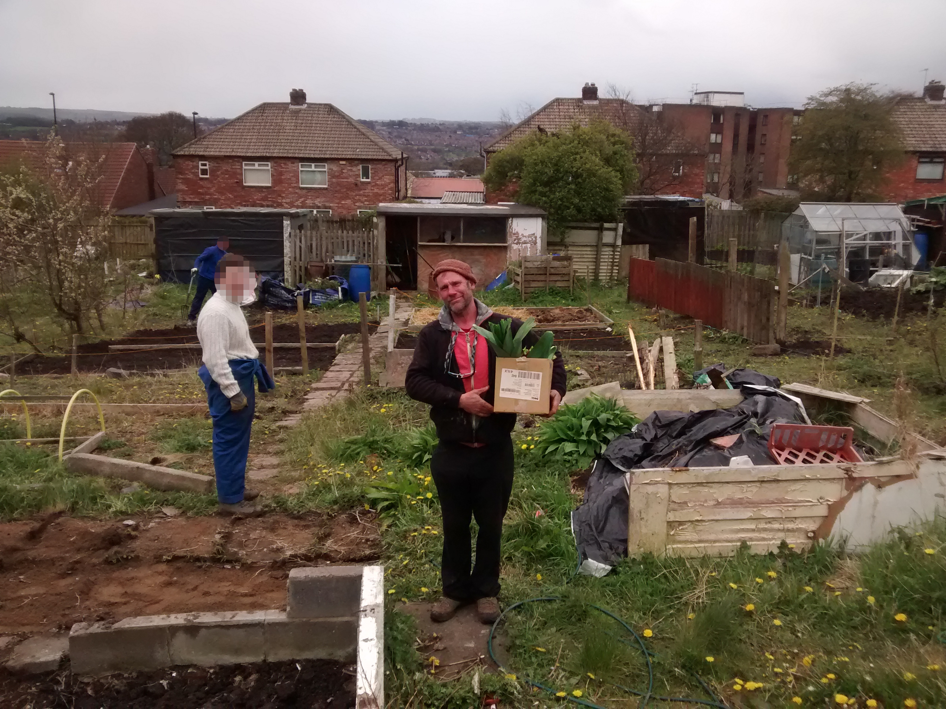
Figure 4.1: The project manager (Michael / Mick) at the Patchwork allotment with hired young people
The service users of Patchwork are generally very consistent in their presence within the context of Youth Work. I am sure any Youth Worker will have the scars of trying to wrangle disaffected young people into a form of schedule and I saw that Patchwork was no different in this. I worked with the 8–12 year old mixed group for several years and there was always a combination of: people who turned up every week; those who only popped through when they could; and those who would disappear for months and reappear later. Young people often attracted their friends to the group and when cliques formed sometimes this would prevent some people from attending regularly. This is exemplary of other Patchwork engagements that I saw. Older service users would sometimes visit every day during drop-ins; sometimes for direct support, to use the computers, or just to be around Patchwork for a chat (and sometimes just to get a free hot drink!). This also translates to the various groups that Patchwork work with; sometimes a group starts off very strong and then stops coming to Patchwork seemingly randomly which causes irritation on the part of the workers. Often the groups reappear for a variety of reasons, but most commonly because they want to take part in the summer programme.
This is to say that the work of Patchwork is exactly what one would expect of a hyper-local charity working directly with young people in a community that is generally seen as alienated. It is myriad, ever-evolving, and bespoke to circumstance. Having illustrated this I will now to elaborate on the people at Patchwork and the organisation structure.

People and Organisation Structure
This chapter discusses the initial fieldwork that was performed from February 2016 to around June or August that same year; wherein it transitioned into a phase of design work as noted in Chapter 3. This is important because the findings in this chapter use quotes from, and observations of, people who no longer work at Patchwork. My research with Patchwork continued until late 2018 and during this time period there were several changes in staff at Patchwork as some workers left and others joined. Further to this my involvement with Patchwork did not end with the completion of this research and they have remained an important part of my life. This involvement has meant that I have witnessed further updates to the roster which I will note at appropriate times.
During this period of initial fieldwork Patchwork consisted of three full-time and four part-time staff. With the exception of “Ludek” and “Charlene” who I have pseudonymised for reporting; all of the names reported are de-anonymised. This was done on request of the workers who wished their story be told as accurately as possible in the name of Transparency. Ludek and Charlene had left the project by the time this request was given and so I’ve not revealed their names.
Andi is the full-time Senior Youth Worker at the project. Her duties at the project involve designing front-end service delivery but also searching for funding via grant applications. She is one of two people whose money is used for purchasing and thus may claim expenses, alongside Michael.
Charlene performed administration duties when I first arrived at Patchwork, although she was never explicitly referred to as an “Administrator”. Her duties included producing the budget and working on the spreadsheets alongside Michael, as well as ensuring all members of staff were paid and expenses claimed properly. She left Patchwork shortly after my fieldwork began in May 2016 to take up a full time position at another organisation.
Dean was a full-time Youth Worker at the project. Hailing from Benwell himself Dean first attended Patchwork as a service user before being hired by the project as a worker. As all workers are involved in planning and delivering activities to young people, Dean performed these duties alongside Andi and Mick; but took a special interest in organising trips for young people. Throughout my fieldwork, Dean also took part in submitting funding applications. In 2019 Dean submitted a resignation to Patchwork due to personal circumstances.
Ludek was a part-time Youth Worker at the project. He was originally involved in the project as a service user; being a member of the Slovak and Romani community that live in the West End of Newcastle. Ludek’s participation in Patchwork appeared to be sporadic and he often did not show up for work, leading to the organisation dismissing him during this initial fieldwork period.
Lynne is the project’s current administrator and took over from Charlene around May 2016. During the period this chapter reports on she worked two days a week at Patchwork (Monday and Tuesday), and worked the rest of the week at another project in the same area (West End Women and Girls). When she came aboard Mick mentioned to the group in a meeting that “It’s quite exciting because the Project hasn’t had a proper Administrator before”. Lynne has since increased her hours at Patchwork and works the majority of the week there.
Michael (Mike / Mick) is the full-time Manager at Patchwork. Hailing from Sunderland he has been involved in delivering Youth Work for many years, and came to Patchwork as a manager in 2005. As a manager and a youth worker himself Mick is involved in front-end service delivery as well as administration and management duties. He writes the majority of the funding applications, and is one of two people who work on the budgeting and accounting (alongside Charlene/Lynne), and also is one of two people who may claim expenses alongside Andi.
Sonia was a part-time Youth Worker at the project. She originally interacted with the project as a service user and, similar to Dean, became involved in delivery. She was the volunteer co-coordinator for the project during my time there and in 2018 moved to a full-time position. A focus of her work was supporting young women and girls and she also headed activities at the play centre. At he end of 2019, Sonia also resigned from Patchwork to seek opportunities elsewhere.
Sydney (Syd) is Andi’s dog but is often conceptualised as a worker in conversation, and is frequently positioned in the front of The Project and as such often interacts with service users and community members.
Throughout the extent of my research at Patchwork across 2016 - 2018 I also worked with a number of volunteers from the community who are too numerous to recount in full. However in 2019 Karl and Owen, two consistent volunteers and service users, began full and part time positions respectively as trainee Youth Workers on a trajectory similar to that of Dean’s.
Structurally the charity is, like all in the UK, governed by a board of trustees. There have been a number of trustees over the years and during this initial period of research my contact with them was limited. Later stages of the research involved the trustees more directly (for evaluation) and these participants will be noted then. A current list of trustees (including myself) is available at Patchwork’s website (The Patchwork Project, 2016). I also provide in Figure 4.2 a diagram of the organisation structure as conceived of by the workers, taken from a drawing hosted on their website (The Patchwork Project, 2017) (note: hyperlink goes to a .doc file).
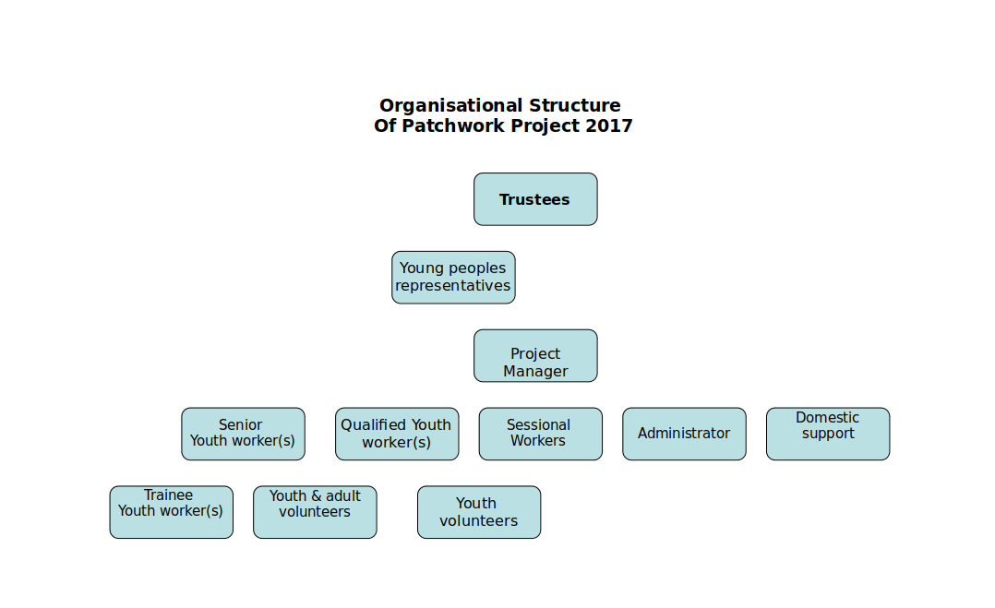
Figure 4.2 A diagram of Patchwork’s organisational structure. Produced in 2017 and taken from their website in 2020
When this work began Patchwork operated on an annual financial turnover of approximately £130k and out of a single site situated on the main Benwell high street. The site serves as a community hub and central offices and is often referred to by several names including “Patchy”, “The Project”, and more recently “Patchy 1” by both staff and community members.
Soon after I began fieldwork with Patchwork they received a large grant (discussed in greater detail later in the chapter) and opened a second site nearby. This site was once the old community play centre which Patchwork received from Newcastle Council by way of Community Asset Transfer (My Community, 2020) in early 2016 and is designed for young people’s play. Patchwork use this as a mutifunctional space for activities such as: young people’s play (primarily for groups aged 8–12 years); public events such as activity days; rented use such as by local religious groups (providing a stream of income for the charity); and storage for equipment that Patchwork use for other activities such as camping and cycling. The play centre is referred to as either “The Play Centre”, “Patchwork 2”, or “Patchy 2” in conversation. During the time of this fieldwork Patchwork also maintained an allotment at the Benwell allotments site although this has since been given up and turned over to others as the Play Centre has a patch which is suitable for growing vegetables.
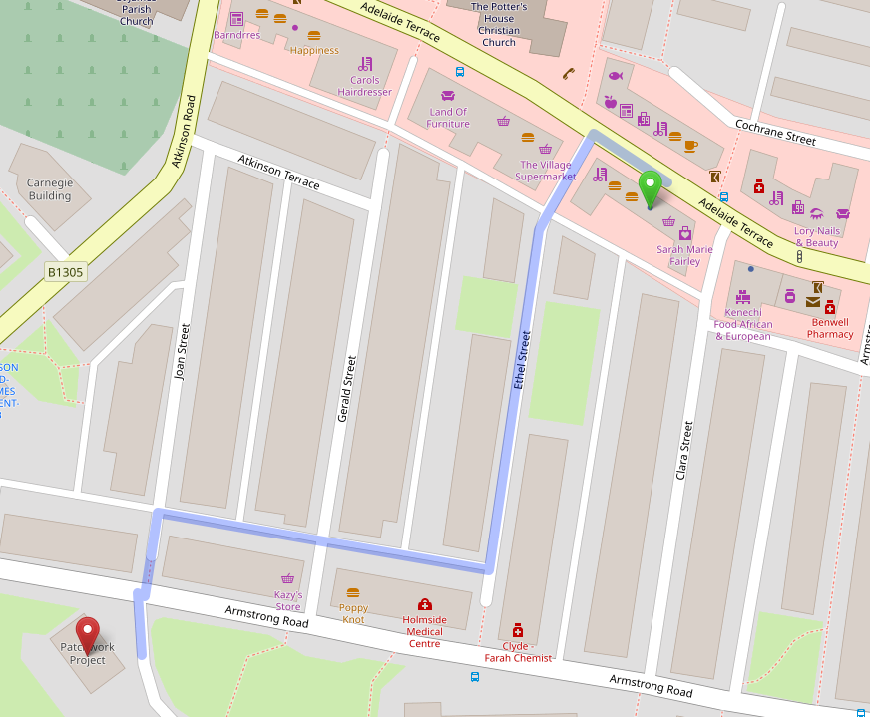
Figure 4.3 Map showing locations of Patchwork 1 (green) and Patchwork 2 (red) and walking route between them

Gaining Access, Integrating, and Research Activities
The fieldwork reported on here was conducted over seven months with Patchwork, beginning in February 2016. As noted in Chapter 02 this fieldwork and data collection were ethnographic in nature (Crabtree et al., 2012) and formed of participatory-observation activities at the charity. I involved myself in a very wide variety of activities at the organisation, including shadowing workers during their day-to-day duties, assisting with accounts preparation, and performing volunteering duties on a weekly basis.
Initially, fieldwork consisted of weekly meetings timed to coincide with Charlene’s shifts (on a Thursday) so that I could assist in administration and budgeting work. After three weeks I expanded this fieldwork to include participation in Patchwork’s work as a volunteer youth worker on Monday nights, and in addition to this would involve myself during the week – travelling to Patchwork and taking part in their activities during the day. These activities could be quite varied across the week and could consist of; planning and organising activities (including purchasing and budgeting); creating monitoring materials such as questionnaires; being involved in strategy meetings with partners; visiting the allotment and digging up food for preparation; responding to needs of service users as they wander in; visiting or hosting academics to discuss broader implications of their work; or writing funding applications.
I also partook in a lot of activities with the organisation outside of their immediate work duties; such as Fell Walking or climbing cliffs in Spain (and hosting Syd on a number of occasions while Andy was on holiday). Participation in these activities integrated me into the organisation not only by increasing my face-time with the workers, but demonstrating that I saw myself as becoming part of their community rather than an outside researcher. This in part has to do with how these activities straddle the workers’ personal and professional lives; this will be discussed in full later in this chapter.
Initially I relied on taking comprehensive field notes during visits, where possible. There were several instances where I was mocked (albeit lovingly) for having my notebook out, and others where the activity (such as digging) had to be reflected upon after the fact when I returned home. Later, when I become more confident, I began to ask workers for clarification on their tasks and purpose in the moment. I conceive of these moments as ‘in-situ’ interviews; and although they were not audio-recorded, they were integrated into my data through inclusion in field notes. As noted in Chapter 03 all of these activities produced my vulgar competence of Patchwork’s work and supported my integration into the organisation.
Following this period my integration with Patchwork increased and I eventually became a trustee of the organisation. However this chapter reports on work performed prior to that.

How do Patchwork account for their work and spending?
These accounts focus on how members of the setting achieve their goals through interactional work and are grouped based on the activities they relate to: Accounts of Spending; Accounts of Activities; and Accounts of Hidden Work.

Accounting for Spending
I describe here how the charity spends money, and what is involved in producing the accounts required by legal processes. Spending occurs in two ways: core organisational costs (salaries, building rental, etc.); and spending which is based in the activities of a given working day. These each have distinct mechanisms through which money is spent, and accounted for.

Everyday Spending
Everyday spending is made accountable internally by funnelling spend through two senior staff members. Charlene, the charity’s part-time administrator, described this:
Charlene: “The staff get paid back through expenses, and only Mick and Andi are allowed to make expenses claims which they’ll make generally when they notice their bank accounts are getting low”.
Charlene’s comment says two things. The first is that two senior workers, Mick and Andi, are the only ones allowed to make expenses claims for purchases. This allows them to ensure that all claims are deemed appropriate since they may monitor purchases and remove the possibility of abuse by other staff members. Their personal practices are also indicated by Charlene – they only make claims when they “notice their bank accounts are getting low”. That this is possible to do also indicates the practice of storing transaction records for compilation and reimbursement. While this may initially seem restrictive, I observed practices involving the devolution of purchasing work to other staff members, allowing multiple workers to make necessary purchases. I saw that this devolution of responsibility could occur in two ways. Below is a vignette describing each of these, which details events that occurred across two days of fieldwork:
Whilst helping prepare for a ‘Community Activity Day’, Sonia and I were tasked with producing a grocery list for the BBQ. While walking to the store we were approached on the side of the road by Mick in the minibus. He asks us if we’re “off to buy food?”. Sonia affirms and Mick replies “Here, take this” handing her his bank card, “Do you know the PIN?”. Sonia nods and Mick chuckles, saying “Aye. Half of Benwell know that PIN now” and driving off. When shopping, we explicitly choose the cheapest possible store-brand products. I ask about this and she tells me “We can’t be seen to be buying brands really”. We use Mick’s card to pay and later, Mick returns around an hour later and retrieves his card and the receipt of purchase from Sonia, checking over it briefly before putting it in his wallet. The next day, I was walking to the Play Centre when Mick pulled up in the minibus heading in the opposite direction at speed. He stops only to hand me 20 and tells me “We need toilet roll for the Play Centre. Go get some from Specials’ [convenience store] across the road, the cheap pack at the back of the shop”. After making the purchase I head to the Play Centre which is already full of activity. I find Andi and hand her the money, which she takes and asks me for a receipt. She stores the receipt together with Mick’s cash in her back pocket.
This illustrates how spending is funnelled through the senior staff whilst still allowing the organisation to distribute the labour of purchasing by devolving responsibility. Sonia is handed Mick’s debit card so that it is his money that is spent, and this acts as a buffer between the member of staff and the organisation’s finances. This buffer is also present when Mick hands cash to me so that they can participate in spending. There is also both evidence of an immediate internal checking process and an awareness of wider notions of being responsible with spending. Mick checks the receipt that Sonia presents to ensure appropriateness, and Sonia does not wish to be “seen to be buying brands”. Sonia may have to justify purchases if called upon by Mick, and in context of the charity’s overall budget – this is due to the perceived appropriateness of a spend. This is also seen when Mick explicitly provides me with instructions to purchase the “the big cheap pack” of toilet roll. This accounting to me also provides them a way of making sense of the organisational values at Patchwork. The activity of going and purchasing some toilet roll is the kind of work a new member of staff would perform when getting used to the organisation; Mick informing me of the purchasing requirements without prompting may be understood as an act of training where the end result is a member of staff (or the community) who implicitly understands that “the big cheap pack” of toilet roll is the best choice (and why). Overall, these internal measures show that the organisation may attest to being responsible with money when able to present context but this is unaccounted for via formal means.

Staff Salaries
In meetings with Charlene during fieldwork, I discussed with her how staff are salaried at Patchwork:
Charlene: “Dean and Andi get paid full time, I get paid part-time. Mick works full-time but he’s only paid part-time.”
Charlene lists several of the staff and their pay-schemes, but noticeably says here that Mick is working full time but only paid for part of his work, indicating that his salary is variable even though his role is central to the organisation. During a subsequent fieldwork session, Mick elaborated on this:
“It’s what’s best for …I don’t care how much I get paid, and it’s money that I have to end up looking for. I put salaries down for the last few years, and it took a while to put Dean up to £20K when he started because of money. With the Big Lottery Fund coming in now we can start thinking about putting the salaries back to normal.”
Mick’s discussion of the staff accepting lower pay provides insight into the values of the organisation. The staff are dedicated to the organisation’s work, and are aware of their impact on its finances; accepting lower pay in order to “keep things going”. Where Mick discusses having to look for the money to pay staff, he also touches upon how raising pay creates an increase in labour as he is required to expend effort sourcing funds to make up the difference. Further into fieldwork, Mick provides additional insight into this during discussion about staff salaries and standard pay increases amid the adjustment:
Mick: “We’re putting salaries up which is a big relief for everyone. I’ll be on £30K, but not really because that means more tax so you have to judge it carefully. Because of the tax brackets, past a certain point it makes no sense to give me a pay increase because of how much it’ll cost. An extra hundred to me per week will be several thousand a year to the charity which I have to find and justify finding. This way everyone still sees their pay increase, including me, but I’m not too worried about finding the extra cash. It’s still the least you’ll ever see another project manager get paid round here though. Some larger organisations have six or seven heads on about £100K; nearly a million you need before you even get anything done.”
This emphasises Mick’s awareness of how staff salaries impact the organisation; he is willing to keep his salary lower than that of comparable positions in the area (“round here”) and demonstrates that he would need to justify to others a pay increase that required searching for a disproportionate amount of further funding. Mick also mentions how the staff will be relieved that the salaries are being brought in line with standard pay rises; illustrating that the salary cuts have tangible effects on staff and further defining their position as a value-driven cohort. When Mick discusses the salaries of larger organisations he also reveals his views on what money and people are supposed to do in an organisation; they are supposed to be put towards the organisation’s work and paying head staff large salaries creates pressure from extra work and financial requirements “before you even get anything done”.

Compiling Accounts
All income and spending must be accounted for formally through compilation of ‘the accounts’; records of financial transactions that must be produced, audited and presented to bodies such as the charity’s Board of Trustees (like a corporate executive board who act in a supervisory capacity for a charity) or the Charity Commission (UK governing body). Compiling accounts was an activity I was involved in during fieldwork, generally performed alongside the administrator (Charlene, and later Lynne). When initially instructed in the task by Mick, I was given insight into the role of financial accounts in the organisation and what is involved in the task:
Mick: “We have this budgeting tool. It’s an Excel spreadsheet really […] this lad who used to work for us set it up, we can add funders and add spending and stuff and we can use it to see how much we have left in each budget. At the end of each financial year this gets sent to the accountant so they can sign it off for us.”
This encapsulates two things about how this work is performed. First, it may be performed by several people, and that this role may be more transitory than others in the organisation. During the course of our involvement, the role of Administrator changes from Charlene to Lynne, and was previously occupied by another prior to research beginning (the “lad”). This brings into question how well imposed administration tasks fit with the value driven nature of the organisation’s other activities. It also reveals how the organisation views using the spreadsheet when doing budgeting; Mick refers to it as a tool, with which he can present an account of the budget to himself, and can be used to generate another account to others (one which is legally or contractually stipulated).
Figure 4.4 outlines the process of how an expense occurs from the Acquisition stage through being filed and recorded, up until how the expenses repayment is then made and the records are adjusted before finally being reconciled.
A major component of producing a canonical set of records to produce this account to others is the act of Reconciling expenditure. Reconciling is the process of mapping transactions in the bank statements to transactions in the budgeting spreadsheet. The process is required as a component of having the financial accounts ‘signed off’ by an independent accountant. I outline the process of reconciling accounts below with an extract from my fieldwork diary and in Figure 4.4:
Lynne taught me how to reconcile accounts today. She first took a large wallet labelled receipts from behind her and inside there were two separate folders for Mick and Andi; being the only two workers who may claim for expenses. She also fetched a small box of printed bank statements. She handed me the wallet and we started going through them one by one starting with Mick’s. As I read the value and items from each, Lynne would note them in the spreadsheet along with the worker and adding a budget code. Occasionally when she knew which project an expense was for she would “cost” this to a fund in a dropdown menu in a column in the spreadsheet. She would then search through her stack of printed bank statement and find the transaction that matched the expenses claim for the worker. Where an expenses claim was comprised of several receipts, she would group these together in the spreadsheet and adjust the value column for the total, rather than the individual expenses. She would then physically tick the transaction in the statement, tick the receipt that I handed to her, and list an “r” in the spreadsheet which stood for “reconciled”
I note from this extract that three components are required for reconciliation: an entry in the logbook (ie the spreadsheet); the transaction in the bank statement; and the receipt of purchase. The first point of note is that the actual reconciliation work is performed by the charity workers themselves, and that the role of the accountant is to act as a checker. It is interesting to note that while the “accounts” are the result of the workers’ labour; the means of producing Accountability using these records is not under worker control but is mediated by a paid third party. Patchwork may not present these accounts to the public and get them “signed off” by them but are required to contract out.
Figure 4.4 presents a diagram of the sequential order of how an expense claim occurs and how it is eventually recorded in the accounts and reconciled to produce a canonical set of accounts. The diagram presents “horizontal and vertical slicing” of the process (Crabtree et al., 2012), where the work order is atop the diagram horizontally, and then elaborated on in sequences which are shown vertically underneath headings. This diagram was produced first on paper in my field notes, verified with Patchwork staff, and then reproduced digitally and in a stylised manner for the thesis.
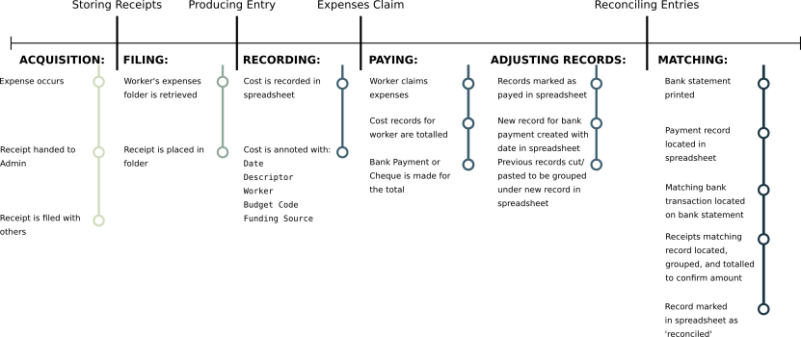
Figure 4.4 A diagram of the sequential order of reconciling expenses to produce a canonical set of accounts
It is also of note that Lynne (and previously Charlene) developed their own internal processes to producing a record that maps onto an external standard. The standard in question is that of having a canonical record of their income and spending; whereas the process of adding ticks and the reconciliation marks (the ‘r’ in the spreadsheet) are their own way of expressing this critical matching stage of producing a canonical set of accounts.
I did, however, witness that there is an inherent tension when presenting accounts for auditing to a chosen third party. The final stage of making your accounts canonical is the auditing processes.These require accounts to be ‘ratified’ (checked and signed) by an accountant, and often experience conflict when engaging with commercial accountants. I describe this below:
During a meeting, Mick asks to speak to me about the accounts. “I’m not happy with the accountants at the moment, they’re being problematic”. I ask why and he responds “They just want us to use Sage do you know Sage? The accountants don’t like that we don’t use Sage, and I think that’s because they can just import it and have it do their job for them.” At a later meeting with trustees Mick speaks again on the issue, “We’re thinking of scrapping Ellison’s. They’ve upped the price to £1300 …, and they’re trying to force us to use Sage so we do their job for them. We’ve spoken to a woman we found on the Chronicle who says she’ll do it for £20 an hour and she’s happy to do them in whatever format we want. She’s been in and looked already and she’s told us that we’ve already done the job, and all she’ll need to do is double-check a few things and sign it off. We have to make sure she’s got the right, y’know, qualifications, to do that but aye it looks much better.”.
Here Mick shows that there is an explicit point of contention that arises when commercial accounting models are misapplied to charities. The accountants use expensive commercial software and apply it as a de facto standard, presenting a barrier to the charity engaging with the auditing processes required of them. These attempts to influence Patchwork’s toolkit and thus their accounting practices demonstrates a conflict that, in order to become transparent in a particular way, they must use methods imposed upon them that do not support their own practices of accounting for money and alienating them from their current accounting processes which match their work practice. That Sage Accounts (Sage UK, 2021) is expensive commercial software is also of note. Patchwork own their spreadsheet; it is tool that they developed and use to produce their records. They do not own Sage, and in addition to the money it would further remove them from the ability to produce their own records in a form that becomes canonical and leads to the production of their Accountability to others.
Other features of the tool and accounting process are brought to light when Mick details the process of ‘Costing’ to me:
Mick: “This lets us see how much money we have in each fund, and then in the other screen here I can assign it to a funding pot and then this updates.”
At a later point in fieldwork, Mick elaborates on this practice, and how the organisation benefits from it:
Mick: “I do this when someone tells me that a report [to a funder] is due. I’ll see what the fund says I can spend it on, and then I’ll cost things to it and move things around so that each fund is happy. Sometimes I do it when we need to spend money from a fund that’s due and I can go back and move things so it’s used up, then there’s loads to put in the report. Or sometimes if we need money for something, I’ll go and free something up from a fund by moving things to other funds.”
Costing work is as such related to the reports that funders stipulate as part of their funding arrangement with the charity. Mick shows that the organisation has some flexibility in the way that it costs things, and uses this to justify spending that may have been outside of the original proposed use for the funding.

Accounting for Activity
As well as having to account for financial spending, Patchwork are also required to account for their work activity. Accountability here is notably experienced through both formal procedures and more interpersonal interactions with the community. I outline below how the organisation navigates this, in order to explicate the work practices that support communicating the organisation’s activities to others.

Curating qualitative records
I observed the workers engaging in the production and curation of qualitative records that assisted them in presenting an account of their work. Some forms of record were stipulated as legal requirements, whereas others were produced at the prerogative of workers as this extract from my fieldwork diary shows:
During a session, I observed Andi taking photographs using her phone. She would often approach participants to take a photograph of them. Whenever possible, Andi would call to another youth worker and ask them to get into the photograph as well. The next morning, I have been tagged in photographs by ’s Facebook account alongside the other workers and young people in the photographs.
Andi’s behaviour shows her producing a qualitative record of the event and activity that occurred. She can be seen collecting photographic evidence of their attendance in-situ, and using this to elaborate on the context of their work. The practice of uploading these to a social media profile produces an account of their activity for others, and tagging people in photographs on the platform encourages those tagged to look at them and potentially allows others (such as parents) to glimpse the activity as well. As well as on social media, print out a selection of photographs in a poster format, which are displayed around their main community hub. The workers reflected on this practice in a group discussion:
Andi: “Part of it’s capturing that moment in time because it’s gonna be gone. Y’know, and it would be very easy for them to forget […] So you’re capturing it for them, you’re capturing it for their parents to see what they’ve achieved, or for the Duke of Edinburgh so they can prove whatever it is they’ve done. You’re putting on the wall as a celebration, you’re putting it in the annual report for funders to see and also for young’uns to see […] Like loads of kids will be like ‘will this be going on the wall?’.”
Mick: “We just take lots of pictures because it becomes a resource for us as well. The ones on the wall are of the D of E because they’re positive images. Sitting down two people and talking one to one and that — it’s not very entertaining.”
It can be seen here how Patchwork use a resource bank of records built up by photographs for different types of accounts, to different people. This illustrates the elasticity a record may possess; Andi relates how photographs may be used as evidence for participant’s involvement in an award, whereas Mick conceptualises them as “positive images” and a resource for the organisation’s future needs. Andi also explicates how the photographs are shown to parents in order to provide an account of their child’s activity with . This also demonstrates how the photographs are repurposed to provide an account of value in the annual report, and to provide a personal record for the young people when it’s placed on the wall in “celebration”. The ability for these records to form a resource from which different accounts can be derived also sits in contrast to other forms of work that perform that, as Mick indicates here, are more difficult to account for (“Sitting down two people and talking one to one and that — it’s not very entertaining”). I observed this first-hand during fieldwork when Mick expressed frustration at the records that are required to keep of their meetings with service users, and how it is difficult to present these to others:
I followed Mick to a filing cabinet that was unlabelled. He took out a folder to show me an example, “Here. This is a monitoring form we have to fill out every time we have a chat with someone. You say who it was, what you chatted about and what the outcomes were. Standard ticky-box stuff. We’re meant to keep this, and we do by the way, but nobody ever asks to see it. I’ve got files here from ten year ago which haven’t seen the light of day. People complain at us that we’re not doing our job and ticking boxes but we are, but nobody ever comes in. Nobody ever asks.”
Mick’s frustration indicates that while he is fulfilling legal and stipulated obligations designed to make Patchwork accountable for their work, they are not given the opportunity to demonstrate this properly. When Mick describes how photographs of these chats would be “not very entertaining” it becomes obvious that while Patchwork could theoretically generate records of these the effort required to do so would not result in a substantial gain for the charity when trying to demonstrate their value.

Accountability of activity in the community
In contrast to the perceived indifference of regulatory bodies, I found that the workers at Patchwork saw themselves as being highly visible and thus accountable to their local community both in their roles as youth workers, but also as individuals within it due to an inherent visibility of their presence. This is characterised by Dean’s conception of Accountability during a group discussion:
Dean: “There’s the visibility in and out of work. It’s not a one-way thing, I’m not Dean the youth worker during the day and I’m not Darts-Dean at night I’m both and I’ve got to be very aware that young people and the families that I work with, […], I live in the same area as them and they are watching me constantly. In and out. I’ve got to be visible. It’s… an awareness of your role within the community. And I think another one for me, being accountable is remaining humble and just thinking that I’m very much where I’ve come from and I’m very like the young people I work with and they know my family.”
With this, Dean shows us how he sees his role in the community by living and working in the same area. Dean provides a view that Accountability for his actions as a youth worker is lived in each moment. He is constantly watched by those around him, even when outside of work during his recreation activities and can therefore be seen as a whole, rather than only through a lens of his output at Patchwork. I saw this value in practice through the way that Patchwork configures their Social Media presence:
Andi: “We didn’t like having a Facebook ’Page’ because it treats you like a business and wants you to pay so everyone sees your posts. We want to be seen in the community. So we made the account a person instead and everyone is our friend and the kids message us at stupid hours …When Facebook changed it so that you couldn’t have a company name as a person, we changed our name to ‘Mick’ as Mick doesn’t use Facebook himself. [The community] know it’s all of us though, not just him.”
Andi emphasises the value-driven nature of the organisation’s work through how they’ve chosen to configure their Social Media presence. She notes that whilst there is a pragmatic benefit in how personal accounts are seen on the Facebook platform, this embodies their desire to be seen as part of the community. Later, the organisation took steps to maintain this dynamic by capitalising the identity of a worker, Mick, for use as a profile name. When Andi elaborates on her belief that the community understands they are interacting with all workers through the Facebook account, she belies her belief in the dynamic that the workers are visible and present as part of the community and are not abstracted by their involvement in the organisation – being visible and accountable.
Another way in which Patchwork curate Accountability to their community is how the workers engage in extra-curricular activities involving both themselves and members of the community. These are ostensibly the workers engaging in recreational activities but in some capacity they almost always involved an element of staff training or engaging with wider members of the community. An example of this would be the activity of Fell Walking. Patchwork staff will often go out as a team to walk up the Fells, putting to use and further developing their skills in the activity directly, but in doing so effectively “scouting” the location as a potential activity to include young people in. That community members such as trustees or Benwell residents are often present also demonstrates Patchwork’s commitment to the area, and further facilitates their ties to their service users.

Accounting for Hidden Work
I have just shown how accounting and reporting for charitable activity is a key part of everyday life at Patchwork however I also witnessed that there is an understanding that a lot of the everyday work of Patchwork is hidden from regular reporting streams. I have termed this Hidden Work which refers to the effort required by the workers to make their work productive, and has been called Unproductive Labour in Political Economy (Marx et al., 1974), and Articulation Work in CSCW texts (Schmidt & Bannon, 1992). I concern myself not only with how this is performed but how it is accounted for and communicated to others. In this context it refers to effort expended by workers at the charity in addition to what the task demands in-the-moment. An example would be the planning required to execute community sessions ahead of time. I found that accounting for this hidden work occurs only in conjunction with its performance, during meetings, or discussions about activities and planning – it is rare for those outside of the organisation and immediate community to be made aware of this work. Accounting for hidden work is thus more informal, and often complicated by the nature of Patchwork’s activity. I elaborate on these points below.

Responding Work
A lot of hidden work arises from Patchwork’s open-door policy, which requires an immediate response to community members coming through the door for their services or informal discussions – disrupting the processes by which workers are performing (and accounting for) hidden work. This came to the fore in one discussion during fieldwork:
We were discussing another youth project operating in the city, as have recently acquired a Play Centre and are finding ways to use it most effectively so have visited other charities to learn from them. It’s mentioned that the other project execute elaborately planned evenings of activities for their attendees and Dean exclaims “They’ve got the time they don’t start until half four! As soon as that shutter goes up we have work to do!” He gestures at street-facing window towards the front of the room. The group nod in agreement
Dean is discussing how Patchwork’s activity cannot be judged against that of another organisation with different working patterns. He also makes reference to the open door policy and its effect on their working day regarding planning and makes clear that these informal meetings are conceived of as ‘work’; there is effort expended when conversing that prevents them from performing other tasks. These conversations must be engaged in because they also form an important part of how Patchwork organise their work. This was elaborated on during a group discussion with me:
Andi: “So aye, [anon] is a good example. […] I know he was doing football, I knew he was doing work experience so he’d have the time and you just think well it would be really good for him to do it for his future. Y’know, so having a conversation with him to say look are you interested in this?”
Engaging in conversations that arise from the open-door policy can thus translate to outcomes, in this case a beneficiary getting a work experience placement based around a hobby. This qualifies Dean’s earlier utterance that the organisation has “work to do” as soon as they start: these conversations are work that must occur for to achieve its goals effectively, but it is difficult to provide an account of this to others.

Understanding Hidden Work through Context
Hidden work is rarely accounted for outside of the organisation and immediate community. During fieldwork, however, Mick related how outsiders may be introduced to the context of the organisation to understand the labour required to perform everyday tasks and achieve outcomes:
“It’s like when this guy from [a funder] came in to check. Most funders don’t and they don’t understand us. He came in and he loved it. He said that he was amazed we could keep the place running, we had so much going on around here that we deal with on a daily basis.”
From this it is established that Mick understands the difficulty of accounting for this labour to others — most funders do not visit and thus do not understand how the project achieves its aims. The work involved in delivering results for Patchwork is responsive, complex, supportive of others, and facilitative of them accomplishing things in a way that makes it difficult to tie these to discrete acts to the project’s stated aims. That the funder is amazed at the scale of everyday work and effort being expended shows that this is not captured or represented elsewhere; and can be accounted for only by being present and producing one’s own account from the context of the activity. I later saw that this problem is compounded and is encapsulated with a vignette of activity leading up to a scheduled evening event in the organisation:
I was due to attend a session with a group referred to as the ‘Slovak Lasses’ group, comprised of young Slovak women aged between 15 and 24. The sessions run from 1600 approx until about 1830, and the plan is to run a BBQ event for the attendees. From 1545, two participants had turned up alongside a part-time worker and sat at computers browsing Facebook. Dean is also on Facebook using the account and has several chat windows open. When prompted, Dean responded that he is “chasing up” the rest of the group to make sure that they were coming. Whilst passing, Andi convinces the attendees to accept her taking a photograph of them. Dean signs off the computer at 1630 and at 1655, there is no sign of other attendees. Dean is visibly concerned, pacing back and forward. He mutters that “we should sack this group”. Sonia nods then says “this is ridiculous. We have two young people and four staff”. I am dismissed by Dean who says “You can go if you want. It’s a bit weird if we outnumber the girls and we have loads of staff in”.
This example shows two things. First, it reinforces the issue of hidden work only being able to be accounted for in-the-moment. Dean performs the additional task of ‘chasing up’ participants; work which emerges as the evening progresses and is only visible to those in the room. Secondly, it raises the issue of how the staff’s efforts would appear if mapped to outcomes in an accounting process. Sonia indicates that such a mapping would not appear favourable (“We have two young people and four staff”), and Dean hints that this is not an uncommon occurrence (“we should sack this group”). Patchwork has to balance the goal of maintaining a relationship with the beneficiaries – which can lead to important outcomes – with the need to make and be seen making effective use of their time and labour resources. The slower and seemingly less productive execution of the event also directly contrasts with what Mick describes as the funder’s surprise at the high levels of activity during a visit. This likely results from an intersection of elements such as the specific beneficiaries, the time of day, etc. but when isolated from context these two incidents each paint seemingly irreconcilable views of the organisation’s daily life.

Inferring Hidden Work
I did see that hidden work may sometimes be inferred by other members of the organisation, in addition to those present as it occurs. This is often achieved through the records that are produced as a by-product of activity in conjunction with the worker’s implicit knowledge of each others’ work practices:
I was participating in a planning session for the evening’s activities; initiated when Dean and Andi each took out large workbooks. Andi asks “Where’s Mick?”, to which Dean responds that he is “down the allotment”. Andi looks puzzled at this and Dean elaborates, “He’s seeing how [the gardener]’s getting on” and turns the notebook to show Andi. There is a task list which shows ‘allotment’. Andi looks at this, and nods.
This shows that workers may use records to infer the activity and thus the work of others in the charity. Dean shows Andi a workbook entry which contains only a single word that allows both Dean and Andi to construct a context around Mick’s current whereabouts. It can be seen how Andi and Dean understand that work is being performed at the allotment, and that Mick’s absence indicates that it is him performing it. Furthermore; the workers are able to infer the nature of this work, as Dean is able to ascertain that Mick is checking up on someone whilst there. Similarly, I also saw that financial records such as receipts could be re-appropriated and used for this inferral:
Mick was having lunch and moving items on the table out of his way, to place his laptop there and write a report. Moving a pile of paper, he turns to inspect it and finds a receipt, saying aloud “What’s this? Ohh. It’s the pancake stuff for tonight; Sonia’s been shopping.”
The receipt makes Sonia’s work accountable internally, as Mick recognises that the items are a list of ingredients to make pancakes, an activity commonly run by the charity. He infers that there has been effort expended in acquiring these materials when he says “Sonia’s been shopping”, and can attribute this to Sonia through knowledge that shopping was a task to be completed and that Sonia was assigned to it. The receipt also pertains to the charity’s activity – running a session involving cooking. This shows how accounting for this hidden work hints at the organisation’s work towards goals. Notably, this testifies that record may exist within several contexts: evidencing expenditure, the inferral of activity, and the by-product of work related to activity (a cooking session) that may be accounted for.

Summary of Accounting practices
This section has provided a detailed description of the work practices involved in making Patchwork transparent and accountable to its stakeholders. This accounting work has been presented as grouped based on the area of activity that this interactional work relates to: Accounting for Spending; Accounting for Activity; and Accounting for Hidden Work.
Each of these areas of this Accountability work is achieved through a variety of ways which are organised to make sure that the organisation meets its legal and contractual obligations to report spending and activity as well as its immediate concerns of being transparent to the community.

How should systems be designed to support Accountability Work?
My field observations demonstrate that those working in a charity may experience Accountability in multiple ways, with reference to their values, work, and responsibilities both as an organisation and individuals. This fieldwork shows how legal and financial frameworks surrounding the organisation has a pronounced effect in the work required for a charity to account for the use of resources – both financial and labour – and also that members of the setting can experience this Accountability as part of their everyday work in the organisation. I also presented evidence that the organisation and its workers view themselves as inseparable from their local community, thus accountable to it; this relationship requires a maintenance effort similar to the legal demands of government and funders.
These findings show how conflicts may emerge from the ways in which the charity views itself as accountable to various stakeholders such as its community, its funders, and governmental bodies. In one key instance, Patchwork must be accountable to funders by reporting their use of grant money whilst simultaneously tailoring activities and spending with regard to the emergent needs of their beneficiaries. This conflict is rooted in the Accountability pathways that they must engage in: charities are controlled by their funders to ensure that their spending falls within a specific remit, and this conflicts with a need to be responsive as an organisation and act in accordance with the needs of beneficiaries. This is discussed by Koppel as Multiple Accountability Disorder (MAD) (Koppell, 2005) and compounding this is the various ways in which the organisation is required to make itself transparent. As discussed, Transparency is often seen as a foundational element of Accountability but the relationship between the two is nuanced – where various forms of being transparent may generate different forms of Accountability (Koppell, 2005; Fox, 2007; Hood, 2010).
This raises questions around the role of technologies in charities and how they allow workers to navigate conflicts inherent in their Accountability requirements. In the following sections I discuss design considerations for future systems that seek to assist charities in managing the tensions associated with becoming transparent and accountable.

Support the Accountability of Work Practice
Our research began by examining Accountability from the perspective of public and voluntary sector administration, where organisations may be accountable to others through a number of different pathways such as producing answers when questioned (Fox, 2007; Koppell, 2005). This is demonstrated in our findings as much of the work involved in ‘doing Accountability’ involves workers producing answers for stakeholders in the form of reports on spending and how activities were delivered in relation to this expenditure. I posit this offers HCI an opportunity to affect change through a form of Accountability with which it is intimately familiar: the accountable nature of work (Garfinkel, 1967).
While ‘work’ in Garfinkel’s terms refers explicitly to interactional work in the accomplishment of ordering social settings, these interactions are what form the basis of an organisation’s accomplishment of its goals. For example, my findings show that a receipt of purchase obviously means someone has been shopping, and is also incorporated as evidence in the financial accounting process. Prior work has been done by Strauss on “Articulation Work” (Strauss, 1985, 1988), referring to how constituent elements of tasks are fit together and articulated by members of the settings to support coordinating work and keeping it flowing. In this chapter, I show how an organisation such as Patchwork engages not only in Articulation Work in order to progress the work and its various project; but that some of this work is performed explicitly to articulate their work to others who are not involved in the daily production of work in the setting so that they are meeting their obligations of being “Transparent and Accountable”. This ‘Accountability Work’ can account for the work it does towards it goals for others and to key stakeholders not necessarily involved in the work — but the emergent nature of outcomes means that this only provides a partial view. I show that visitors to Patchwork comment upon activity there as the work and the context of that work is made obvious; yet the accountable nature of that interaction is not supported through systematic processes for reporting.
Making Accountability accountable here, then, involves producing systems that allow the communication of organisation’s accomplishment of their work practice in relation to their goals. This should be in such a way that the work of an organisation is made obvious at a glance. My findings demonstrate that the charity appropriates social media as an ‘organisational accounting device’ (Dourish, 2001), making their activities observable and reportable to those who care to look. As such, I propose that technologies be developed to support the communication of work practices in context with organisational goals. For instance, accounting software that appropriates social media features such as timelines, tagging, and events to contextualise financial records or work toward outcomes. This would provide a resource for both workers and stakeholders and in doing so may begin to address the current chasm between reporting processes and the emergent nature of outcomes; making it clearer to all parties how the work of a charity sits in its local context.
In speaking of providing resources for workers I feel that an otherwise obvious point must explicitly be made in that any systems designed for their use must be provided as a non-proprietary system. Patchwork express a clear desire to avoid costly software (“The accountants don’t like that we don’t use Sage”) and prefer to rely instead on their home-grown toolkit that they’ve designed and assembled to meet their needs. If Patchwork are to benefit long-term from any system deployed, then it must be developed explicitly as a non-proprietary system would be one that is released as Free Software under an open license so that they may use it without cost.
Since any new system will need to be both Free Software and purpose built to address the needs of Patchwork it must also address the issue of interoperability. Speaking again of their obligations with accountants Patchwork note of the accountants system that “they can just import it and have it do their job for them”. This fieldwork has focused on a single organisation’s work practice and design requirements but in order to leave the door adequately open to future developments this interoperability should be designed into the system as a core value.
It is also imperative to ensure that these systems cannot be used to control or monitor the actions of workers, effectively ‘managing’ productive labour to make this accountable to funders (Harper, 1992). Systems should instead provide workers with means to produce accounts of their work flexibly, and express these accounts in a diverse manner. This enables the different forms of Transparency that predicate various accountabilities (Koppell, 2005; Fox, 2007; Hood, 2010). Such systems will thus need to enable the configuration of Transparency to support making work accountable for those who care to look. I discuss how this may be achieved below.

Enable configuration of Transparency
Charities such as are shown to engage simultaneously in multiple forms of Transparency to satisfy their Accountability requirements. While regulatory bodies and funders are concerned with spending money and monitoring output this is widely accepted to be divorced from the true impact of an organisation’s work (Heald, 2006). Simultaneously, Patchwork take efforts to make themselves transparent and accountable to their community through practices such as using social media and having open-door policies.
These efforts are in line with calls to partake in more active forms of Transparency which are seen as more communicative (Oliver, 2004; Schauer, 2011). It can be seen here, however, that this often requires extra work on behalf of the workers to articulate their results and efforts to the community on top of compiling reports for other government entities and funders. Important here is the narrative form this Transparency takes, and HCI has previously seen how charities can construct narratives surrounding their work through the use of Open Data (Erete et al., 2016). Patchwork engage in a process which involves them collecting data which they fashion into narratives. Digital tools also play a role in ‘Costing Work’ to satisfy requirements that spending appears to have been in accordance with funding conditions, but is actually spent as the charity responds more directly to beneficiaries. This is an example of how charities may feel compelled to frame their work by tailoring reports to meet expectations (Lowe & Wilson, 2015), and demonstrates how the values embedded in the design have negative impacts on how the organisation may achieve its goals (Pine & Mazmanian, 2014).
While my previous work calls for qualitative forms of accounting (Marshall et al., 2016), I put forward that new systems must do more than simply incorporate additional data into the accounting process; they must be designed with embedded values that better reflect the needs of an organisation and its beneficiaries. As these may differ between organisations, systems should seek to support workers in easily matching their records to the required format per request without much additional labour. Providing interfaces to retrieve, combine, and present data in a multitude of ways would go some way in supporting charities experiencing multiple Accountability requirements. Doing so acknowledges not only the conflict of multiple accountabilities and transparencies; but the problem that is the effort required to manage these conflicts separately. This would allow organisations a material means to configure Transparency based on context. It also presents new opportunities for stakeholders to engage charities; if systems allowed the controlled retrieval of information (McAuley et al., 2011), then stakeholders may actually assist in configuration work and create new ways to interpret the data that is more meaningful for them.
This may be achieved practically through providing lightweight, inter-operable, data collection tools and interfaces (e.g. mobile and web applications) that allow workers to easily collect, combine, and process information based on evolving needs but operate independently without commitment to one platform. Thus the design embodies values of organisational control and flexibility to support workers collaborating in curating an organisational account. This account would then take the form of an interrogable dataset that can be configured to meet the mode of Transparency and Accountability required for a given purpose. That these systems and interfaces must be simple to use should also be forefronted. Patchwork are a charitable organisation which means that any time (and money) spent on training may be equated to resources directed away from service delivery. Simple and purposeful tools accommodate Patchwork’s economic nature as well as the social character of staff turnover; systems should able to be learned easily from people with a variety of skillsets and backgrounds.
Providing this configurable form of Transparency requires that systems consider the means by which the dataset is created, curated, and queried. I address this below.

Create Contexts through Linked Accounting
I have portrayed the challenges of accounting for Hidden Work; the activity behind what is being accounted for. This challenge also manifests in terms of the increasing demand for charities to not just account for their activity, but for their outcomes - the effect of their activity on the lives of those with whom they work (Lowe & Wilson, 2015). Holding organisations accountable for delivering outcomes (e.g. improving the health of a community) has been critiqued as they are often the result of overwhelmingly complex systems, which any given organisation cannot control, and therefore cannot be held accountable for (Lowe, 2013). Our findings demonstrate that a disconnect exists in how organisations may perform work and how it is reported upon; such as being concerned about numbers attending a group.
Historically, the ‘Linking Processes’ between input of work and money to work output and eventual outcomes has been problematic and poorly understood (Heald, 2006). People often seek to create ‘program logic models’ which connect activity to outcomes as a linear model of cause-and-effect (Schalock & Bonham, 2003) but as discussed; outcomes are generally emergent and such models are not representative of how they come about.
Since outcomes emerge from complex systems interacting (Lowe, 2013; Lowe & Wilson, 2015), I have proposed that digital technologies support configuration of Transparency. The role of Linked Data (Bizer, 2009) is central in this for two reasons. First, data is a boundary object (Crabtree & Mortier, 2015; Leigh Star & Griesemer, 1989) that may be appropriated and adapted as a means of providing ‘alternative lenses’ (Elsden et al., 2017) on work and spending; as such, Linked Data supports the configuration of Transparency by providing the material means to combine and show information in context based on need. This allows organisations to rapidly produce lenses on their work to satisfy reporting requirements while predicating only that an initial link be developed between income, work, and outcome to support traversal and presentation of the data. Second, Linked Data implies interoperability with other datasets which speaks to the complex nature of outcomes discussed above. These linking processes could support charities, or other actors, linking multiple datasets to better understand the complex nature of how outcomes are emergent; and from this produce a context that better situates the role of the charity in producing that outcome.
Such a system also has grounds in the legal procedures necessary to audit a charity’s financial accounts. I note that these are somewhat federated in nature; there exists a standard and agreed upon mechanism for having one’s accounts verified and signed, yet multiple actors may perform the ratification. This ecosystem resembles that postulated by the Dataware Manifesto (McAuley et al., 2011), and creating a Linked Data set within a charity would support this process through the controlled sharing of data. This federation may be achieved through making digital tools independent and interoperable, as described above. Furthermore, linking data could see this form of federated system used to produce other forms of Transparency; processes acting on Linked Data could be used to create new interfaces around work and spending that support the more active forms of Transparency discussed at the start of this paper (Schauer, 2014).
In doing this, systems would support the creation of ‘Linked Accounting’. That is to say these systems may engender accounting and reporting process built upon the premise that organisations are being asked to account for outcomes that have no control over, but their work (and spending) is accountable and may be linked to outcomes as having taken place. This shifts the focus of ‘accounting’ in charities towards the accountable performance of work, and contributes Linked Data for the wider community to use in mapping and understanding the complex systems contributing to outcomes.

Summary
This chapter has provided an ethnographic account of work practice within a small charity as it pertains to the everyday work of becoming transparent and accountable for their work and spending. The organisation was introduced before accounts of their work practice were provided and then these were discussed as a design space which indicates that Accountability work may be supported by systems that: support the Accountability of work practice; enable the configuration of Transparency; and create contexts through linked accounting practices.
These design implications may be realised through the provision of a system that:
- Is provided at no charge to organisations
- Is simple to use for workers
- Provides a way of exchanging its data in a way which is interoperable with other systems that other actors may be using
- Provides a way of joining financial spend data to activity information
- Provides mechanisms for the workers of the organisation to curate the records that are in the system and the links between them
- Provides multiple ways of presenting or retrieving information from the system
The next chapter of this thesis illustrates the designing of systems that seek to meet these requirements.

Bibliography
360Giving (2021a) Benwell Young People’s Development Group. 360Giving GrantNav
360Giving (2021b) The Patchwork Project. 360Giving GrantNav
Allen, L. (2015) Losing face? Photo-anonymisation and visual research integrity. Visual Studies. 30 (3), 295–308.
Bizer, C. (2009) The Emerging Web of Linked Data. IEEE Intelligent Systems. 24 (5), 87–92.
Charity Commission for England and Wales (2021) PATCHWORK PROJECT - Charity 1157186. Charity Commission For England and Wales
Crabtree, A. & Mortier, R. (2015) 'Human data interaction: Historical lessons from social studies and cscw', in ECSCW 2015: Proceedings of the 14th European Conference on Computer Supported Cooperative Work, 19-23 September 2015, Oslo, Norway. [Online]. 2015 Springer. p. 3.
Crabtree, A., Rouncefield, M. & Tolmie, P. (2012) Doing design ethnography. London; New York: Springer.
Davies, A. (2014) 'Does Anonymising Steal the Voices of Researchers and Research Subjects?', in Echoes. [Online]. Brill Sense. pp. 25–33.
Dourish, P. (2001) 'Process descriptions as organisational accounting devices: The dual use of workflow technologies', in Proceedings of the 2001 International ACM SIGGROUP Conference on Supporting Group Work. [Online]. 2001 ACM. pp. 52–60.
Elsden, C., Durrant, A.C., Chatting, D. & Kirk, D.S. (2017) 'Designing Documentary Informatics', in Proceedings of the 2017 Conference on Designing Interactive Systems. DIS ’17. [Online]. 2017 New York, NY, USA: ACM. pp. 649–661.
Erete, S., Ryou, E., Smith, G., Fassett, K.M. & Duda, S. (2016) 'Storytelling with Data: Examining the Use of Data by Non-Profit Organizations', in Proceedings of the 19th ACM Conference on Computer-Supported Cooperative Work & Social Computing. CSCW ’16. [Online]. 2016 New York, NY, USA: ACM. pp. 1273–1283.
Find that Charity (n.d.a) Benwell Young People’s Development Group.
Find that Charity (n.d.b) Patchwork Project. Find That Charity
Fox, J. (2007) The uncertain relationship between transparency and accountability. Development in Practice. 17 (4-5), 663–671.
Garfinkel, H. (1967) Studies in ethnomethodology. Englewood Cliffs, N.J.: Prentice-Hall.
Harper, R.H. (1992) 'Looking at ourselves: An examination of the social organisation of two research laboratories', in Proceedings of the 1992 ACM conference on Computer-supported cooperative work. [Online]. 1992 ACM. pp. 330–337.
Heald, D. (2006) 'Varieties of transparency', in Christopher Hood & David Heald (eds.) Transparency: The Key to Better Governance? [Online]. Oxford, UK: Oxford University Press. pp. 25–43.
Hood, C. (2010) Accountability and transparency: Siamese twins, matching parts, awkward couple? West European Politics. 33 (5), 989–1009.
Kaufman, S. (2001) Detached youth work. eds. F. Factor, V. Chauhan and J. Pitts The RHP Companion to Working with Young People, Lyme Regis: Russell House Publishing.
Koppell, J.G. (2005) Pathologies of accountability: ICANN and the challenge of ‘multiple accountabilities disorder’. Public Administration Review. 65 (1), 94–108.
Leigh Star, S. & Griesemer, J.R. (1989) Institutional ecology,Translations’ and boundary objects: Amateurs and professionals in Berkeley’s Museum of Vertebrate Zoology, 1907-39. Social studies of science. 19 (3), 387–420.
Lowe, T. (2013) New development: The paradox of outcomes — the more we measure, the less we understand. Public Money & Management. 33 (3), 213–216.
Lowe, T. & Wilson, R. (2015) Playing the Game of Outcomes-based Performance Management. Is Gamesmanship Inevitable? Evidence from Theory and Practice. Social Policy & Administration.
Marshall, M., Kirk, D.S. & Vines, J. (2016) 'Accountable: Exploring the Inadequacies of Transparent Financial Practice in the Non-Profit Sector', in Proceedings of the 2016 CHI Conference on Human Factors in Computing Systems. CHI ’16. [Online]. 2016 New York, NY, USA: ACM. pp. 1620–1631.
Marshall, M., Vines, J., Wright, P., Kirk, D.S., Lowe, T. & Wilson, R. (2018) 'Accountability Work: Examining the Values, Technologies and Work Practices That Facilitate Transparency in Charities', in Proceedings of the 2018 CHI Conference on Human Factors in Computing Systems. CHI ’18. [Online]. 2018 New York, NY, USA: ACM. pp. 275:1–275:12.
Marx, K., Engels, F., Moore, S. & Aveling, E.B. (1974) Capital. London: Lawrence and Wishart.
McAuley, D., Mortier, R. & Goulding, J. (2011) 'The dataware manifesto', in Communication Systems and Networks (COMSNETS), 2011 Third International Conference on. [Online]. 2011 IEEE. pp. 1–6.
Moosa, D. (2013) Challenges to anonymity and representation in educational qualitative research in a small community: A reflection on my research journey. Compare: A Journal of Comparative and International Education. 43 (4), 483–495.
My Community (2020) Undestanding Community Asset Transfer.
Oliver, R.W. (2004) What is transparency? New York: McGraw-Hill.
Pine, K.H. & Mazmanian, M. (2014) 'Institutional logics of the EMR and the problem of’perfect’but inaccurate accounts', in Proceedings of the 17th ACM conference on Computer supported cooperative work & social computing. [Online]. 2014 ACM. pp. 283–294.
Sage UK (2021) Sage UK. Sage UK
Schalock, R.L. & Bonham, G.S. (2003) Measuring outcomes and managing for results. Evaluation and program planning. 26 (3), 229–235.
Schauer, F. (2014) Mixed Blessings of Financial Transparency, The. Yale J. on Reg. 31809.
Schauer, F. (2011) Transparency in three dimensions. U. Ill. L. Rev. 1339.
Schmidt, K. & Bannon, L. (1992) Taking CSCW seriously. Computer Supported Cooperative Work (CSCW). 1 (1-2), 7–40.
Smith, M.K. (2001) Detached, street-based and project work with young people infed.org:
Strauss, A. (1988) The articulation of project work: An organizational process. Sociological Quarterly. 29 (2), 163–178.
Strauss, A. (1985) Work and the division of labor. Sociological quarterly. 26 (1), 1–19.
The Duke of Edinburgh Award (2021) DofE. The Duke of Edinburgh’s Award
The Independant (1994) No-Go Britain: Where, what, why. The Independent.
The Patchwork Project (2021) About & Governance. The Patchwork Project
The Patchwork Project (2017) Organisational Structure.
The Patchwork Project (n.d.) What We Do | patchworkproject.org.uk.
The Patchwork Project (2016) Who We Are | patchworkproject.org.uk. Who we are - patchworkproject.org.uk

This is also traceable through open data. There are GrantNav entries for each the BYPD (360Giving, 2021a) and The Patchwork Project (360Giving, 2021b) which shows the transition between the two legal structures.
Detached Youth Work is an approach to youth work which attempts to reach young people who are “detached” and approaches them on their terms and in their “territory” (Kaufman, 2001; Smith, 2001).
This discussion with Patchwork came about when I was publishing the CHI paper that shares its origin with this chapter (Marshall et al., 2018). The paper used pseudonymised names for all Patchwork staff; which they subsequently expressed their disappointment in. They questioned whether the research process itself was Transparent: indicating that it could be perceived of as hypocritical of them to be involved in research about Transparency, and providing research materials that showed dedication to their roles, without themselves being “Transparent” and present in the research. Up to this point, the research project had been presented to Patchwork as relatively participatory and, through anonymisation, they saw themselves has being “stripped of their credentials” of having taken part and losing their voice. This echoes academic concerns regarding anonymisation of participants (Allen, 2015; Moosa, 2013; Davies, 2014) and, faced with the choice, I chose to honour the wishes of my research partners.
In August of 2021, between the defense of this thesis and the submission of the revised version, Michael sadly died as a victim of the coranavirus pandemic. Michael was the second person taken from me in 2021, the first being my father. In many ways Mick was a second father during the five years that I knew him. You can read more about Mick in the appendices of this thesis.
It should be noted here that during this time at Patchwork, Mick was also registered as a volunteer at the organisation. This meant that he could scale his pay up or down according to the organisation’s finances while still delivering the same amount of work. Patchwork repeated this pattern during the COVID-19 crisis as their paid staff each took furlough, while volunteering to deliver essential services to the Benwell area.

